COT5405: Programming Assignment 2 (Spring 2015)
For all programming questions, you should generate the corresponding code in any one of the following language (c, c++, Java, Python) that can be executed under the Eustis2 Unix machine. How to log in to this Unix machine in our Computer Science Division is introduced on 2/12 lecture and slides. For code execution result, you should show the screenshot image of your SSH client window containing the code printout in your report.
Submission: (1). Answering report document; (2). Corresponding program source codes (and explanation words on how they can be run on eustis2 machine).
- (RNA Secondary Structure) Given the following RNA molecule
B = AUGGCUACCGGUCGAUUGAGCGCCAAUGUAAUCAUU
find a secondary structure S that maximizes the number of base pairs.
(1). Show the value of the number of base pairs for the above molecule derived from the algorithm explained in ‘06dynamic-programming.ppt’ slides.
(2). Show (or draw by hand) the RNA secondary structure graph, in the similar way as the graph on Page 31 of slides ‘06dynamic-programming.ppt’.

- (Sequence Alignment): Consider the following two strings:
AGGCTATCACCTGACCTCCAGGCCGATGCCC
TAGCTATCACGACCGCGGTCGATTTGCCCGAC
For alignment, assume that each ‘mismatch’ penalty is α=2, each ‘gap’ penalty is δ=1. Please find the alignment with minimum penalty cost. Please refer to Page 40-45 in lecture slides ‘06dynamic-programming.ppt’ to solve this problem.
(1). Show the final penalty cost of the alignment you have found.
(2). Show the alignment of these two strings, in the similar format as the alignment example on Page 42 of the lecture slides.

Hint: Remember that you can know which alignment of the symbol x_{i} and y_{j} takes by checking which equation has been used on Page 44’s equation set of the lecture slides.

- (Max Flow: Ford–Fulkerson algorithm): For the following directed graph (link capacity values are shown on the graph).
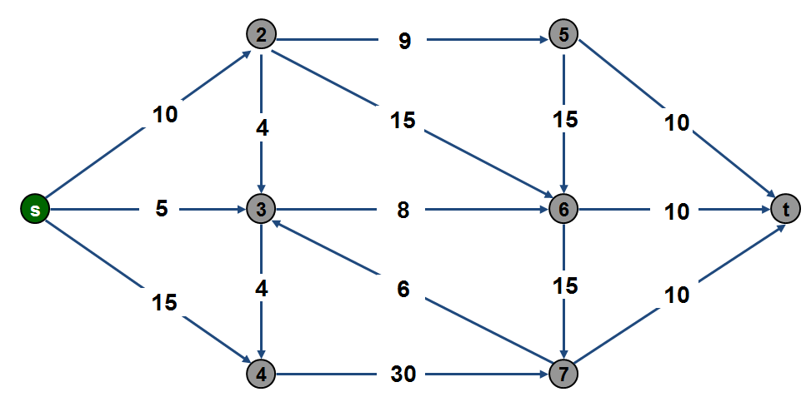
(1). What is the maximum flow value from the source node s to the target node t?
(2). Show the flow values on each link on this directed graph for the maximum flow scenario.

