**COT5405: Homework 1 (Spring 2015)**

1. Consider the directed acyclic graph G in the following figure. How many topological orderings does it have?

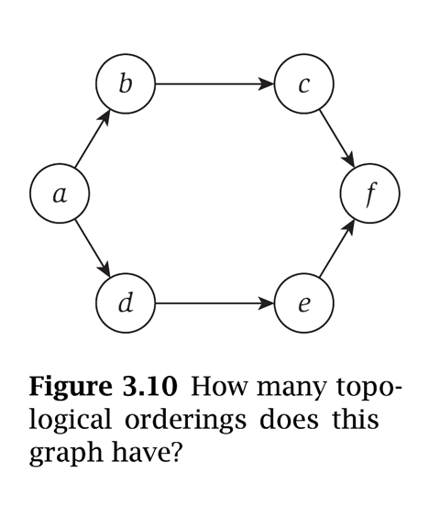

1. Stable Matching: For the following marriage preference between 5 women and 5 men:

 

a). Manually run the Gale-Shapley algorithm ( Page 11 in stable-matching.ppt slides). In this algorithm, men do proposal, so the result is men-optimal. Please show the procedure in each iteration, i.e., you must show what actions/results at the end of each iteration. Show the final result as well.

b). Now manually run the Gale-Shapley algorithm by letting women to do the proposal. Show the procedure in each iteration, and show the final result as well.

1. Show the adjacency matrix representation and adjacency list representation (in the format like the example on Page 8,9 in slides ‘graphs.ppt’) of the following graph:

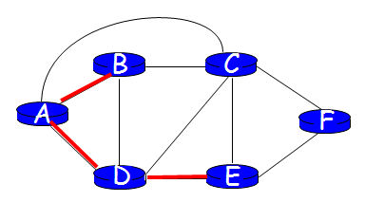

1. Shortest path. Manually run the Dijsktra’s algorithm on Page 30 in slides ‘greedy.ppt’ for the following undirected graph starting from the source node ‘A’. You must show the entire procedure, i.e., what is the result of set S and D’(v) for all nodes after initialization; at the end of each iteration, what is the result of set S, and for all nodes what is the value of D(v) if the node v is in the set S and what is the value of D’(v) if the node v is not in set S.

