CNT3004: Computer Network Concepts (Summer 2012)
Homework 1: Chapter 1,2,3
(assigned 05/29; due: 06/06 midnight on webcourse)

Name: ______________________________________ PID: ____________________

Note: You need to compute the final numerical results for all computing questions (i.e., you cannot just list the formula as the final result).

- Knowledge Questions:
(a). How many layers are defined in OSI model? List them from top to bottom.
(b). How many layers are defined in TCP/IP model? List them from top to bottom.
(c). How many bytes are used for MAC address? How many bytes are used for IP address? How many bytes are used for port number?
(d). Comparing the star topology and the bus topology in constructing a LAN, which one is better? Why?

- Television channels are 6 MHz wide. What is the maximum bit rate can be achieved if two-level digital signals are used? Assume a noiseless channel.

- If a binary signal is sent over a 3 KHz channel whose signal-to-noise-ratio is 20 dB. What is the maximum achievable data rate?

- If we need to send 10 Mbps, what is the required bandwidth (in terms of Hz) of a low-pass channel by using baseband transmission if we use one harmonic, three harmonics, five harmonics and nine harmonics, respectively? Now assume that we need to send 100 Mbps, what is the bandwidth required for the above cases? Complete the table.
 | Required Bandwidth
Bit rate | Harmonics 1 | Harmonics 1,3 | Harmonics 1,3,5 | Harmonics 1,3,5,9
10 Mbps
100 Mbps

- A signal with 200mW power is transmitted by a bridge (or a router). It passes through several connectors and cables (as shown on the figure). If the power losses at points A,B,C are 6dB each and the gain of the antenna is 19 dB, what is the power of the signal at point D?
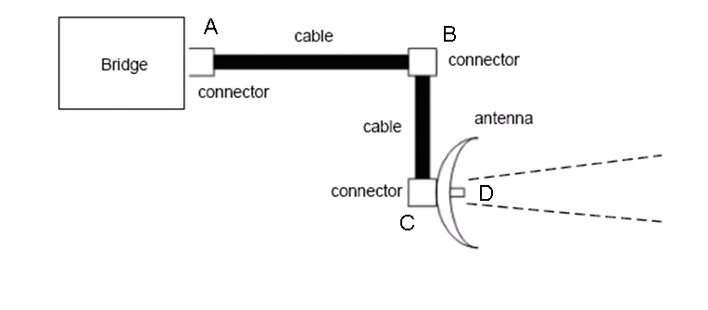
- We have a channel with a 10-MHz bandwidth. The SNR for this channel is 400. Assume that we choose a bit rate that is 50% of the maximum theoretical bit rate. What are the bit rate and signal level for this design? Tip: Use both Shannon formula and Nyquist formula.

- What is the delay of sending a data file a station to a destination station? Suppose that the length of the data file is 1 Mbytes and the bandwidth of the channel is 200 Kbps, and the network link between the sender and receiver is 2000 Km and the speed of the light inside the link is 2x10⁸ m/s? Assume that the delay is composed of only transmission time and propagation time.

- If a signal is 15dBm, what is its power in terms of millwatt? If the signal-to-noise ratio of this signal is 10dB, what is the noise’s power in terms of both millwatt and dBm? If this signal passes through a transmission line that could cause 3dB signal energy loss (i.e., attenuation is -3dB), how much power does this signal left after this transmission line in terms of dBm and millwatt, respectively?

