CNT3004: Computer Network Concepts (Spring 2011)
Homework 1: Chapter 1,2,3
(assigned 02/02; due: 02/09 in class with hardcopy handed in)

Name: ______________________________________ PID: ____________________

Note: You need to compute the final numerical results for all computing questions (i.e., you cannot just list the formula as the final result).

- Which of the OSI layers handles each of the following:
- Dividing the transmitted bit stream into frames.
- Determining which route through Internet backbone network to use.
- Dealing with mechanical, electrical and timing interfaces.
- Ensuring that the data from above layer arrives correctly at the other end.
- Compressing data.
- Ethernet switch determining which interface is used to send out a frame.

- How many bytes are used for MAC address? How many bytes are used for IP address? How many bytes are used for port number?

- Television channels are 6 MHz wide. What is the maximum bit rate can be achieved if two-level digital signals are used? Assume a noiseless channel.

- If a binary signal is sent over a 3 KHz channel whose signal-to-noise-ratio is 20 dB. What is the maximum achievable data rate?

- If we need to send 10 Mbps, what is the required bandwidth (in terms of Hz) of a low-pass channel by using baseband transmission if we use one harmonic, three harmonics, five harmonics and nine harmonics, respectively? Now assume that we need to send 100 Mbps, what is the bandwidth required for the above cases? Complete the table.
 | Required Bandwidth
Bit rate | Harmonics 1 | Harmonics 1,3 | Harmonics 1,3,5 | Harmonics 1,3,5,9
10 Mbps
100 Mbps

- A signal with 200mW power is transmitted by a bridge (or a router). It passes through several connectors and cables (as shown on the figure). If the power losses at points A,B,C are 6dB each and the gain of the antenna is 19 dB, what is the power of the signal at point D?
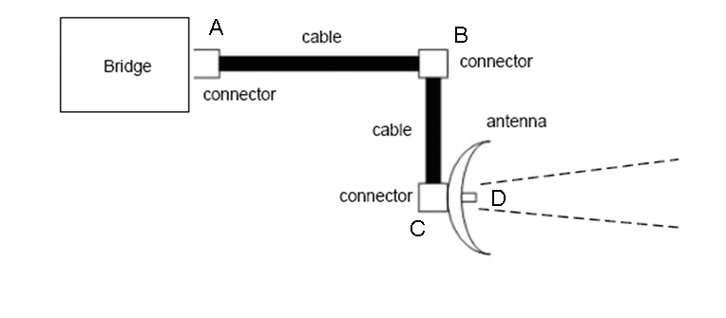
- We have a channel with a 10-MHz bandwidth. The SNR for this channel is 400. Assume that we choose a bit rate that is 50% of the maximum theoretical bit rate. What are the bit rate and signal level for this design? Tip: Use both Shannon formula and Nyquist formula.

- What is the delay of sending a data file a station to a destination station? Suppose that the length of the data file is 1 Mbytes and the bandwidth of the channel is 200 Kbps, and the network link between the sender and receiver is 2000 Km and the speed of the light inside the link is 2x10⁸ m/s ? Assume that the delay is composed of only transmission time and propagation time.

Important: I won’t receive any assignment after Wednesday 02/09/11, 11:59 pm. If for any reason you cannot come to my class that day, please send me an email with your assignment attached, and then on the next Monday, give me a hardcopy of the assignment.

