CDA6530: Performance Models of Computers and Networks (Fall 2015)
Project 4: Discrete Event Simulation
(Assigned 11/04; due: 11/15 midnight)

In this project, you will need to use discrete event simulation approach I introduced in class to simulate a computer architecture based closed queuing network.
Suppose a computer has 5 processes that are continuously running and they will share and use one network interface card (NIC) for data communication from time to time. We are interested in how these processes use the network interface card.
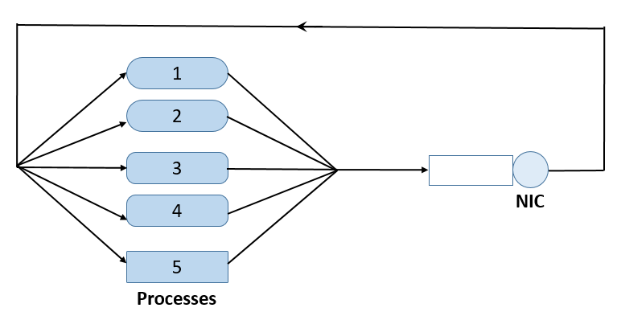
System Description:
Each process will use NIC and use the computer’s other resources alternatively and runs indefinitely. We assume the other resources are abundant such that those processes do not affect each other when using the other resources. However, there is only a single NIC so if multiple processes want to use the NIC, they have to wait in queue and use the NIC one after another. In other word, you can treat the NIC as a single server and there are 5 customers in this closed queuing network.
Suppose each process finishes using other resources following exponential distribution with the same rate λ = 0.1/sec. When a process is using the NIC, it finishes using the NIC service following a 5-th order Erlang distribution with rate µ = 1/sec.
We also assume that these 5 processes belong to 3 priorities when using the NIC service: Process 1 and 2 have the lowest priority; Process 3 and 4 have the middle priority; and Process 5 has the highest priority. Processes belonging to the same priority will wait in NIC queue following “first come, first serve” rule. If a higher priority process enters the queue and finds a lower priority process in the queue, the higher one will be served before the lower one (this is called a “priority queue”). Note that an incoming process does not affect or interrupt the process that is being served (this is called non-preemptive).

Simulation Requirements:
You need to simulate this system until the NIC has finished serving 50,000 processes. Initially (t=0) all 5 processes start to use other resources. You can use Matlab, or C or C++ or Java or Python to write this simulation code. If it is not Matlab code, you must make sure your code can be compiled and run under our department Eustis machine.
Your simulation code should provide results of:
(1). The utilization of the NIC based on your simulation result, i.e., the fraction of time the NIC is busy serving any processes.
(2). What is the simulation end time when your simulation finishes? How long does your simulation code run on your computer to finish the simulation (note: this time could vary a lot dependent on your computer)?
(3). How many times have each process use the NIC service?
(4). For each process, what is the average waiting time respectively when it waits in the NIC queue?

Submission: please submit a project report with explanations of your design and codes, and your answers to all the above questions. In addition, submit your program source code as a separate file so that the TA can test it (explain in your report how to compile or run your code on Eustis machine if it is not Matlab code). Please submit the files via webcourse.
In your report, you need to explain your design and code of the following aspects:
(1). The important variables you used in your simulation code, and what are they corresponding to?
(2). What events do you define? What is included in the event list?
(3). How do you keep tracking of the NIC queue?

