CDA6530: Performance Models of Computers and Networks (Fall 2014)
Project 4: Discrete Event Simulation
(Assigned Nov. 17th; due: Nov. 30th midnight via webCourse)

Let us consider a queuing network that is similar but different from the feedback queuing network example introduced in lecture ‘queue-network.pdf’. The queuing network is following. The two incoming customer flows still follow Poisson process with rate r₁ = 4 and r₂=5, respectively. The two servers also have the expo. Distr. Service time with rate μ₁ = 8 and μ₂ = 10, respectively. The differences are in two places: First, Server 1’s queue can hold up to 3 customers (so there could be up to 4 customers in server 1’s system); and Server 2’s queue can hold up to 4 customers. Second, the feedback link from Server 1’s output is not random sampling anymore----for customers coming out of Server 1, all even numbers of customers are feedback to Sever 2’s input.
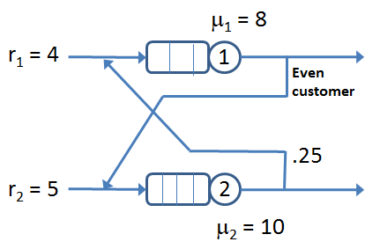

You are required to conduct discrete event simulation of this queuing network system until N = 10,000 customers have left the queuing network (regardless whether a customer left from Server 1 or from Server 2). The initial condition is that all 2 Servers are empty and ready.

Based on simulation results, you are required to provide answers to the following questions (provide the procedure on how you derive the answers):

(1). What is the probability that the entire queuing system has 0 customer? Has 2 customers? Has 9 customers? (please clearly describe how you derive the answers)
(2). During the entire simulation process, how many customers have been dropped from the system because of the limited queue sizes of the two servers?
(3). If we consider each server individually, what is the average response time (time between the customer enters a queue and time the customer finishes service from this server) of Server 1 and Server 2, respectively?

Submission: Please submit your report document (a word file or PDF file), and your simulation codes. You can use Matlab or C or java or Python to program your simulation code. But if you do not use Matlab, your C/java/Python code must be able to run on Eustis machine in case I need to verify your simulation results by running your code (explain how to compile and run your code on Eustis). Your report should explain how you design your simulation, how I can compile/run and test your code, what important variables you used in your code.

