EEL 4890 Class Demo #3 Fall 2011

A single tank with cross-sectional area  ft2 receives an inflow of  in ft3/min at a temperature of  measured in deg F. Outflow  is in ft3/min and at temperature in deg F. The liquid level and temperature in the tank at time  is  respectively.















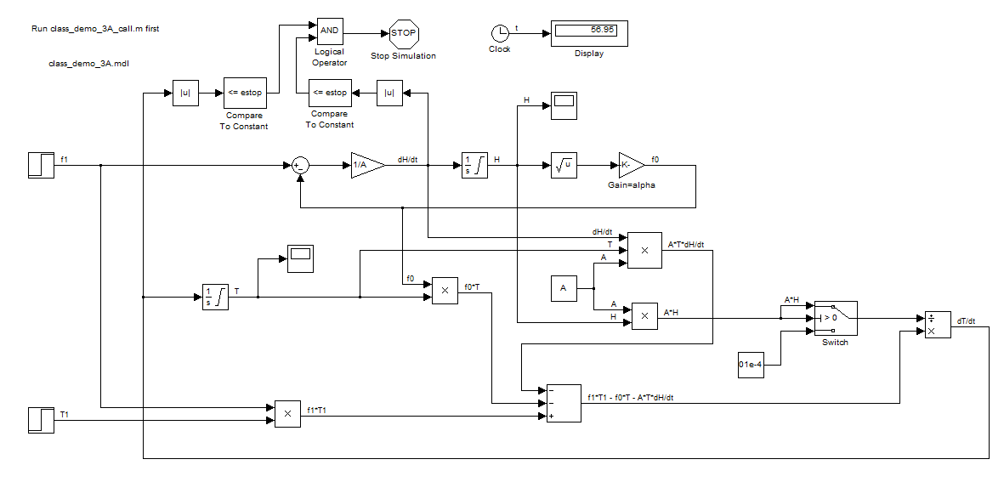

% class_demo_3A.m

% example of a tank with two inputs, flow and temperature

clc, close all, clear all

A=10; % tank area

F1=12; % amplitude of step flow in

alpha=4; % discharge flow constant

H_init=10;

T_init=70;

delta_T=50; % change in temp step flow in above T_init

step_size=0.025; % RK-4 integration step size

tfinal=500;

estop=0.01; % stop condition for |dH/dt| and |dT/dt|

sim('class_demo_3A')

t=t_H(:,1);

H=t_H(:,2);

T=t_T(:,2);

subplot(2,1,1)

plot(t,H)

ylabel('H (ft)')

title('H vs t')

subplot(2,1,2)

plot(t,T)

xlabel('t (min)')

ylabel('T (deg F)')

title('T vs t')