Assignment 1

1. An inverting amplifier is ideal, apart from having finite gain of 5*10^3. design the circuit such that the closed loop voltage gain is -12 and input resistor R1 is 25K. Find R2.

2. Design a summing amplifier such that Vo = -(Vi1+Vi2+Vi3)/3. The maximum allowable resistance is 1M.

3
.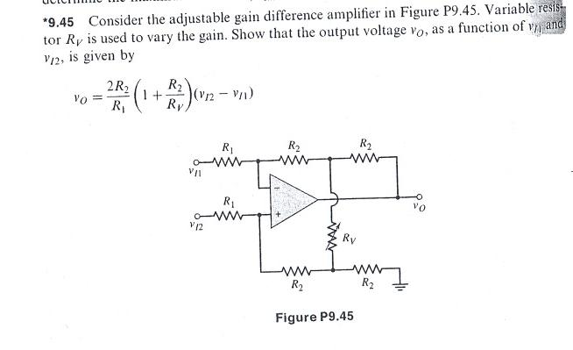

4.
