COT5405 - Homework 2

Out date: 09/22/2010 (Wednesday), due date: 09/29/2010 (Wednesday)
15 points each problem.
You need to turn in the solutions for all four problems. But we will select two problems and only grade these two.

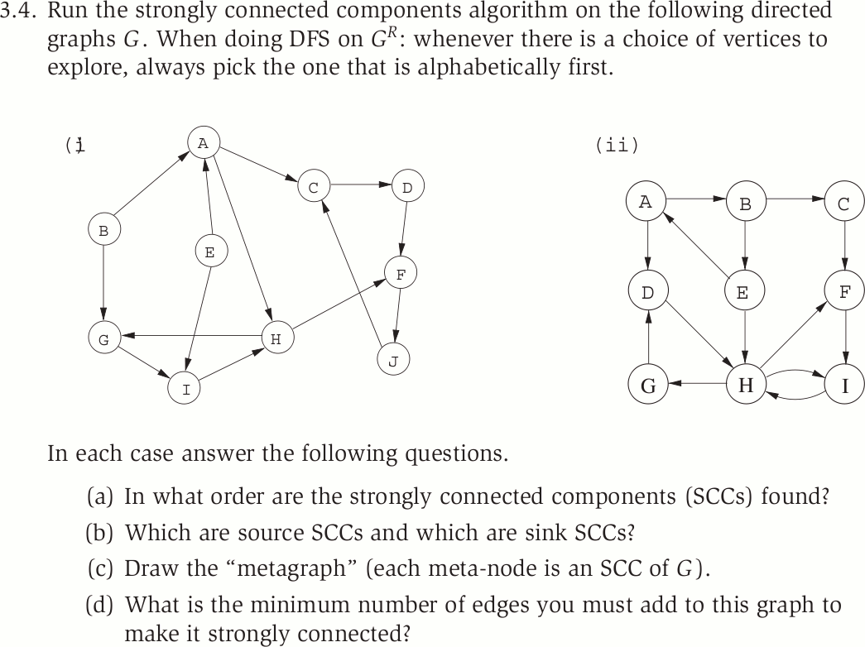

(i.a) {CDFJ}, {GHI}, {A},{B},{E}

(i.b) Source SCCs: {B},{E}

Sink SCCs: {CDFJ}

(i.c) Metagraph:

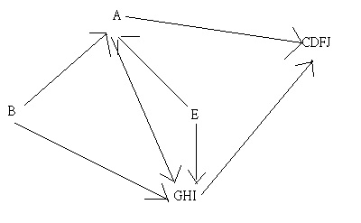
(i.d) 2

(ii.a) {DFGHI}, {C}, {ABE}

(ii.b) Source SCCs: {ABE}

Sink SCCs: {DFGHI}

(ii.c) Metagraph:

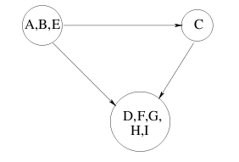

(ii.d) 1
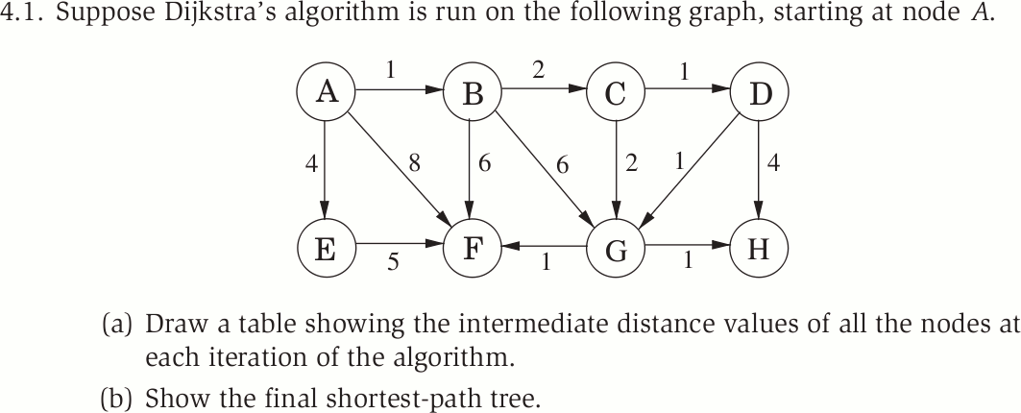
(a)
Node | Iteration
Node | 0 | 1 | 2 | 3 | 4 | 5 | 6 | 7
A | 0 | 0 | 0 | 0 | 0 | 0 | 0 | 0
B | ꝏ | 1 | 1 | 1 | 1 | 1 | 1 | 1
C | ꝏ | ꝏ | 3 | 3 | 3 | 3 | 3 | 3
D | ꝏ | ꝏ | ꝏ | 4 | 4 | 4 | 4 | 4
E | ꝏ | 4 | 4 | 4 | 4 | 4 | 4 | 4
F | ꝏ | 8 | 7 | 7 | 7 | 7 | 6 | 6
G | ꝏ | ꝏ | 7 | 5 | 5 | 5 | 5 | 5
H | ꝏ | ꝏ | ꝏ | ꝏ | 8 | 8 | 6 | 6

(b)

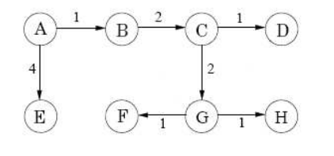
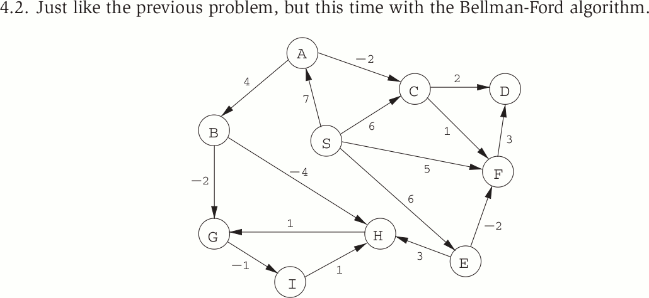
Start at node S. Update the edges in the following order: S->A, S->C, S->E, S->F and the remaining edges in lexicographic order. For example, E->F comes before E->H and C->F comes before F->D.
(a)
Both the following tables are correct. The big table below is obtained from the official solution manual. It seems the authors showed the results of a new iteration whenever there are updates overwriting previous shortest distances.
Node | Iteration
Node | 0 | 1 | 2 | 3 | 4 | 5 | 6
S | 0 | 0 | 0 | 0 | 0 | 0 | 0
A | ꝏ | 7 | 7 | 7 | 7 | 7 | 7
B | ꝏ | ꝏ | 11 | 11 | 11 | 11 | 11
C | ꝏ | 6 | 5 | 5 | 5 | 5 | 5
D | ꝏ | ꝏ | 8 | 7 | 7 | 7 | 7
E | ꝏ | 6 | 6 | 6 | 6 | 6 | 6
F | ꝏ | 5 | 4 | 4 | 4 | 4 | 4
G | ꝏ | ꝏ | ꝏ | 9 | 8 | 8 | 8
H | ꝏ | ꝏ | 9 | 7 | 7 | 7 | 7
I | ꝏ | ꝏ | ꝏ | ꝏ | 8 | 7 | 7

This is what some of you may be getting, where each iteration corresponds to an iteration of the outer for loop.
Node | Iteration
Node | 0 | 1 | 2
S | 0 | 0 | 0
A | ꝏ | 7 | 7
B | ꝏ | 11 | 11
C | ꝏ | 5 | 5
D | ꝏ | 7 | 7
E | ꝏ | 6 | 6
F | ꝏ | 4 | 4
G | ꝏ | 8 | 8
H | ꝏ | 7 | 7
I | ꝏ | 8 | 7

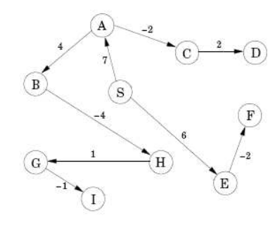
(b)

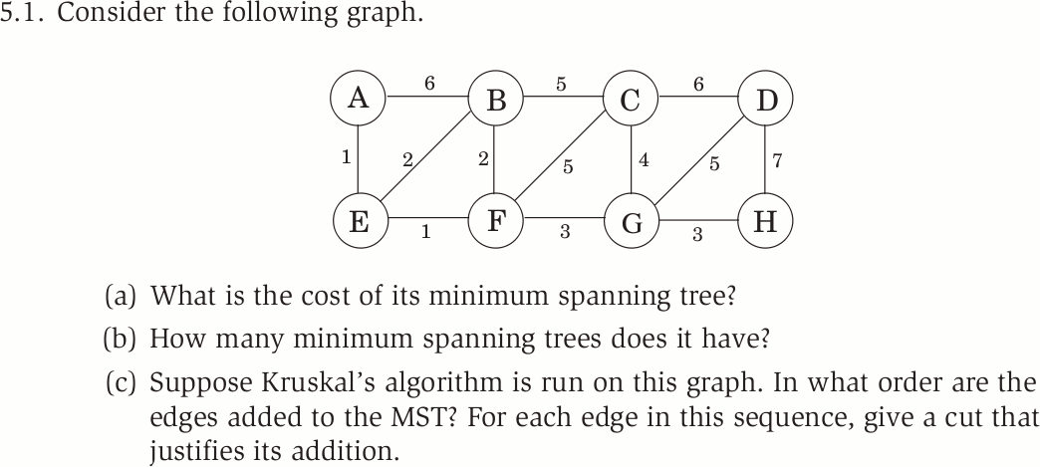

(a) 19

(b) 2

(c)
No | Edge included | Cut
1 | AE | ABCD | EFGH
2 | EF | ABCDE | FGH
3 | BE | AEFGH | BCD
4 | FG | ABEF | CDGH
5 | GH | ABEFG | CDH
6 | CG | ABEFGH | CD
7 | GD | ABCEFGH | D

