COT5405 - Homework I

Out date: 09/08/2010 (Wednesday), due date: 09/14/2010 (Wednesday)
15 points each problem.
You need to turn in the solutions for all four problems. But we will select two problems and only grade these two.
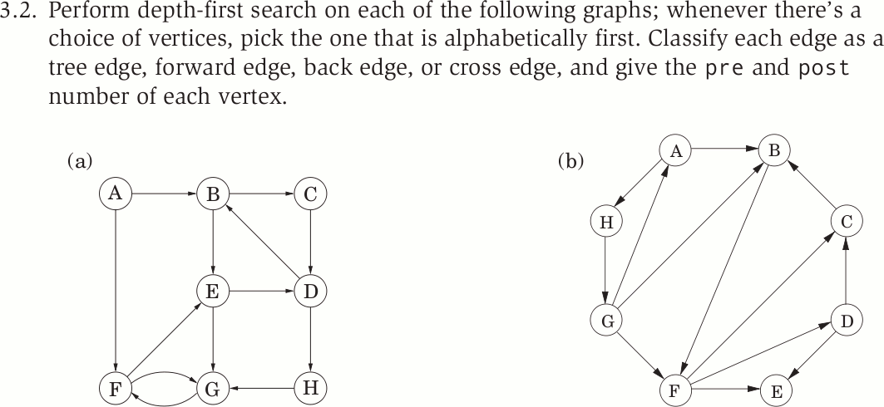

Problem (a)
Vertices | Pre number | Post number
A | 1 | 16
B | 2 | 15
C | 3 | 14
D | 4 | 13
E | 8 | 9
F | 7 | 10
G | 6 | 11
H | 5 | 12

Edges | Tree Edge | Cross Edge | Back Edge | Forward Edge
A-->B | x
A-->F |  |  |  | x
B-->C | x
B-->E
C-->D | x
D-->B |  |  | x
D-->H | x
E-->D |  |  | x
E-->G |  |  | x
F-->E | x
F-->G |  |  | x
G-->F | x
H-->G | x

Problem (b)
Vertices | Pre number | Post number
A | 1 | 16
B | 2 | 11
C | 4 | 5
D | 6 | 9
E | 7 | 8
F | 3 | 10
G | 13 | 16
H | 12 | 15

Edges | Tree Edge | Cross Edge | Back Edge | Forward Edge
A-->B | x
A-->H | x
B-->F | x
C-->B |  |  | x
D-->C |  | x
D-->E | x
F-->C | x
F-->D | x
F-->E |  |  |  | x
G-->A |  |  | x
G-->B |  | x
G-->F |  | x
H-->G | x

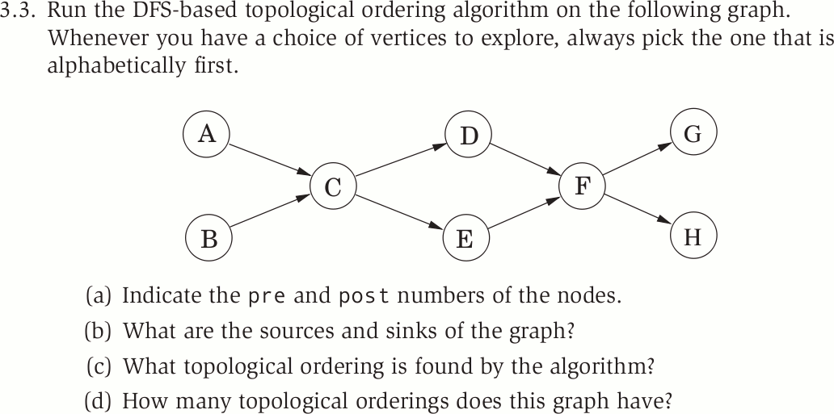

Problem (a)
Vertices | Pre number | Post number
A | 1 | 14
B | 15 | 16
C | 2 | 13
D | 3 | 10
E | 11 | 12
F | 4 | 9
G | 5 | 6
H | 7 | 8

Problem (b)

Sources | A B
Sinks | G H

Problem (c)

Topo ordering | B | A | C | E | D | F | H | G

Problem (d)

8

