Advanced Tree Structures – Multi-way Trees (7)

Introduction

General trees are commonly referred to as multi-way trees. If there is a maximum value m placed on the number of children that a given node may have the tree is referred to as an m-way tree. There are many variations of m-way trees, however, we will focus on the special variant suitable for search-based applications. This variant is called the m-way search tree.

M-way Search Tree

An m-way search tree T is a general tree in which an ordering is imposed on the set of keys which reside in each node such that:

- Each node has a maximum of m children between 1 and m-1 keys.

- The keys in each node appear in ascending order.

- The keys in the first i children are smaller than the ith key.

- The keys in the last m-1 children are larger than the ith key.

M-way search trees play the same role amongst general trees that binary search trees play among binary trees, and they are used for exactly the same purpose: fast information retrieval and update. The problems in dealing with m-way search trees are similar to those experienced with BSTs. Balancing problems are more critical in general trees since there is a potential for many subtrees. Figure 1 presents an example of an m-way search tree, this one happens to be a 4-way search tree. Figure 2 provides a second example which is that of a 7-way search tree. In the m-way trees illustrated in Figures 1 and 2, the external nodes are not shown for the sake of clarity. As we mentioned when discussing red-black trees, the external nodes are rarely, if ever, actually implemented, but they can aid in the visualization of these types of structures and the operations that occur on them. Rather than implement external nodes, null pointers are typically utilized. Figure 3 illustrates the 7-way search tree of Figure 2 but with the external nodes represented.

506080

30 35
58 59
100
63 70 73

52 54
61 62

57

55 56

Figure 1. M-way search tree of order 4.

10
80
5
2
3
4
32
36
20
30
40
50
60
70
82
84
86
88
90
92
94
96
98

Figure 2. M-way search tree of order 7.

10
80

20
30
40
50
60
70
82
84
86
88
5

90
92
94
96
2
3
4
32
36
98

Figure 3. M-way search tree of order 7 with external nodes shown.

10
80

20
30
40
50
60
70
82
84
86
88
5

90
92
94
96
2
3
4
32
36
98

Figure 4. M-way search tree of order 7 shown with typical external node implementation.

Justification for M-way Search Trees

One common application for m-way search trees is the file system for secondary memory, such as disks and tapes, on computer systems. The basic unit of I/O transfer associated with a disk is a block. When information is read from a disk, the entire block, in which the information required is contained, is read into the memory (main memory) and when information is written from the main memory back to the secondary memory (the disk), the entire block is written back. Each time information is requested from a disk, the information must be located on the disk, the read/write head on the disk must be correctly positioned above the portion of the disk where the information is located, and the system must wait for the spinning disk to rotate the entire required block underneath the read/write head to be transferred to the main memory. This would indicate that there are several time factors involved with every request for information from the secondary memory, which are:

access time = seek time + latency + transfer time

where, seek time represents the time required to properly position the read/write head; latency refers to the rotational delay required to spin the disk to the proper position under the read/write head; and transfer time refers to the total time required to move the disk block into the main memory. Compared to transferring information within the main memory, the process of transferring information from secondary memory is extremely slow. The seek time is especially long since it requires positioning an electro-mechanical device. Latency, on the average is equal to the time required to rotate the disk one-half revolution. For example, the time required to transfer 5KB (kilobytes) from a disk drive that requires 40 msec seek time, is spinning at 3000 rev/min (50 rev/sec = 0.05 rev/msec, thus one-half revolution requires 0.5 = x * 0.05 = 10 msec), and has a data transfer rate of 1000 KB/sec (5KB = 1/200th of 1000KB so 1/200th of 1 sec = 0.005 sec = 5 msec) is:

access time = 40 msec + 10 msec + 5 msec = 55 msec

This example clearly indicates that transferring information to and from secondary memory (disk technology) requires time of the order of milliseconds. On the other hand, modern CPUs process data on the order of 1 million times faster. For example, a 1 GHz processor has a clock cycle of 1/1x10⁹ seconds = 1x10⁻⁹ sec = 1 nanosecond! Thus processing information on secondary memory will significantly decrease the speed of a program. If a program uses information stored in secondary storage, the characteristics of that storage must be considered when designing the algorithms and programs that will operate on that information. For example, a binary search tree can be spread over many different blocks on a disk, such as in Figure 5 shown below, which will require an average of two block accesses per search.

Figure 5. BST for searching file blocks.

When the tree is frequently accessed by a program, these accesses can significantly slow down the program. Also the insertion and deletion of key values within the tree will require many block accesses. Thus, the BST which seems to be such an efficient search tool when it resides entirely in main memory turns out to be a hindrance to performance. In the context of secondary memory, its otherwise good performance counts very little because the constant accessing of the disk blocks that this implementation causes, severely hamper its performance.
It is also better to access a large amount of data at one time than it is to jump around from one position to the next on the disk to transfer small portions of data. For example, using the earlier parameters, if we have 10KB to be transferred, we have:

access time = 40 msec + 10 msec + 10 msec = 60 msec

However, if this information is stored in two separate 5KB pieces at different locations on the disk, then we have:

access time = 2 × (40 msec + 10 msec + 5 msec) = 110 msec

which is nearly twice as long as the previous case requiring only 60 msec! Since each disk access is so costly, we need to organize the data in such a way as to minimize the number of disk accesses.

Height of an M-way Search Tree

An m-way search tree of height h (excluding external nodes) may have as few as h elements (one node per level and one element per node) and as many as m^{h}-1 elements. The upper bound is achieved by an m-way search tree of height h in which at each node at levels 1 through h-1 has exactly m children and nodes at level h have no children. The number of nodes in such as tree is given by:
$\sum_{i=0}^{h−1}{m^{i}=\frac{m^{h}−1}{m−1}}$

Since each of these nodes has m-1 elements, the number of elements is m^{h}-1.

Since the number of elements in an m-way search tree of height h ranges from a low of h to a high of m^{h}-1, the height of an m-way search tree with n elements ranges from a low of log_{m}(n+1) to a high of n.

For example, a 200-way search tree of height 5 can hold 32 × 10¹⁰ – 1 elements but might hold as few as 5! Equivalently, a 200-way search tree with 32 × 10¹⁰ – 1 elements has a height between 5 and 32 × 10¹⁰ – 1. When the search tree resides on disk, the search, insert, and delete times are dominated by the number of disk accesses made (assuming that each node in no larger than a disk block). Since the number of disk accesses needed for search, insert, and delete operations are O(h) where h is the tree height, clearly we need to be sure that the height is close to log_{m}(n+1). This assurance is provided by balanced m-way search trees which are variants of the m-way search tree that we will explore.

Searching a M-way Search Tree

Using the 7-way search tree illustrated in Figure 3 as an example, consider the search for the element with key value = 31. Searching begins at the root as with other search trees. Since 31 lies between 10 and 80, the middle pointer from the root is followed, since by definition, all elements in the first subtree will have key values < 10 and all elements in the third subtree will have key values > 80. The root of the middle subtree is searched. Since k₂ < 31 < k₃, the search will be directed to the third subtree of this node. At this point, the search will determine that 31 < k₁ and will move the search into the first subtree of this node. This move will direct the search into an external node and the search will conclude that the element with key value 31 does not exist.

Insertion Into an M-way Search Tree

Using the 7-way search tree of Figure 3 as an example, suppose that we now wish to insert a new element with key value 31. As before, we initially search for the key value 31 and will enter the external node level at node [32, 26]. Since this node is capable of holding up to 6 elements, the new element is simply inserted as the first element in this existing node.

On the other hand, insertion of an element with key value 65 will not be quite as simple. The search will again fall into the external node level when it moves to the sixth subtree of the node [20,30,40,50,60,70]. This node, however, is full and cannot accommodate additional elements. A new node must be obtained. The new element is put into this new node, and the new node becomes the sixth child of [20,30,40,50,60,70]. This is shown in Figure 6 below.

10
80

20
30
40
50
60
70
82
84
86
88
5

90
92
94
96
2
3
4
32
36
98
65

Figure 6. 7-way search tree of Figure 3 after insertion of element with key value 65.

Deletion From an M-way Search Tree

Once again, using the 7-way search tree shown in Figure 3, suppose that we wish to delete the element with key value 20 from the tree. As before, we search for this key value and in this case it is found as the first child in the middle child of the root node. The key value does not reference any other child (i.e., it has no subtree with key values less than 20 nor is there as subtree with key values greater than 20 but less than 30). The new middle node of the root then becomes [30,40,50,60,70]. This is shown in Figure 7.

A similar situation arises if we delete the element with key value 84, the element is first located and since it has no children, it can simply be deleted making the new node configuration [82,86,88] as shown in Figure 8.

10
80

40
50
60
70
82
84
86
88
5
30

90
92
94
96
2
3
4
32
36
98

Figure 7. 7-way search tree of Figure 3 after the deletion of the element with key value 20.

10
80

20
30
40
50
60
70
86
88
5
82

90
92
94
96
2
3
4
32
36
98

Figure 8. 7-way search tree of Figure 3 after the deletion of the element with key value 84.

Deletion becomes a bit more complicated when the subtrees of the deleted node are not external nodes. Consider for example, deletion of the element with key value 5 from the tree of Figure 3. In this case, one of the neighboring children (in this case the first child of node 5) is non-null. This type of situation requires that the deleted element be replaced by an element from a neighboring nonempty subtree. In this case, the largest element in the first subtree is moved up to replace the element with key value 5. This will produce the tree of Figure 9.

10
80

20
30
40
50
60
70
82
84
86
88
4

90
92
94
96
2
3
32
36
98

Figure 9. 7-way search tree of Figure 3 after the deletion of the element with key value 5.

Deletion of an element with a key value which has two neighboring subtrees provides an option of moving either the largest element in the left-side subtree or the smallest in the right-side subtree up to replace the deleted element. Which choice is best is dependent upon the structure of the tree at the point of the deletion. Using the tree from Figure 3 as an example, suppose that the element with key value 10 is deleted from the tree. Since this element has two non-null subtrees, then either the largest element in its left-side subtree, which is 5 in this case, is moved to the root or the smallest element in its right-side subtree, which is 20 in this case is moved to the root. If we choose to move the element with key value 5, this will empty this node and a replacement must be found for the element with key value 5 which will require moving the largest element in node 5’s left subtree to this position which will elevate node 4 into this position. This choice is illustrated in Figure 10.

On the other hand, we could also choose to move the smallest element in the right-side subtree; the 20. For the configuration of the tree in Figure 3 this represents the better choice since the node containing the element with key value 20 has two null children and it can then simply be moved into the root and no further movement will be required in the tree to complete the deletion. This case is illustrated in Figure 11.

5
80

20
30
40
50
60
70
82
84
86
88
4

90
92
94
96
2
3
32
36
98

Figure 10 7-way search tree of Figure 3 after deletion of element with key value 10 assuming
the largest element in the left-side subtree is moved to replace deleted node.

20
80

40
50
60
70
82
84
86
88
5
30

90
92
94
96
2
3
4
32
36
98

Figure 11. 7-way search tree of Figure 3 after deletion of element with key value 10 assuming
the smallest element in the right-side subtree is moved to replace deleted node.

B-Trees

In database systems/programs where most information is stored on secondary memory systems, the time penalty for accessing the secondary storage can be significantly reduced by the proper choice of data structures. The B-tree is one such data structure that gives good overall performance as it can be tuned to operate closely with the secondary storage system. The tuning will reduce the impediments that this type of storage imposes to fast searching. One important property of a B-tree is that the size of each node can be made as large as the size of a block on the secondary storage media on which it resides. The number of key values in one node of the B-tree will vary depending upon the size of the keys, the organization of the data (are only key values maintained in the nodes or are entire records maintained in these nodes?), and of course, on the size of the block. Block sizes vary from system to system. Typical ranges for block size range anywhere from 512 bytes to 4KB or even more. Whatever the block size, that will be the size of a node in the B-tree. Thus, the amount of information stored in one node of a B-tree can be quite large.
Definition:

A B-tree of order m is a multiway search tree with the following properties:

- The root has at least two subtrees unless it is a leaf.
- Each non-root and each non-leaf node holds k-1 keys and k references to subtrees where ⎡m/2⎤ ≤ k ≤ m.
- Each leaf node holds k-1 keys where ⎡m/2⎤ ≤ k ≤ m.
- All leaves are on the same level*.

In this definition, the order of the B-tree specifies the maximum number of children.
Some definitions will specify the order as the minimum number of children.

The definition of the B-tree implies that a B-tree is always at least half full, has few levels (the tree is not very deep), and is perfectly balanced. Notice that the 7-way tree we have been using as an example of an m-way search tree is not a B-tree since it has external nodes on more than one level. Notice too, that even if all of its external nodes were on one level it would still not be a B-tree of order 7 since all of the internal nodes would need to have ⎡7/2⎤ = 4 children and the tree of Figure 3 does not meet this requirement.

Usually, m is large, somewhere in the 50-500 range, so that information stored in one page or block of the secondary memory can fit into one node. If the contents of one such node also reside in secondary memory (extremely likely), each key access would require two secondary storage accesses. In the long run, this is better than keeping the entire record in the nodes, since in this case, the nodes can hold a much smaller number of records. The resulting B-tree is much deeper and the search paths much longer than in a B-tree which contains the addresses of the records.

Searching in a B-tree

Inserting a Key in a B-tree

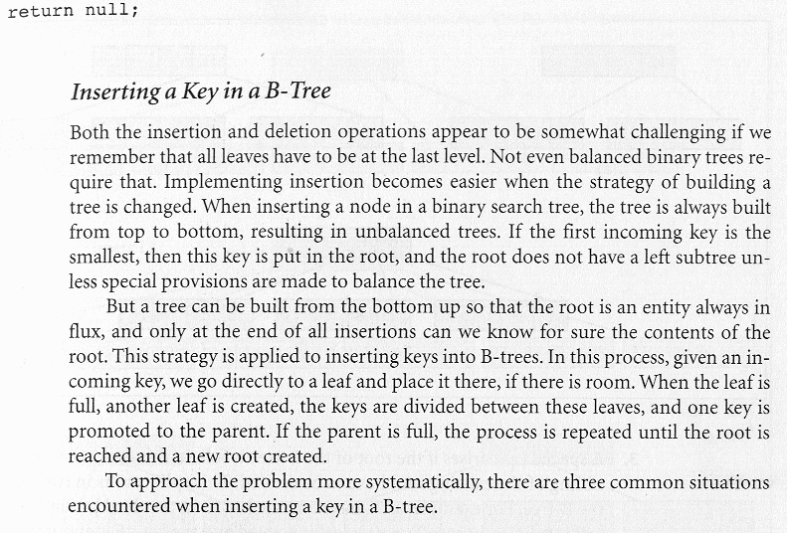
Case 1: A key is inserted into a leaf which still has room. In the example below, in a B-tree of order 5 (Figure 12(a)), a new key value of 7, is inserted into a leaf, preserving the order of the keys in that leaf so that key value 8 must be shifted to the right by one position (Figure 12(b)).

Figure 12. Insertion into a leaf node with available space

Case 2: The leaf in which the key needs to be inserted is full. In this case the leaf is split, creating a new leaf, and half of the keys in the existing leaf are moved from the full leaf to the new leaf. But the new leaf must be incorporated into the B-tree. The last key of the old leaf is moved to the parent, and a reference to the new leaf is placed in the parent as well. The same procedure is repeated for each internal node of the B-tree so that each such split adds one more node to the B-tree. Also, such a split guarantees that each leaf never has less than ⎡m/2⎤ -1 keys.

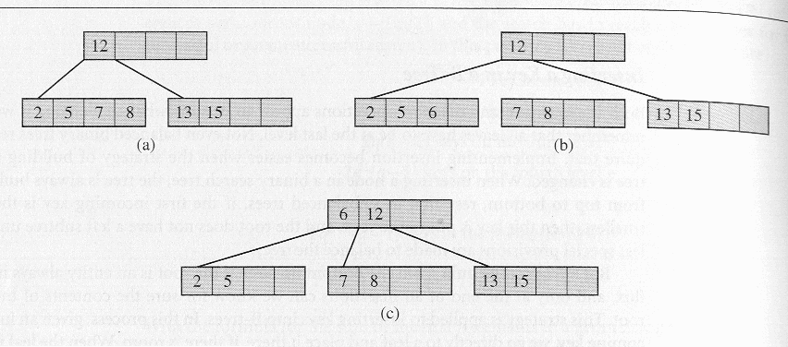
Figure 13. Inserting the key value 6 into a full leaf.

Case 3: A special case arises if the root of the B-tree is full. In this case, a new root node and a new sibling of the existing root must be created. This split results in two new nodes in the B-tree. The example below illustrates the case when the new key value is inserted into the B-tree in the third leaf. In (a) the leaf is split (as in case 2), in (b) a new leaf is created and the key value 15 is about to be moved to the parent, but the parent is full, so in (c) the parent is split, but now two B-trees have to be combined into one. This is achieved by creating a new root and moving the last key from the old root to it, as shown in (d). It should be apparent that this is the only case in which the height of the B-tree will increase.

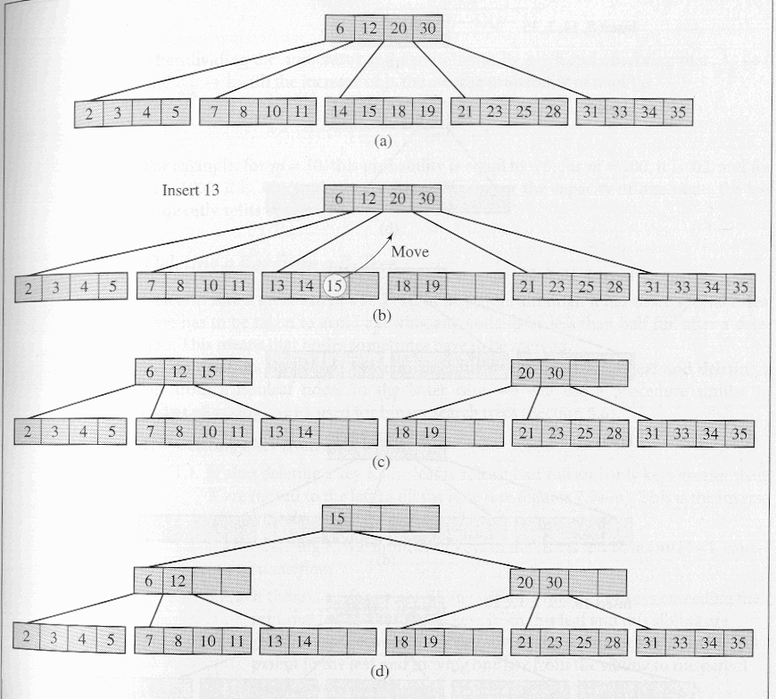
Figure 14. Node splitting causing creation of new root node.

Deleting a Key from a B-tree

Deletion is to a great extent a reversal of insertion, although it has more special cases. Care must be taken to avoid allowing any node to be less than half full after a deletion. This means that nodes sometimes need to be merged.

In deletion, there are two main cases: (1) deleting a key from a leaf and (2) deleting a key from a non-leaf node. In the latter case, a technique similar to the delete-via-copying technique that was employed for BSTs is typically used.
Case 1: Deleting a key from a leaf:

1.1: If after deleting a key K, the leaf is at least half full and only keys greater than K are moved to the left to fill the hole. See Figure 15(a) and Figure 15(b). This is the inverse of insertion’s case 1.

1.2: If after deleting K, the number of keys in the leaf is less than ⎡m/2⎤ -1, causing an underflow.

1.2.1: If there is a left or right sibling with the number of keys exceeding the minimal ⎡m/2⎤ -1, then all keys from this leaf and this sibling are redistributed between them by moving the separator key from the parent to the leaf and moving one key from the sibling to the parent. See Figure 15(b) and Figure 15(c).

1.2.2: If the leaf underflows and the number of keys in its siblings is ⎡m/2⎤ -1, then the leaf and a sibling are merged; the keys from the leaf, from its sibling, and the separating key from the parent are all put in the leaf, and the sibling node is discarded. The keys in the parent are moved if a hole appears. See Figure 15(c) and Figure 15(d). This can initiate a chain of operations if the parent underflows. The parent is then treated as though it were a leaf, and either case 1.2.2 is repeated until case 1.2.1 can be achieved or the root of the tree has been reached. This step is the inverse of insertion’s case 2.

1.2.2.1: A special case arises when merging a leaf or nonleaf with its sibling when its parent is the root with only one key. In this case, the keys from the node and its sibling, along with the only key of the root, are put in the node which becomes a new root, and both the sibling and the old root nodes are discarded. This is the only case when two nodes disappear at one time. Also the height of the tree decreases by one. This is the inverse of insertion’s case 3 and is illustrated in Figures 15(c) through Figure 15(e).

Case 2: Deleting a key from a non-leaf node. This can lead to problems with tree reorganization. Therefore, deletion from a nonleaf node is reduced to deleting a key from a leaf. The key to be deleted is replaced by its immediate successor, which can only be found in a leaf. This successor key is deleted from the leaf, which brings returns you to case 1. This is illustrated in diagrams (e) and (f) below.

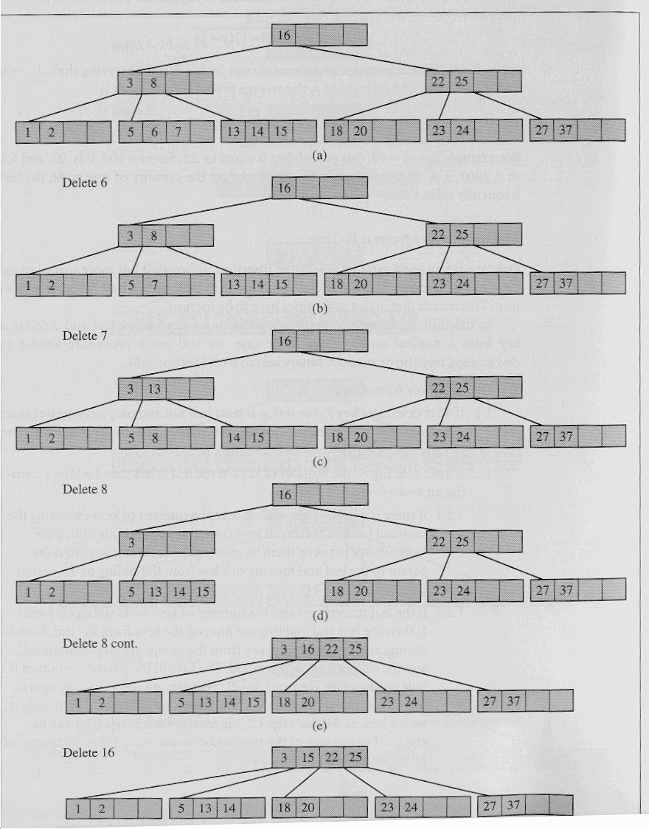
(f)
Figure 15. Deletion in a B-tree
Final comments on B-trees

B-trees, according to their definition, are guaranteed to be at least 50% full, so it may happen that 50% of the space is basically wasted. How often would you expect this to happen? If it happens too often, then the definition must be reconsidered or some other restrictions imposed on the B-tree. Analyses and simulations indicate that after a series of numerous random insertions and deletions, the B-tree is typically 69% full. After an initial “settling in period” during which numerous insertions and deletions occur, the B-tree structure undergoes very little change in the percentage of occupied cells. However, it is extremely unlikely that a B-tree will ever be filled to the brim, so additional variations on the theme have been developed over the years which are designed to enjoy the benefits of the B-tree with a higher utilization of the available space. B*-trees and B⁺-trees are two common variations on the B-tree theme and we will examine them in the next set of notes.

