COP 3503 – Computer Science II – CLASS NOTES - DAY #23

Graphs Continued

Graph Traversals

As with trees, traversing a graph consists of visiting each vertex only one time. The simple traversal algorithms used for trees (preorder, inorder, postorder) cannot be applied here because graphs may include cycles which would cause the tree traversal algorithms to enter an infinite loop. To prevent this from happening, each visited vertex is typically marked in some fashion to avoid revisiting it (a common technique is to renumber the vertices as they are visited). However, graphs can have isolated vertices (unconnected vertices), which means that some parts of the graph are left unvisited if unmodified tree traversal algorithms are applied.

Depth-First Traversal

The depth-first search algorithm for graphs was developed by Hopcroft and Tarjan. In this algorithm, each vertex V is visited and then each unvisited vertex adjacent to V is visited. If a vertex V has no adjacent vertices or all of its adjacent vertices have been visited, the traversal backtracks to the predecessor of V. The traversal is complete when this process of visiting and backtracking leads to the first vertex where the traversal started. If there are still unvisited vertices in the graph, the traversal continues by restarting on one of the unvisited vertices. This algorithm renumbers each vertex as it is visited.

Algorithm:
DFS(v)
num(v) = i++;
for all vertices u adjacent to v
if num(u) is 0
attach edge (uv) to edges;
DFS(u);

depthFirstSearch( )
for all vertices v
num(v) = 0;
edges = null;
i = 1;
while there is a vertex v such that num(v) is 0
DFS(v);
output edges;
Example:
The numbers assigned to each vertex are shown in parentheses in the figure below. Once the initializations have been made, depthFirstSearch( ) calles DFS(a). DFS( ) is invoked for vertex a; num(a) is assigned number 1. Vertex a has four adjacent vertices, and vertex e is chosen for the next invocation, DFS(e), which assigns number 2 to this vertex (num(e) = 2) and puts the edge(ae) in the set edges. Vertex e has two unvisited adjacent vertices, and DFS( ) is called for the first of them, the vertex f. The call DFS(f) will lead to the assignment num(f) = 3 and will put edge(ef) in edges. Vertex f has only one unvisited adjacent vertex, i, thus the fourth call DFS(i) will lead to the assignment num(i) = 4 and to the attaching of edge(fi) to edges. Vertex i has only visited adjacent vertices, thus a return to the call DFS(f) occurs and then to DFS(e) in which vertex i is accessed only to discover that num(i) is not 0, thus edge(ei) is not included in the set of edges. The rest of the execution is shown in the figure below where the solid lines indicate edges that are included in the set edges. Part (a) is the original graph and part (b) illustrates the algorithm’s technique.

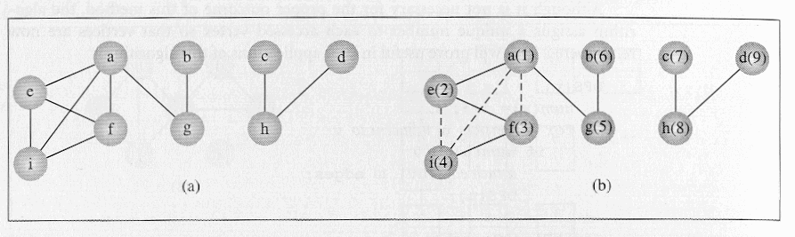
The depth-first graph traversal algorithm can also be applied to digraphs. This is illustrated in the next figure using the same symbolism as before.

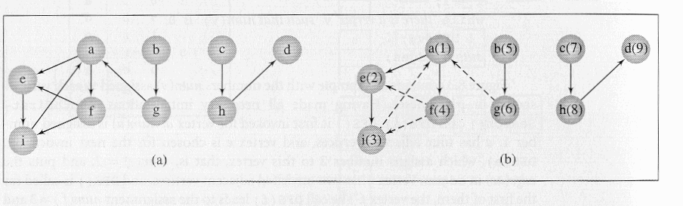Notice that this algorithm guarantees generating a tree (or a forest) which includes or spans over all vertices of the original graph. A tree that meets this condition is called a spanning tree. The fact that a tree (or a forest) is generated is ascertained by the fact that the algorithm does not include in the resulting tree any edge which leads from the currently visited vertex to a vertex which has already been visited. An edge is added only if the condition in “if num(u) is 0” is true, that is, only if vertex u reachable from vertex v has not been visited. As a result, certain edges in the original graph do not appear in the resulting tree. The edges included in this tree are called forward edges (or tree edges), and the edges not included in the tree are called back edges (the ones shown by dashed lines in the figures above).

Breadth-First Search

There are many different algorithms which are based on a depth-first traversal of a graph. Certain algorithms can be made more efficient if the underlying graph traversal is not depth-first but breadth-first. While depth-first tree traversals rely on a stack (either explicitly or implicitly with recursion), the breadth first tree traversal relies on a queue to handle the traversal (recall the level-order breadth first tree-traversal algorithm). This same technique can be extended to graph traversals.

Algorithm:
breadthFirstSearch( )
for all vertices u
num(u) = 0;
edges = null;
i = 1;
while there is a vertex v such that num(v) == 0
num(v) = i++;
enqueue(v);
while queue is not empty
v = dequeue( );
for all vertices u adjacent to v
if num(u) is 0
num(u) = i++;
enqueue(u);
attach edge (vu) to edges;
output edges;

Example:
The two figures below illustrate how breadthFirstSearch operates on both simple graphs and digraphs. The algorithm first attempts to mark all neighbors of a vertex v before proceeding to other vertices. This is the opposite of how the depthFirstSearch algorithm operated, where it picked one neighbor of a vertex v and then proceeded to a neighbor of this neighbor before processing any other neighbors of vertex v.
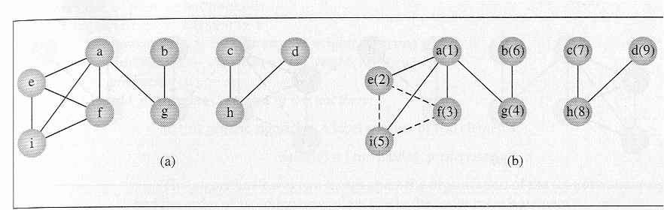Example of breadthFirstSearch on a simple graph

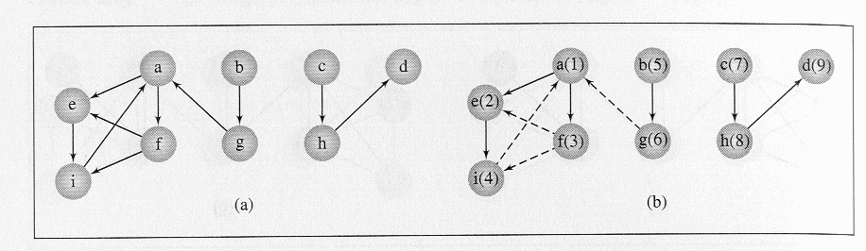Example of breadthFirstSearch on a digraph

Graph Problems

There are many classical problems in graph theory and for most of these problems there have been many different solutions proposed. For now we will focus on one of these classical problems: the shortest path problem.

Shortest Path Problem

In the shortest path problem, the edges of the graph are assigned certain weights. The meaning of the weights will vary from application to application, but common representations are: distance between two cities indicated by the vertices, cost of transmission across this link, amounts of some substance moved across the network., etc. When determining the shortest path from vertex v to vertex u, information about the distances between intermediate vertices w must be recorded. This information can be recorded as a label associated with these vertices, where the label is only the distance from v to w or the distance along with the predecessor of w in this path. The methods of finding the shortest path rely on these labels. Depending upon how many times these labels are updated, the methods solving the shortest path problem are divided into two classes: label-setting algorithms and label-correcting algorithms.
For label-setting algorithms, in each pass through the vertices still to be processed, one vertex is set to a value which remains unchanged to the end of the execution. This, however, limits such methods to processing graphs with only positive weights. The label-correcting algorithms will allow for the changing of any label during the execution of the algorithm. Most of the label-setting and label-correcting algorithms can be subsumed to the same form which will allow finding the shortest path from one vertex to all other vertices in the graph.

Dijkstra’s Label-Setting Algorithm

Dijkstra was one of the first to develop a label-setting algorithm for finding the shortest path in a graph. In this algorithm (shown below) a number of paths p₁, p₂, …, p_{n} from a vertex v are tried, and each time, the shortest path among them is tried, which may mean that the same path p_{i} can be continued by adding one more edge to it. But if p_{i} turns out to be longer than any other path that can be tried, p_{i} is abandoned and this other path is tried by resuming from where it was left and by adding one more edge to it. Since paths can lead to vertices with more than one outgoing edge, new paths for possible exploration are added for each outgoing edge. Each vertex is tried once, all paths leading from it are opened, and the vertex itself is put away and not used anymore. After all vertices are visited, the algorithm terminates.

Dijkstra’s algorithm:
Dijkstra (weighted simple digraph, vertex first)
for all vertices v
currDist(v) = ∞;
currDist(first) = 0;
tobeChecked = all vertices;
while tobeChecked is not empty
v = a vertex in tobeChecked with minimal currDist(v);
remove v from tobeChecked;
for all vertices u adjacent to v and in tobeChecked
if currDist(u) > currDist(v) + weight(edge(vu))
currDist(u) = currDist(v) + weight(edge(vu));
predecessor(u) = v;

The figure below illustrates an example execution of Dijkstra’s algorithm. Part (a) of the figure is the digraph and part (b) illustrates a table which shows all iterations of the while loop. In this case there are ten iterations because there are ten vertices. The table indicates the current distances determined up until the current iteration. The list tobeChecked is initialized to {a, b, …, j}, the current distances of all vertices are initialized to a very large value (denoted by ∞ in the figure). In the first iteration, the current distances of d’s neighbors are set to numbers equal to the weights of the edges from d. Now there are two candidates for the next try, a, and h, since d was excluded from tobeChecked. In the second iteration, h is chosen, since its current distance is minimal, and then the two vertices accessible from h, namely, e and i, acquire the current distances 6 and 10 respectively. Now, there are three candidates in tobeChecked for the next try a, e, and i. Since s has the smallest current distance (value of 4), it is chosen in the third iteration. Eventually, in the tenth iteration, tobeChecked becomes empty and the execution terminates.

Explanation of How the Table is Constructed:

Initially the currDist(v) for every vertex in the graph is set to ∞. Then the currDist(start) is set to 0, where start is the initial node for the path. In this example start = vertex d. The set tobeChecked is initialize to contain every vertex in the graph. Since start = d and currDist(d)= 0 this vertex will have the minimum currDist( ) value and thus vertex d will be the first vertex removed from the set tobeChecked. In the sequence of tables shown below, the set tobeChecked is indicated by the leftmost column with the current members of the set indicated by shading the cells for current members. After this initialization stage the table will look like the one shown below:
iteration | initial | 1 | 2 | 3 | 4 | 5 | 6 | 7 | 8 | 9 | 10
active vertex | −
a | ∞
b | ∞
c | ∞
d | 0
e | ∞
f | ∞
g | ∞
h | ∞
i | ∞
j | ∞

The first iteration of the algorithm will remove the vertex with the minimum currDist( ) which will be vertex d and then set the currDist( ) for every vertex which is both adjacent to d and in tobeChecked. In this case, only vertices a and h are both adjacent to d and in tobeChecked. The value of currDist(a) = currDist(d) + weight(edge(da)) = 0 + 4 = 4. The value of currDist(h) = currDist(d) + weight(edge(dh)) = 0 + 1 = 1. After the first iteration the table will look like the table shown below:

iteration | initial | 1 | 2 | 3 | 4 | 5 | 6 | 7 | 8 | 9 | 10
active vertex | − | d
a | ∞ | 4
b | ∞ | ∞
c | ∞ | ∞
d | 0
e | ∞ | ∞
f | ∞ | ∞
g | ∞ | ∞
h | ∞ | 1
i | ∞ | ∞
j | ∞ | ∞
Notice that when a vertex is removed from the set tobeChecked it is no longer participating in setting the values in the table so its row is unused after its removal from the set. The second iteration will again selected the minimum value of currDist( ) from the vertices in tobeChecked. In this case the vertex with this minimum value is vertex h since currDist(h) = 1 and currDist(a) = 4. So vertex h is removed from the set tobeChecked and the active vertex is set to h. Vertices which are both adjacent to h and in tobeChecked are vertices e and i. The value of currDist(e) = currDist(h) + weight(edge(he)) = 1 + 5 = 6. The value of currDist(i) = currDist(h) + weight(edge(hi)) = 1 + 9 = 10. After the second iteration the table looks like the one below:

iteration | initial | 1 | 2 | 3 | 4 | 5 | 6 | 7 | 8 | 9 | 10
active vertex | − | d | h
a | ∞ | 4 | 4
b | ∞ | ∞ | ∞
c | ∞ | ∞ | ∞
d | 0
e | ∞ | ∞ | 6
f | ∞ | ∞ | ∞
g | ∞ | ∞ | ∞
h | ∞ | 1
i | ∞ | ∞ | 10
j | ∞ | ∞ | ∞

The third iteration will select vertex a as it has the minimum weight for all of the vertices in tobeChecked( ). So the next active vertex becomes vertex a.

iteration | initial | 1 | 2 | 3 | 4 | 5 | 6 | 7 | 8 | 9 | 10
active vertex | − | d | h | a
a | ∞ | 4 | 4
b | ∞ | ∞ | ∞ | ∞
c | ∞ | ∞ | ∞ | ∞
d | 0
e | ∞ | ∞ | 6 | 5
f | ∞ | ∞ | ∞ | ∞
g | ∞ | ∞ | ∞ | ∞
h | ∞ | 1
i | ∞ | ∞ | 10 | 10
j | ∞ | ∞ | ∞ | ∞
Notice in the third iteration with active vertex a, the only vertex adjacent to a which has not been visited previously is vertex e. The value of currDist(e) is set to 5 during this iteration. The fourth iteration will selected vertex e to be the active vertex and remove it from the set tobeChecked. The only vertex adjacent to vertex e which has not yet been visited is vertex f. The next table illustrates the fourth iteration:

iteration | initial | 1 | 2 | 3 | 4 | 5 | 6 | 7 | 8 | 9 | 10
active vertex | − | d | h | a | e
a | ∞ | 4 | 4
b | ∞ | ∞ | ∞ | ∞ | ∞
c | ∞ | ∞ | ∞ | ∞ | ∞
d | 0
e | ∞ | ∞ | 6 | 5
f | ∞ | ∞ | ∞ | ∞ | 8
g | ∞ | ∞ | ∞ | ∞ | ∞
h | ∞ | 1
i | ∞ | ∞ | 10 | 10 | 10
j | ∞ | ∞ | ∞ | ∞ | ∞

The fifth iteration will select vertex f as the active vertex. Vertices adjacent to f that have not yet been visited are b, c, g, and i. The value of currDist( ) for each of these vertices will be set during the fifth iteration. The fifth iteration is shown in the next table.

iteration | initial | 1 | 2 | 3 | 4 | 5 | 6 | 7 | 8 | 9 | 10
active vertex | − | d | h | a | e | f
a | ∞ | 4 | 4
b | ∞ | ∞ | ∞ | ∞ | ∞ | 9
c | ∞ | ∞ | ∞ | ∞ | ∞ | 11
d | 0
e | ∞ | ∞ | 6 | 5
f | ∞ | ∞ | ∞ | ∞ | 8
g | ∞ | ∞ | ∞ | ∞ | ∞ | 15
h | ∞ | 1
i | ∞ | ∞ | 10 | 10 | 10 | 9
j | ∞ | ∞ | ∞ | ∞ | ∞ | ∞

The sixth iteration will find two vertices with equal values as the minimum currDist( ) (both vertex b and i have values of 9). Which vertex is selected as the active vertex in this case is arbitrary. In this example, we have selected vertex b as the next active vertex. Only vertex c is adjacent to vertex b and unvisited. Only the currDist(c) will change during the sixth iteration. Upon completion of the sixth iteration the only unvisited vertices are c, g, i, and j. The sixth iteration is shown in the next table:

iteration | initial | 1 | 2 | 3 | 4 | 5 | 6 | 7 | 8 | 9 | 10
active vertex | − | d | h | a | e | f | b
a | ∞ | 4 | 4
b | ∞ | ∞ | ∞ | ∞ | ∞ | 9
c | ∞ | ∞ | ∞ | ∞ | ∞ | 11 | 11
d | 0
e | ∞ | ∞ | 6 | 5
f | ∞ | ∞ | ∞ | ∞ | 8
g | ∞ | ∞ | ∞ | ∞ | ∞ | 15 | 15
h | ∞ | 1
i | ∞ | ∞ | 10 | 10 | 10 | 9 | 9
j | ∞ | ∞ | ∞ | ∞ | ∞ | ∞ | ∞

The seventh iteration will select vertex i as the active vertex. Only vertex j is adjacent to vertex i. Iteration seven is illustrated in the next table:

iteration | initial | 1 | 2 | 3 | 4 | 5 | 6 | 7 | 8 | 9 | 10
active vertex | − | d | h | a | e | f | b | i
a | ∞ | 4 | 4
b | ∞ | ∞ | ∞ | ∞ | ∞ | 9
c | ∞ | ∞ | ∞ | ∞ | ∞ | 11 | 11 | 11
d | 0
e | ∞ | ∞ | 6 | 5
f | ∞ | ∞ | ∞ | ∞ | 8
g | ∞ | ∞ | ∞ | ∞ | ∞ | 15 | 15 | 15
h | ∞ | 1
i | ∞ | ∞ | 10 | 10 | 10 | 9 | 9
j | ∞ | ∞ | ∞ | ∞ | ∞ | ∞ | ∞ | 11

The eighth iteration will select vertex c or vertex j arbitrarily, for this example we have selected vertex c. The eighth iteration is shown in the next table.
iteration | initial | 1 | 2 | 3 | 4 | 5 | 6 | 7 | 8 | 9 | 10
active vertex | − | d | h | a | e | f | b | i | c
a | ∞ | 4 | 4
b | ∞ | ∞ | ∞ | ∞ | ∞ | 9
c | ∞ | ∞ | ∞ | ∞ | ∞ | 11 | 11 | 11
d | 0
e | ∞ | ∞ | 6 | 5
f | ∞ | ∞ | ∞ | ∞ | 8
g | ∞ | ∞ | ∞ | ∞ | ∞ | 15 | 15 | 15 | 15
h | ∞ | 1
i | ∞ | ∞ | 10 | 10 | 10 | 9 | 9
j | ∞ | ∞ | ∞ | ∞ | ∞ | ∞ | ∞ | 11 | 11

Notice in the eighth iteration above, that vertex c has no adjacent vertices and thus no values in the table are set, however, vertex c is removed from the set tobeChecked. The ninth iteration will select vertex j as the active vertex. Only vertex g is both adjacent to vertex j and unvisited (i.e., still in the set tobeChecked). The ninth iteration is illustrated in the next table:

iteration | initial | 1 | 2 | 3 | 4 | 5 | 6 | 7 | 8 | 9 | 10
active vertex | − | d | h | a | e | f | b | i | c | j
a | ∞ | 4 | 4
b | ∞ | ∞ | ∞ | ∞ | ∞ | 9
c | ∞ | ∞ | ∞ | ∞ | ∞ | 11 | 11 | 11
d | 0
e | ∞ | ∞ | 6 | 5
f | ∞ | ∞ | ∞ | ∞ | 8
g | ∞ | ∞ | ∞ | ∞ | ∞ | 15 | 15 | 15 | 15 | 12
h | ∞ | 1
i | ∞ | ∞ | 10 | 10 | 10 | 9 | 9
j | ∞ | ∞ | ∞ | ∞ | ∞ | ∞ | ∞ | 11 | 11

The tenth and final iteration (there are only ten vertices in the original graph) serves only to remove the vertex g from the set tobeChecked. The final table is exactly the same as the previous table expect that the set tobeChecked is now empty and thus the algorithm will terminate. The final iteration is shown in the next (and last!) table. Notice that this final table looks like the one that appeared in the original diagram for this example.

iteration | initial | 1 | 2 | 3 | 4 | 5 | 6 | 7 | 8 | 9 | 10
active vertex | − | d | h | a | e | f | b | i | c | j | g
a | ∞ | 4 | 4
b | ∞ | ∞ | ∞ | ∞ | ∞ | 9
c | ∞ | ∞ | ∞ | ∞ | ∞ | 11 | 11 | 11
d | 0
e | ∞ | ∞ | 6 | 5
f | ∞ | ∞ | ∞ | ∞ | 8
g | ∞ | ∞ | ∞ | ∞ | ∞ | 15 | 15 | 15 | 15 | 12
h | ∞ | 1
i | ∞ | ∞ | 10 | 10 | 10 | 9 | 9
j | ∞ | ∞ | ∞ | ∞ | ∞ | ∞ | ∞ | 11 | 11
Final table for Dijkstra’s algorithm example

The final table has determined the shortest path from the original start vertex d to every other vertex in the graph. For example, the shortest path from vertex d to vertex e has length (weight) 5. The shortest path from vertex d to vertex c has length 11.

Although Dijkstra’s algorithm is quite efficient when dealing with graphs which contain only positive weights. Although many graphs contain only positive weights, it is also possible for them to contain negative weights. Shortest path algorithms for graphs containing negative weights are, in general, more robust and have less efficient execution (higher overhead for handling the negative weights) when dealing with graphs that contain only positive weights. Therefore, Dijkstra’s algorithm is very popular for positive weighted graphs, however, Dijkstra’s algorithm is not general enough, and will fail when negative weights are used in the graph. To see why, change the weight of edge(ah) from 10 to –10. Note that the path d, a, h, e is now –1, whereas the path d, a, e as determined by the algorithm is 5. The reason for overlooking this less costly path is that the vertices with the current distance set from ∞ to a value are not checked anymore (remember it’s a label-setting algorithm): First successors of vertex d are checked and d is removed from tobeChecked, then vertex h is removed from tobeChecked, and only afterward is the vertex a considered to be a candidate to be included in the path from d to other vertices. But now, edge(ah) is not taken into consideration because the condition in the for loop prevents the algorithm from doing so. To overcome this limitation, a label-correcting algorithm is required.
Ford’s Label-Correcting Algorithm

One of the first label-correcting algorithms was developed by Lester Ford. Ford’s algorithm is more powerful than Dijkstra’s in that it can handle graphs with negative weights (but it cannot handle graphs with negative weight cycles). To impose a certain ordering on monitoring the edges, an alphabetically ordered sequence of edges is commonly used so that the algorithm can repeatedly go through the entire sequence and adjust the current distance of any vertex if it is needed. The graph shown in the example below contains negatively weighted edges. The table in the figure, again illustrates the iterations of Ford’s algorithm as the while loop updates the current distances (one iteration is one pass through the edge set). Note that a vertex can change its current distance during the same iteration. However, at the end, each vertex of the graph can be reached through the shortest path from the starting vertex. (The example assumes that the initial vertex was vertex c.)

Ford’s Algorithm:
Ford (weighted simple digraph, vertex first)
for all vertices v
currDist(v) = ∞;
currDist(first) = 0;
while there is an edge (vu) such that currDist(u) > currDist(v) +
weight( edge(vu))
currDist(u) = currDist(v) + weight(edge(vu));

Notice that Ford’s algorithm does not specify the order in which the edges are checked. In the example below, we will use the simple, but very brute force technique, of simply checking the adjacency list for every vertex during every iteration. This is not necessary and can be done much more efficiently, but clarity suffers and we are not worried about efficiency at this point. Therefore, in the example the edges have been ordered alphabetically based upon the vertex letter. So, the edges are examined in the order of ab, be, cd, cg, ch, da, de, di, ef, gd, hg, if. Ford’s algorithm proceeds in much the same way that Dijkstra’s algorithm operates, however, termination occurs not when all vertices have been removed from a set but rather when no more changes (based upon the edge weights) can be made to any currDist( ) value. Shown below is an example of Ford’s algorithm for a negatively weighted digraph.

Explanation of the Table Construction for the Ford Algorithm Example:
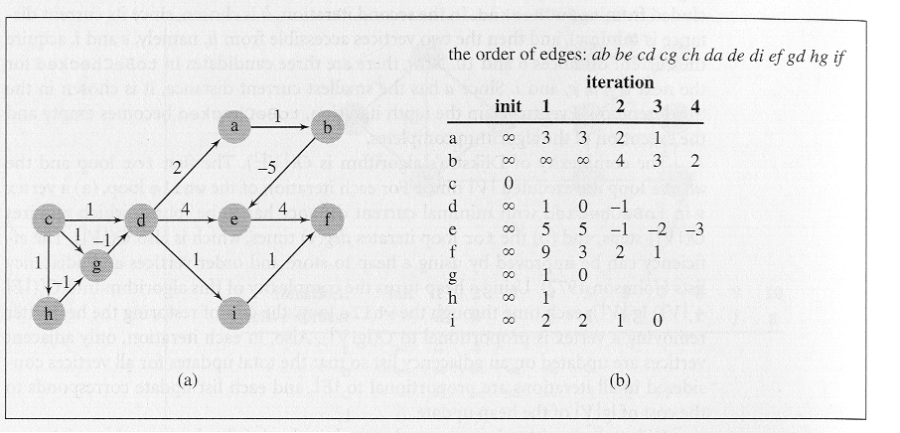
Since the edge set is ordered alphabetically and we are assuming that the start vertex is c, then the first iteration of the while loop in the algorithm will ignore the first two edges (ab) and (be). The first past will set the currDist( ) value for all single edge paths (at least), the second pass will set all the values for two-edge paths, and so on. In this example graph the longest path is of length four so only four iterations will be required to determine the shortest path from vertex c to all other vertices. The table below shows the status after the first iteration completes. Notice that the path from c to d is reset (as are the paths from c to f and c to g) since a path of two edges has less weight than the first path of one edge. This is illustrated in the un-numbered column. More explanation of this is given below the table.

iteration → | init | 1 |  | 2 | 3 | 4
vertex ↓
a | ∞ | 3 | 3
b | ∞ | ∞ | ∞
c | 0
d | ∞ | 1 | 0
e | ∞ | 5 | 5
f | ∞ | 9 | 3
g | ∞ | 1 | 0
h | ∞ | 1
i | ∞ | 2 | 2
Table after First Iteration

The first iteration sets the following:
start vertex is c:
edge(ab) sets nothing
edge(be) sets nothing
edge(cd) sets currDist(d) = 1
edge(cg) sets currDist(g) = 1
edge(ch) sets currDist(h) = 1
edge(da) sets currDist(a) = 3 since currDist(d) + weight(edge(da)) = 1+ 2 = 3
edge(de) sets currDist(e) = 5 since currDist(d) + weight(edge(de)) = 1+ 4 = 5
edge(di) sets currDist(i) = 2 since currDist(d) + weight(edge(di)) = 1+ 1 = 2
edge(ef) sets currDist(f) = 9 since currDist(e) + weight(edge(ef)) = 5+ 4 = 9
edge(gd) resets currDist(d) = 0 since currDist(d)+ weight(edge(gd)) = 1+ (-1) = 0
edge(hg) resets currDist(g) = 0 since currDist(g)+ weight(edge(hg)) = 1+ (-1) = 0
edge(if) resets currDist(f) = 3 since currDist(i) + weight(edge(if)) = 2+ 1 = 3

Notice that after the first iteration the distance from vertex c to every other vertex, except b has been determined. This is because of the order in which we ordered the edges. This means that the second pass will possibly set the distance to vertex b but the distance to all other vertices can only be reset if a new path with less weight is encountered.

The second iteration sets the following:
edge(ab) sets currDist(b)= 4 since currDist(a) + weight(edge(ab)) = 3+ 1 = 4
edge(be) resets currDist(e)= -1 since currDist(b)+weight(edge(be)) = 4 +(-5) = -1
edge(cd) no change currDist(d) = 0
edge(cg) no change currDist(g)= 0
edge(ch) no change currDist(h) = 1
edge(da) resets currDist(a) = 2 since currDist(d) + weight(edge(da)) = 0+ 2 = 2
edge(de) no change currDist(e)= -1
edge(di) resets currDist(i) = 1 since currDist(d) + weight(edge(di)) = 0 + 1 = 1
edge(ef) no change currDist(f) = 3
edge(gd) resets currDist(d)= -1 since currDist(d)+ weight(edge(gd))= 0+ (-1) = -1
edge(hg) no change currDist(g) = 0
edge(if) resets currDist(f) = 2 since currDist(i) + weight(edge(if)) = 1+ 1 = 2

These changes are reflected in the table below which illustrates the current distance to each of the vertices:

iteration → | init | 1 |  | 2 | 3 | 4
vertex ↓
a | ∞ | 3 | 3 | 2
b | ∞ | ∞ | ∞ | 4
c | 0
d | ∞ | 1 | 0 | −1
e | ∞ | 5 | 5 | −1
f | ∞ | 9 | 3 | 2
g | ∞ | 1 | 0
h | ∞ | 1
i | ∞ | 2 | 2 | 1
Table after Second Iteration

The third iteration makes the following updates to the table:
edge(ab) resets currDist(b)= 3 since currDist(a) + weight(edge(ab)) = 2+ 1 = 3
edge(be) resets currDist(e)= -2 since currDist(b)+weight(edge(be)) = 3 +(-5) = -2
edge(cd) no change currDist(d) = -1
edge(cg) no change currDist(g)= 0
edge(ch) no change currDist(h) = 1
edge(da) resets currDist(a) = 1 since currDist(d) + weight(edge(da))= (-1)+ 2 = 1
edge(de) no change currDist(e)= -2
edge(di) resets currDist(i) = 0 since currDist(d) + weight(edge(di)) = -1 + 1 = 0
edge(ef) resets currDist(f) = 2 since currDist(e) + weight(edge(ef)) = -2 + 4 = 2
edge(gd) no change currDist(d)= -1
edge(hg) no change currDist(g) = 0
edge(if) resets currDist(f) = 1 since currDist(i) + weight(edge(if)) = 0+ 1 = 1

iteration → | init | 1 |  | 2 | 3 | 4
vertex ↓
a | ∞ | 3 | 3 | 2 | 1
b | ∞ | ∞ | ∞ | 4 | 3
c | 0
d | ∞ | 1 | 0 | −1
e | ∞ | 5 | 5 | −1 | −2
f | ∞ | 9 | 3 | 2 | 1
g | ∞ | 1 | 0
h | ∞ | 1
i | ∞ | 2 | 2 | 1 | 0
Table after Third Iteration

The fourth iteration makes the following updates to the table:
edge(ab) resets currDist(b)= 2 since currDist(a) + weight(edge(ab)) = 1+ 1 = 2
edge(be) resets currDist(e)= -3 since currDist(b)+weight(edge(be)) = 2 +(-5) = -3
edge(cd) no change currDist(d) = -1
edge(cg) no change currDist(g)= 0
edge(ch) no change currDist(h) = 1
edge(da) no change currDist(a) = 1
edge(de) no change currDist(e)= -3
edge(di) no change currDist(i) = 0
edge(ef) no change currDist(f) = 1
edge(gd) no change currDist(d)= -1
edge(hg) no change currDist(g) = 0
edge(if) no change currDist(f) = 1

iteration → | init | 1 |  | 2 | 3 | 4
vertex ↓
a | ∞ | 3 | 3 | 2 | 1
b | ∞ | ∞ | ∞ | 4 | 3 | 2
c | 0
d | ∞ | 1 | 0 | −1
e | ∞ | 5 | 5 | −1 | −2 | −3
f | ∞ | 9 | 3 | 2 | 1
g | ∞ | 1 | 0
h | ∞ | 1
i | ∞ | 2 | 2 | 1 | 0
Table after Fourth Iteration

A fifth and final iteration is needed (its not shown in the table) which upon ending will terminate the algorithm as no changes will be made to the table on the fifth iteration. Since the fourth iteration reset only the currDist( ) for vertices b and e, the only possible changes that could be made to the table during the fifth iteration would be to those same vertices again since these two did not affect the distance to any other vertex during the previous iteration. The fifth and final iteration is shown below:

edge(ab) no change currDist(b)= 2 edge(be) no change currDist(e)= -3
edge(cd) no change currDist(d) = -1 edge(cg) no change currDist(g)= 0
edge(ch) no change currDist(h) = 1 edge(da) no change currDist(a) = 1
edge(de) no change currDist(e)= -3 edge(di) no change currDist(i) = 0
edge(ef) no change currDist(f) = 1 edge(gd) no change currDist(d)= -1
edge(hg) no change currDist(g) = 0 edge(if) no change currDist(f) = 1

