COP 3503 – Computer Science II – CLASS NOTES - DAY #22

Graphs

In spite of the flexibility of trees and the many different tree applications, trees, by their very nature, have one limitation, namely, they can only represent relationships of a hierarchical type, such as the relation between a parent and child. Other relationships can only be represented indirectly, such as the relationship of being a sibling. In a tree there are no links between children of the same parent, thus the sibling relationship is determined only through the parent node. A graph, which is a generalization of a tree, does not have this limitation. Intuitively, a graph is a collection of vertices (nodes) and the connections (edges or arcs) between them. Generally, there are no restrictions imposed on the number of vertices in a graph nor on the number of connections one vertex can have to other vertices. Graphs are versatile data structures that can represent a large number of different situations and events from a rather diverse group of applications. Graph theory has grown into a sophisticated area of mathematics and computer science in the last two hundred years since it was first studied. We will look only very briefly at this data structure and restrict our focus to areas of interest to computer science.

The picture below illustrates just four areas in which graphs and graph theory have applications ranging from simple graph traversal techniques to what can be very complex abstract machines known as FSA (finite state automata, also called FSM; finite state machines – see…there’s that discrete stuff again!). In the diagram below the portion labeled (a) shows how a graph can be used to determine the shortest distance between the airports in two different cities (so you can calculate your frequent flyer miles!). The diagram labeled (b) illustrates a graph modeling an electrical circuit where the vertices in the graph denote where the components are connected together with the edges representing the components themselves (e.g., resistors and capacitors). Using a graph you can answer questions such as “What are the mesh equations which describe the circuit’s behavior?” The diagram component labeled (c) shows how a logic circuit can be reduced to a graph. In this case the logic gates are represented by the vertices, and the arrows represent the signal propagation from gate outputs to gate inputs. Using a graph such as this you can answer questions of the form: “How long does it take for the signals to propagate from the inputs to the outputs?” or “Which gates are on the critical path?” Finally, the portion of the diagram labeled (d) represents a FSA with the vertices representing the states of the machine and the labeled arrows representing the allowable state transitions. Given such a graph representation of the FSA questions such as: “Are all the states reachable?” or “Can the FSA deadlock?”

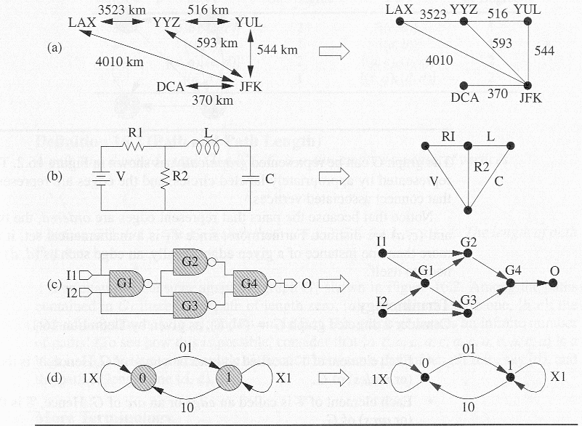Figure illustrating graph applications

Definitions

- A simple graph G = (V, E) consists of a non-empty set V of vertices and a possibly empty set E of edges, each edge being a set of two vertices from V. The number of vertices and edges is typically denoted ⏐V⏐ and ⏐E⏐, respectively.
- A directed graph (digraph) G = (V, E) consists of a non-empty set V of vertices and a possibly empty set E of edges (called arcs), where each edge is a pair of vertices from V. The difference is that an arc denotes a direction so that the edge (V_{i}, V_{j} ) ∈ E implies that the edge may be traversed in the direction from vertex i to vertex j. Traversal from vertex j to vertex i can occur only if the edge (V_{j}, V_{i} ) ∈ E.
- A weighted digraph is a digraph to which weights have been assigned to the edges. Weights may also be applied to the edges of an undirected graph. It is common to refer to a weighted digraph or weighted undirected graph as a network.

The two definitions above are restrictive in that they do not allow for two vertices to have more than one edge.

- A multigraph is a graph in which two vertices can be joined by multiple edges. The geometric interpretation is simple (see the figures below). More formally, a multigraph G = (V, E, f) is composed of a set of vertices V, edges E, and a function f: E → {{V_{i}, V_{j} }: V_{i} , V_{j} ∈ V & V_{i} ≠ V_{j}}.

- A pseudograph is a multigraph which does not have the restriction that an edge cannot begin and end on the same vertex. This allows cycles to be introduced into the graph which involve only a single node (see below).

Both multigraphs and pseudographs are less common than undirected and digraphs.

Graph Examples

simple graph directed graph multigraph

pseudograph complete graph

Additional Graph Specific Definitions

- In an undirected graph two vertices V₁ and V₂ are adjacent if the edge (V₁, V₂) ∈ E. Such an edge is said to be incident on the vertices V₁ and V₂.
- In a directed graph the edge (V₁, V₂) is incident to vertex V₂ and incident from V₁. Being incident from is more commonly referred to as emanating from, thus the edge above emanates from V₁ and is incident on V₂.
- In a directed graph the out degree of a node is the number of edges which emanate from the node. The in degree of a node is the number of edges which are incident on the node.
- In an undirected graph the degree(V) of a vertex V is the number of edges incident on V.
- A path in a digraph G = (V, E) is a non-empty sequence of vertices P={V₁, V₂, …, V_{k}}, where V_{i}∈V for 1≤ i ≤ k such that (V_{i}, V_{i+1}) ∈E for 1 ≤ i ≤ k. The path length of P is k-1.
- Given a path as defined above, vertex V_{i+1} is the successor of vertex V_{i} for 1 ≤ i ≤ k. Every vertex V_{i} of path P (except the last vertex) has a successor.
- Given a path as defined above, vertex V_{i-1} is the predecessor of vertex V_{i} for 1 ≤ i ≤ k. Every vertex V_{i} of path P (except the first vertex) has a predecessor.
- A path is called a simple path if and only if V_{i} ≠ V_{j} for all i and j such that 1 ≤ i < j ≤ k. However, it is permissible for V₁ = V_{k} in a simple path. If V₁=V_{k} the the path is a cycle (see below).
- A circuit is a path in which no edge is repeated.
- A cycle is a path of non-zero length in which the starting and ending vertex are the same. The length of the cycle is just the length of the path P. A graph containing a cycle has an infinite number of paths in the graph.
- A loop is a cycle of length 1; that is, it is a path of the form {V_{i}, V_{i}}.
- A simple cycle is a path that is both a cycle and simple.
- A graph is called a weighted graph if each edge has an associated weight. Depending upon the application the weight might refer to cost, distance, length, or some other factor. A weighted graph may be undirected or directed depending upon the application.

Before we consider any more graph definitions, let’s look at some examples that illustrate the definitions we covered so far.
A
B
C
D
Graph G

Graph G is defined by: V = {A, B, C, D} and
E = {(A,C), (A,B), (B,C), (C,A), (C,D), (D,D)}
The edge (A,C) is incident to C and emanates from A.
The out degree of node B is 1, the out degree of node C is 2.
The in degree of node C is 2, the in degree of node B is 1.
There is a path P = {A, B, C} in G. This is a simple path of length 2.
The path P is also a circuit.
There is a path P = {A, B, C, A} in G which is a simple cycle of length 3.
The cycle {A, C, A, C, A} has length 4, but is not a simple cycle.
There is a loop in G consisting of (D, D).
The path {C, A, C, D} is not a simple path, C is repeated (but not at the end)

Even More Graph Specific Definitions

- A graph of n vertices is complete, and is denoted K_{n}, if for each pair of distinct vertices there is exactly one edge connecting them. That is, each vertex can be connected to any other vertex. The number of edges is such a graph is O(⏐V⏐).
- An undirected graph G = (V, E) is connected iff (if and only if) there is a path between every pair of vertices in G. A graph which is unconnected contains at least one vertex which is unreachable, i.e., the graph does not contain any paths which include the unreachable vertex. Note that given a specific graph G = (V, E), it may be possible to remove edges from E while G remains connected. An edge which can be removed from E and yet G remains connected is said to be unnecessary.
- A connected undirected graph that contains no cycles is called a tree.
- A graph H is a subgraph of another graph G iff its vertex and edge sets are subsets of those of G.
- A subgraph of G that contains all of the vertices of G and is a tree is called a spanning tree of G.

Examples:
1
2
3
4
5
6
7
1
2
3
4

- (b)

In the two figures above, undirected graph (a) represents a connected graph while figure (b) is an unconnected graph. Figure (b) contains four vertices which are not reachable from vertices {1, 2, 3} which are {4, 5, 6, 7} and three vertices which are not reachable from vertices {4, 5, 6, 7} which are {1, 2, 3}. The two figures below represent complete graphs.
1
2
3
43
1
2

3
43

1
2
3
4
1
2
3
4
1
2
3
4
1
2
3
4

(a) (b) (c) (d)

In the figures above, figures (b), (c), and (d) represent some of the possible spanning trees of graph (a).

Still More Graph Specific Terminology

- A directed acyclic graph (DAG) is a directed graph which contains no cycles. All trees are DAGs, however, not all DAGs are trees. In figure (a) below we see a DAG which is clearly a tree (binary in fact), yet figure (b) represents a DAG which is clearly not a tree (node “K” has two parents and all trees in Computer Science are from single parent homes).
- A directed graph which is connected is called a strongly connected graph. If a directed graph is not strongly connected but the underlying graph (its undirected counterpart) is connected, then the digraph is said to be weakly connected.
H
I
J
K
A
B
C
D
EA
FA
GA

(a) (b)

Graph Representations

There are a variety of ways to represent a graph and we will examine a couple of these techniques with a focus on the efficient implementation of the graph structure.
Consider a directed graph G = (V, E). Since E ⊆ V × V, graph G contains at most ⏐V⏐² edges. There are $2^{{\left|V\right|}^{2}}$possible sets of edges for a given set of vertices V. Therefore, the main concern when designing a graph representation scheme is to find an efficient way to represent the set of edges. To do this properly depends upon whether the graph is a dense graph or a sparse graph. Informally, a graph with relatively few edges is a sparse graph while a graph with many edges is a dense graph. More formally we have:

- A sparse graph is a graph G = (V, E) in which ⏐E⏐= O(⏐V⏐). For example, consider a graph G=(V,E) with n nodes. Suppose that the out-degree of each vertex in G is some fixed constant k. Graph G is a sparse graph because ⏐E⏐= k⏐V⏐ = O(⏐V⏐)
- A dense graph is a graph G = (V, E) in which ⏐E⏐ = θ(⏐V⏐²). For example, consider a graph G=(V,E) with n nodes. Suppose that the out-degree of each vertex in G is some fraction f of n, 0 < f ≤ 1. For example, if n = 16 and f = 0.25, the out-degree of each node is 4. Graph G is a dense graph because ⏐E⏐= f⏐V⏐² = θ(⏐V⏐²).

For sparse graphs a simple representation technique is given by an adjacency list which specifies all vertices which are adjacent to each vertex in the graph. This list is typically implemented as a table in which case it is referred to as a star representation. It can also be implemented as a matrix (a two-dimensional table) in which case it comes in two possible forms: an adjacency matrix or an incidence matrix.

- An adjacency matrix, A, of graph G = (V, E) is a binary matrix: ⏐V⏐× ⏐V⏐such that each entry of the matrix is:
$A_{\text{ij}}=\begin{aligned}\left\{1 \text{if} \text{there} \text{exists} \text{an} \text{edge} (V_{i},V_{j}) | \right.\end{aligned}$

- An incidence matrix, A, of graph G = (V, E) is a binary matrix: ⏐V⏐× ⏐E⏐such that each entry of the matrix is:
$A_{\text{ij}}=\begin{aligned}\left\{1 \text{if} \text{edge} E_{j} \text{is} \text{incident} \text{with} \text{vertex} V_{i} | \right.\end{aligned}$

a
c
f
d
b
e
g

Example

The adjacency matrix:

 | a | b | c | d | e | f | g
a | 0 | 0 | 1 | 1 | 0 | 1 | 0
b | 0 | 0 | 0 | 1 | 1 | 0 | 0
c | 1 | 0 | 0 | 0 | 0 | 1 | 0
d | 1 | 1 | 0 | 0 | 1 | 1 | 0
e | 0 | 1 | 0 | 1 | 0 | 0 | 0
f | 1 | 0 | 1 | 1 | 0 | 0 | 0
g | 0 | 0 | 0 | 0 | 0 | 0 | 0

The incident matrix:
 | ac | ad | af | bd | be | cf | de | df
a | 1 | 1 | 1 | 0 | 0 | 0 | 0 | 0
b | 0 | 0 | 0 | 1 | 1 | 0 | 0 | 0
c | 1 | 0 | 0 | 0 | 0 | 1 | 0 | 0
d | 0 | 1 | 0 | 1 | 0 | 0 | 1 | 1
e | 0 | 0 | 0 | 0 | 1 | 0 | 1 | 0
f | 0 | 0 | 1 | 0 | 0 | 1 | 0 | 1
g | 0 | 0 | 0 | 0 | 0 | 0 | 0 | 0

Note the differences and the similarities in these two matrices. Clearly, the more efficient implementation is dependent upon the number of edges compared to the number of nodes in the graph. We will discuss these in more detail later.

The adjacency list:
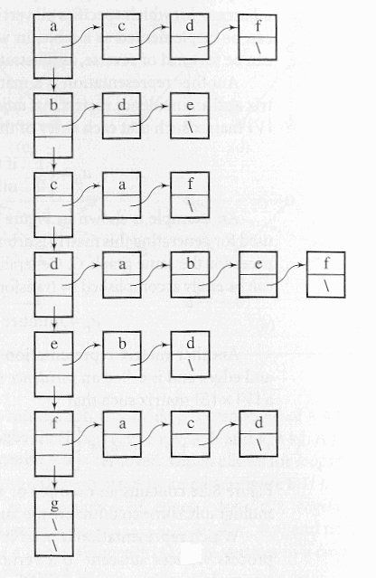

Which representation is the best? It depends on the application at hand. For example, if the application involves processing vertices adjacent to a particular vertex V, then the adjacency list requires only degree(V) steps. On the other hand the adjacency matrix will require ⏐V⏐steps. If the application requires the insertion or deletion of a vertex adjacent to V, this will require maintenance on the adjacency list (it would be implemented as a linked list), but for the adjacency matrix, it will simply require changing a 0 to a 1 for insertion and a 1 to a 0 for deletion, in only one cell of the matrix.

