COP 3503 – Computer Science II – CLASS NOTES - DAY #20

Beyond Binary Search Trees

The last couple of day’s notes have introduced special case of the binary tree known as the binary search tree (BST) and the self-balancing search tree known as the AVL tree. General search trees are special cases of M-way trees (sometimes also referred to as multiway trees). Some of the variants of m-way trees are beyond the scope of this course, however one special variant is not and that is the variant which is called the m-way search tree. There are many different variants and we will examine only one of these special trees, the B-tree, and a particularly suitable application for this data structure.

M-way Search Tree (Mutliway Search Tree)

A multiway search tree T is a general tree in which an ordering is imposed on the set of keys which reside in each node such that:

- Each node has m children and m-1 keys.

- The keys in each node appear in ascending order.

- The keys in the first I children are smaller than the ith key.

- The keys in the last m-1 children are larger than the ith key.

M-way search trees play the same role amongst general trees that binary search trees play among binary trees, and they are used for exactly the same purpose: fast information retrieval and update. The problems in dealing with m-way search trees are similar to those experienced with BSTs. Balancing problems are more critical in general trees since there is a potential for many subtrees. Shown below is an example of an m-way search tree, this one happens to be a 4-way search tree.

506080
30 35
58 59
52 54
61 62
55 56
57
100
63 70 73

4-way search tree

The Reasons for M-way Search Trees

One common application for m-way search trees is the file system for secondary memory, such as disks and tapes, on computer systems. The basic unit of I/O transfer associated with a disk is a block. When information is read from a disk, the entire block, in which the information required is contained, is read into the memory (main memory) and when information is written from the main memory back to the secondary memory (the disk), the entire block is written back. Each time information is requested from a disk, the information must be located on the disk, the read/write head on the disk must be correctly positioned above the portion of the disk where the information is located, and the system must wait for the spinning disk to rotate the entire required block underneath the read/write head to be transferred to the main memory. This would indicate that there are several time factors involved with every request for information from the secondary memory, which are:

access time = seek time + latency + transfer time

where, seek time represents the time required to properly position the read/write head; latency refers to the rotational delay required to spin the disk to the proper position under the read/write head; and transfer time refers to the total time required to move the disk block into the main memory. Compared to transferring information within the main memory, the process of transferring information from secondary memory is extremely slow. The seek time is especially long since it requires positioning an electro-mechanical device. Latency, on the average is equal to the time required to rotate the disk one-half revolution. For example, the time required to transfer 5KB (kilobytes) from a disk drive that requires 40 msec seek time, is spinning at 3000 rev/min (50 rev/sec = 0.05 rev/msec, thus one-half revolution requires 0.5 = x * 0.05 = 10 msec), and has a data transfer rate of 1000 KB/sec (5KB = 1/200th of 1000KB so 1/200th of 1 sec = 0.005 sec = 5 msec) is:

access time = 40 msec + 10 msec + 5 msec = 55 msec

This example clearly indicates that transferring information to and from secondary memory (disk technology) requires time of the order of milliseconds. On the other hand, modern CPUs process data on the order of 1 million times faster. For example, a 1 GHz processor has a clock cycle of 1/1x10⁹ seconds = 1x10⁻⁹ sec = 1 nanosecond! Thus processing information on secondary memory will significantly decrease the speed of a program. If a program uses information stored in secondary storage, the characteristics of that storage must be considered when designing the algorithms and programs that will operate on that information. For example, a binary search tree can be spread over many different blocks on a disk, such as in the diagram below, which will require an average of two block accesses per search.

When the tree is frequently accessed by a program, these accesses can significantly slow down the program. Also the insertion and deletion of key values within the tree will require many block accesses. Thus, the BST which seems to be such an efficient search tool when it resides entirely in main memory turns out to be a hindrance to performance. In the context of secondary memory, its otherwise good performance counts very little because the constant accessing of the disk blocks that this implementation causes, severely hamper its performance.

It is also better to access a large amount of data at one time than it is to jump around from one position to the next on the disk to transfer small portions of data. For example, using the earlier parameters, if we have 10KB to be transferred, we have:

access time = 40 msec + 10 msec + 10 msec = 60 msec

However, if this information is stored in two separate 5KB pieces at different locations on the disk, then we have:

access time = 2 × (40 msec + 10 msec + 5 msec) = 110 msec

which is nearly twice as long as the previous case requiring only 60 msec! Since each disk access is so costly, we need to organize the data in such a way as to minimize the number of disk accesses.

B-Trees

In database systems/programs where most information is stored on secondary memory systems, the time penalty for accessing the secondary storage can be significantly reduced by the proper choice of data structures. The B-tree is one such data structure that gives good overall performance as it can be tuned to operate closely with the secondary storage system. The tuning will reduce the impediments that this type of storage imposes to fast searching. One important property of a B-tree is that the size of each node can be made as large as the size of a block on the secondary storage media on which it resides. The number of key values in one node of the B-tree will vary depending upon the size of the keys, the organization of the data (are only key values maintained in the nodes or are entire records maintained in these nodes?), and of course, on the size of the block. Block sizes vary from system to system. Typical ranges for block size range anywhere from 512 bytes to 4KB or even more. Whatever the block size, that will be the size of a node in the B-tree. Thus, the amount of information stored in one node of a B-tree can be quite large.
Definition:

A B-tree of order m is a multiway search tree with the following properties:

- The root has at least two subtrees unless it is a leaf.
- Each non-root and each non-leaf node holds k-1 keys and k references to subtrees where ⎡m/2⎤ ≤ k ≤ m.
- Each leaf node holds k-1 keys where ⎡m/2⎤ ≤ k ≤ m.
- All leaves are on the same level*.

In this definition, the order of the B-tree specifies the maximum number of children.
Some definitions will specify the order as the minimum number of children.

According to the definition of the B-tree given on the previous page, a B-tree is always at least half full, has few levels (the tree is not very deep), and is perfectly balanced.

Java Note:

A node of a B-tree is usually implemented as a class containing an array of m-1 cells for key values, and m-cell references to other nodes, and possibly other information which will facilitate tree maintenance, such as the number of keys in a node and perhaps an indication as to whether the node is a leaf or not, typically as a leaf/non-leaf flag. Such as implementation is shown below for the example 4-way search tree shown earlier:

class BTreeNode {
int m = 4;
boolean leaf = true;
int keyTally = 1;
int keys[ ] = new int[m-1];
BTreeNode references[ ] = new BTreeNode[m];

BTreeNode (int key) {
keys[0] = key;
for (int i = 0; i < m; i++)
references[i] = null;
}//end constructor
}//end BTreeNode class

Usually, m is large, somewhere in the 50-500 range, so that information stored in one page or block of the secondary memory can fit into one node. The diagram below illustrates a B-tree of order 7 which stores codes for some items. In part (1) of this example, only the key values are represented in the nodes. It is quite common for the nodes to contain much larger structures, possibly variant records (unions). In these cases the array keys would be an array of objects, each containing a unique identifier field and an address field, which represents the address of the entire record on secondary storage as in part (b) of the diagram.

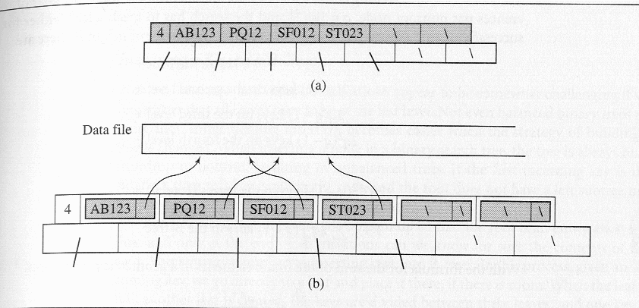
If the contents of one such node also reside in secondary memory (extremely likely), each key access would require two secondary storage accesses. In the long run, this is better than keeping the entire record in the nodes, since in this case, the nodes can hold a much smaller number of records. The resulting B-tree is much deeper and the search paths much longer than in a B-tree which contains the addresses of the records. From now on we will illustrate the B-trees in an abbreviated form without explicitly indicating keyTally (the 4 in the example above) or the reference fields. This abbreviated form looks like the B-tree in the diagram below:

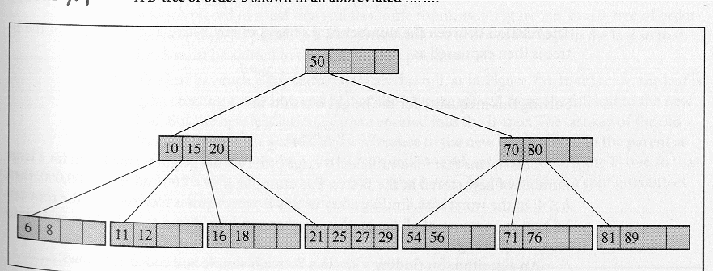
B-tree of order 5 shown in abbreviated format

Searching in a B-tree

Inserting a Key in a B-tree

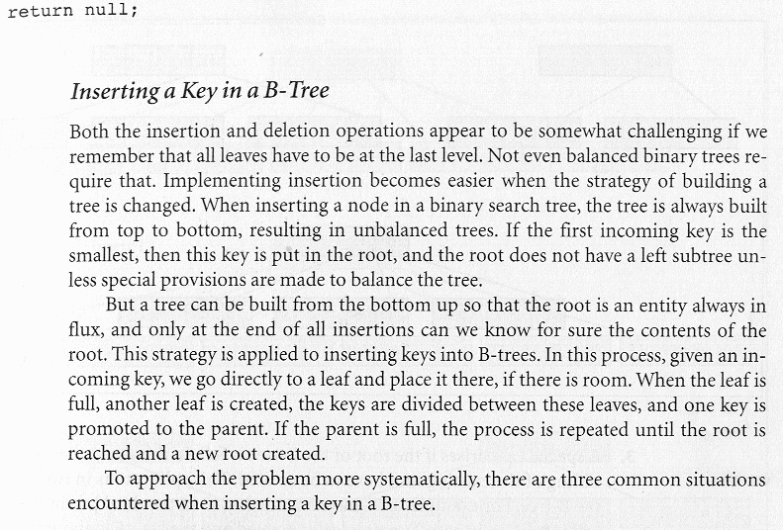
Case 1: A key is inserted into a leaf which still has room. In the example below, in a B-tree of order 5 (figure (a)), a new key value of 7, is inserted into a leaf, preserving the order of the keys in that leaf so that key value 8 must be shifted to the right by one position (figure (b)).

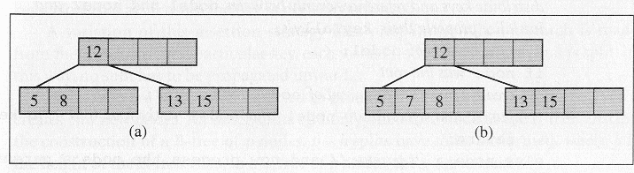
Insertion into a leaf node with available space

Case 2: The leaf in which the key needs to be inserted is full. In this case the leaf is split, creating a new leaf, and half of the keys in the existing leaf are moved from the full leaf to the new leaf. But the new leaf must be incorporated into the B-tree. The last key of the old leaf is moved to the parent, and a reference to the new leaf is placed in the parent as well. The same procedure is repeated for each internal node of the B-tree so that each such split adds one more node to the B-tree. Also, such a split guarantees that each leaf never has less than ⎡m/2⎤ -1 keys.

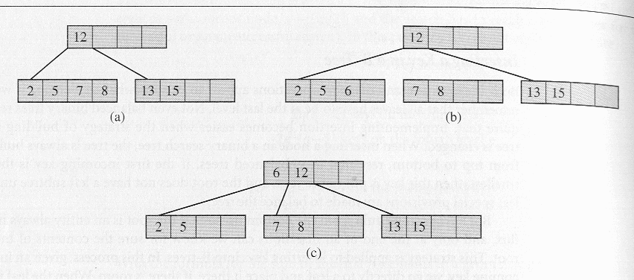
Inserting the key value 6 into a full leaf

Case 3: A special case arises if the root of the B-tree is full. In this case, a new root node and a new sibling of the existing root must be created. This split results in two new nodes in the B-tree. The example below illustrates the case when the new key value is inserted into the B-tree in the third leaf. In (a) the leaf is split (as in case 2), in (b) a new leaf is created and the key value 15 is about to be moved to the parent, but the parent is full, so in (c) the parent is split, but now two B-trees have to be combined into one. This is achieved by creating a new root and moving the last key from the old root to it, as shown in (d). It should be apparent that this is the only case in which the height of the B-tree will increase.

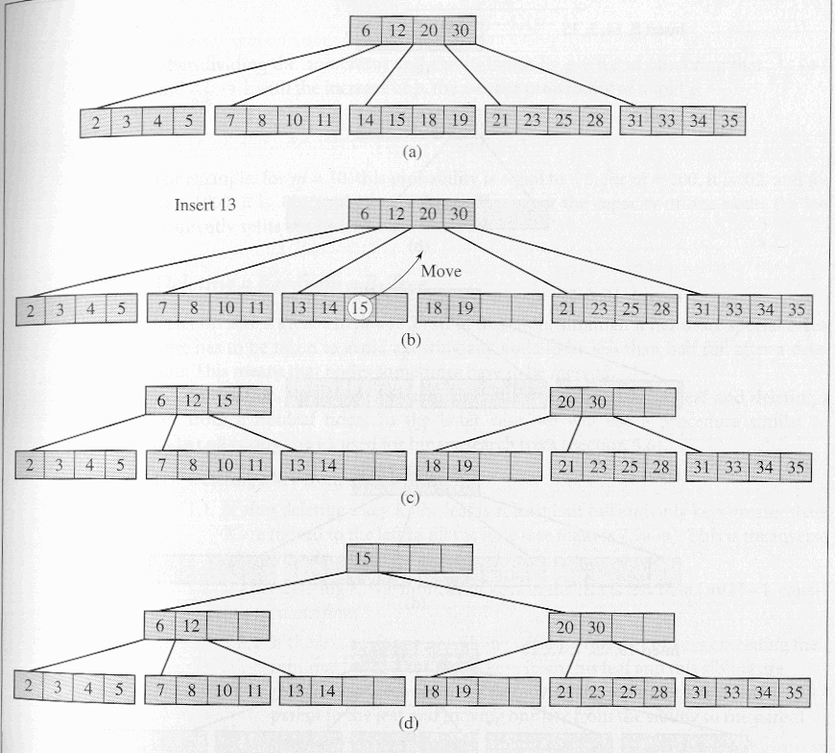
Figure illustrating case 3 – creation of new root

Deleting a Key from a B-tree

Deletion is to a great extent a reversal of insertion, although it has more special cases. Care must be taken to avoid allowing any node to be less than half full after a deletion. This means that nodes sometimes need to be merged.

In deletion, there are two main cases: (1) deleting a key from a leaf and (2) deleting a key from a non-leaf node. In the latter case, a technique similar to the delete-via-copying technique that was employed for BSTs is typically used.
Case 1: Deleting a key from a leaf:

1.1: If after deleting a key K, the leaf is at least half full and only keys greater than K are moved to the left to fill the hole. See diagrams (a) and (b) below. This is the inverse of insertion’s case 1.

1.2: If after deleting K, the number of keys in the leaf is less than ⎡m/2⎤ -1, causing an underflow.

1.2.1: If there is a left or right sibling with the number of keys exceeding the minimal ⎡m/2⎤ -1, then all keys from this leaf and this sibling are redistributed between them by moving the separator key from the parent to the leaf and moving one key from the sibling to the parent. See diagrams (b) and (c) below.

1.2.2: If the leaf underflows and the number of keys in its siblings is ⎡m/2⎤ -1, then the leaf and a sibling are merged; the keys from the leaf, from its sibling, and the separating key from the parent are all put in the leaf, and the sibling node is discarded. The keys in the parent are moved if a hole appears. See diagrams (c) and (d) below. This can initiate a chain of operations if the parent underflows. The parent is then treated as though it were a leaf, and either case 1.2.2 is repeated until case 1.2.1 can be achieved or the root of the tree has been reached. This step is the inverse of insertion’s case 2.

1.2.2.1: A special case arises when merging a leaf or nonleaf with its sibling when its parent is the root with only one key. In this case, the keys from the node and its sibling, along with the only key of the root, are put in the node which becomes a new root, and both the sibling and the old root nodes are discarded. This is the only case when two nodes disappear at one time. Also the height of the tree decreases by one. This is the inverse of insertion’s case 3 and is illustrated in diagrams (c) through (e) below.

Case 2: Deleting a key from a non-leaf node. This can lead to problems with tree reorganization. Therefore, deletion from a nonleaf node is reduced to deleting a key from a leaf. The key to be deleted is replaced by its immediate successor, which can only be found in a leaf. This successor key is deleted from the leaf, which brings returns you to case 1. This is illustrated in diagrams (e) and (f) below.

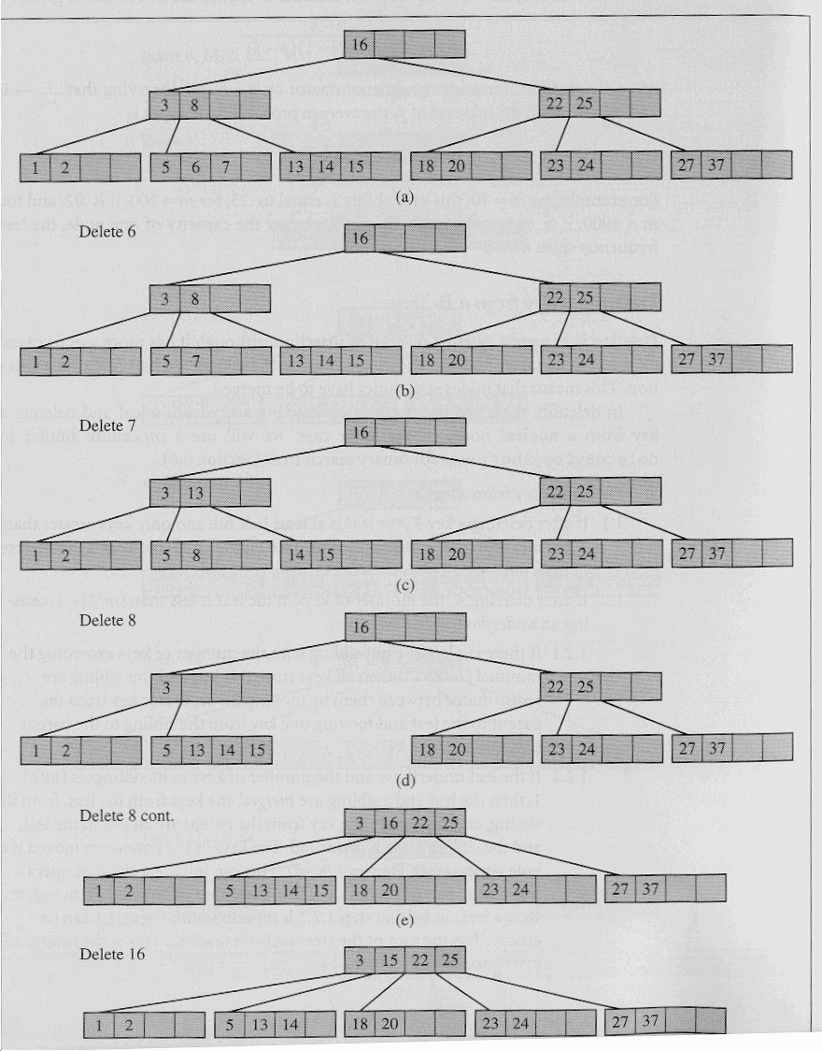 (f)

Final comments on B-trees

B-trees, according to their definition, are guaranteed to be at least 50% full, so it may happen that 50% of the space is basically wasted. How often would you expect this to happen? If it happens too often, then the definition must be reconsidered or some other restrictions imposed on the B-tree. Analyses and simulations indicate that after a series of numerous random insertions and deletions, the B-tree is typically 69% full. After an initial “settling in period” during which numerous insertions and deletions occur, the B-tree structure undergoes very little change in the percentage of occupied cells. However, it is extremely unlikely that a B-tree will ever be filled to the brim, so additional variations on the theme have been developed over the years which are designed to enjoy the benefits of the B-tree with a higher utilization of the available space. B*-trees and B⁺-trees are two common variations on the B-tree theme. You will, most likely, examine these structures in CS3.

