COP 3503 – Computer Science II – CLASS NOTES - DAY #18

Shell Sort Algorithms

From Data Structures and Problem Solving using Java, Mark Weiss:

void shellsort (int[] a) {
for (int gap = a.length / 2; gap > 0;gap = gap == 2 ? 1 : (int) ( gap / 2 ) )
for(int i = gap; i < a.length; i++ ){
int tmp = a[ i ];
int j = i;
for( ; j >= gap && tmp < ( a[ j - gap] ); j -= gap )
a[ j ] = a[ j -gap ];
a[ j ] = tmp;
}
}

From Data Structures, Algorithms, and Applications in Java, Sartaj Sahni:

public class ShellSort
{
/** sort the elements a[0 : a.length - 1] using
* the shaker sort method */
public static void shellSort(Comparable [] a)
{
int incr = a.length / 2; // initial increment
while (incr >= 1)
{// insertion sort all sequences spaced by incr
for (int i = incr; i < a.length; i++)
{// insert a[i] into a[i - incr], a[i - 2*incr], ...
Comparable insertElement = a[i];
int j;
for (j = i - incr;
j >= 0 && insertElement.compareTo(a[j]) < 0;
j -= incr)
a[j + incr] = a[j];
a[j + incr] = insertElement;
}

// reduce increment by a factor of 2.2
if (incr == 2)
incr = 1; // last increment must be 1
else
incr = (int) (incr / 2.2);
}
}
}

Beyond Binary Search Trees

As we have discussed within the context of the binary search tree, the performance of the algorithms which utilize the BST are dependent upon the height of the tree. We have looked at the DSW algorithm to balance a binary tree. In this section of the notes we will look at binary trees which in addition to the ordering properties which ensure that the tree is a search tree, there will be structure properties imposed on the tree which ensures that the tree is balanced. So all of the binary search tree variants that are discussed in this section of the notes are self-balancing search trees.

AVL Trees

The AVL tree (named after its discoverers, Adelson-Velskii and Landis, but originally called an admissible tree) was the first balanced binary search tree. Any search tree which is self-balancing must use balance conditions which are easy to maintain and ensure that the height of the tree is O(log n), where n is the number of nodes in the tree. The simplest idea is to require that the left and right subtrees have the same height. Using the recursive definition of the binary search tree implies that this condition be applied to all the nodes in the tree, since every node is considered the root of some subtree. While this simple requirement will ensure that the height of the tree is logarithmic in terms of n, it is too restrictive because inserting new key values while maintaining overall balance is too difficult (i.e., too costly in terms of time). Therefore, the definition of the AVL tree uses a slightly different interpretation of balance, one that is weaker than total balance between all left and right subtrees, yet is still strong enough to ensure logarithmic height of the tree.

AVL Tree

An AVL tree is a binary search tree with the additional balance property that, for any node in the tree, the height of the left and right subtrees can differ by at most one.

Notice that the DSW algorithm (see Day 22 notes) balances trees using the same balancing condition that is employed by the AVL tree. However, an AVL tree is not necessarily perfectly balanced. All of the trees shown in the figure below are AVL trees:

-1
0
+1
0
-1
0
+1
-1
-1
0
+1
0
0

Examples of AVL Trees

In the example AVL trees above, the values shown in the nodes are called balancing factors. The balance factor of any node, represents the difference between the heights of its left and right subtrees. The balance factor is the height of the right subtree minus the height of the left subtree. Thus, for an AVL tree all of the balance factor should be +1, 0, or –1. Considering the tree shown in the middle above, the balance factor of the root is +1 since the height of the right subtree is 2 and the height of the left subtree is 1 and 2−1 = 1.

The definition of an AVL tree indicates that the minimum number of nodes in an AVL tree is defined by the recurrence equation:

${\text{AVL}}_{h}={\text{AVL}}_{h−1}+{\text{AVL}}_{h−2}+ 1$ where AVL₀ = 0 and AVL₁ = 1 are the initial conditions. Adel’son-Vel’skii and Landis have proven that this produces the following bounds on the height of an AVL tree depending upon the number of nodes n:

$\text{log}(n+1)≤h< 1\text{.}\text{44}\text{log}(n+2)−0\text{.}\text{328}$

Therefore, the height of the tree is bounded by O(log n) and the worst case search requires O(log n) comparisons. Notice that for a perfectly balanced tree of the same height $h=\left\lceil \text{log}(n+1)\right\rceil$. Therefore, the search time in the worst case in an AVL tree is 44% worse (it requires 44% more comparisons) than in the best case tree configuration. Donald Knuth has shown through empirical results that the average case number of comparisons is much closer to the best case than to the worst case and is equal to log n+0.25 for large n. This is why AVL trees are so important for searching applications, they have a logarithmic time bound on the search and are self-balancing.

If the balance factor of any node in an AVL tree becomes less than –1 or greater than +1, then the tree must be balanced.

Insertion

An AVL tree can become unbalanced in one of four ways, two of which are symmetric to each other and thus, we need to consider only two different situations. These two cases are:

- The result of inserting a node in the right subtree of the right child of a node.
- The result of inserting a node in the left subtree of the right child.

The first case is the simpler of the two and we will consider it first. The diagram below illustrates the technique.
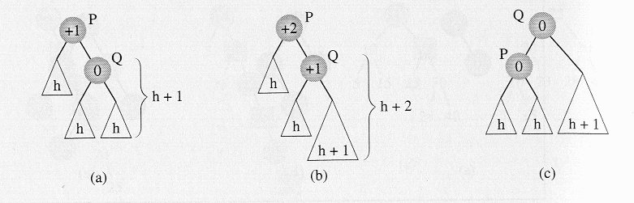In (a) a new node is inserted somewhere in the right subtree of node Q, this causes an imbalance in the tree rooted at P since the balance factor in P is now greater than 1. The solution is to rotate node Q about its parent P which is shown in (c). Having done this the balance factor of both P and Q become 0, which is even better than the original tree!

The second case, the result of inserting a new node in the left subtree of the right child, is illustrated in the diagram below:

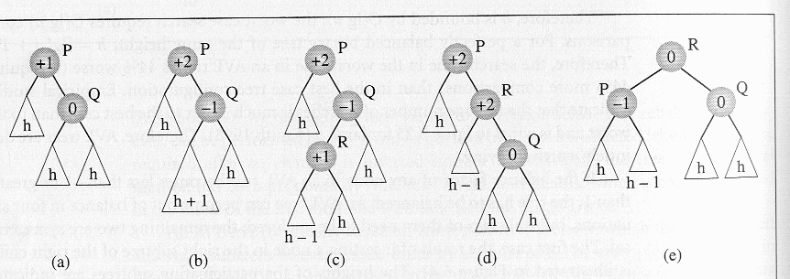
In (a) a new node is inserted somewhere in the left subtree of Q which creates an imbalance in the tree at node P shown in (b) and in more detail in (c). The solution to this problem is a double rotation, the first by rotating R about Q as shown in (d) and then by rotating R about P as shown in (e).

Both of the cases illustrated use a stand-alone tree to illustrate the technique of the rotation, however, the tree rooted at P can be part of a larger AVL tree. If P itself is the child of some node (it is not the root of the entire tree), the question arises, will additional work be required to adjust the balance of P’s predecessors? The answer is no. Considering the two examples above, note that the heights of the two trees which result at the end of the rotations are the same as the heights of the trees before the insertion occurred. This means that the balance factor of the parent of the new root (Q in the first case and R in the second case) remain the same as they were before the insertion, and the changes which occur to subtree P are sufficient to restore the balance of the entire AVL tree.

The problem is in finding a node P for which the balance factor becomes unacceptable after a node has been inserted into the tree. This node can be detected by moving up toward the root of the tree from the position in which the new node was inserted and updating all of the balance factors of the nodes which are encountered. Then, if a node with a ±1 balance factor is encountered, the balance factor is changed to ±2, and the first node whose balance factor is changed in this manner becomes the root P of a subtree for which the balance has to be restored. Note that the balance factors above this node will not require resetting using the argument we just presented.

Shown below are a couple of examples of AVL trees and the rotations which are required to rebalance the tree upon the insertion of a new node.

Example 1
1. An initial AVL tree
30
20
50
10
26
40
70
23
28
45
90

initial AVL tree – shown with data values
0
+1
0
0
0
+1
+1
0
0
0
0

initial AVL tree – shown with balance factors

2. An insertion occurs in the left subtree of the right child of node 26 (case 2)
30
20
50
10
26
40
70
23
28
45
90
27

0
+2
0
0
+1
+1
+1
0
-1
0
0
0

3. The subtree rooted at node 20 must be singly rotated to restore balance.
30
26
50
20
28
40
70
45
90
27
10
23

final AVL tree showing data values

0
0
0
0
-1
+1
+1
0
0
0
0
0

final AVL tree showing balance factors

Example 2
30
20
50
10
26
40
70
23
28
45
90

1. An initial AVL tree

initial AVL tree – shown with data values

0
+1
0
0
0
+1
+1
0
0
0
0

initial AVL tree – shown with balance factors

2. An insertion occurs in the right subtree of the right child of node 26 (case 1)
30
20
50
10
26
40
70
23
28
45
90
29

0
+2
0
0
+1
+1
+1
0
+1
0
0
0

3. The subtree rooted at node 20 must be singly rotated to restore balance.
30
26
50
20
28
40
70
10
29
45
90
23

final AVL tree showing data values
0
0
0
0
+1
+1
+1
0
0
0
0
0

final AVL tree showing balance factors
It is possible that the insertion of a new node into an AVL tree will not require a rotation as the new tree may remain balanced. If the balance factors from the newly inserted node up to the root of the tree are all zero, the balance factors will need to be updated from the insertion point up to the root of the tree, but no rotation will need to be performed. This situation is illustrated in the following example:
0
0
0
+1
0
+1
+1
0
0
0
0
0

Initial AVL tree

0
0
0
+1
0
+1
+1
0
0
0
0
0
0

nodes along the indicated path must all have balance factors reset

−1

+1
0

+1
−1
+1
+1

0
0
0
0
+1

0

nodes along the path with reset balance factors

Deletion

Deletion may be a more time-consuming task that insertion in an AVL tree. Typically, an algorithm such as deletion-via-copying or deletion-via-merging is used to reduce the problem of deleting a node with two descendants to the problem of deleting a node with at most one descendant. After a node has been deleted from the tree balance factors must be updated from the parent of the deleted node up to the root of the tree. For each node in this path whose balance factor becomes ±2, a single or double rotation must be performed to restore the balance of that subtree. Notice that the rebalancing does not stop at the first node P for which the balance factor has become ±2, as in the case with insertion! This means that deletion has the potential for requiring, at most O(log n) rotations, since in the worst case, every node along the path from the parent of the deleted node to the root will require rebalancing!

Deletion of a node does not necessitate an immediate rotation because it may actually improve the balance factor of its parent, by changing its parent’s balancing factor from ±1 to 0. However, it may worsen the balancing factor of its grandparent, by changing it from a ±1 to a ±2. For the sake of brevity, we’ll consider only those cases where the deletion requires an immediate rotation. There are four such cases (plus four symmetric ones). These cases are all shown in the following diagram:

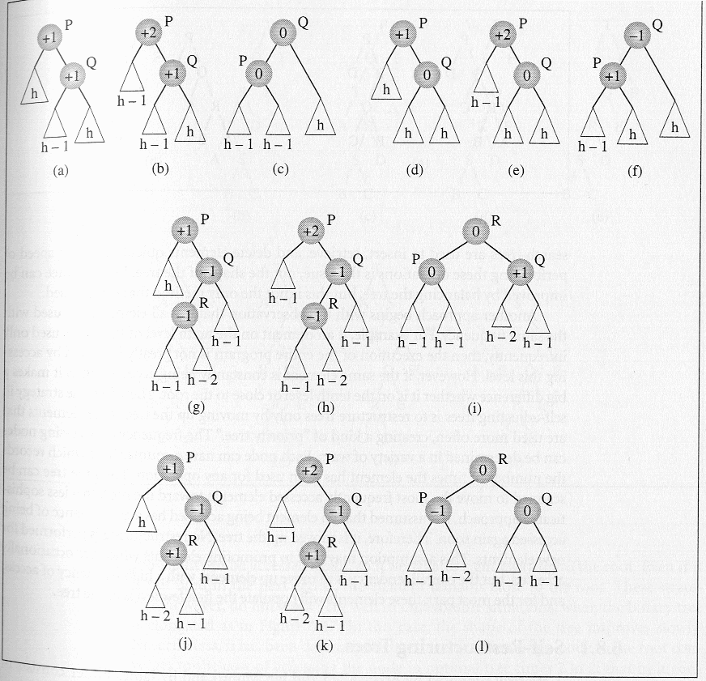
The first case of deletion is represented in (a) which after the deletion (which occurs in the left subtree of the right child of P) turns into the tree in (b). The tree is rebalanced by rotating Q about P which gives the final tree (c) for the first case.

The second case of deletion is represented in (d) in which node P has a balance factor of +1, and its right subtree Q has a balance factor equal to 0. After the deletion of a node in the left subtree of P, shown in (e), the tree is rebalanced using exactly the same rotation as in the first case to produce the tree shown in (f).

Notice that cases 1 and 2 can be processed together in an implementation after checking that the balance factor of Q is +1 or 0.

When Q is –1, the other two cases for deletion occur which are both more complicated than the first two.
In the third case, the left subtree R of Q has a balance factor equal to –1 as shown in (g). To rebalance the tree, first R is rotated about Q (h) and then about P (i).

The fourth case differs from the third case only in that R’s balance factor is +1, as in (j), in which case the same two rotations are performed in order to restore the balance factor of P (shown in (k) and (l)). As before, cases three and four can be processed together based only upon a check of the balance factor associated with node R.

Final Comments On AVL Trees

Insertions and deletions in an AVL tree require at most 1.44 log(n+2) comparisons. Insertion can require either one single rotation or one double rotation, and deletion can require 1.44 log(n+2) rotations, in the worst case. However, as mentioned earlier, the average case requires log(n) + 0.25 comparisons, which reduces the number of rotations in the case of deletions to this number. In the average case, insertion may lead to one single/one double rotation. Empirical results, based primarily upon simulations, have indicated that deletions in 78% of the cases will not require a rebalancing at all! On the other hand, only 53% of the insertions do not force the tree out of balance. Therefore, the more time-consuming deletion operation occurs less frequently than the insertion operation, which does not unduly limit the efficiency of rebalancing AVL trees.

AVL trees can be extended by allowing the differences in heights, Δ, of subtrees to be greater than 1. For example, you can allow subtrees to become more and more unbalanced by allowing a greater height differential between the left and right subtrees. Not unexpectedly, the worst-case height increases as Δ increases. Again empirical results indicate the following trend:

$h=\begin{aligned}\left\{1\text{.}\text{81} \text{log}(n)−0\text{.}\text{71} \text{if} Δ=2 | \right.\end{aligned}$

As the experimental evidence indicates, the average number of visited nodes increases by one-half in comparison to pure AVL trees (Δ = 1), but the amount of restructuring required can be decreased by a factor of 10!

