COP 3503 – Computer Science II – CLASS NOTES - DAY #17

More Details On The Operations On Binary Search Trees

The previous day’s notes introduced the special case of the binary tree known as the binary search tree (BST). As mentioned before general search trees are called M-way search trees and are beyond the scope of this course. A binary search tree is a special case of an m-way search tree defined as follows:

Binary Search Tree

A binary search tree T is a finite set of keys. Either the set is empty, T = ∅; or the set consists of a root r and exactly two binary search trees T_{L} and T_{R}, T = {r, T_{L}, T_{R}}, such that the following properties are satisfied:

- All keys contained in left subtree, T_{L}, are less than r.

- All keys contained in right subtree, T_{R}, are greater than r.

Insertion into a BST

In the previous day’s notes we saw that insertion into a BST is a straight forward procedure which basically involves searching for the value to be inserted, knowing that it is presently not in the tree. The search will always be unsuccessful and will terminate on a leaf node (actual termination will occur on the null child reference at this leaf node). Once the “dead-end” is found, the insertion is straightforward.

Deletion in a BST

The complexity of the deletion operation is dependent upon the position of the node to be deleted in the tree. It is a far more difficult operation to delete a node which is the root of two non-null subtrees than it is to delete a leaf node. The complexity of the deletion operation is proportional to the number of children of the node to be deleted.

- The node is a leaf. This is the trivial case in which the appropriate reference of the parent is set to null. An example is shown below.

5
1
6
7
3
2
4
5
1
6
7
3
2

A BST with a leaf node The BST with the leaf node
marked for deletion deleted. A BST remains

- The node has one child. This case is also not too complicated, but is more so than case 1 above. The parent’s reference to the node is reset to refer to the deleted node’s child. This has the effect of lifting up the deleted node’s children by one level in the tree. (All great-great-…-grandchildren will lose one great from their kinship designations.) An example is shown below.
5
1
6
7
3
2

A BST with an internal node
having only one child marked
to be deleted

5

The marked internal node has
only a right subtree so the parent
6
3
of the deleted node will now
reference the deleted node’s child
7
2

Note that it makes no difference if the node to be deleted has only a left or a right child. The previous example illustrated the case when the only child was a right child. The next example illustrates the case when the only child is a left child.
95
7
166
27
3
2
4

Initial BST with the node to be
deleted shown in green. Its only
child is a left child

95
166
27
3
2
4
The BST after the deletion has occurred

- The last case of deletion from a BST is the most difficult to handle. There is no one-step operation that can be performed since the parent’s right or left reference cannot refer to both node’s children at the same time. There are basically two different approaches that can be used to handle this case: deletion via merging and deletion via copying. We will look at both cases.

Deletion via merging

This technique makes one tree out of the two subtrees of the node which will be deleted and then attaches it to that node’s parent. The main question is how can these two subtrees be merged? The nature of the BST is that every value in the right subtree is greater than every value in the left subtree, so the best thing to do is find, within the left subtree, the node with the greatest value and make this the parent of the right subtree. Symmetrically, the node with the lowest value can be found in the right subtree and made a parent of the left subtree.
The desired node is the rightmost node of the left subtree. This node can be located by traversing this subtree always taking right references until a null reference is encountered (indicating that we have reached a leaf node). This means that the node which has been located has no right child, and there is no danger of violating the property of BSTs in the original tree by setting that rightmost node’s right reference to the right subtree. [Symmetry would allow us to accomplish exactly the same effect by setting the left reference of the leftmost node of the right subtree to the left subtree.] This operation is depicted graphically in the diagram below.

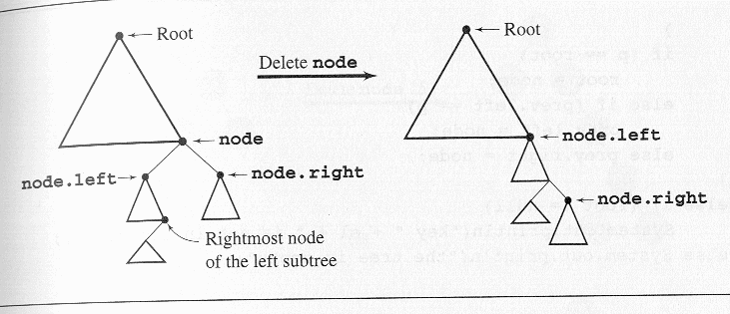
The algorithm for effecting a deletion in a BST via merging is given below.

public void deletebyMerging ( int element) {
IBSTNode tmp, node, p = root, prev = null;
while (p != null && p.key != element) {//find the node with key = element
prev = p;
if (p.key < element)
p = p.right;
else p = p.left;
}
node = p;
if (p != null && p.key == element) {
if (node.right == null) //node has no right child
node = node.left;
else if (node.left == null) //node has no left child
node = node.right;
else { //prepare for merging
tmp = node.left; //move left
while (tmp.right != null) //now go to the right as far as possible
tmp = tmp.right;
tmp.right = node.right; //set link between rightmost node of the left subtree
// and the right subtree
node = node.left;
}
if (p == root)
root = node;
else if (prev.left == p)
prev.left = node;
else prev.right = node;
}//end if
else if (root != null)
System.out.println(“key “ + element + “ is not in the tree”);
else System.out.println(“the tree is empty”);
}

Deletion via Merging

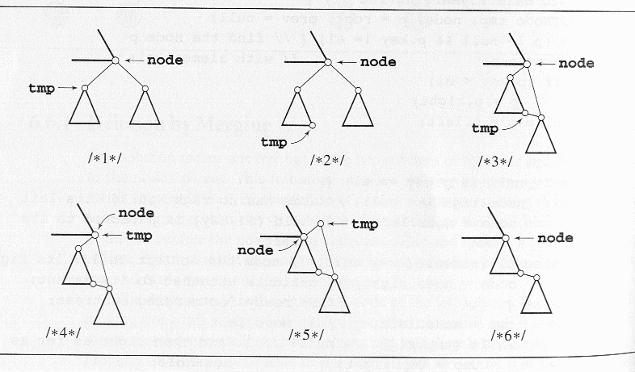
The problem with deletion via merging is that it is possible for the height of the tree to increase after a deletion! In some cases the resulting tree may be highly unbalanced. Some cases may decrease the overall height of the tree. These two situations are shown below.

height of the resulting tree increases
15
10
5
11
12
30
20
40
10
5
11
12
30
20
40

node 15 to be deleted

resulting tree has greater height

height of the resulting tree decreases
15
10
5
4
7
30
20
40
10
5
4
7
30
20
40

resulting tree has decreased height

node 15 to be deleted

It isn’t that the algorithm is inefficient, but it certainly is not perfect. There is however a need for an algorithm that does not give the resulting tree the chance to increase in height through deletion. The second technique, deletion via copying, provides us with this solution.

Deletion via copying

Deletion via copying was proposed by Thomas Hibbard and Donald Knuth. If the node has two children, it can be reduced to one of two simple cases: The node is a leaf or the node has only one nonempty child. This can be done by replacing the key being deleted with its immediate predecessor (or successor). As we mentioned in the previous technique of deleting via merging, a key’s predecessor is the key in the rightmost node in the left subtree (via symmetry, its immediate successor is the key in the leftmost node in the right subtree). First, the predecessor has to be located. This is again done by moving one step to the left by first reaching the root of the node’s left subtree and then moving as far to the right as possible. Next, the key of the located node replaces the key to be deleted. At this point is where one of the two simple cases comes into play. If the rightmost node is a leaf, the first case applies; however, if it has one child the second case will apply. In this way, deletion via copying removes a key k₁ by overwriting it with another key k₂ and then removing the node that holds k₂, whereas deletion by merging consisted of removing a key k₁ along with the node that holds it. Deletion by copying is shown graphically in the diagrams below as a step by step process.

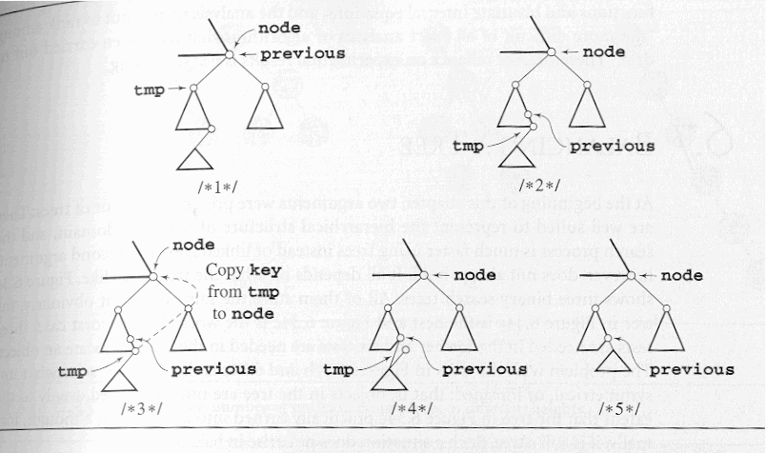

This deletion via copying does not increase the height of the tree, but it is not without its own problems. The problem arises if the algorithm is applies many times along with insertions into the BST. This algorithm is asymmetric; it always deletes the node of the immediate predecessor of information in node. This has the effect of possibly reducing the height of the left subtree (it might not change the height). However, the right subtree is unaffected by these changes. Therefore, the right subtree of node can grow after subsequent insertions, and if the information in node is again deleted, the height of the right tree will remain the same. After many insertions and deletions, the entire tree becomes right skewed (unbalanced favoring the right side).

To prevent this problem from occurring, a simple improvement to the Hibbard/Knuth algorithm will make the algorithm symmetric. In the improved algorithm, the predecessor information which is to be deleted will alternate between left and right subtrees with each deletion operation. In this fashion the first deletion will delete the predecessor information in a node in the left subtree and the next deletion will delete the successor in the right subtree.

public void deleteByCopying( int element) {
IBSTNode node, p = root, prev = null;
while (p != null && !p.key.equals(element) ) {//find node p with value element
prev = p;
if (p.key.isLessThan(element))
p = p.right;
else p = p.left;
}
node = p;
if (p != null && p.key.equals(element)) {
if (node.right == null) //node has no right child
node = node.left;
else if (node.left == null) //node has no left child
node = node.right;
else { //node has two children
IBSTNode tmp = node.left;
IBSTNode previous = node;
while (tmp.right != null) {
previous = tmp;
tmp = tmp.right;
}
node.key = tmp.key; //overwrite reference, i.e., the copy
if (previous == node)
previous.left = tmp.left; //node’s left child’s right subtree is null
else previous.right = tmp.left;
}
if (p == root)
root = node;
else if (prev.left == p)
prev.left = node;
else prev.right = node;
}
else if (root != null)
System.out.println(“key “ + element.toString( ) + “ is not in the tree”);
else System.out.println(‘the tree is empty);
}

Deletion via Copying Technique

Simulations have shown that an expected path length for many insertions and asymmetric deletions (the un-improved version of the algorithm) gives an expected internal path length (IPL) of Θ(n log³ n) for n nodes. When the improved symmetric version of the algorithm is used, the expected IPL becomes Θ(n log n)! Use of the simpler asymmetric version is however, quite acceptable, as the simulations have also shown that even for a BST containing 2048 nodes, approximately 1.5 million insertions and asymmetric deletions will need to occur before the IPL becomes worse than in a randomly generated tree! Theoretical results for these algorithms are only fragmentary because of the extraordinary complexity of the problem. Jonassen and Knuth analyzed the problem of random insertions and deletions for a tree consisting of only three nodes, which required the use of Bessel functions and bivariate integral equations, and the analysis of these turned out to rank among “the more difficult of all exact analyses of algorithms that have been carried out to date.” Thus, the reliance on simulation to determine the running times of these algorithms.

Balancing Trees

When we first began discussing the tree data structure, we made two points in favor of trees: (1) the tree can easily represent hierarchical relationships, and (2) searching a tree (assuming a BST) is much faster than searching a list. As we have discussed since then, the second point is not always true. It is possible for a tree to become so skewed (unbalanced) that it deteriorates into a list. In order for the second point to be valid, the search tree must be well balanced.
A binary tree is height-balanced (or simply balanced) if the difference in height of both subtrees of any node in the tree is either zero or one. A tree is said to be perfectly balanced if it is balanced and all of the leaves are found on one or two levels.

For example, a perfectly balanced binary tree consisting of 10,000 nodes, the height of this tree will be ⎡log(10,001)⎤ = ⎡13.289⎤ = 14. In practical terms, this means that if 10,000 elements are stored in a perfectly balanced tree, then at most 14 nodes will need to be checked to locate a specific element. This is a substantial difference when compared to the worst case of 10,000 elements in a list! Therefore, in trees which are to be used primarily for searching, it is worth the effort to either build the tree so that it is balanced or modify the existing tree so that it is balanced.

There are a number of techniques that have been developed to balance binary trees. Some of the techniques consist of constantly restructuring the tree when elements arrive and lead to an unbalanced tree. Some of them consist of reordering the data and then build the tree according to some ordering of the data which will ensure that the tree is balanced when it is constructed.

If the data which is used to construct a BST arrives in either ascending or descending order the tree will be skewed to the point of representing a linear list. Thus, if the smallest value in the data set is the first value read, the root of the tree will contain only a right subtree. Similarly, if the largest value in the data set is entered first, the root of the tree will contain only a left subtree. Before looking at more sophisticated algorithms to balance binary trees, lets examine a very simple technique.

When the data arrive, store all of them into an array. Once all the data have arrived, sort the array using an efficient sorting algorithm. Once sorted the element at the midpoint of the array will become the root of the BST. The array can now be viewed as consisting of two subarrays, one to the left of the midpoint and one to the right of the midpoint. The middle element in the left subarray becomes the left child of the root node and the middle element in the right subarray becomes the right child of the root. This process continues with further subdivision of the original array until all the elements in the array have been positioned in the BST. A slight modification of this would be to completely generate the left subtree of the root before generating the right subtree of the root. If this is done, then the very simple recursive procedure shown below can be used to generate a balanced BST.
void balance( int data[], int first, int last) {
if (first <= last) {
int middle = (first + last)/2; //find middle element in the array
insert(data[middle]); //add node to the tree
balance(data, first, middle-1);
balance(data, middle+1, last);
}
}

An example of this algorithm’s execution is shown below:

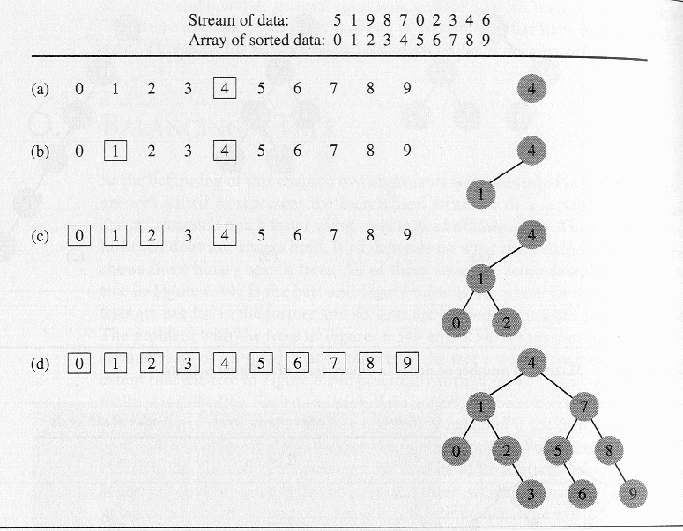
While this algorithm is certainly simple, it has one serious drawback: all the data must be put into an array before the balanced tree can be created. This algorithm will not work when the tree must be in use before all of the data have arrived. However, the data from an unbalanced tree can be entered into an array using an inorder traversal of the tree. The unbalanced tree could then be destroyed and a new one created from the data in the array using the balance( ) algorithm. In this fashion, no sort is required to put the data into order!

The DSW Algorithm

While the previous algorithm was certainly simple, it was basically inefficient in that an additional array was required which commonly required sorting before the balanced tree could be created. Alternatively, to avoid the sorting, required deconstructing an existing unbalanced tree and reconstructing the tree, which is quite inefficient except for very small trees (in which case their unbalanced nature is probably not a hindrance in any case). There are however, several algorithms which require very little additional storage for intermediate variables and use no sorting procedure. The DSW algorithm, developed by Colin Day and later improved by Quentin Stout and Bette Warren, is a very elegant algorithm which falls into this category.

The basic building block for tree transformations in the DSW algorithm is the rotation. There are two types of rotations, left and right, which are symmetric to one another. The right rotation of the node Ch (for child) about its parent Par is performed according to the following algorithm:

rotateRight (Gr, Par, Ch)
if Par is not the root of the tree //i.e., if Gr is not null
grandparent Gr of child Ch becomes Ch’s parent by replacing Par;
right subtree of Ch becomes left subtree of Ch’s parent Par;
node Ch acquires Par as its right child;

A right rotation is shown graphically below:
Gr
Par
Ch
R
P
Q
Gr
Ch
Par
R
P
Q

before rotation after rotation

The heart of the right rotation is the third step in the algorithm, when Par, the parent of child Ch, becomes the child of Ch, i.e., when the roles of the parent and child interchange. Notice that this exchange of roles does not affect the principal property of the tree, namely, that it is still a BST. The first and second steps of the algorithm are required to ensure that after the rotation the BST property is preserved. The example below should clarify this property:

27
29
35
P
Q
R
27
35
29
R
P
Q

before rotation after rotation

The basic operation of the DSW algorithm is to convert an arbitrary BST into a linked list-like structure called a backbone or vine. Then this elongated tree is transformed in a series of passes into a perfectly balanced tree by repeatedly rotating every second node of the backbone about its parent. In the first phase the backbone is created according to the following algorithm:

createBackbone (root, n)
tmp = root;
while (tmp != null)
if tmp has a left child
rotate this child about tmp; //the left child becomes the parent of tmp
set tmp to the child which just became the parent;
else set tmp to its right child;

This execution of this algorithm is shown in the diagram below:

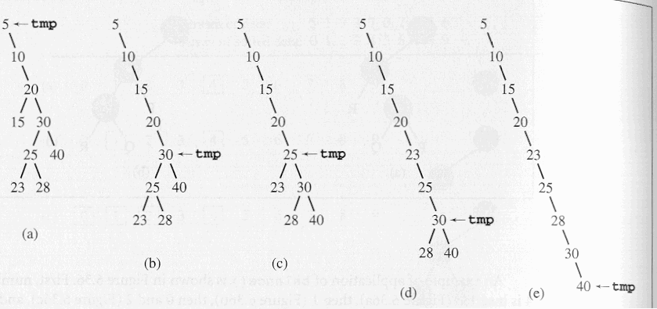
Since the rotation requires knowledge about the parent of tmp, an additional reference must be maintained when the algorithm is implemented. In the best case, the tree is already a backbone and the while loop will execute n times and no rotation is performed. In the worst case, when the root does not have a right child, the while loop will be executed 2n-1 times and n-1 rotations will be performed, where n is the number of nodes in the tree. Thus, the run time of the first phase of the DSW algorithm is O(n).

In the second phase, the backbone is transformed into a tree, but this time the tree will be perfectly balanced by having leaves only on two adjacent levels. In each pass down the backbone, every second node is rotated about its parent. One such pass decreases the size of the backbone by one-half. Only the first pass may not reach the end of the backbone. It is used to account for the difference between the number n of nodes in the current tree and the number 2^{⎣lg(n+1)⎦}-1 of nodes in the closest complete binary tree. Thus, overflowing nodes are treated separately. The core of the DSW algorithm is given below:

createPerfectTree(n)
m = 2^{⎣lg(n+1)⎦} -1;
make n-m rotations starting from the top of the backbone;
while (m > 1)
m = m/2;
make m rotations starting from the top of the backbone;

The diagram below illustrates this part of the DSW algorithm:

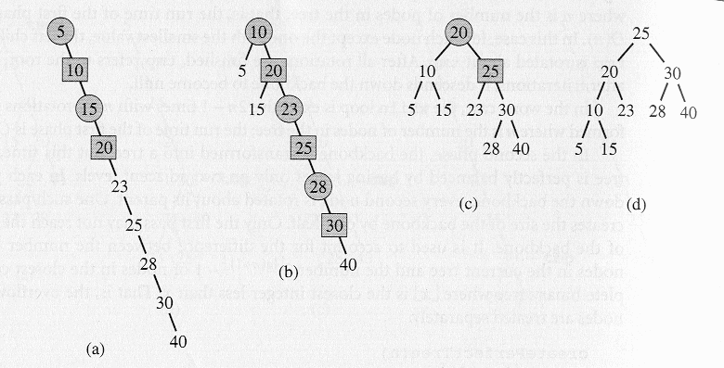

This example starts with the backbone (a) generated in the previous example. The first pass through the backbone to produce the backbone shown in (b). Now two passes are executed. In each backbone, the nodes to be promoted by one level by left rotations are shown as squares; their parents, about which they are rotated are shown as circles.

To compute the complexity of the tree building phase, note that the number of iterations performed by the while loop equals:

$$\left(2^{\text{lg}(m+1)−1}−1)+⋯+\text{15}+7+3+1\right)=\sum_{i=1}^{\text{lg}(m+1)−1}{(2^{i}}−1)=m−\text{lg}(m+1)$$
The number of rotations can now be given by the expression:
$$n−m+\left(m−\text{lg}(m+1))=n−\text{lg}(m+1\right)=n−\left\lfloor \text{lg}(n+1)\right\rfloor$$

Thus, the number of rotations is O(n). Because creating a backbone also required at most O(n) rotations, the cost of global rebalancing with the DSW algorithm is optimal in terms of time because it grows linearly with n and requires a very small and fixed amount of storage.

