COP 3503 – Computer Science II – CLASS NOTES - DAY #11 - Supplement

“Sorting” – What does it mean?

Many times the question arises as to how the theory covered in discrete structures courses (COT 3100 at UCF) applies to various areas in Computer Science. We can use sorting as an easy example to illustrate the connection. We have dealt with several different sorting techniques in the last couple of days of class and frequently made mention of the fact that we want to sort the numbers in our arrays in ascending order. While it may be clear to us what we mean by such a statement, it is far cry from a precise statement. If we are to analyze sorting algorithms with any mathematical rigor a much more mathematically precise definition must be formulated. The following paragraph or two will give you a flavor of the mathematical precision that is required to do the job correctly. For those of you already familiar with discrete structures this should look familiar, for those of you who haven’t had that pleasure yet, hang on you’re in for quite an experience at some point.

Consider a arbitrary sequence S = {s₁, s₂, s₃, …, s_{n}} composed of n ≥ 0 elements drawn from a universal set U. The goal of sorting is to rearrange the elements of S to produce a new sequence, say S’, in which the elements of S appear in order. What does it mean to appear in order. We will assume that there exists a relation <, defined over the universe U. The relation < must be a total order. A total order is defined as:

A total order is a relation, say <, defined on the elements of some universal set U with the following properties:

- For all pairs of elements (i, j) ∈ U × U, exactly one of the following is true: i < j, i = j, or j < i.
(All elements are commensurate.)
- For all triples (i, j, k) ∈ U × U, i < j AND j < k ⇔ i < k
(The relation < is transitive.)

In order to sort the elements of the sequence S, we determine the permutation P = {p₁, p₂, p₃, …,p_{n}} of the elements of S such that

$$s_{p_{1}}≤s_{p_{2}}s_{p_{3}} … ≤s_{p_{n}}$$

In practice, we are not interested in the permutation P, per se. Instead the objective is to compute the sorted sequence $S^{'}=\left\{ s_{1}^{'}, s_{2}^{'}, s_{3}^{'}, … ,s_{n}^{'} \right\}$in which $s_{i}^{'}=s_{p_{ i }}$for 1 ≤ i ≤ n.

Sometimes the sequence to be sorted contains duplicates – that is, ∃i, j ⏐1 ≤ i ≤ j ≤ n ⏐ s_{i} = s_{j}. In general when a sequence that contains duplicates is sorted, there is no guarantee that the duplicated elements remain in their relative positions, that is, s_{i} could appear either before or after s_{j} in the sorted sequence S’. If duplicates retain their relative positions in the sorted sequence, the sort is said to be stable. For s_{i} and s_{j} to retain the relative order in the sorted sequence, we require that $s_{p_{i}}^{'}$precedes $s_{p_{j}}^{'}$in S’. Therefore the sort is stable if p_{i} < p_{j}.

The few paragraphs above should illustrate to you the necessity for the precision required to be able to mathematical define an algorithmic technique. It should also more clearly give you an idea of what it means to sort something.

More on Inversions and Average Running Time for Sorting Algorithms

We discussed in the notes on sorting the concept of an inversion. Noting that a sequence of numbers which is sorted contains no inversions while an unsorted sequence will contain some number of inversions. The comparison based sorting algorithms operate by removing one or more inversions per pass through the sequence. Thus, the run-time of the algorithm is affected by the number of inversions present in the sequence. In other words, if we are presented with a sequence which is already sorted (the number of inversions is 0) then there is no work to do in terms of the number of elements that will need to be swapped. Similarly, if we are presented with a sequence which contains the maximum number of inversions (incidentally, what is the maximum number of inversions that could be present in a sequence of N terms? - answer is at the end of this set of notes) then we will have the maximum amount of work to do in terms of swapping elements. However, most of the time we are not concerned with either of these two extreme cases, i.e., best performance or worst performance, but are much more concerned with how the algorithm will perform on the average. In other words we would like to know the expected run-time of the algorithm. For example, with the insertion sort algorithm we discovered that its best run-time is O(N) while its worst case run-time is O(N²). We would expect that its average running time would fall somewhere in between these two extremes. What do we mean by the average running-time for a sorting algorithm? We might simply state this as the time required to sort the average sequence. But again, what do we mean by the average sequence? The usual way to determine the average running-time of a sorting algorithm is to first consider sequences that contain no duplicate elements. Since every sorted sequence of length n is simply a permutation of an unsorted one, we can represent every such sequence by a permutation of the sequence S = {1, 2, 3, …, n}. When computing the average running-time, we assume that every permutation is equally likely (this is a simplification that may or may not be true and we will explore this in the next chapter when we look more closely at permutations and distribution functions). Therefore, the average running time of a sorting algorithm is the running time averaged over all possible permutations of S.

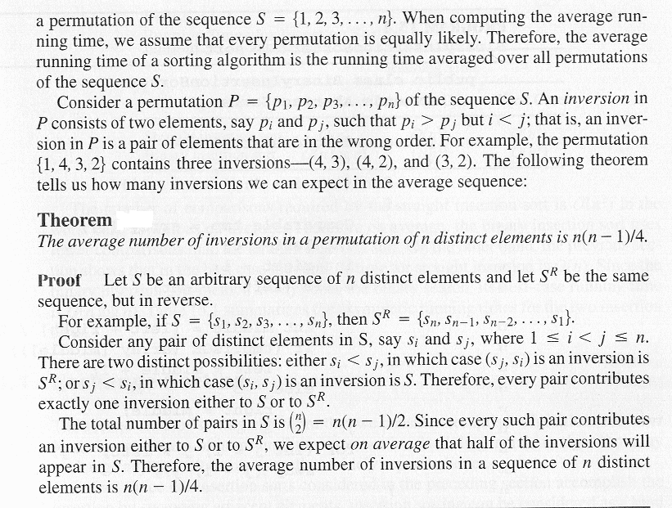

The maximum number of inversions possible in a sequence of n elements occurs when the elements are in reverse sorted order and the number is (n² –n)/2. See if you can figure out why this is true before you look at the next page.
Consider the following sequences A through G.

A = {1}
B = {1, 2}
C = {1, 2, 3}
D = {1, 2, 3, 4}
E = {1, 2, 3, 4, 5}
F = {1, 2, 3, 4, 5, 6}
G = {1, 2, 3, 4, 5, 6, 7}

Sequence A has a maximum number of inversions of 0

Sequence B has a maximum number of inversions of 1.
This occurs when it is permuted to {2, 1} the inversions are: (2,1)

Sequence C has a maximum number of inversions of 3.
This occurs for the permutation {3, 2, 1} the inversions are: (3,2), (3,1), and (2,1)

Sequence D has a maximum number of inversions of 6.
This occurs for the permutation {4, 3, 2, 1} the inversions are: (4,3), (4,2), (4,1), (3,2), (3,1), and (2,1)

Sequence E has a maximum number of inversions of 10.
This occurs for the permutation {5, 4, 3, 2, 1} the inversions are: (5,4), (5,3), (5,2), (5,1), (4,3), (4,2), (4,1), (3,2), (3,1), and (2,1)

Sequence F has a maximum number of inversions of 15.
This occurs for the permutation {6, 5, 4, 3, 2, 1} the inversions are: (6,5), (6,4), (6,3), (6,2), (6,1), (5,4), (5,3), (5,2), (5,1), (4,3), (4,2), (4,1), (3,2), (3,1), and (2,1)

Sequence G has a maximum number of inversions of 21.
This occurs for the permutation {7, 6, 5, 4, 3, 2, 1} the inversions are: (7,6), (7,5), (7,4), (7,3), (7,2), (7,1), (6,5), (6,4), (6,3), (6,2), (6,1), (5,4), (5,3), (5,2), (5,1), (4,3), (4,2), (4,1), (3,2), (3,1), and (2,1)

By now the pattern should be obvious and the number of inversions can be expressed by the summation:
$\sum_{i=1}^{n}{(i−1)=\sum_{i=1}^{n}{i −}} \sum_{i=1}^{n}{1=\frac{n(n+1)}{2}−n=\frac{n(n+1)−2n}{2}=\frac{n^{2}−n}{2}}$

