COP 3503 – Computer Science II – CLASS NOTES - DAY #12 Supplement

Efficient Sorting Algorithms

The O(N²) limit for sorting based upon inversion removal for adjacent elements is too costly for large sorts and must be broken down to improve efficiency and decrease run-times. Several different techniques have been developed which involve the basic divide and conquer strategy – some more subtly than others. The diminishing increment sort developed by Donald Shell is one such sort as are the merge sort and quick sort techniques.

Shell Sort

The basic approach to Shell’s sort is given by the following pseudocode algorithm.

divide data into h subarrays;
for (i = 1; i ≤ h; i++)
sort subarray data_{(i)};
sort array data;

If h is too small, then the subarray data_{(i)} could be too large and the sort will remain inefficient. On the other hand, if h is too large, then too many small subarrays are created, and although they are sorted, the overall order of the original array will remain largely unchanged. If only one partition of the original array is performed – the gain in execution time will be slight. To solve this problem, several different subdivisions must be used, and for every subdivision, the same procedure will be applied separately. This is shown in the pseudocode algorithm shown below.
determine numbers h_{t} . . . h₁ of ways of dividiny array data into subarrays;
for (h = h_{t}; t > 1; t--, h = h_{t})
divide data into h subarrays
for (i = 1; i ≤ h; i++)
sort subarray data_{(i)};
sort array data;

This is the basic idea behind the Shell sort. The division of the array into several subarrays is done in such a fashion that elements spaced further apart are compared first, then the elements closer to each other are compared, and so on, until adjacent elements are compared on the last pass. The original array is subdivided into subarrays by picking every h_{t}th element as part of one subarray. Therefore, there are h_{t} subarrays, and for every h = 1, …, h_{t},

${\text{data}}_{h_{t}h}[i]=\text{data}[h_{t}i+(h−1)]$

For example, if h_{t} = 3, the array data will be subdivided into three subarrays data₁, data₂, and data₃ so that:

data₃₁[0] = data[0], data₃₁[1] = data[3], data₃₁[2] = data[6], data₃₁[i] = data[3*i], …
data₃₂[0] = data[1], data₃₂[1] = data[4], data₃₂[2] = data[7], data₃₂[i] = data[3*1+1], …
data₃₃[0] = data[2], data₃₃[1] = data[5], data₃₃[2] = data[8], data₃₃[i] = data[3*1+2], …

If h_{t} = 3, the process of extracting subarrays and sorting them is called a 3-sort. If h_{t} = 3, the process is called a 5-sort, and so on.

Example – Shell Sort (same example – different view)
Original | 81 | 94 | 11 | 96 | 12 | 35 | 17 | 95 | 28 | 58 | 41 | 75 | 15
5 subarrays | 35 |  |  |  |  | 81 |  |  |  |  | 41
before |  | 17 |  |  |  |  | 94 |  |  |  |  | 75
sorting |  |  | 11 |  |  |  |  | 95
 |  |  |  | 28 |  |  |  |  | 96
 |  |  |  |  | 12 |  |  |  |  | 58
5 subarrays | 35 |  |  |  |  | 41 |  |  |  |  | 81
after |  | 17 |  |  |  |  | 75 |  |  |  |  | 94
sorting |  |  | 11 |  |  |  |  | 95
 |  |  |  | 28 |  |  |  |  | 96
 |  |  |  |  | 12 |  |  |  |  | 58
After 5-sort | 35 | 17 | 11 | 28 | 12 | 41 | 75 | 15 | 96 | 58 | 81 | 94 | 95

Start 3-sort | 35 | 17 | 11 | 28 | 12 | 41 | 75 | 15 | 96 | 58 | 81 | 94 | 95
3 subarrays | 28 |  |  | 35 |  |  | 75 |  |  | 58 |  |  | 95
before |  | 12 |  |  | 17 |  |  | 15 |  |  | 81
sorting |  |  | 11 |  |  | 41 |  |  | 96 |  |  | 94
3 subarrays | 28 |  |  | 35 |  |  | 58 |  |  | 75 |  |  | 95
after |  | 12 |  |  | 15 |  |  | 17 |  |  | 81
sorting |  |  | 11 |  |  | 41 |  |  | 94 |  |  | 96
After 3-sort | 28 | 12 | 11 | 35 | 15 | 41 | 58 | 17 | 94 | 75 | 81 | 96 | 95
Start 1-sort | 28 | 12 | 11 | 35 | 15 | 41 | 58 | 17 | 94 | 75 | 81 | 96 | 95
shown as | 12 | 28
insertion | 11 | 12 | 28
sort | 11 | 12 | 28 | 35
 | 11 | 12 | 15 | 28 | 35
 | 11 | 12 | 15 | 28 | 35 | 41
 | 11 | 12 | 15 | 28 | 35 | 41 | 58
 | 11 | 12 | 15 | 17 | 28 | 35 | 41 | 58
 | 11 | 12 | 15 | 17 | 28 | 35 | 41 | 58 | 94
 | 11 | 12 | 15 | 17 | 28 | 35 | 41 | 58 | 75 | 94
 | 11 | 12 | 15 | 17 | 28 | 35 | 41 | 58 | 75 | 81 | 94
 | 11 | 12 | 15 | 17 | 28 | 35 | 41 | 58 | 75 | 81 | 94 | 96
After 1-sort  SORTED | 11 | 12 | 15 | 17 | 28 | 35 | 41 | 58 | 75 | 81 | 94 | 95 | 96

Generic Java Implementation of Shell Sort

void Shellsort (Object[ ] data)
{ int i, j, k, h, hCnt, increments[ ] = new int[20];
Comparable temp;
// create an appropriate number of increments h
for (h = 1, i = 0; h < data.length; i++)
{ increments[i] = h
h = 3*h + 1;
}
// loop on the number of different increments h
for (i--; i ≥ 0; i--)
{ h = increments[i];
// loop on the number of subarrays h-sorted in the ith pass
for (hCnt = h; hCnt < 2*h; hCnt++)
{ //insertion sort for subarray containing every hth element of array data
for (j = hCnt; j < data.length; )
{ temp = (Comparable)data[j];
k = j;
while (k-h ≥ 0 && temp.compareTo(data[k-h]) < 0)
{ data[k] = data[k-h];
k –= h;
}
data[k] = temp;
j += h;
}
}
}
}

Quicksort

The quicksort algorithm was developed by C.A.R. Hoare and is a recursive divide and conquer approach to sorting. It is also the fastest known sort. The original array is divided into two subarrays, the first of which contains elements less than or equal to a chosen key called the bound or pivot. The second array includes elements equal to or greater than the pivot. The two subarrays can be sorted separately, but before this is done, the partition process is repeated for both subarrays. As a result, two new pivots are chosen, one for each subarray. The four subarrays are created because each subarray in the first phase is not divided into two segments. This process of partitioning the subarrays is continued until there are only one-cell arrays, which do not require sorting (by default an array of one element is sorted). Through the process of dividing task of sorting a large array into two simpler tasks and then further dividing those tasks into even simpler tasks – it turns out that in the process of getting prepared to sort – the data have become sorted! Quicksort is an inherently recursive algorithm because it is applied to both subarrays of an array at each level of partitioning. A psuedocode version of quicksort is shown below.

Pseudocode version
quicksort (array[ ])
if array length > 1
chose pivot; //partition array into subarray1 and subarray2
while there are elements left in array
if element < pivot
include element in either subarray1 = {e1: e1 ≤ pivot};
or in subarray2 = {e1: e1 ≥ pivot};
quicksort(subarray1);
quicksort(subarray2);

To partition the array, two operations need to be performed: (1) a pivot has to be found and (2) the array must be scanned to place the elements into the proper subarrays. Choosing a good pivot is not a trivial task. The main problem is that the two subarrays should contain approximately the same number of elements. A number of different strategies exist for selecting a pivot. One of the simplest consists of choosing the first element of an array. For some situations this technique might suffice – however, since many arrays to be sorted already have many elements in the proper positions, a safer approach would be to chose the element in the middle of the array. Selecting the element which is the median of the elements in the array is the safest approach but is, in general, too costly and is simulated with median of three or median of five techniques.

The task of scanning the array and dividing the elements between the two subarrays is rather vague in the pseudocode algorithm shown above and is in many ways implementation dependent. Notice in particular that the algorithm above does not specifically indicate to which subarray an element equal to the pivot belongs. This is done so that such elements can be used to balance the number of elements in the subarrays.

Shown below is a Java implementation of a quicksort algorithm followed by an example of how the quicksort algorithm functions.

Generic Java version of quicksort
void quicksort( Object[ ] data, int first, int last)
{ int lower = first + 1, upper = last;
swap(data, first, (first+last)/2);
Comparable pivot = (Comparable) data[first];
while (lower <= upper)
{ while (((Comparable)data[lower]).compareTo(pivot) < 0)
lower++;
while (pivot.compareTo(data[upper]) < 00
upper--;
if (lower < upper)
swap(data, lower++, upper--);
else lower++;
}
swap(data, upper, first);
if (first < upper-1)
quicksort(data, first, upper-1);
if (upper+1 < last)
quicksort(data, upper+1, last);
}

void quicksort(Object[ ] data)
{ if (data.length < 2)
return;
int max = 0;
// find the largest element and put it at the end of data
for (int i = 1; i < data.length; i++)
if (((Comparable)data[max]).compareTo(data[i]) < 0
max = 1;
swap(data, data.length-1, max); //largest element now in its place
quicksort(data, 0, data.length-2); //final position
}

The next two figures illustrate an example of the operation of the quicksort algorithm on the data array containing [8, 5, 4, 7, 6, 1, 6, 3, 8, 12, 10]. In this example, the pivot is used as a boundary item and is placed on the borderline between the two subarrays obtained as a result of one call to quicksort( ). In this fashion, the pivot is located in its final position and can be excluded from further processing. To ensure that the pivot is not moved around, it is placed in the first position, and after the partitioning process is completed, it is moved to its proper location – which will be the rightmost position in the first subarray. In the partitioning process, the largest element, the 12, is located and interchanged with the last element in the array. This results in the array [8, 5, 4, 7, 6, 1, 6, 3, 8, 10, 12]. Since the last element is already in its proper position – it requires no further processing. In the first partitioning lower =1 and upper =9 and the first element of the array8, is swapped with the pivot 6 in position 4, so the array becomes: [6, 5, 4, 7, 8, 1, 6, 3, 8, 10, 12] (see part (b) of the figure). In the first iteration of the outer while loop, the inner while loop moves lower to position 3 with 7, which is greater than the pivot. The second inner while loop moves upper to position 7 with 3, which is less than the pivot (see part (c)). Next the elements in these two cells are interchanged, producing the array [6, 5, 4, 3, 8, 1, 6, 7, 8, 10, 12] (see part (d)). Then lower is incremented to 4 and upper is decremented to 6 (see part (e)). This will conclude the first iteration of the outer while loop. In its second iteration, neither of the two inner while loops modifies any of the two indicies because lower indicates a position occupied by 8, which is greater than the pivot, and upper indicates a position occupied by 6, which is equal to the pivot. The two numbers are swapped (see part (f)) and both indicies are updated to 5 (see part (g)). In the third iteration of the outer while loop, lower is moved to the next position containing 8, which is greater than the pivot and upper stays at the same position because the 1 in this position is smaller than the piovt (see part (h)). But at that point, lower and upper cross each other, so no swapping occurs and after a redundant increment of lower to 7, the outer while loop terminates. At this point, upper is the index of the rightmost element of the first subarray (with the element not exceeding the pivot), so the element in this position is swapped with the pivot (see part (i)). In this fashion the pivot is placed in its final position and is excluded from subsequent processing.

The two subarrays that are processed next are the left subarray, with elements to the left of the pivot and the right subarray with elements to the right of the pivot (see part (j)). Then the partitioning of these two subarrays begins separately, and then for the subarrays of these subarrays, until the subarrays have less than two elements. This entire process is summarized in the second of the two figures that follow.

The worst case occurs if in each invocation of quicksort(), the smallest element of the array is chosen as the pivot. To see this try quicksort on the array [5, 3, 1, 2, 4, 6, 8]. The first pivot will be 1 causing an empty subarray and the subarray [3, 5, 2, 4, 6] to be formed. The new pivot is 2, which again will form an empty subarray plus the array [5, 3, 4, 6]. Thus, the algorithm operates on arrays of size n-1, n-2, …, 2. The partitions require n-2 + n-3+…+1 comparisons. This results in a run-time of O(N²). The best case occurs when the pivot divides the array into two subarrays of equal size and will be O(N log N).

Example - Paritioning the Array [8, 5, 4, 7, 6, 1, 6, 3, 8, 12, 10] with Quicksort( )
Example continued – Sorting the Array with Quicksort( )

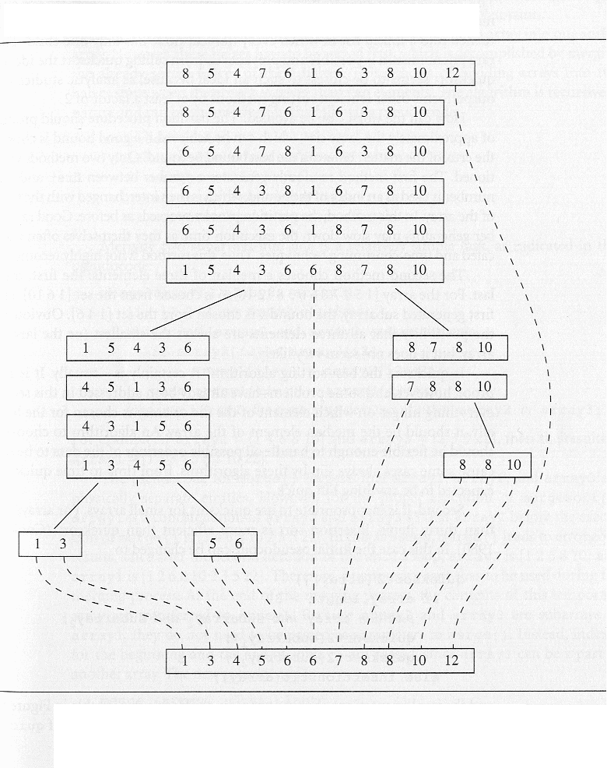

Merge Sort

The problem with the quicksort algorithm is that its complexity in the worst case is O(N²) (although in reality this can be avoided) due to the difficulty in controlling the partitioning process. Different techniques for choosing the pivot will provide differing run-times unless the subarrays are of equal size. Another strategy is to make the partitioning process as simple as possible (unlike quicksort) and concentrate on the merging of the two sorted arrays. This is the strategy employed by the mergesort algorithm. Merge sort was one of the first sorting algorithms used on a computer and was developed by John von Neumann.

The key process in mergesort is merging sorted halves of an array into one sorted array. However, these halves must first be sorted, which is accomplished by merging the already sorted halves of these halves, and so on. The process of dividing the arrays into two halves stops when the array has fewer than two elements. As with quicksort, mergesort is an inherently recursive algorithm and is summarized by the following pseudocode.

Pseuodcode for Mergesort
mergesort (data)
if data have at least two elements
mergesort( left half of data);
mergesort( right half of data);
merge( both halves into a sorted list);

Merging two subarrays into one is a relatively simple task as indicated by the following pseudocode algorithm:

merge (array1, array2, array3)
i1, i2, i3 are properly initialized
while both array2 and array3 contain elements
if array2[i2] < array3[i3]
array1[i1++] = array2[i2++];
else array1[i1++] = array2[i3++];
load into array1 the remaining elements of either array2 or array3;

Example

Let array2 = [1, 4, 6, 8, 10] and array3 = [2, 3, 5, 22] then array1 = [1, 2, 3, 4, 5, 6, 8, 10, 22].

The pseudocode for merge( ) suggests that array1, array2, and array3 are physically separate entities. However, for the proper execution of mergesort( ), array1 is a concatenation of array2 and array3 (see the pseudocode for mergesort()) so that, in the example above, array1 before the execution of merge( ) is [1, 4, 6, 8, 10, 2, 3, 5, 22]. In this situtation, merge( ) leads to erroneous results, since after the second iteration of the while loop, array2 is [1, 2, 6, 8, 10] and array1 is [1, 2, 6, 8, 10, 22, 3, 5, 22]. Therefore, a temporary array has to be used during the merging process. At the end of the merging process, the contents of this temporary array are transferred to array1. Because array2 and array3 are subarrays of array1, they do not need to be passed as parameters to merge( ). Instead, indices for the beginning and end of array1 are passed, since array1 can be part of another array. To reflect this the pseudocode for merge is modified to:

merge (array1, first, last)
mid = (first + last)/2;
i1 = 0;
i2 = first;
i3 = mid+1;
while both left and right subarrays of array1 contain elements
if array1[i2] < array1[i3]
temp[i1++] = array1[i2++];
else temp[i1++] = array1[i3++];
load into temp the remaining elements of array1;
load into array1 the contents of temp;

Since the entire array1 is copied to temp and then temp is copied back to array1, the number of movements in each execution of merge( ) is always the same and is equal to: 2 × (last – first + 1). The number of comparisons depends on the ordering in array1. If array1 is in order or if the elements in the right half precede the elements in the left half, the number of comparisons is (first + last)/2. The worst case occurs when the last element of one half precedes only the last element of the other half, such as in [1, 6, 10, 12] and [5, 9, 11, 13]. In this case the number of comparisons is (last – first). For an n-element array, the number of comparisons is n-1.

mergesort (data, first, last)
if (first < last)
mid = (first + last)/2;
mergesort (data, first, mid);
mergesort (data, mid + 1, last);
merge(data, first, last);

The following diagram illustrates the mergesort algorithm.

Mergesort can be made more efficient by replacing recursion with iteration or by applying insertion sort to small portions of an array (similar to what we suggested for quicksort). However, mergesort has one serious drawback: the need for additional storage for merging the arrays, which for large amounts of data can be an insurmountable obstacle.

