COP 3502H – Computer Science I – CLASS NOTES - DAY #27

Graphs

In spite of the flexibility of trees and the many different tree applications, trees, by their very nature, have one limitation, namely, they can only represent relationships of a hierarchical type, such as the relation between a parent and child. Other relationships can only be represented indirectly, such as the relationship of being a sibling. In a tree there are no links between children of the same parent, thus the sibling relationship is determined only through the parent node. A graph, which is a generalization of a tree, does not have this limitation. Intuitively, a graph is a collection of vertices (nodes) and the connections (edges or arcs) between them. Generally, there are no restrictions imposed on the number of vertices in a graph nor on the number of connections one vertex can have to other vertices. Graphs are versatile data structures that can represent a large number of different situations and events from a rather diverse group of applications. Graph theory has grown into a sophisticated area of mathematics and computer science in the last two hundred years since it was first studied. We will look only very briefly at this data structure and restrict our focus to areas of interest to computer science.

The picture below illustrates just four areas in which graphs and graph theory have applications ranging from simple graph traversal techniques to what can be very complex abstract machines known as FSA (finite state automata, also called FSM; finite state machines – see…there’s that discrete stuff again!). In the diagram below the portion labeled (a) shows how a graph can be used to determine the shortest distance between the airports in two different cities (so you can calculate your frequent flyer miles!). The diagram labeled (b) illustrates a graph modeling an electrical circuit where the vertices in the graph denote where the components are connected together with the edges representing the components themselves (e.g., resistors and capacitors). Using a graph you can answer questions such as “What are the mesh equations which describe the circuit’s behavior?” The diagram component labeled (c) shows how a logic circuit can be reduced to a graph. In this case the logic gates are represented by the vertices, and the arrows represent the signal propagation from gate outputs to gate inputs. Using a graph such as this you can answer questions of the form: “How long does it take for the signals to propagate from the inputs to the outputs?” or “Which gates are on the critical path?” Finally, the portion of the diagram labeled (d) represents a FSA with the vertices representing the states of the machine and the labeled arrows representing the allowable state transitions. Given such a graph representation of the FSA questions such as: “Are all the states reachable?” or “Can the FSA deadlock?”

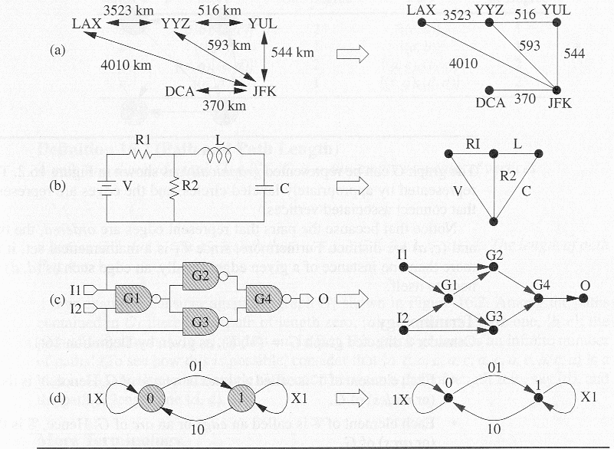Figure illustrating graph applications

Definitions

- A simple graph G = (V, E) consists of a non-empty set V of vertices and a possibly empty set E of edges, each edge being a set of two vertices from V. The number of vertices and edges is typically denoted ⏐V⏐ and ⏐E⏐, respectively.
- A directed graph (digraph) G = (V, E) consists of a non-empty set V of vertices and a possibly empty set E of edges (called arcs), where each edge is a pair of vertices from V. The difference is that an arc denotes a direction so that the edge (V_{i}, V_{j} ) ∈ E implies that the edge may be traversed in the direction from vertex i to vertex j. Traversal from vertex j to vertex i can occur only if the edge (V_{j}, V_{i} ) ∈ E.
- A weighted digraph is a digraph to which weights have been assigned to the edges. Weights may also be applied to the edges of an undirected graph. It is common to refer to a weighted digraph or weighted undirected graph as a network.

The two definitions above are restrictive in that they do not allow for two vertices to have more than one edge.

- A multigraph is a graph in which two vertices can be joined by multiple edges. The geometric interpretation is simple (see the figures below). More formally, a multigraph G = (V, E, f) is composed of a set of vertices V, edges E, and a function f: E → {{V_{i}, V_{j} }: V_{i} , V_{j} ∈ V & V_{i} ≠ V_{j}}.

- A pseudograph is a multigraph which does not have the restriction that an edge cannot begin and end on the same vertex. This allows cycles to be introduced into the graph which involve only a single node (see below).

Both multigraphs and pseudographs are less common than undirected and digraphs.

Graph Examples

simple graph directed graph multigraph

pseudograph complete graph

Additional Graph Specific Definitions

- In an undirected graph two vertices V₁ and V₂ are adjacent if the edge (V₁, V₂) ∈ E. Such an edge is said to be incident on the vertices V₁ and V₂.
- In a directed graph the edge (V₁, V₂) is incident to vertex V₂ and incident from V₁. Being incident from is more commonly referred to as emanating from, thus the edge above emanates from V₁ and is incident on V₂.
- In a directed graph the out degree of a node is the number of edges which emanate from the node. The in degree of a node is the number of edges which are incident on the node.
- In an undirected graph the degree(V) of a vertex V is the number of edges incident on V.
- A path in a digraph G = (V, E) is a non-empty sequence of vertices P={V₁, V₂, …, V_{k}}, where V_{i}∈V for 1≤ i ≤ k such that (V_{i}, V_{i+1}) ∈E for 1 ≤ i ≤ k. The path length of P is k-1.
- Given a path as defined above, vertex V_{i+1} is the successor of vertex V_{i} for 1 ≤ i ≤ k. Every vertex V_{i} of path P (except the last vertex) has a successor.
- Given a path as defined above, vertex V_{i-1} is the predecessor of vertex V_{i} for 1 ≤ i ≤ k. Every vertex V_{i} of path P (except the first vertex) has a predecessor.
- A path is called a simple path if and only if V_{i} ≠ V_{j} for all i and j such that 1 ≤ i < j ≤ k. However, it is permissible for V₁ = V_{k} in a simple path. If V₁=V_{k} the the path is a cycle (see below).
- A circuit is a path in which no edge is repeated.
- A cycle is a path of non-zero length in which the starting and ending vertex are the same. The length of the cycle is just the length of the path P. A graph containing a cycle has an infinite number of paths in the graph.
- A loop is a cycle of length 1; that is, it is a path of the form {V_{i}, V_{i}}.
- A simple cycle is a path that is both a cycle and simple.
- A graph is called a weighted graph if each edge has an associated weight. Depending upon the application the weight might refer to cost, distance, length, or some other factor. A weighted graph may be undirected or directed depending upon the application.

Before we consider any more graph definitions, let’s look at some examples that illustrate the definitions we covered so far.
A
B
C
D
Graph G

Graph G is defined by: V = {A, B, C, D} and
E = {(A,C), (A,B), (B,C), (C,A), (C,D), (D,D)}
The edge (A,C) is incident to C and emanates from A.
The out degree of node B is 1, the out degree of node C is 2.
The in degree of node C is 2, the in degree of node B is 1.
There is a path P = {A, B, C} in G. This is a simple path of length 2.
The path P is also a circuit.
There is a path P = {A, B, C, A} in G which is a simple cycle of length 3.
The cycle {A, C, A, C, A} has length 4, but is not a simple cycle.
There is a loop in G consisting of (D, D).
The path {C, A, C, D} is not a simple path, C is repeated (but not at the end)

Even More Graph Specific Definitions

- A graph of n vertices is complete, and is denoted K_{n}, if for each pair of distinct vertices there is exactly one edge connecting them. That is, each vertex can be connected to any other vertex. The number of edges is such a graph is O(⏐V⏐).
- An undirected graph G = (V, E) is connected iff (if and only if) there is a path between every pair of vertices in G. A graph which is unconnected contains at least one vertex which is unreachable, i.e., the graph does not contain any paths which include the unreachable vertex. Note that given a specific graph G = (V, E), it may be possible to remove edges from E while G remains connected. An edge which can be removed from E and yet G remains connected is said to be unnecessary.
- A connected undirected graph that contains no cycles is called a tree.
- A graph H is a subgraph of another graph G iff its vertex and edge sets are subsets of those of G.
- A subgraph of G that contains all of the vertices of G and is a tree is called a spanning tree of G.

Examples:
1
2
3
4
5
6
7
1
2
3
4

- (b)

In the two figures above, undirected graph (a) represents a connected graph while figure (b) is an unconnected graph. Figure (b) contains four vertices which are not reachable from vertices {1, 2, 3} which are {4, 5, 6, 7} and three vertices which are not reachable from vertices {4, 5, 6, 7} which are {1, 2, 3}. The two figures below represent complete graphs.
1
2
3
43
1
2

3
43

1
2
3
4
1
2
3
4
1
2
3
4
1
2
3
4

(a) (b) (c) (d)

In the figures above, figures (b), (c), and (d) represent some of the possible spanning trees of graph (a).

Still More Graph Specific Terminology

- A directed acyclic graph (DAG) is a directed graph which contains no cycles. All trees are DAGs, however, not all DAGs are trees. In figure (a) below we see a DAG which is clearly a tree (binary in fact), yet figure (b) represents a DAG which is clearly not a tree (node “K” has two parents and all trees in Computer Science are from single parent homes).
- A directed graph which is connected is called a strongly connected graph. If a directed graph is not strongly connected but the underlying graph (its undirected counterpart) is connected, then the digraph is said to be weakly connected.
H
I
J
K
A
B
C
D
EA
FA
GA

(a) (b)

Graph Representations

There are a variety of ways to represent a graph and we will examine a couple of these techniques with a focus on the efficient implementation of the graph structure.
Consider a directed graph G = (V, E). Since E ⊆ V × V, graph G contains at most ⏐V⏐² edges. There are $2^{{\left|V\right|}^{2}}$possible sets of edges for a given set of vertices V. Therefore, the main concern when designing a graph representation scheme is to find an efficient way to represent the set of edges. To do this properly depends upon whether the graph is a dense graph or a sparse graph. Informally, a graph with relatively few edges is a sparse graph while a graph with many edges is a dense graph. More formally we have:

- A sparse graph is a graph G = (V, E) in which ⏐E⏐= O(⏐V⏐). For example, consider a graph G=(V,E) with n nodes. Suppose that the out-degree of each vertex in G is some fixed constant k. Graph G is a sparse graph because ⏐E⏐= k⏐V⏐ = O(⏐V⏐)
- A dense graph is a graph G = (V, E) in which ⏐E⏐ = θ(⏐V⏐²). For example, consider a graph G=(V,E) with n nodes. Suppose that the out-degree of each vertex in G is some fraction f of n, 0 < f ≤ 1. For example, if n = 16 and f = 0.25, the out-degree of each node is 4. Graph G is a dense graph because ⏐E⏐= f⏐V⏐² = θ(⏐V⏐²).

For sparse graphs a simple representation technique is given by an adjacency list which specifies all vertices which are adjacent to each vertex in the graph. This list is typically implemented as a table in which case it is referred to as a star representation. It can also be implemented as a matrix (a two-dimensional table) in which case it comes in two possible forms: an adjacency matrix or an incidence matrix.

- An adjacency matrix, A, of graph G = (V, E) is a binary matrix: ⏐V⏐× ⏐V⏐such that each entry of the matrix is:
$A_{\text{ij}}=\begin{aligned}\left\{1 \text{if} \text{there} \text{exists} \text{an} \text{edge} (V_{i},V_{j}) | \right.\end{aligned}$

- An incidence matrix, A, of graph G = (V, E) is a binary matrix: ⏐V⏐× ⏐E⏐such that each entry of the matrix is:
$A_{\text{ij}}=\begin{aligned}\left\{1 \text{if} \text{edge} E_{j} \text{is} \text{incident} \text{with} \text{vertex} V_{i} | \right.\end{aligned}$

a
c
f
d
b
e
g

Example

The adjacency matrix:

 | a | b | c | d | e | f | g
a | 0 | 0 | 1 | 1 | 0 | 1 | 0
b | 0 | 0 | 0 | 1 | 1 | 0 | 0
c | 1 | 0 | 0 | 0 | 0 | 1 | 0
d | 1 | 1 | 0 | 0 | 1 | 1 | 0
e | 0 | 1 | 0 | 1 | 0 | 0 | 0
f | 1 | 0 | 1 | 1 | 0 | 0 | 0
g | 0 | 0 | 0 | 0 | 0 | 0 | 0

The incident matrix:
 | ac | ad | af | bd | be | cf | de | df
a | 1 | 1 | 1 | 0 | 0 | 0 | 0 | 0
b | 0 | 0 | 0 | 1 | 1 | 0 | 0 | 0
c | 1 | 0 | 0 | 0 | 0 | 1 | 0 | 0
d | 0 | 1 | 0 | 1 | 0 | 0 | 1 | 1
e | 0 | 0 | 0 | 0 | 1 | 0 | 1 | 0
f | 0 | 0 | 1 | 0 | 0 | 1 | 0 | 1
g | 0 | 0 | 0 | 0 | 0 | 0 | 0 | 0

Note the differences and the similarities in these two matrices. Clearly, the more efficient implementation is dependent upon the number of edges compared to the number of nodes in the graph. We will discuss these in more detail later.

The adjacency list:
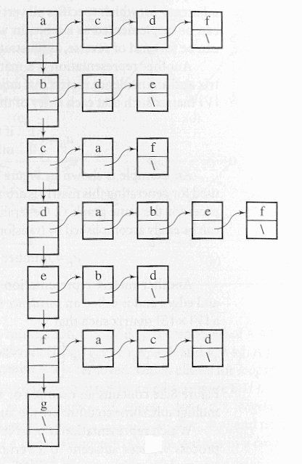

Which representation is the best? It depends on the application at hand. For example, if the application involves processing vertices adjacent to a particular vertex V, then the adjacency list requires only degree(V) steps. On the other hand the adjacency matrix will require ⏐V⏐steps. If the application requires the insertion or deletion of a vertex adjacent to V, this will require maintenance on the adjacency list (it would be implemented as a linked list), but for the adjacency matrix, it will simply require changing a 0 to a 1 for insertion and a 1 to a 0 for deletion, in only one cell of the matrix.

Graph Traversals

As with trees, traversing a graph consists of visiting each vertex only one time. The simple traversal algorithms used for trees (preorder, inorder, postorder) cannot be applied here because graphs may include cycles which would cause the tree traversal algorithms to enter an infinite loop. To prevent this from happening, each visited vertex is typically marked in some fashion to avoid revisiting it (a common technique is to renumber the vertices as they are visited). However, graphs can have isolated vertices (unconnected vertices), which means that some parts of the graph are left unvisited if unmodified tree traversal algorithms are applied.

Depth-First Traversal

The depth-first search algorithm for graphs was developed by Hopcroft and Tarjan. In this algorithm, each vertex V is visited and then each unvisited vertex adjacent to V is visited. If a vertex V has no adjacent vertices or all of its adjacent vertices have been visited, the traversal backtracks to the predecessor of V. The traversal is complete when this process of visiting and backtracking leads to the first vertex where the traversal started. If there are still unvisited vertices in the graph, the traversal continues by restarting on one of the unvisited vertices. This algorithm renumbers each vertex as it is visited.

Algorithm:
DFS(v)
num(v) = i++;
for all vertices u adjacent to v
if num(u) is 0
attach edge (uv) to edges;
DFS(u);

depthFirstSearch( )
for all vertices v
num(v) = 0;
edges = null;
i = 1;
while there is a vertex v such that num(v) is 0
DFS(v);
output edges;
Example:
The numbers assigned to each vertex are shown in parentheses in the figure below. Once the initializations have been made, depthFirstSearch( ) calles DFS(a). DFS( ) is invoked for vertex a; num(a) is assigned number 1. Vertex a has four adjacent vertices, and vertex e is chosen for the next invocation, DFS(e), which assigns number 2 to this vertex (num(e) = 2) and puts the edge(ae) in the set edges. Vertex e has two unvisited adjacent vertices, and DFS( ) is called for the first of them, the vertex f. The call DFS(f) will lead to the assignment num(f) = 3 and will put edge(ef) in edges. Vertex f has only one unvisited adjacent vertex, i, thus the fourth call DFS(i) will lead to the assignment num(i) = 4 and to the attaching of edge(fi) to edges. Vertex i has only visited adjacent vertices, thus a return to the call DFS(f) occurs and then to DFS(e) in which vertex i is accessed only to discover that num(i) is not 0, thus edge(ei) is not included in the set of edges. The rest of the execution is shown in the figure below where the solid lines indicate edges that are included in the set edges. Part (a) is the original graph and part (b) illustrates the algorithm’s technique.

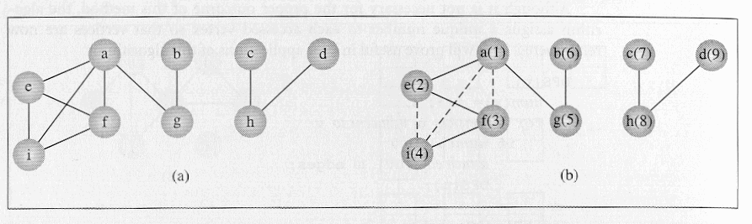
The depth-first graph traversal algorithm can also be applied to digraphs. This is illustrated in the next figure using the same symbolism as before.

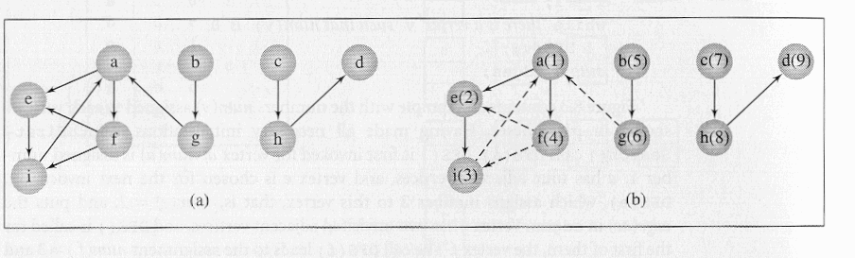Notice that this algorithm guarantees generating a tree (or a forest) which includes or spans over all vertices of the original graph. A tree that meets this condition is called a spanning tree. The fact that a tree (or a forest) is generated is ascertained by the fact that the algorithm does not include in the resulting tree any edge which leads from the currently visited vertex to a vertex which has already been visited. An edge is added only if the condition in “if num(u) is 0” is true, that is, only if vertex u reachable from vertex v has not been visited. As a result, certain edges in the original graph do not appear in the resulting tree. The edges included in this tree are called forward edges (or tree edges), and the edges not included in the tree are called back edges (the ones shown by dashed lines in the figures above).

Breadth-First Search

There are many different algorithms which are based on a depth-first traversal of a graph. Certain algorithms can be made more efficient if the underlying graph traversal is not depth-first but breadth-first. While depth-first tree traversals rely on a stack (either explicitly or implicitly with recursion), the breadth first tree traversal relies on a queue to handle the traversal (recall the level-order breadth first tree-traversal algorithm). This same technique can be extended to graph traversals.

Algorithm:
breadthFirstSearch( )
for all vertices u
num(u) = 0;
edges = null;
i = 1;
while there is a vertex v such that num(v) == 0
num(v) = i++;
enqueue(v);
while queue is not empty
v = dequeue( );
for all vertices u adjacent to v
if num(u) is 0
num(u) = i++;
enqueue(u);
attach edge (vu) to edges;
output edges;

Example:
The two figures below illustrate how breadthFirstSearch operates on both simple graphs and digraphs. The algorithm first attempts to mark all neighbors of a vertex v before proceeding to other vertices. This is the opposite of how the depthFirstSearch algorithm operated, where it picked one neighbor of a vertex v and then proceeded to a neighbor of this neighbor before processing any other neighbors of vertex v.
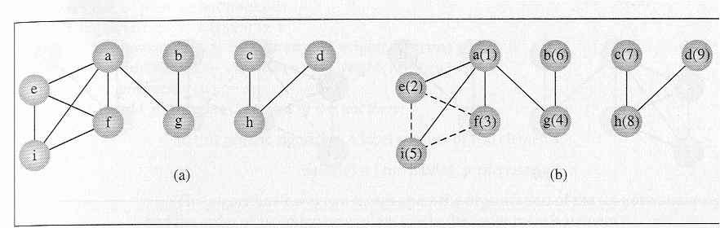Example of breadthFirstSearch on a simple graph

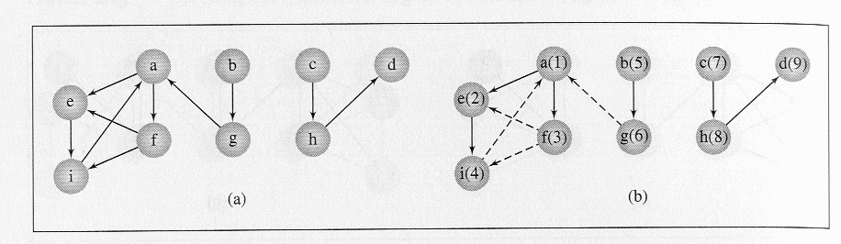Example of breadthFirstSearch on a digraph

Graph Problems

There are many classical problems in graph theory and for most of these problems there have been many different solutions proposed. For now we will focus on one of these classical problems: the shortest path problem.

Shortest Path Problem

In the shortest path problem, the edges of the graph are assigned certain weights. The meaning of the weights will vary from application to application, but common representations are: distance between two cities indicated by the vertices, cost of transmission across this link, amounts of some substance moved across the network., etc. When determining the shortest path from vertex v to vertex u, information about the distances between intermediate vertices w must be recorded. This information can be recorded as a label associated with these vertices, where the label is only the distance from v to w or the distance along with the predecessor of w in this path. The methods of finding the shortest path rely on these labels. Depending upon how many times these labels are updated, the methods solving the shortest path problem are divided into two classes: label-setting algorithms and label-correcting algorithms.
For label-setting algorithms, in each pass through the vertices still to be processed, one vertex is set to a value which remains unchanged to the end of the execution. This, however, limits such methods to processing graphs with only positive weights. The label-correcting algorithms will allow for the changing of any label during the execution of the algorithm. Most of the label-setting and label-correcting algorithms can be subsumed to the same form which will allow finding the shortest path from one vertex to all other vertices in the graph.

Dijkstra’s Label-Setting Algorithm

Dijkstra was one of the first to develop a label-setting algorithm for finding the shortest path in a graph. In this algorithm (shown below) a number of paths p₁, p₂, …, p_{n} from a vertex v are tried, and each time, the shortest path among them is tried, which may mean that the same path p_{i} can be continued by adding one more edge to it. But if p_{i} turns out to be longer than any other path that can be tried, p_{i} is abandoned and this other path is tried by resuming from where it was left and by adding one more edge to it. Since paths can lead to vertices with more than one outgoing edge, new paths for possible exploration are added for each outgoing edge. Each vertex is tried once, all paths leading from it are opened, and the vertex itself is put away and not used anymore. After all vertices are visited, the algorithm terminates.

Dijkstra’s algorithm:
Dijkstra (weighted simple digraph, vertex first)
for all vertices v
currDist(v) = ∞;
currDist(first) = 0;
tobeChecked = all vertices;
while tobeChecked is not empty
v = a vertex in tobeChecked with minimal currDist(v);
remove v from tobeChecked;
for all vertices u adjacent to v and in tobeChecked
if currDist(u) > currDist(v) + weight(edge(vu))
currDist(u) = currDist(v) + weight(edge(vu));
predecessor(u) = v;

The figure below illustrates an example execution of Dijkstra’s algorithm. Part (a) of the figure is the digraph and part (b) illustrates a table which shows all iterations of the while loop. In this case there are ten iterations because there are ten vertices. The table indicates the current distances determined up until the current iteration. The list tobeChecked is initialized to {a, b, …, j}, the current distances of all vertices are initialized to a very large value (denoted by ∞ in the figure). In the first iteration, the current distances of d’s neighbors are set to numbers equal to the weights of the edges from d. Now there are two candidates for the next try, a, and h, since d was excluded from tobeChecked. In the second iteration, h is chosen, since its current distance is minimal, and then the two vertices accessible from h, namely, e and i, acquire the current distances 6 and 10 respectively. Now, there are three candidates in tobeChecked for the next try a, e, and i. Since s has the smallest current distance (value of 4), it is chosen in the third iteration. Eventually, in the tenth iteration, tobeChecked becomes empty and the execution terminates.

Explanation of How the Table is Constructed:

Initially the currDist(v) for every vertex in the graph is set to ∞. Then the currDist(start) is set to 0, where start is the initial node for the path. In this example start = vertex d. The set tobeChecked is initialize to contain every vertex in the graph. Since start = d and currDist(d)= 0 this vertex will have the minimum currDist( ) value and thus vertex d will be the first vertex removed from the set tobeChecked. In the sequence of tables shown below, the set tobeChecked is indicated by the leftmost column with the current members of the set indicated by shading the cells for current members. After this initialization stage the table will look like the one shown below:
iteration | initial | 1 | 2 | 3 | 4 | 5 | 6 | 7 | 8 | 9 | 10
active vertex | −
a | ∞
b | ∞
c | ∞
d | 0
e | ∞
f | ∞
g | ∞
h | ∞
i | ∞
j | ∞

The first iteration of the algorithm will remove the vertex with the minimum currDist( ) which will be vertex d and then set the currDist( ) for every vertex which is both adjacent to d and in tobeChecked. In this case, only vertices a and h are both adjacent to d and in tobeChecked. The value of currDist(a) = currDist(d) + weight(edge(da)) = 0 + 4 = 4. The value of currDist(h) = currDist(d) + weight(edge(dh)) = 0 + 1 = 1. After the first iteration the table will look like the table shown below:

iteration | initial | 1 | 2 | 3 | 4 | 5 | 6 | 7 | 8 | 9 | 10
active vertex | − | d
a | ∞ | 4
b | ∞ | ∞
c | ∞ | ∞
d | 0
e | ∞ | ∞
f | ∞ | ∞
g | ∞ | ∞
h | ∞ | 1
i | ∞ | ∞
j | ∞ | ∞
Notice that when a vertex is removed from the set tobeChecked it is no longer participating in setting the values in the table so its row is unused after its removal from the set. The second iteration will again selected the minimum value of currDist( ) from the vertices in tobeChecked. In this case the vertex with this minimum value is vertex h since currDist(h) = 1 and currDist(a) = 4. So vertex h is removed from the set tobeChecked and the active vertex is set to h. Vertices which are both adjacent to h and in tobeChecked are vertices e and i. The value of currDist(e) = currDist(h) + weight(edge(he)) = 1 + 5 = 6. The value of currDist(i) = currDist(h) + weight(edge(hi)) = 1 + 9 = 10. After the second iteration the table looks like the one below:

iteration | initial | 1 | 2 | 3 | 4 | 5 | 6 | 7 | 8 | 9 | 10
active vertex | − | d | h
a | ∞ | 4 | 4
b | ∞ | ∞ | ∞
c | ∞ | ∞ | ∞
d | 0
e | ∞ | ∞ | 6
f | ∞ | ∞ | ∞
g | ∞ | ∞ | ∞
h | ∞ | 1
i | ∞ | ∞ | 10
j | ∞ | ∞ | ∞

The third iteration will select vertex a as it has the minimum weight for all of the vertices in tobeChecked( ). So the next active vertex becomes vertex a.

iteration | initial | 1 | 2 | 3 | 4 | 5 | 6 | 7 | 8 | 9 | 10
active vertex | − | d | h | a
a | ∞ | 4 | 4
b | ∞ | ∞ | ∞ | ∞
c | ∞ | ∞ | ∞ | ∞
d | 0
e | ∞ | ∞ | 6 | 5
f | ∞ | ∞ | ∞ | ∞
g | ∞ | ∞ | ∞ | ∞
h | ∞ | 1
i | ∞ | ∞ | 10 | 10
j | ∞ | ∞ | ∞ | ∞
Notice in the third iteration with active vertex a, the only vertex adjacent to a which has not been visited previously is vertex e. The value of currDist(e) is set to 5 during this iteration. The fourth iteration will selected vertex e to be the active vertex and remove it from the set tobeChecked. The only vertex adjacent to vertex e which has not yet been visited is vertex f. The next table illustrates the fourth iteration:

iteration | initial | 1 | 2 | 3 | 4 | 5 | 6 | 7 | 8 | 9 | 10
active vertex | − | d | h | a | e
a | ∞ | 4 | 4
b | ∞ | ∞ | ∞ | ∞ | ∞
c | ∞ | ∞ | ∞ | ∞ | ∞
d | 0
e | ∞ | ∞ | 6 | 5
f | ∞ | ∞ | ∞ | ∞ | 8
g | ∞ | ∞ | ∞ | ∞ | ∞
h | ∞ | 1
i | ∞ | ∞ | 10 | 10 | 10
j | ∞ | ∞ | ∞ | ∞ | ∞

The fifth iteration will select vertex f as the active vertex. Vertices adjacent to f that have not yet been visited are b, c, g, and i. The value of currDist( ) for each of these vertices will be set during the fifth iteration. The fifth iteration is shown in the next table.

iteration | initial | 1 | 2 | 3 | 4 | 5 | 6 | 7 | 8 | 9 | 10
active vertex | − | d | h | a | e | f
a | ∞ | 4 | 4
b | ∞ | ∞ | ∞ | ∞ | ∞ | 9
c | ∞ | ∞ | ∞ | ∞ | ∞ | 11
d | 0
e | ∞ | ∞ | 6 | 5
f | ∞ | ∞ | ∞ | ∞ | 8
g | ∞ | ∞ | ∞ | ∞ | ∞ | 15
h | ∞ | 1
i | ∞ | ∞ | 10 | 10 | 10 | 9
j | ∞ | ∞ | ∞ | ∞ | ∞ | ∞

The sixth iteration will find two vertices with equal values as the minimum currDist( ) (both vertex b and i have values of 9). Which vertex is selected as the active vertex in this case is arbitrary. In this example, we have selected vertex b as the next active vertex. Only vertex c is adjacent to vertex b and unvisited. Only the currDist(c) will change during the sixth iteration. Upon completion of the sixth iteration the only unvisited vertices are c, g, i, and j. The sixth iteration is shown in the next table:

iteration | initial | 1 | 2 | 3 | 4 | 5 | 6 | 7 | 8 | 9 | 10
active vertex | − | d | h | a | e | f | b
a | ∞ | 4 | 4
b | ∞ | ∞ | ∞ | ∞ | ∞ | 9
c | ∞ | ∞ | ∞ | ∞ | ∞ | 11 | 11
d | 0
e | ∞ | ∞ | 6 | 5
f | ∞ | ∞ | ∞ | ∞ | 8
g | ∞ | ∞ | ∞ | ∞ | ∞ | 15 | 15
h | ∞ | 1
i | ∞ | ∞ | 10 | 10 | 10 | 9 | 9
j | ∞ | ∞ | ∞ | ∞ | ∞ | ∞ | ∞

The seventh iteration will select vertex i as the active vertex. Only vertex j is adjacent to vertex i. Iteration seven is illustrated in the next table:

iteration | initial | 1 | 2 | 3 | 4 | 5 | 6 | 7 | 8 | 9 | 10
active vertex | − | d | h | a | e | f | b | i
a | ∞ | 4 | 4
b | ∞ | ∞ | ∞ | ∞ | ∞ | 9
c | ∞ | ∞ | ∞ | ∞ | ∞ | 11 | 11 | 11
d | 0
e | ∞ | ∞ | 6 | 5
f | ∞ | ∞ | ∞ | ∞ | 8
g | ∞ | ∞ | ∞ | ∞ | ∞ | 15 | 15 | 15
h | ∞ | 1
i | ∞ | ∞ | 10 | 10 | 10 | 9 | 9
j | ∞ | ∞ | ∞ | ∞ | ∞ | ∞ | ∞ | 11

The eighth iteration will select vertex c or vertex j arbitrarily, for this example we have selected vertex c. The eighth iteration is shown in the next table.
iteration | initial | 1 | 2 | 3 | 4 | 5 | 6 | 7 | 8 | 9 | 10
active vertex | − | d | h | a | e | f | b | i | c
a | ∞ | 4 | 4
b | ∞ | ∞ | ∞ | ∞ | ∞ | 9
c | ∞ | ∞ | ∞ | ∞ | ∞ | 11 | 11 | 11
d | 0
e | ∞ | ∞ | 6 | 5
f | ∞ | ∞ | ∞ | ∞ | 8
g | ∞ | ∞ | ∞ | ∞ | ∞ | 15 | 15 | 15 | 15
h | ∞ | 1
i | ∞ | ∞ | 10 | 10 | 10 | 9 | 9
j | ∞ | ∞ | ∞ | ∞ | ∞ | ∞ | ∞ | 11 | 11

Notice in the eighth iteration above, that vertex c has no adjacent vertices and thus no values in the table are set, however, vertex c is removed from the set tobeChecked. The ninth iteration will select vertex j as the active vertex. Only vertex g is both adjacent to vertex j and unvisited (i.e., still in the set tobeChecked). The ninth iteration is illustrated in the next table:

iteration | initial | 1 | 2 | 3 | 4 | 5 | 6 | 7 | 8 | 9 | 10
active vertex | − | d | h | a | e | f | b | i | c | j
a | ∞ | 4 | 4
b | ∞ | ∞ | ∞ | ∞ | ∞ | 9
c | ∞ | ∞ | ∞ | ∞ | ∞ | 11 | 11 | 11
d | 0
e | ∞ | ∞ | 6 | 5
f | ∞ | ∞ | ∞ | ∞ | 8
g | ∞ | ∞ | ∞ | ∞ | ∞ | 15 | 15 | 15 | 15 | 12
h | ∞ | 1
i | ∞ | ∞ | 10 | 10 | 10 | 9 | 9
j | ∞ | ∞ | ∞ | ∞ | ∞ | ∞ | ∞ | 11 | 11

The tenth and final iteration (there are only ten vertices in the original graph) serves only to remove the vertex g from the set tobeChecked. The final table is exactly the same as the previous table expect that the set tobeChecked is now empty and thus the algorithm will terminate. The final iteration is shown in the next (and last!) table. Notice that this final table looks like the one that appeared in the original diagram for this example.

iteration | initial | 1 | 2 | 3 | 4 | 5 | 6 | 7 | 8 | 9 | 10
active vertex | − | d | h | a | e | f | b | i | c | j | g
a | ∞ | 4 | 4
b | ∞ | ∞ | ∞ | ∞ | ∞ | 9
c | ∞ | ∞ | ∞ | ∞ | ∞ | 11 | 11 | 11
d | 0
e | ∞ | ∞ | 6 | 5
f | ∞ | ∞ | ∞ | ∞ | 8
g | ∞ | ∞ | ∞ | ∞ | ∞ | 15 | 15 | 15 | 15 | 12
h | ∞ | 1
i | ∞ | ∞ | 10 | 10 | 10 | 9 | 9
j | ∞ | ∞ | ∞ | ∞ | ∞ | ∞ | ∞ | 11 | 11
Final table for Dijkstra’s algorithm example

The final table has determined the shortest path from the original start vertex d to every other vertex in the graph. For example, the shortest path from vertex d to vertex e has length (weight) 5. The shortest path from vertex d to vertex c has length 11.

Although Dijkstra’s algorithm is quite efficient when dealing with graphs which contain only positive weights. Although many graphs contain only positive weights, it is also possible for them to contain negative weights. Shortest path algorithms for graphs containing negative weights are, in general, more robust and have less efficient execution (higher overhead for handling the negative weights) when dealing with graphs that contain only positive weights. Therefore, Dijkstra’s algorithm is very popular for positive weighted graphs, however, Dijkstra’s algorithm is not general enough, and will fail when negative weights are used in the graph. To see why, change the weight of edge(ah) from 10 to –10. Note that the path d, a, h, e is now –1, whereas the path d, a, e as determined by the algorithm is 5. The reason for overlooking this less costly path is that the vertices with the current distance set from ∞ to a value are not checked anymore (remember it’s a label-setting algorithm): First successors of vertex d are checked and d is removed from tobeChecked, then vertex h is removed from tobeChecked, and only afterward is the vertex a considered to be a candidate to be included in the path from d to other vertices. But now, edge(ah) is not taken into consideration because the condition in the for loop prevents the algorithm from doing so. To overcome this limitation, a label-correcting algorithm is required.

