Advanced Tree Structures – AVL Trees (Day 25)

Introduction

In the previous set of notes you were introduced to binary search trees (BSTs). Recall that one of the problems with general BSTs is that the tree may be unbalanced and thus skewed to the right or left. The more heavily skewed the tree, the further in general, you will get from the logarithmic time bound on searching in the tree. Therefore, it becomes a potentially important task to be able to balance the search tree. We will briefly examine a global balancing algorithm known as the DSW algorithm (named for its developer’s Day and later improved by Stout and Warren). Algorithm’s such as the DSW algorithm perform balancing (or rebalancing actually) on the entire tree, thus algorithm’s of this type are known as global balancing algorithms. Global balancing algorithms are fairly costly, particularly when the search tree is already fairly well balanced. As an alternative, algorithms which adjust the balance of the search tree on a local basis; that is, they do not consider the entire tree but restrict their rebalancing to a subtree, have been developed as more efficient techniques for such well balanced search trees. This set of notes will introduce the AVL tree which is a search tree variant that self-balances at the local level.

Most advanced tree structures, each with particular properties regarding balance, restricting the height growth, specifying insertion points, etc. are geared toward searching operations in one form or another, rather than simple data representation. We’ll start our foray into advanced tree structures with a quick look at the DSW algorithm, and AVL trees.

Binary Search Trees

The property that turns a binary tree into a binary search tree is that for every node x, in the tree, the values of all the items in the left subtree of x are smaller than the item in x and the values of all the items in the right subtree of x are larger than the item in x. Notice that this implies that every item in the tree is part of a total ordering. Using this definition and considering the two trees shown in Figure 1, the tree on the left is a BST while the tree on the right is not a BST.

c
c
a
b
c
e
d
f
g
i
h
7

22
3

5
6
25

2
9
21

(a)
(b)
(a) (b)

Figure 1 – (a) A BST, (b) Not a BST (nodes 2 and 6 are in error)

Recall that inserting a new node into a BST essentially involves a search for that node which will direct you to the correct location at which it is to be inserted as a new leaf node. Note that it is not possible to insert a new internal node in a BST. Deletion of a node in a BST is trivial if the node to be deleted is a leaf node. Deletion of an internal node is also trivial if the node to be deleted has only a single child. However, if the internal node has two children, then no single step operation will be able to complete the deletion of the node. The two basic techniques for deleting a node with two children are: deletion by copying and deletion by merging.

Deletion by Merging

This technique makes one tree out of the two subtrees of the node which will be deleted and then attaches it to that node’s parent. The main question is how can these two subtrees be merged? The nature of the BST is that every value in the right subtree is greater than every value in the left subtree, so the best thing to do is find, within the left subtree, the node with the greatest value and make this the parent of the right subtree. Symmetrically, the node with the lowest value can be found in the right subtree and made a parent of the left subtree.

The desired node is the rightmost node of the left subtree. This node can be located by traversing this subtree always taking right references until a null reference is encountered (indicating that we have reached a leaf node). This means that the node which has been located has no right child, and there is no danger of violating the property of BSTs in the original tree by setting that rightmost node’s right reference to the right subtree. [Symmetry would allow us to accomplish exactly the same effect by setting the left reference of the leftmost node of the right subtree to the left subtree.] This operation is depicted graphically in Figure 2.

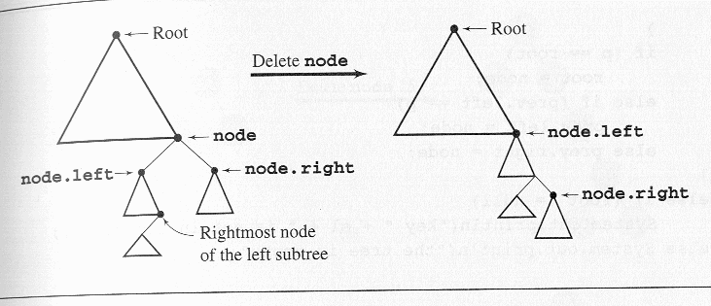

Figure 2 – Illustration of Deletion by Merging in a BST

Deletion by Copying

Deletion by copying was proposed by Thomas Hibbard and Donald Knuth. The justification for this technique is the deletion by merging technique may increase the height of the tree! In some cases the resulting tree may be highly unbalanced. Some cases may decrease the overall height of the tree. For our purposes here, this will not be a concern because we will rebalance the tree in any case. I’ll illustrate the technique of deletion by copying so that you will have it, but deletion by merging is easier to understand.

If the node has two children, it can be reduced to one of two simple cases: The node is a leaf or the node has only one nonempty child. This can be done by replacing the key being deleted with its immediate predecessor (or successor). As we mentioned in the previous technique of deleting by merging, a key’s predecessor is the key in the rightmost node in the left subtree (via symmetry, its immediate successor is the key in the leftmost node in the right subtree). First, the predecessor has to be located. This is again done by moving one step to the left by first reaching the root of the node’s left subtree and then moving as far to the right as possible. Next, the key of the located node replaces the key to be deleted. At this point is where one of the two simple cases comes into play. If the rightmost node is a leaf, the first case applies; however, if it has one child the second case will apply. In this way, deletion via copying removes a key k₁ by overwriting it with another key k₂ and then removing the node that holds k₂, whereas deletion by merging consisted of removing a key k₁ along with the node that holds it. Deletion by copying is shown graphically in the diagrams illustrated in Figure 3.

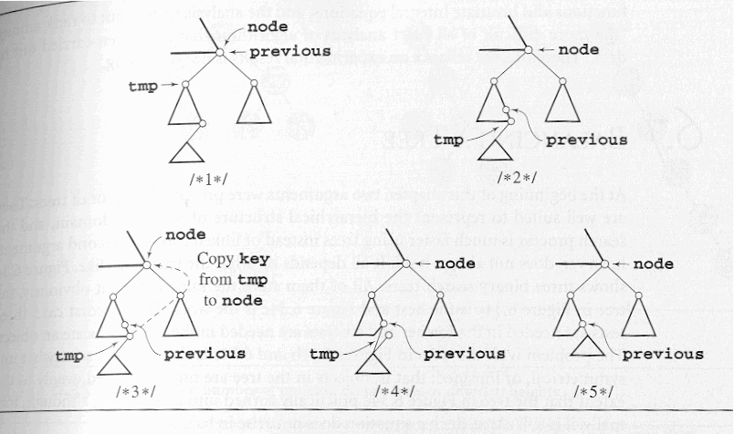

Figure 3 – Illustration of Deletion by Copying in a BST

DSW Algorithm

Recall that a binary tree is height-balanced or simply balanced if the difference in height of both subtrees of any node is either zero or one. A perfectly balanced tree is one in which all leaf nodes are found on one or two levels.
A binary tree is height-balanced (or simply balanced) if the difference in height of both subtrees of any node in the tree is either zero or one. A tree is said to be perfectly balanced if it is balanced and all of the leaves are found on one or two levels.

For example, a perfectly balanced binary tree consisting of 10,000 nodes, the height of this tree will be ⎡log(10,001)⎤ = ⎡13.289⎤ = 14. In practical terms, this means that if 10,000 elements are stored in a perfectly balanced tree, then at most 14 nodes will need to be checked to locate a specific element. This is a substantial difference when compared to the worst case of 10,000 elements in a list! Therefore, in trees which are to be used primarily for searching, it is worth the effort to either build the tree so that it is balanced or modify the existing tree so that it is balanced.

The DSW algorithm, developed by Colin Day and later improved by Quentin Stout and Bette Warren, is a very elegant algorithm which requires little additional storage to effect the balancing and does not require sorting the elements in the initial tree.

The basic building block for tree transformations in the DSW algorithm is the rotation. There are two types of rotations, left and right, which are symmetric to one another. The right rotation of the node Ch (for child) about its parent Par is performed according to the following algorithm:
rotateRight (Gr, Par, Ch)
if Par is not the root of the tree //i.e., if Gr is not null
grandparent Gr of child Ch becomes Ch’s parent by replacing Par;
right subtree of Ch becomes left subtree of Ch’s parent Par;
node Ch acquires Par as its right child;

A right rotation is shown graphically in Figure 4.

Gr
Par
Ch
R
P
Q
Gr
Ch
Par
R
P
Q

before rotation after rotation

Figure 4 – A Right Rotation

The heart of the right rotation is the third step in the algorithm, when Par, the parent of child Ch, becomes the child of Ch, i.e., when the roles of the parent and child interchange. Notice that this exchange of roles does not affect the principal property of the tree, namely, that it is still a BST. The first and second steps of the algorithm are required to ensure that after the rotation the BST property is preserved. The example in Figure 5 should clarify this property:

27
29
35
P
Q
R
27
35
29
R
P
Q

before rotation after rotation

Figure 5 – Example of Right Rotation

The basic operation of the DSW algorithm is to convert an arbitrary BST into a linked list-like structure called a backbone or vine. Then this elongated tree is transformed in a series of passes into a perfectly balanced tree by repeatedly rotating every second node of the backbone about its parent. In the first phase the backbone is created according to the following algorithm:

createBackbone (root, n)
tmp = root;
while (tmp != null)
if tmp has a left child
rotate this child about tmp; //the left child becomes the parent of tmp
set tmp to the child which just became the parent;
else set tmp to its right child;

This execution of this algorithm is shown in Figure 6.

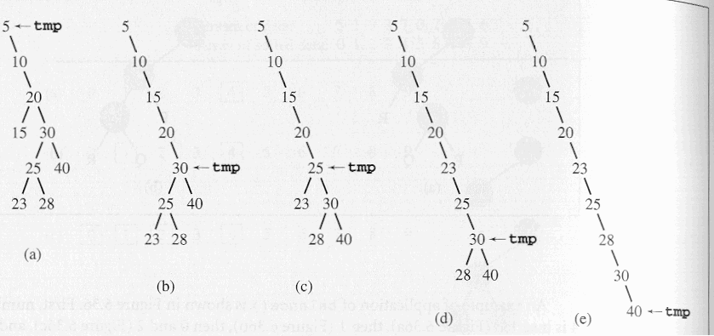

Figure 6 – Creation of a Backbone for the DSW Algorithm

Since the rotation requires knowledge about the parent of tmp, an additional reference must be maintained when the algorithm is implemented. In the best case, the tree is already a backbone and the while loop will execute n times and no rotation is performed. In the worst case, when the root does not have a right child, the while loop will be executed 2n-1 times and n-1 rotations will be performed, where n is the number of nodes in the tree. Thus, the run time of the first phase of the DSW algorithm is O(n).

In the second phase, the backbone is transformed into a tree, but this time the tree will be perfectly balanced by having leaves only on two adjacent levels. In each pass down the backbone, every second node is rotated about its parent. One such pass decreases the size of the backbone by one-half. Only the first pass may not reach the end of the backbone. It is used to account for the difference between the number n of nodes in the current tree and the number 2^{⎣lg(n+1)⎦}-1 of nodes in the closest complete binary tree. Thus, overflowing nodes are treated separately. The core of the DSW algorithm is given below:

createPerfectTree(n)
m = 2^{⎣lg(n+1)⎦} -1;
make n-m rotations starting from the top of the backbone;
while (m > 1)
m = m/2;
make m rotations starting from the top of the backbone;

Figure 7 illustrates this part of the DSW algorithm.

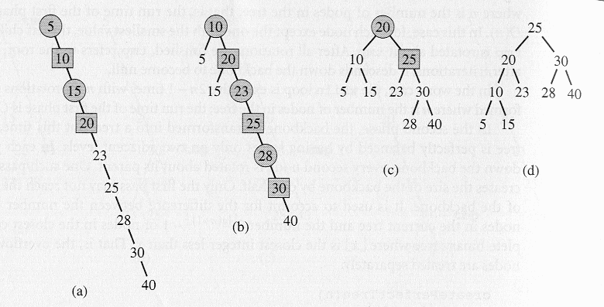

Figure 7 – Illustration of the DSW Algorithm

The example in Figure 7 starts with the backbone (a) generated in Figure 6. The first pass through the backbone to produce the backbone shown in (b). Now two passes are executed. In each backbone, the nodes to be promoted by one level by left rotations are shown as squares; their parents, about which they are rotated are shown as circles.

To compute the complexity of the tree building phase, note that the number of iterations performed by the while loop equals:

$$\left(2^{\text{lg}(m+1)−1}−1)+⋯+\text{15}+7+3+1\right)=\sum_{i=1}^{\text{lg}(m+1)−1}{(2^{i}}−1)=m−\text{lg}(m+1)$$
The number of rotations can now be given by the expression:
$$n−m+\left(m−\text{lg}(m+1))=n−\text{lg}(m+1\right)=n−\left\lfloor \text{lg}(n+1)\right\rfloor$$

Thus, the number of rotations is O(n). Because creating a backbone also required at most O(n) rotations, the cost of global rebalancing with the DSW algorithm is optimal in terms of time because it grows linearly with n and requires a very small and fixed amount of storage.

AVL Trees

The AVL tree (named after its discoverers, Adelson-Velskii and Landis, but originally called an admissible tree) was the first balanced binary search tree. Any search tree which is self-balancing must use balance conditions which are easy to maintain and ensure that the height of the tree is O(log n), where n is the number of nodes in the tree. The simplest idea is to require that the left and right subtrees have the same height. Using the recursive definition of the binary search tree implies that this condition be applied to all the nodes in the tree, since every node is considered the root of some subtree. While this simple requirement will ensure that the height of the tree is logarithmic in terms of n, it is too restrictive because inserting new key values while maintaining overall balance is too difficult (i.e., too costly in terms of time). Therefore, the definition of the AVL tree uses a slightly different interpretation of balance, one that is weaker than total balance between all left and right subtrees, yet is still strong enough to ensure logarithmic height of the tree.

An AVL tree is a binary search tree with the additional balance property that, for any node in the tree, the height of the left and right subtrees can differ by at most one.

Notice that the DSW algorithm balances trees using the same balancing condition that is employed by the AVL tree. However, an AVL tree is not necessarily perfectly balanced. All of the trees shown in the figure below are AVL trees:

-1
0
+1
0
-1
0
+1
-1
-1
0
+1
0
0

Examples of AVL Trees

In the example AVL trees above, the values shown in the nodes are called balancing factors. The balance factor of any node, represents the difference between the heights of its left and right subtrees. The balance factor is the height of the right subtree minus the height of the left subtree. Thus, for an AVL tree all of the balance factor should be +1, 0, or –1. Considering the tree shown in the middle above, the balance factor of the root is +1 since the height of the right subtree is 2 and the height of the left subtree is 1 and 2−1 = 1.

The definition of an AVL tree indicates that the minimum number of nodes in an AVL tree is defined by the recurrence equation:

${\text{AVL}}_{h}={\text{AVL}}_{h−1}+{\text{AVL}}_{h−2}+ 1$

where AVL₀ = 0 and AVL₁ = 1 are the initial conditions. Adel’son-Vel’skii and Landis have proven that this produces the following bounds on the height of an AVL tree depending upon the number of nodes n:

$\text{log}(n+1)≤h< 1\text{.}\text{44}\text{log}(n+2)−0\text{.}\text{328}$

Therefore, the height of the tree is bounded by O(log n) and the worst case search requires O(log n) comparisons. Notice that for a perfectly balanced tree of the same height $h=\left\lceil \text{log}(n+1)\right\rceil$. Therefore, the search time in the worst case in an AVL tree is 44% worse (it requires 44% more comparisons) than in the best case tree configuration. Donald Knuth has shown through empirical results that the average case number of comparisons is much closer to the best case than to the worst case and is equal to log n+0.25 for large n. This is why AVL trees are so important for searching applications, they have a logarithmic time bound on the search and are self-balancing.

If the balance factor of any node in an AVL tree becomes less than –1 or greater than +1, then the tree must be balanced.

Insertion

An AVL tree can become unbalanced in one of four ways, two of which are symmetric to each other and thus, we need to consider only two different situations. These two cases are:

- The result of inserting a node in the right subtree of the right child of a node.
- The result of inserting a node in the left subtree of the right child.

The first case is the simpler of the two and we will consider it first. Figure 8 illustrates the technique.
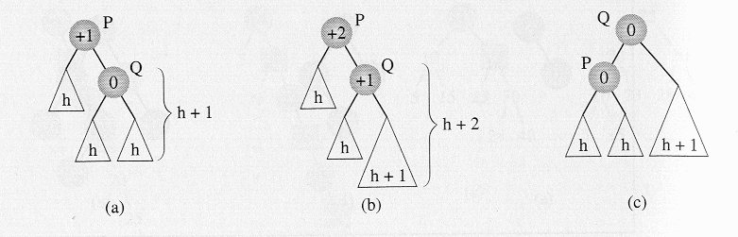
Figure 8 – Illustration of Insertion in an AVL Tree – Case 1

In (a) a new node is inserted somewhere in the right subtree of node Q, this causes an imbalance in the tree rooted at P since the balance factor in P is now greater than 1. The solution is to rotate node Q about its parent P which is shown in (c). Having done this the balance factor of both P and Q become 0, which is even better than the original tree!

The second case, the result of inserting a new node in the left subtree of the right child, is illustrated in Figure 9.

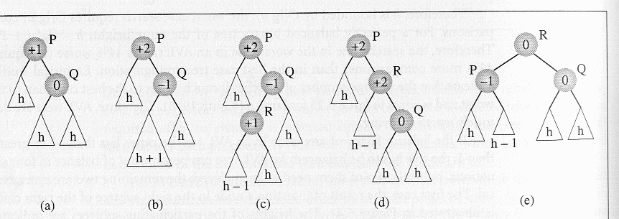

Figure 9 – Illustration of Insertion in an AVL Tree – Case 2

In (a) a new node is inserted somewhere in the left subtree of Q which creates an imbalance in the tree at node P shown in (b) and in more detail in (c). The solution to this problem is a double rotation, the first by rotating R about Q as shown in (d) and then by rotating R about P as shown in (e).

Both of the cases illustrated use a stand-alone tree to illustrate the technique of the rotation, however, the tree rooted at P can be part of a larger AVL tree. If P itself is the child of some node (it is not the root of the entire tree), the question arises, will additional work be required to adjust the balance of P’s predecessors? The answer is no. Considering the two examples above, note that the heights of the two trees which result at the end of the rotations are the same as the heights of the trees before the insertion occurred. This means that the balance factor of the parent of the new root (Q in the first case and R in the second case) remain the same as they were before the insertion, and the changes which occur to subtree P are sufficient to restore the balance of the entire AVL tree.

The problem is in finding a node P for which the balance factor becomes unacceptable after a node has been inserted into the tree. This node can be detected by moving up toward the root of the tree from the position in which the new node was inserted and updating all of the balance factors of the nodes which are encountered. Then, if a node with a ±1 balance factor is encountered, the balance factor is changed to ±2, and the first node whose balance factor is changed in this manner becomes the root P of a subtree for which the balance has to be restored. Note that the balance factors above this node will not require resetting using the argument we just presented.

Shown below are a couple of examples of AVL trees and the rotations which are required to rebalance the tree upon the insertion of a new node.

Example 1
1. An initial AVL tree
30
20
50
10
26
40
70
23
28
45
90

initial AVL tree – shown with data values

0
+1
0
0
0
+1
+1
0
0
0
0

initial AVL tree – shown with balance factors

2. An insertion occurs in the left subtree of the right child of node 26 (case 2)
30
20
50
10
26
40
70
23
28
45
90
27

0
+2
0
0
+1
+1
+1
0
-1
0
0
0

3. The subtree rooted at node 20 must be singly rotated to restore balance.
30
26
50
20
28
40
70
45
90
27
10
23

final AVL tree showing data values

0
0
0
0
-1
+1
+1
0
0
0
0
0

final AVL tree showing balance factors

Example 2
30
20
50
10
26
40
70
23
28
45
90

1. An initial AVL tree

initial AVL tree – shown with data values

0
+1
0
0
0
+1
+1
0
0
0
0

initial AVL tree – shown with balance factors

2. An insertion occurs in the right subtree of the right child of node 26 (case 1)
30
20
50
10
26
40
70
23
28
45
90
29

0
+2
0
0
+1
+1
+1
0
+1
0
0
0

3. The subtree rooted at node 20 must be singly rotated to restore balance.
30
26
50
20
28
40
70
10
29
45
90
23

final AVL tree showing data values
0
0
0
0
+1
+1
+1
0
0
0
0
0

final AVL tree showing balance factors
It is possible that the insertion of a new node into an AVL tree will not require a rotation as the new tree may remain balanced. If the balance factors from the newly inserted node up to the root of the tree are all zero, the balance factors will need to be updated from the insertion point up to the root of the tree, but no rotation will need to be performed. This situation is illustrated in the following example:
0
0
0
+1
0
+1
+1
0
0
0
0
0

Initial AVL tree

0
0
0
+1
0
+1
+1
0
0
0
0
0
0

Nodes along the indicated path must all have balance factors reset

−1

+1
0

+1
−1
+1
+1

0
0
0
0
+1

0

Nodes along the path with reset balance factors

Deletion

Deletion may be a more time-consuming task that insertion in an AVL tree. Typically, an algorithm such as deletion-via-copying or deletion-via-merging is used to reduce the problem of deleting a node with two descendants to the problem of deleting a node with at most one descendant. After a node has been deleted from the tree balance factors must be updated from the parent of the deleted node up to the root of the tree. For each node in this path whose balance factor becomes ±2, a single or double rotation must be performed to restore the balance of that subtree. Notice that the rebalancing does not stop at the first node P for which the balance factor has become ±2, as in the case with insertion! This means that deletion has the potential for requiring, at most O(log n) rotations, since in the worst case, every node along the path from the parent of the deleted node to the root will require rebalancing!

Deletion of a node does not necessitate an immediate rotation because it may actually improve the balance factor of its parent, by changing its parent’s balancing factor from ±1 to 0. However, it may worsen the balancing factor of its grandparent, by changing it from a ±1 to a ±2. For the sake of brevity, we’ll consider only those cases where the deletion requires an immediate rotation. There are four such cases (plus four symmetric ones). These cases are all shown in Figure 10.

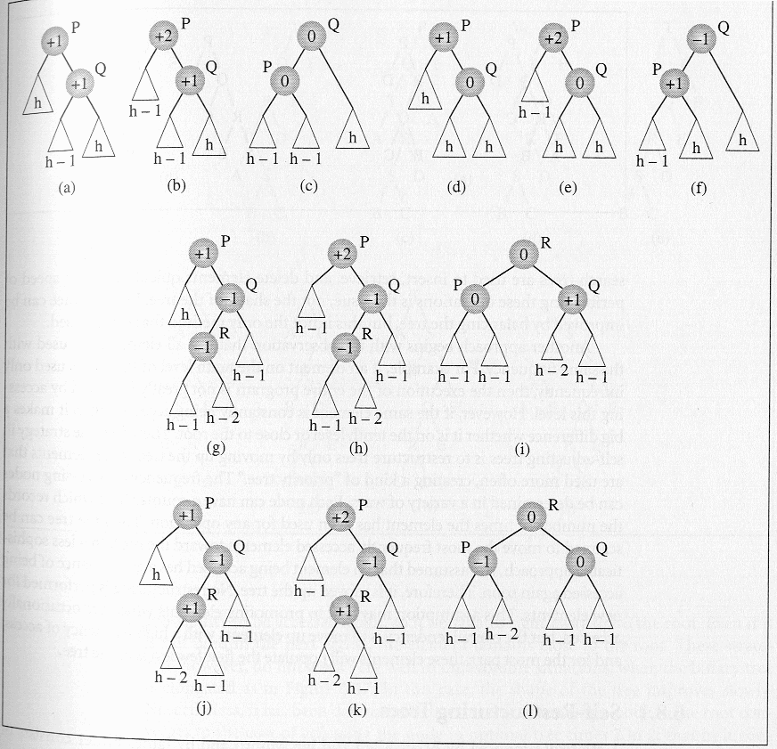

Figure 10 – Deletion in an AVL Tree

The first case of deletion is represented in (a) which after the deletion (which occurs in the left subtree of the right child of P) turns into the tree in (b). The tree is rebalanced by rotating Q about P which gives the final tree (c) for the first case.

The second case of deletion is represented in (d) in which node P has a balance factor of +1, and its right subtree Q has a balance factor equal to 0. After the deletion of a node in the left subtree of P, shown in (e), the tree is rebalanced using exactly the same rotation as in the first case to produce the tree shown in (f).
Notice that cases 1 and 2 can be processed together in an implementation after checking that the balance factor of Q is +1 or 0.

When Q is –1, the other two cases for deletion occur which are both more complicated than the first two.
In the third case, the left subtree R of Q has a balance factor equal to –1 as shown in (g). To rebalance the tree, first R is rotated about Q (h) and then about P (i).

The fourth case differs from the third case only in that R’s balance factor is +1, as in (j), in which case the same two rotations are performed in order to restore the balance factor of P (shown in (k) and (l)). As before, cases three and four can be processed together based only upon a check of the balance factor associated with node R.

Final Comments On AVL Trees

Insertions and deletions in an AVL tree require at most 1.44 log(n+2) comparisons. Insertion can require either one single rotation or one double rotation, and deletion can require 1.44 log(n+2) rotations, in the worst case. However, as mentioned earlier, the average case requires log(n) + 0.25 comparisons, which reduces the number of rotations in the case of deletions to this number. In the average case, insertion may lead to one single/one double rotation. Empirical results, based primarily upon simulations, have indicated that deletions in 78% of the cases will not require a rebalancing at all! On the other hand, only 53% of the insertions do not force the tree out of balance. Therefore, the more time-consuming deletion operation occurs less frequently than the insertion operation, which does not unduly limit the efficiency of rebalancing AVL trees.

AVL trees can be extended by allowing the differences in heights, Δ, of subtrees to be greater than 1. For example, you can allow subtrees to become more and more unbalanced by allowing a greater height differential between the left and right subtrees. Not unexpectedly, the worst-case height increases as Δ increases. Again empirical results indicate the following trend:

$h=\begin{aligned}\left\{1\text{.}\text{81} \text{log}(n)−0\text{.}\text{71} \text{if} Δ=2 | \right.\end{aligned}$

As the experimental evidence indicates, the average number of visited nodes increases by one-half in comparison to pure AVL trees (Δ = 1), but the amount of restructuring required can be decreased by a factor of 10!

