COP 3502 – Lab Notes

Tree Traversals and BSTs

This lab is designed to give you some practice with binary tree traversal algorithms and binary search trees. The last question is from a previous foundation exam.

Binary Tree Traversals
a
b
c

Preorder

a b c

Postorder
b c a

Inorder
b a c

a
b
c
d
e
f
g
h
i
j

Preorder
a b d g h e i c f j

Postorder

g h d i e b j f c a

Inorder
g d h b e i a f j c

Do a Preorder, Postorder and Inorder traversal of this tree.

+
a
b
-
c
d
+
e
f
*
/

Preorder traversal: / * + a b - c d + e f

Postorder traversal: a b + c d - * e f + /

Inorder traversal: a + b * c – d / e + f
Binary Tree Traversal Algorithms

Preorder (Depth-First Search)
void preorder(struct treeNode * p)
{ if (p !=NULL)
{
printf(“%d\n”, p->data);
preorder(p->left_child);
preorder(p->right_child);
}
}
Inorder
void inorder(struct treeNode *p)
{ if (p !=NULL)
{
inorder(p->left_child);
printf(“%d\n”, p->data);
inorder(p->right_child);
}
}
Postorder
void postorder(struct treeNode *p)
{ if (p !=NULL)
{
postorder(p->left_child);
postorder(p->right_child);
printf(“%d\n”, p->data);
}
}

Binary Search Trees

Binary search tree is a binary tree that is either empty or in
which each node contains a data value that satisfies the
following:

a) all data values in the left subtree are smaller than the
data value in the root.

b) the data value in the root is smaller than all values in
its right subtree.

c) the left and right subtrees are also binary search tees.
This structure allows us to quickly search for a particular value.

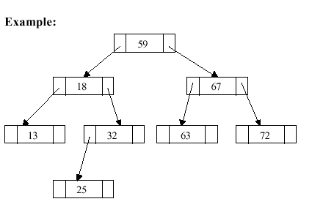

Question from a previous Foundation Exam

Given the following Binary Tree, answer the questions below :
24
14
30
34
38
32
28
20
26
22

a) Is this a valid Binary Search Tree? (circle one YES NO

b) List the nodes of this tree in the order that they are visited in a preorder traversal:

24 | 14 | 20 | 22 | 26 | 30 | 28 | 34 | 32 | 38
first node last node
visited visited

c) Perform the following procedure on the tree above, listing the output in the spaces below and leaving any unused spaces blank. Assume that the procedure is initially called with: P6(root, 30) and that the tree nodes and pointers are defined as:

struct treeNode{
int data;
struct tree_node *left, *right;
}
struct tree_node *tree_ptr;

void P6(struct tree_ptr *node_ptr, int key)
{
if (node_ptr != NULL)
{
P6(node_ptr->right, (key – 5));
P6(node_ptr->left, (key + 5));
if (node_ptr->data < key)
printf(“%d ”,node_ptr->data);
}
}

ANSWER
28
22
20
14
24

