CNT 4714 – Programming Assignment #5 – Summer 2014

Title: “Program Assignment 5: Developing A Three-Tier Distributed Web-Based Application Using PHP and Apache”
Points: 100 points (110 points with the bonus problem completed)
Due Date: Wednesday July 30, 2014 by 11:59 pm (WebCourses time) – NO EXTENSIONS ! ! !

Objectives: To incorporate many of the techniques you’ve learned this semester into a distributed web-based application which uses PHP running on an Apache server to access and maintain a persistent MySQL database.

Description: In this assignment you will utilize the suppliers/parts/jobs/shipments database that was developed for assignment #4 (although we’ll use a new script and create another version of this database for this project) and access this database through a client front-end. The first-tier (client-level front-end) of your application will be a simple HTML page that allows the client to enter SQL commands into a window and submit them to the database for processing. Note that the client front-end must provide for the login of the user so that any of our clients (see below) can login to the database to execute operations. The client front-end will provide the user the option of querying the database or updating the database (see programs 3, and 4). The client front-end will run on any web-based browser that you would like to use. The second-tier will use PHP technology to extract values from the client-side form and submit the SQL command to the MySQL database server for processing. The results returned by the MySQL database will be formatted by PHP into an HTML document to be displayed in the user’s browser. We’ll implement the same business logic in this assignment that we used in Program 5 and increment the status of any supplier by 5 anytime any shipment in which the quantity is greater than or equal to 100 is entered into the database through insertion or update. Note that any update of quantity >= 100 will affect any supplier involved in a shipment with a quantity >= 100. The example screen shots illustrate this case. An insert of a shipment tuple (S5, P6, J7, 400) will cause the status of every supplier who has a shipment with a quantity of 100 or greater to be increased by 5. In other words, even if a supplier’s shipment is not directly affected by the update, their status will be affected if they have any shipment with quantity >= 100. (You can also employ the business logic used in the bonus problem of Assignment #4 if you choose for a 10 point bonus for this assignment.) The business logic of the second tier will reside on the Apache web-application server (server-side application in PHP). The third-tier (back-end) is the persistent MySQL database and is under control of the MySQL server.

We will assume that the front-end will allow any client to connect to the database, so like Program 4, you must provide the user the ability to enter login credentials on the initial screen (see screen shots below). Once a user has logged into the system, your main page should show the name of the currently logged in user and provide them the ability to logout (disconnect). The initial screen (application home page, should explain a bit about the application and explain the user login procedure. Once a user has logged into the system, the main application page should appear which provides the user the ability to issue SQL commands against the database. While your application screens do not need to look exactly like mine, they must provide the same functionality including the ability to submit both queries and updates, clear result windows, and login and logout of the system.

References:
Notes: Lecture Notes for MySQL Documentation for MySQL available at: http://www.mysql.com. Lecture Notes for PHP. Assignments 3, and 4.

Restrictions:
Your source file shall begin with comments containing the following information:
/* Name:
Course: CNT 4714 – Summer 2014
Assignment title: A Three-Tier Distributed Web-Based Application Using PHP and Apache
Date: July 30, 2014
*/

Input Specification: The same suppliers/parts database that was developed in program 4 is the back-end to this application, although I’ve created a new script and named this database project5. All other input comes from the front-end client form submitted to the application server and processed by PHP entered as either queries or updates to this database.

The first step in this assignment is to login as the root user and execute/run the script to create and populate the backend database. This script is available on the course assignment page and is named “prog5dbscript.sql”. This script creates a database named project5. You can use the MySQL Workbench for this step, or the command line whichever you prefer.

The second step is to create authorizations for two client users (in addition to the root user) named client1 and client2. By default your root user has all permissions on the project5 database. Use either SQL Grant statements from the command line or the MySQL Workbench (see separate document for details on how to accomplish this task) to check and set permissions for the clients as follows:

Register the new user named client1 (assign them an easy to remember password – ignore the MySQL warning on weak password setting) and assign to this user only selection and insertion privileges on the project5 schema. Next, register the new user named client2 and assign to this user only selection and update privileges on the project5 schema.

Output Specification: All output is generated by the MySQL server, formatted by the PHP server-side application and should be processed into an HTML table or text (error pages) and returned by PHP to the user’s browser as a text/html page. Output will be generated for three different users, the root user, client1, and client2.

Deliverables:
- Submit a working copy of your source code via WebCourses no later than 11:59pm Wednesday July 30, 2014. Include all of files that you generated to handle this application. I did my version of this project using one script file, but there are many different ways you could organize things, just be sure to include all your relevant files.
- Screen shots showing the output for each user. There will be a total of 28 different screen shots. Divide them up into three different files, one file for the root user (8 screen shots), one file for client1 (10 screen shots), and one file for client 2 (10 screen shots).

Additional Information:

Remember that your PHP scripts belong in the htdocs directory under the Apache server. See the course notes on setting up Apache and PHP for the details.

Some screen shots illustrating the application are shown on the next few pages. Except for the user interface, the output screen shots of this application will look pretty similar to that from Program 4 so I did not repeat all of the variances that I illustrated in that assignment document. You may want to look over Program 4 again if you’ve forgotten what some of the output should look like.

The due date is firm on this one as I can grant no extensions so that Ana can get all the programs graded before final grades will be due. Submit whatever you’ve completed by the due date in order to receive credit for this assignment.

Screen Shots Illustrating the Application:

Main client login screen (initial application page):
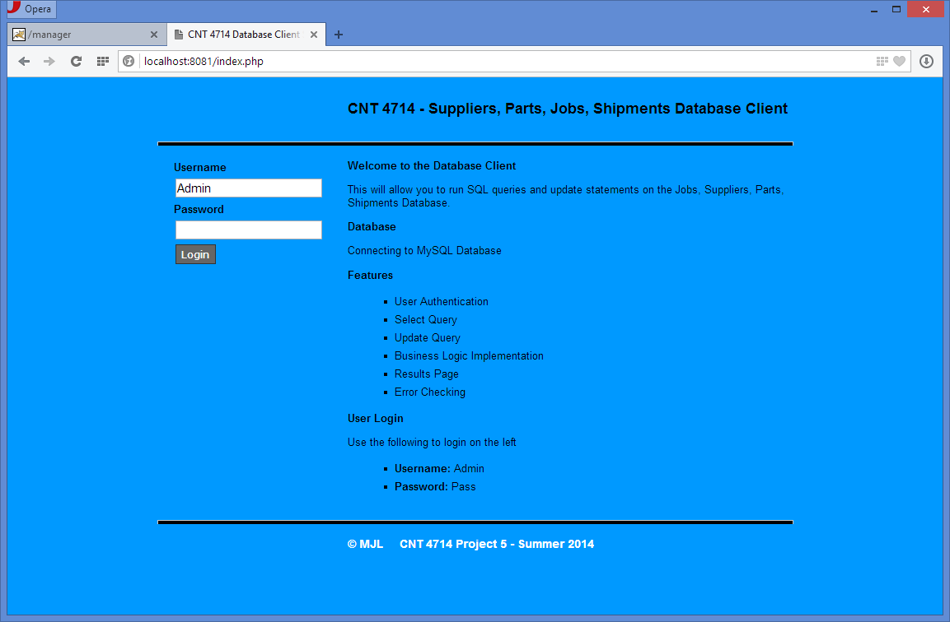

\
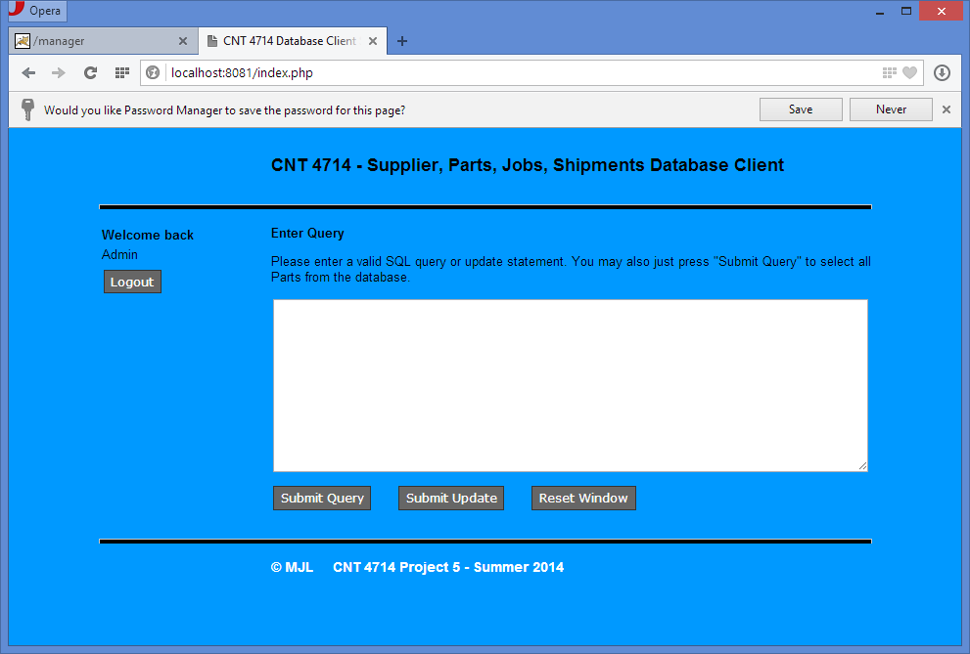
Page after the client logs in:

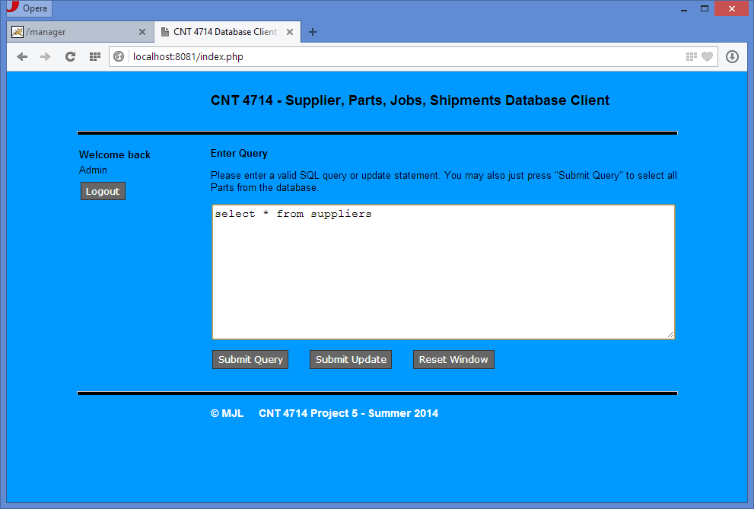
Client enters a query expression:

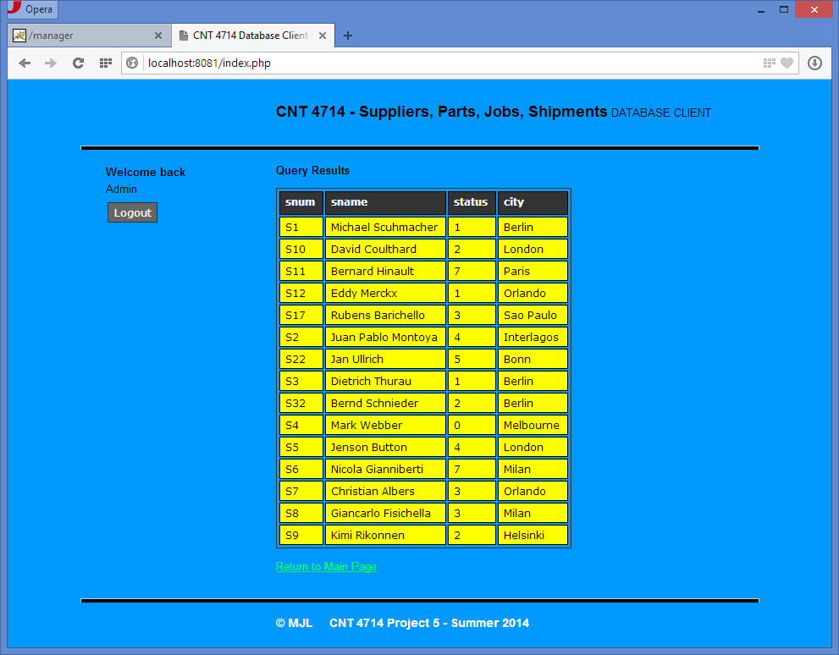
Display of query results to the client:

Client enters an invalid query:
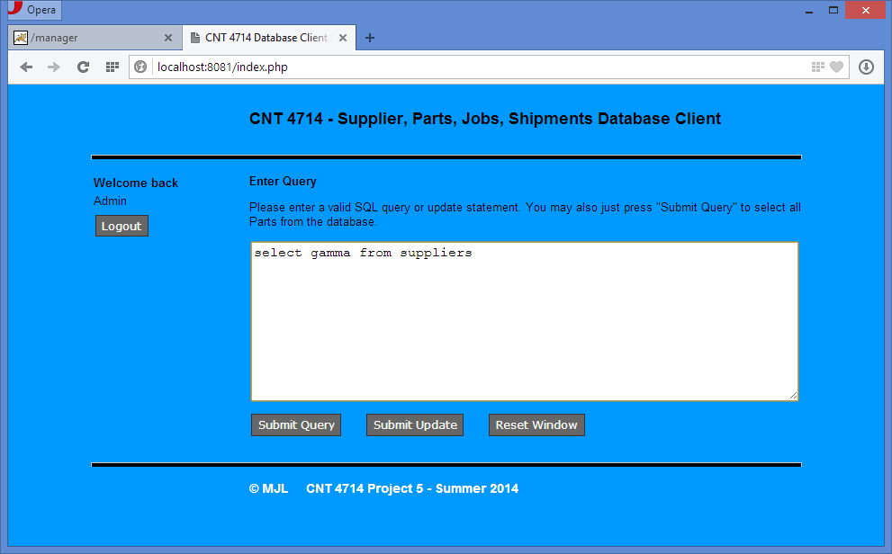

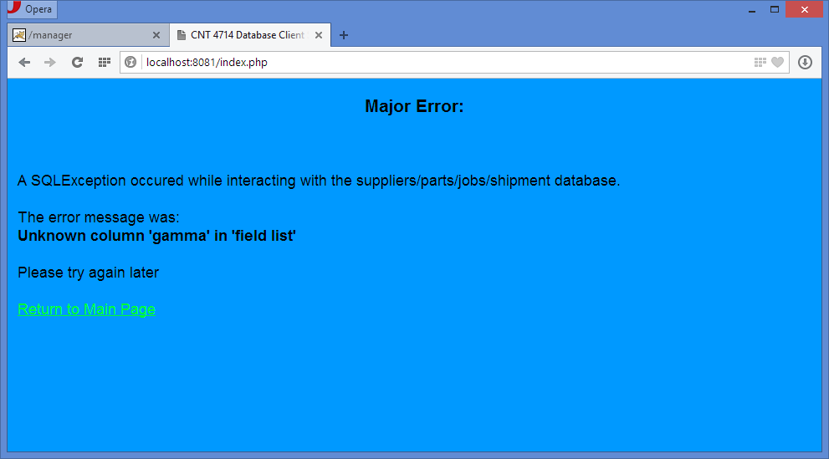
Error reporting screen illustrating return of MySQL error message to client:
This is a MySQL error message returned here.

Initial Suppliers table:
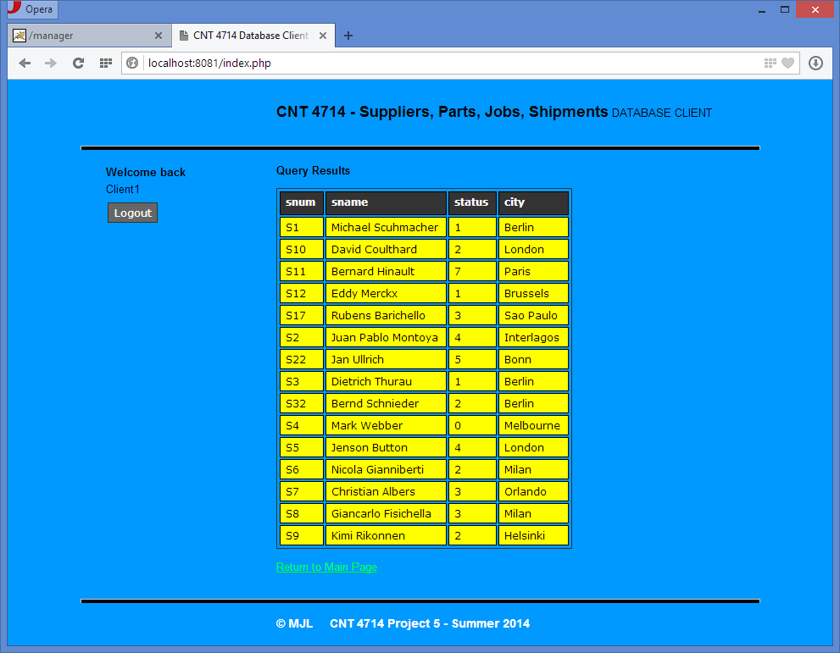

Client issues update: insert into shipments values (“S4”,’P2”,”J3”, 400)
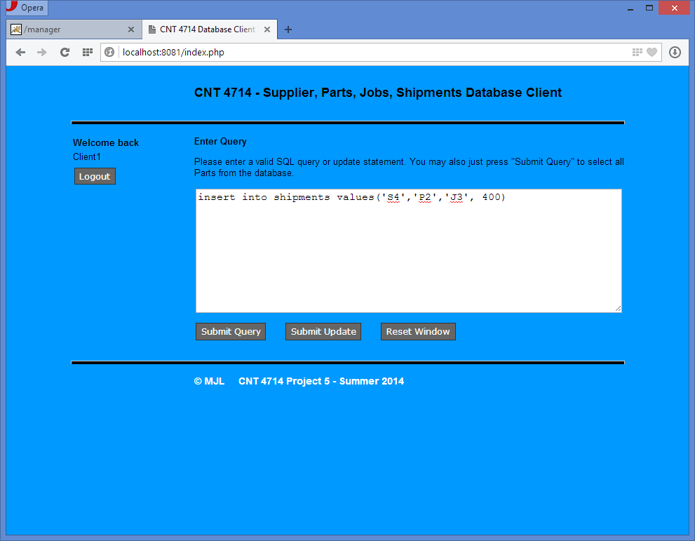

Client is notified that business logic was activated:

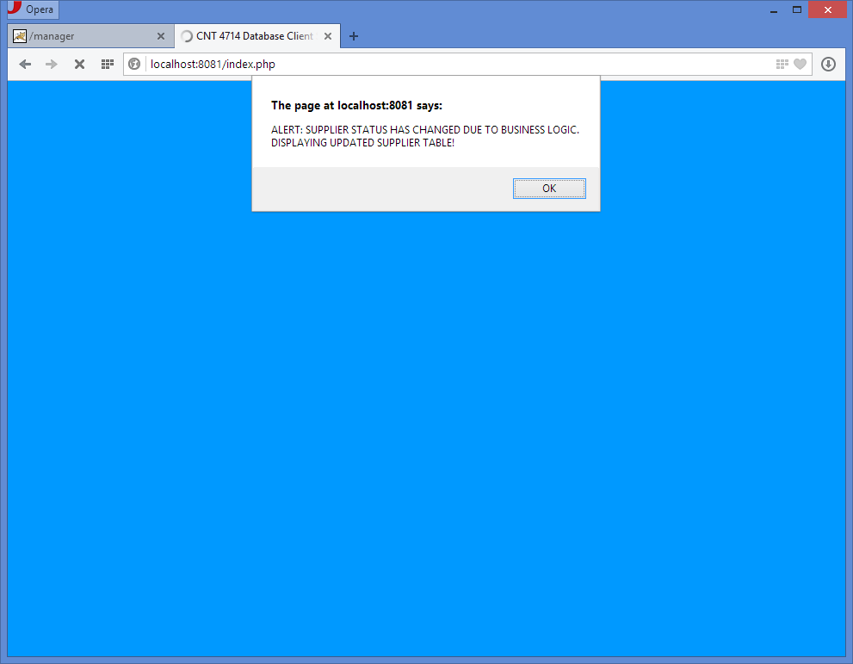
This was generated by a simple html file that executes a basic JavaScript command. I’ve placed my version of this on the course assignment page if you want to use it, but feel free to develop your own.

Automatically generated query of “SELECT * FROM suppliers” to illustrate the effects of the business logic being triggered by the previous update (note that this is distinguished from a normal query by the header that indicates this is an insert query result – meaning triggered by the business logic rather than
a direct user query):
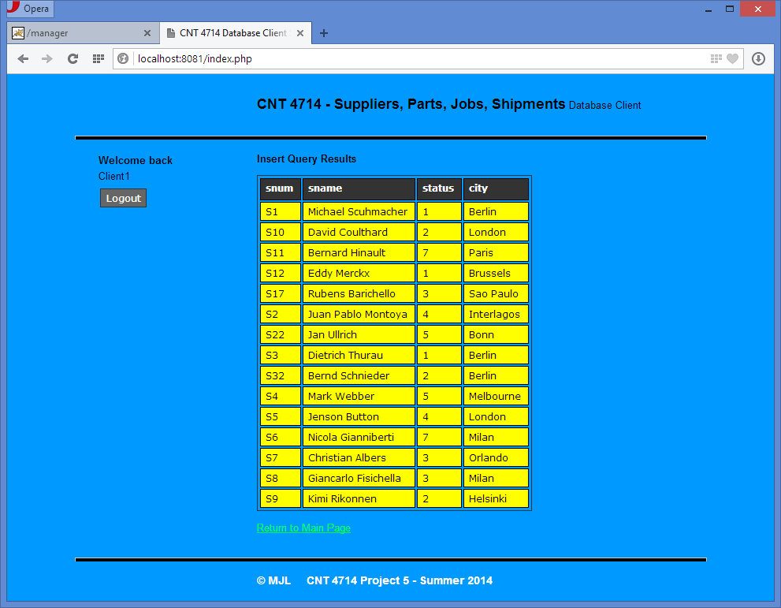

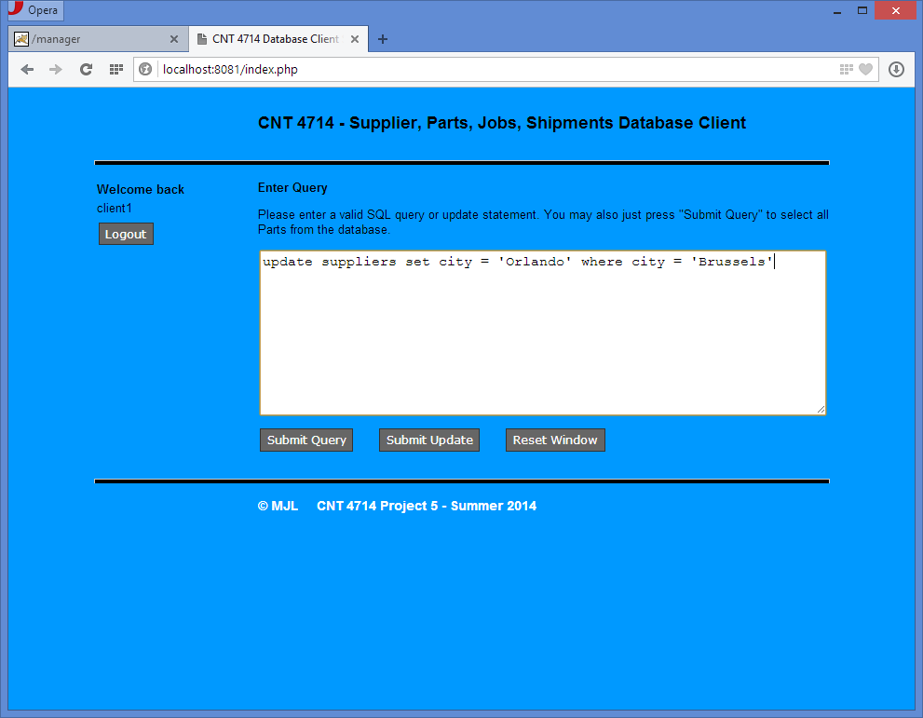
Login by client1, who attempts to enter an update command:

MySQL returns the error that you saw in the Workbench version when a privilege was not granted.

