CNT 4714 – Programming Assignment #4 – Summer 2014

Title: “Program Assignment 4: Developing A Three-Tier Distributed Web-Based Application”
Points: 100 points (bonus problem potentially adds 15 points – see page 8.)
Due Date: Friday July 11, 2014 by 11:59 pm (WebCourses time)

Objectives: To incorporate many of the techniques you’ve learned so far this semester into a distributed three-tier web-based application which uses servlets running on a Tomcat server to access and maintain a persistent MySQL database using JDBC.

Description: In this assignment you will utilize a suppliers/parts/jobs/shipments database (creation/population script available on the course assignment page) as the back-end database. Front-end access to this database by the client will occur through a simple page displayed in the client’s web browser. The schema of this database consists of four tables with the following schemas for each table:

suppliers (snum, sname, status, city) //information about suppliers
parts (pnum, pname, color, weight, city) //information about parts
jobs (jnum, jname, numworkers, city) //information about jobs
shipments (snum, pnum, jnum, quantity) //suppliers ship parts to jobs in specific quantities

The first-tier (client-level front-end) of your application will be a simple HTML page that allows the client to enter SQL commands into a window (i.e. a form) and submit them to the server application for processing. The front-end (and only the front-end) can utilize JSP technology if you wish. The client front-end will provide the user a simple form in which they will enter a SQL command (any DML, DDL, or DCL command could be entered by the user). The front-end will provide only two buttons for the user, and Execute button that will cause the execution of the SQL command they enter, and a Reset button that simply clears any content in the form input area. The client front-end will run on any web-based browser that you would like to use. You can elect to have a default query or not, it is entirely your decision.

The second-tier servlet, in addition to handling the SQL command interface will also implement the business/application logic. This logic will increment by 5, the status of a supplier anytime that supplier is involved in the insertion/update of a shipment record in which the quantity is greater than or equal to 100. Note that any update of quantity >= 100 will affect any supplier involved in a shipment with a quantity >= 100. The example screen shots illustrate this case. An insert of a shipment tuple (S5, P6, J7, 400) will cause the status of every supplier who has a shipment with a quantity of 100 or greater to be increased by 5. In other words, even if a supplier’s shipment is not directly affected by the update, their status will be affected if they have any shipment with quantity >= 100. (See page 8 for a bonus problem that implements a modified version of this business rule.) The business logic of the second tier will reside in the servlet on the Tomcat web-application server (server-side application). This means that the business logic is not to be implemented in the DBMS via a trigger.

The third-tier (back-end) is the persistent MySQL database described above and is under control of the MySQL DBMS server. All you need to do with the database is run the creation/population script. See the important note below concerning when/how to re-run this script for your final submission.

References:
Notes: Lecture Notes for MySQL installation and use. Documentation for MySQL available at: http://www.mysql.com. More information on JDBC can be found at: http://docs.oracle.com/javase/6/docs/technotes/guides/jdbc/. More information on Tomcat can be found at http://tomcat.apache.org. Lecture Notes for Servlets. Lecture Notes for JSPs.

Restrictions:
Your source file shall begin with comments containing the following information:
/* Name:
Course: CNT 4714 – Summer 2014 – Project Four
Assignment title: Developing A Three-Tier Distributed Web-Based Application
Date: July 11, 2014
*/
Input Specification: The suppliers/part/jobs/shipments database that is created/populated by the script project4dbscript.sql, is the back-end to this application. All other input comes from the front-end client submitted to the application server based servlet entered as either queries or updates to this database. The set of commands that you are to execute against this database are included in the project5commands.sql file available on the course homework page. I do not expect your front-end to execute the script. You’ll need to execute the commands in this script one at a time in your application (copy and paste!). I’ve put them into a script file for convenience and so that you can run the script in the MySQL Workbench if you’d like to compare/see the result sets for each user command.

Output Specification: All output is generated by the servlet and should appear in the user’s browser as a text/html page presented to the user. IMPORTANT: Be sure to re-run the project4 database creation/population script before you begin creating your screen shots for submission. By doing so you will ensure that the database is in its initial state so that all update operations will produce the values we are expecting to see in your result outputs.

Deliverables:
- You should submit your entire webapps folder from Tomcat for this program. If you submit the entire folder, then all of the files necessary to execute your web application will be included with the directory structure intact. Submit this via WebCourses no later than 11:59pm Friday July 11, 2014.
- The following 11 screen shots must be submitted along with your webapps folder. (You can include the screenshots in the top-level of your webapps folder if you’d like, just be sure to include a note that you’ve done so.)
  - Command 1
  - Command 2
  - Command 3A
  - Command 3B – output may vary here
  - Command 3C
  - Command 4A – output may vary here
  - Command 4B
  - Command 4C – output may vary here
  - Command 4D
  - Command 5
  - Command 6

Additional Information:
Be very careful when setting up the directory structures required for the web applications running under your server (Tomcat 7.0.52 or later). See the course notes on servlets for the exact directory structure that must be developed.

Important: Please name your webapp: Project4. Let the Ana (the TA) know if you are doing the bonus problem by attaching a note to your WebCourses submission.

Some screen shots illustrating the application.

Main client screen (initial configuration using a default query string):

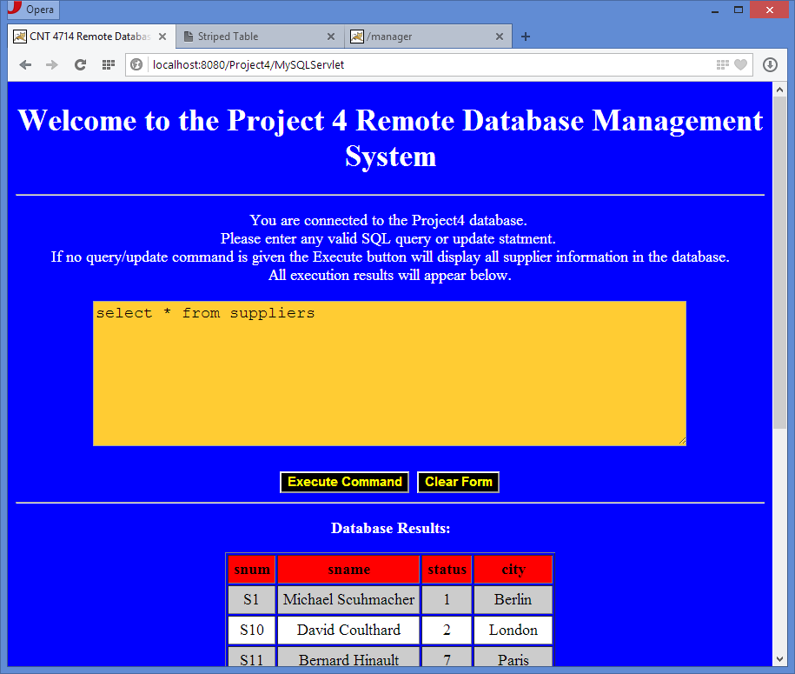
User input area.
Two form buttons
All results returned in this area.

Client simply clicks the “Execute Command” button and the SQL command in the form is executed:
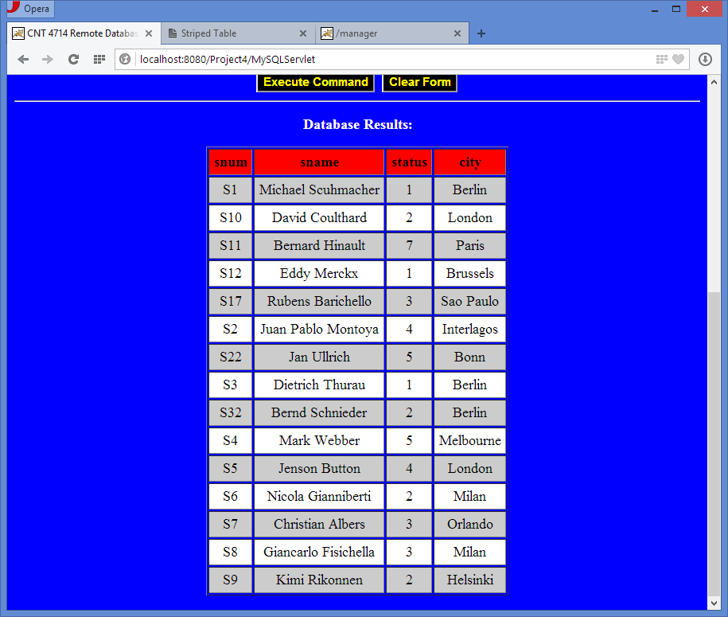
Results from running the query “select * from suppliers” – to be used to illustrate an update operation explained on pages 6-8. Notice that the supplier S5’s status is currently 4.

Client makes a mistake typing a query:

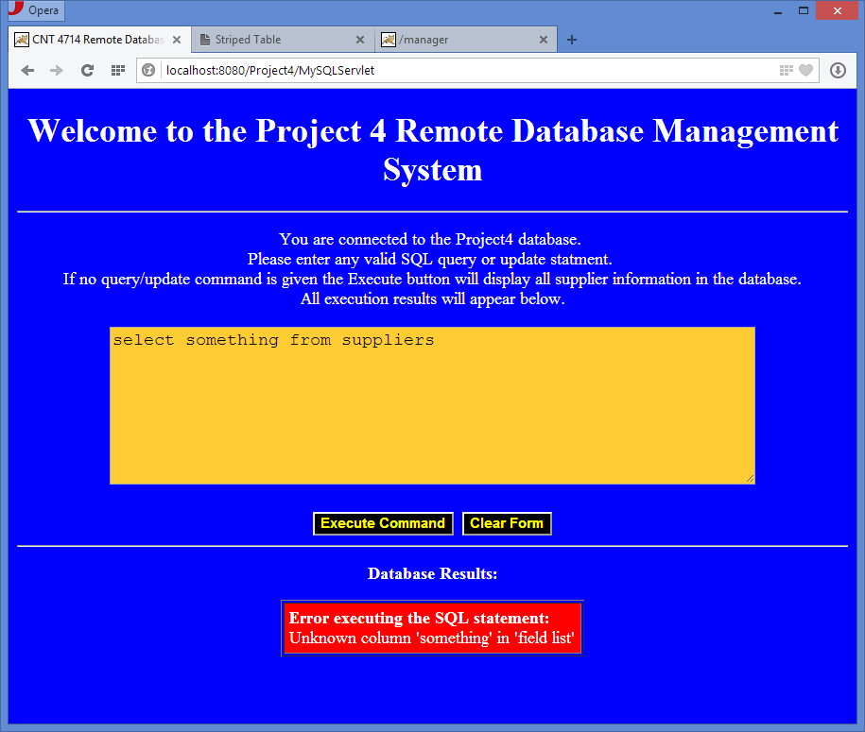
There is no column named something in the shipments table.

Error message is returned from MySQL indicating the problem with the operation.

Inserts and updates may cause changes to the supplier status field (business logic is triggered) as shown below:

Client issues the following insert command.

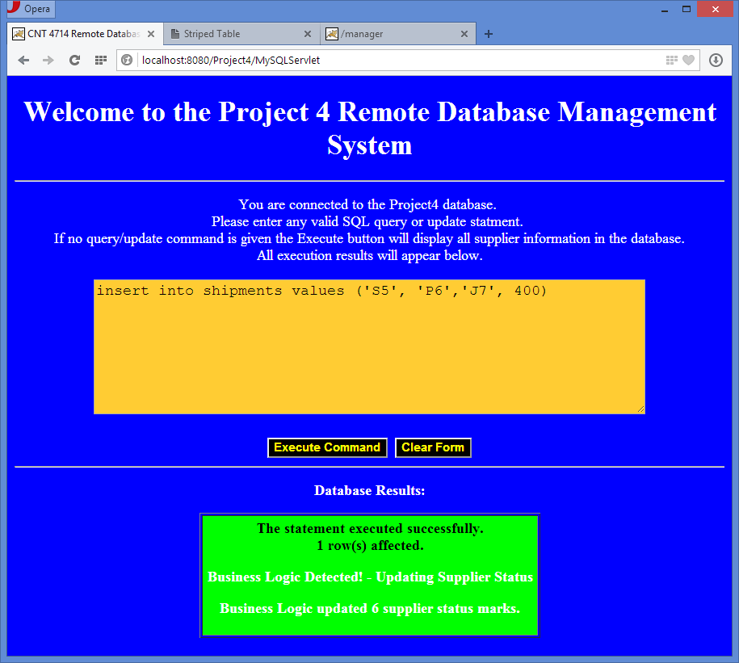

Alert message when an update to the quantity field in the shipments table has caused an update of a supplier’s status in the supplier table. Note that in my application, I used this alert message any time the business logic was tested even if it did not trigger any updates. This means that this message would appear with different values even if no rows are updated.

After executing update command (the previous insert), client runs select * from suppliers.
Notice on page 4 (in the original suppliers table) that supplier S5 had a status of 4. After this update, the business logic has increased supplier S5’s status by 5, so it is now 9.

Notice too, that suppliers S1, S2, S6, S22, and S3) also had their status increased by 5, since they were involved with a shipment in which the quantity was >= 100 when the insert command was issued. See bonus problem below for a “fix”.
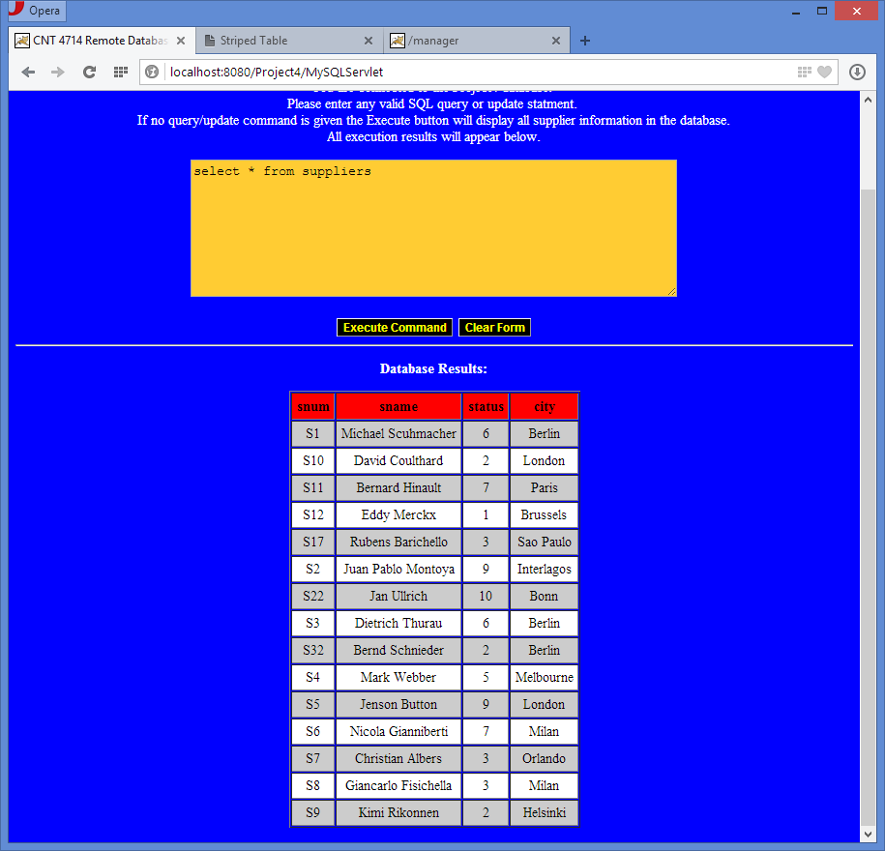

BONUS PROBLEM: 15 points

Instead of allowing any update/insert of a quantity >= 100 to affect any supplier with a shipment involving a quantity >= 100, adjust the business logic portion of your application so that an insert/update of a quantity greater than 100, causes a change to the status of only those suppliers affected by the update. For example, using the case shown above, when inserting the row (S5, P6, J7, 400) into the shipments table, only the status of supplier S5 should be increased by 5 (see screen shot below). However, an update such as: UPDATE shipments SET quantity = quantity + 50 WHERE pnum = “P3”, would increase by 5 the status of every supplier who ships part P3 in a quantity >= 100 after the update has been issued.

NOTE: If you elect to do the bonus problem, submit only this version of your application. Do not also submit the non-bonus problem version. Let Ana (the TA) know if you’ve elected to do the bonus problem or not.

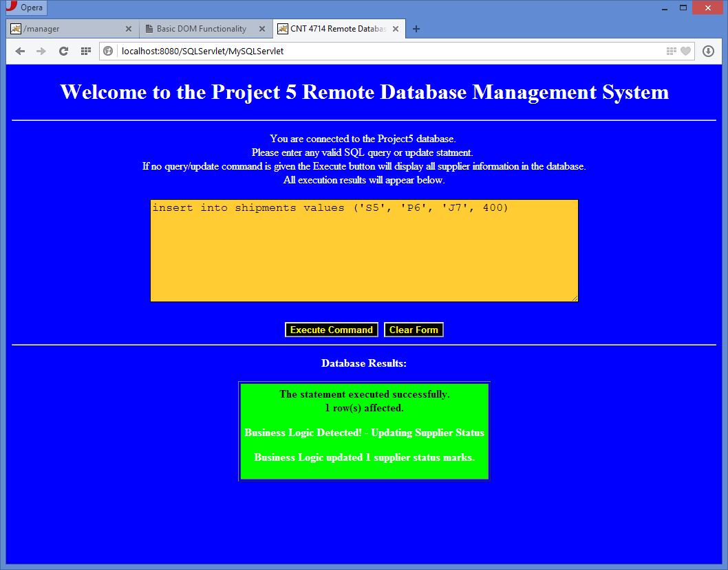

No changes here this time
Only supplier S5 had a change of status due to the insertion of the row (S5, P6, J7, 400) as they were the only supplier affected by this update.

Immediately after issuing the update (insert above), the user reruns the select * from suppliers query:

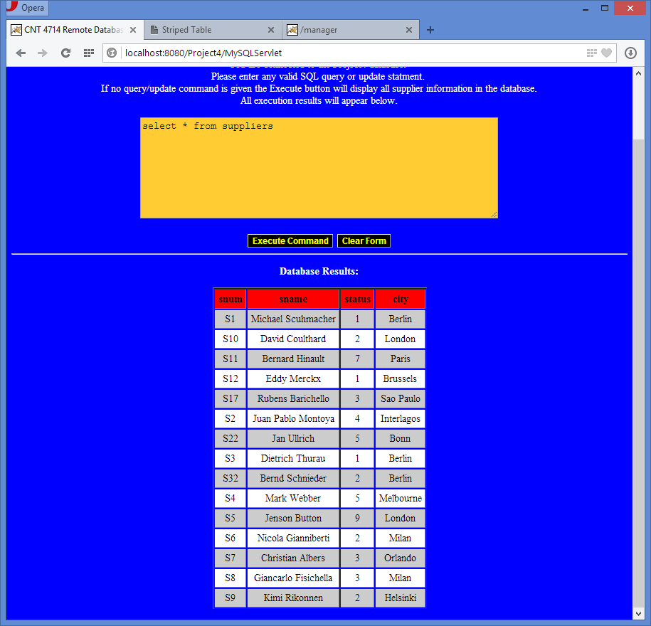
Notice that this time, with the improved business logic that only the supplier directly affected by the insert has had their status updated, all other supplier status values remain unchanged.

