CNT 4714 – Programming Assignment #1 – Summer 2014

Title: “Program Assignment 1: Event-Driven Programming”
Points: 100 points
Due Date: Friday May 23rd by 11:59 pm (WebCourses time)

Objectives: To practice event-driven programming using Java-based GUIs.

Description: Develop a Java program that creates a standalone GUI application (not an applet) that simulates an e-store which allows the user to add items (music CDs) to a shopping cart and once all items are included, total all costs (including tax) and produce an invoice.

Your program development must include the following steps:
- Create a main GUI containing the following components:
  - An area that allows the user to input data into the application along with the descriptive text that describes each input area.
  - A total of six buttons as shown below with functionality as described below.
- An input file named “inventory.txt”. This file contains the data that will be read by the application when the user makes a selection. This file is provided for you on the course website.
- An output file named “transactions.txt” must be created that uniquely logs each user transaction with the e-store. The unique transaction id will be generated as a permutation of the date/time string.

References:
Notes: Lecture Notes for GUIs.

Restrictions:
Your source file shall begin with comments containing the following information:
/* Name: <your name goes here>
Course: CNT 4714 – Summer 2014
Assignment title: Program 1 – Event-driven Programming
Date: Friday May 23, 2014
*/

Input Specification: The file “inventory.txt” as described above (see example below as well).

Output Specification: Output is to appear in the specified components of the GUI and various message boxes that appear, plus the contents of the “transactions.txt” log file that will be generated.

Deliverables:
- Submit a working copy of your source code via WebCourses no later than 11:59pm Friday May 23rd .
- Include a screen shot of your “inventory.txt” file if you modify the one I’ve provided in any manner.
- Include your “inventory.txt” file fi you modify the one I’ve provided in any manner.
- Include a screen shot of your “transactions.txt” file showing at least the last few transactions.

Additional Information:

Shown below are example screen shots of the GUI to help illustrate how your application is to operate.

1. Screen shot of the contents of “inventory.txt”.
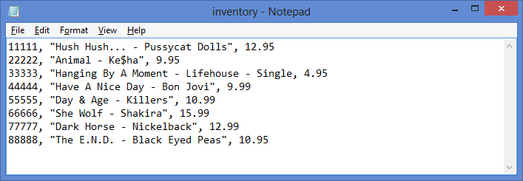

2. Initial GUI:
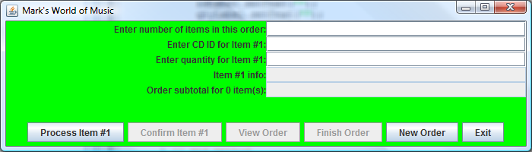
Quit!

Note that these buttons are not initially “active”.
Allows for processing an item once it is selected.
Clears order and starts over.

Confirms that the item is correct.

View the order so far.
Completes an order – generates invoice and adds to transaction file.

3. GUI after user specifies total number of items in the order and makes a selection for item #1.
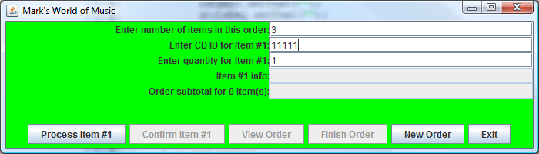

4. GUI after user has selected the first item and clicked the “Process Item #1” button.

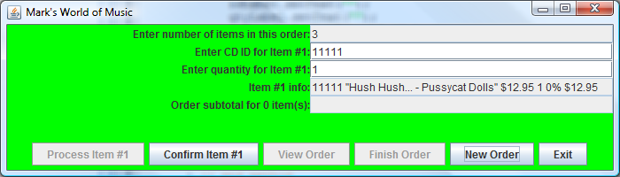

Note that the “Confirm Item #1” button is now active and the “Process Item #1” button is inactive.
Information on the CD purchased has been extracted from the inventory file and written into the window on the line for item #1.

5. When the user clicks on the “Confirm Item #1” button, a confirmation information message appears on the screen.
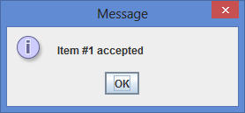

Discount is
1-4 = 0%
5-9 = 10%
10-14 = 15%
>=15 = 20%
6. The main GUI after the user has confirmed the first item.
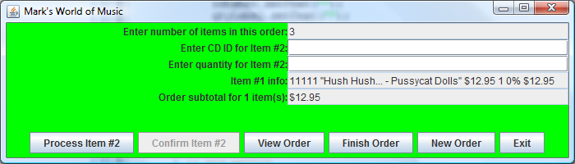
Note that the button changes number.
Information for previous item remains on display.
Note that the text areas for entering the second item information are cleared and ready for input.

Subtotal should reflect current total of all confirmed items.

7. The GUI after the user has entered the information for all the items and confirmed the last item.
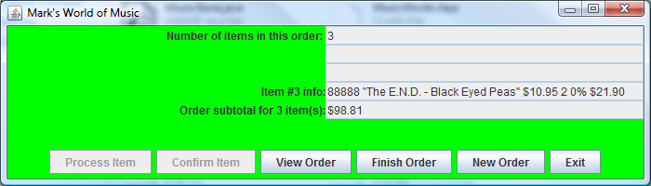

8. When the user clicks the “View Order” button, the following message box should appear.
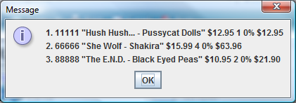

9. When the user clicks the “Finish Order” button, the invoice message should be generated and displayed.
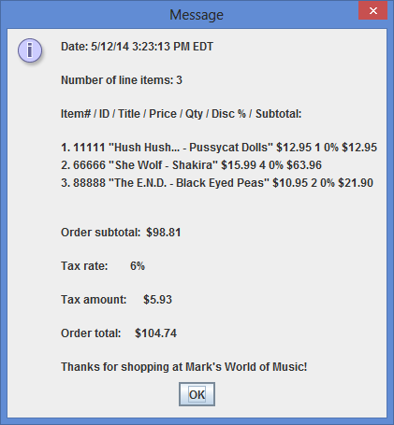

The date and time are used to create the unique transaction id in the “transactions.txt” file. Format is “DD/MM/YY HH:MM:SS TMZ”

10. The transaction file after order shown above was finished. Note the unique transaction ids based on the date and time.
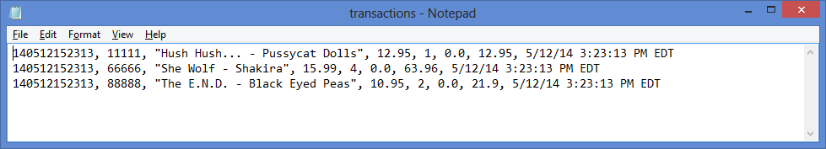

The last transaction occurred on 5/12/2014 at 3:23:13 pm. See the invoice message above. Permutation is: YYMMDDHHMMSS.

- The transaction file after several orders have been completed. Note the unique transaction ids based on the date and time for every separate transaction.
