
School of Electrical Engineering and Computer Science
CNT 3004: Computer Network Concepts (Spring 2009)

Assignment 1
(Due date: 01/23/09 in class)

Name: ______________________________________ PID: ____________________

- Choose any communication technology/protocol. For example, the communication technology used by your cellular phone system or by your home local area network or a protocol used on the Internet. For this technology/protocol, you must indicate:
- Kind of standard (de facto, de jure).
- Standards organization which developed it.
- Overview of the technology/protocol (no more than 3 lines).
- When you use the Internet, which of the following applications are more sensitive to delay?
- Transfer a file.
- On Demand Video.
- E- Commerce transaction.
- Telnet (Remote Login).
- Chat.
- Draw a topology with a four start networks connected to a backbone hub. Assume that each hub has five I/O ports (including the backbone hub). The backbone hub is connected to a router. The router is connected to the ISP router by a point-to-point WAN.
- Classify the following systems according to the kind of data flow (simplex, half-duplex, full-duplex), which best suits the application that each of them supports:
- GPS.
- Baby Monitor.
- Infrared communication between two devices using IRDA.
- Communication between two laptops connected by a wireless router.
- Which of the OSI layers handles each of the following:
- Dividing the transmitted bit stream into frames.
- Determining which route through the subnet to use.
- Dealing with mechanical, electrical and timing interfaces.
- Ensuring that the data from above layer arrives correctly at the other end.
- Compressing data.
- The ping program allows you to send a test packet to a given location and see how long it takes to get there and back. Try using ping to see how long it takes to get from your location to several known location. From these data, plot the one-way transit time over the Internet as a function of distance. It is best to use universities since the location of their servers is known accurately. For example, Berkeley.edu is in Berkeley, California, mit.edu is in Cambridge, Massachusetts, vu.nl is in Amsterdam, The Netherlands, www.usyd.edu.au is in Sydney, Australia, and www.uct.ac.za is in Cape Town, South Africa.
- List two ways in which the OSI reference model and the TCP/IP reference model are the same. Now list two ways in which they differ.
- In Figure 1: Exercise 8. , assume that the communication is between a process running at computer A with port address b and a process running at computer C with port address j. Show how the contents of packets and frames at the network layer, data link, and transport layer for each hop. We use lowercase letters to show port addresses, uppercase letters for logical addresses, and numbers for physical addresses.
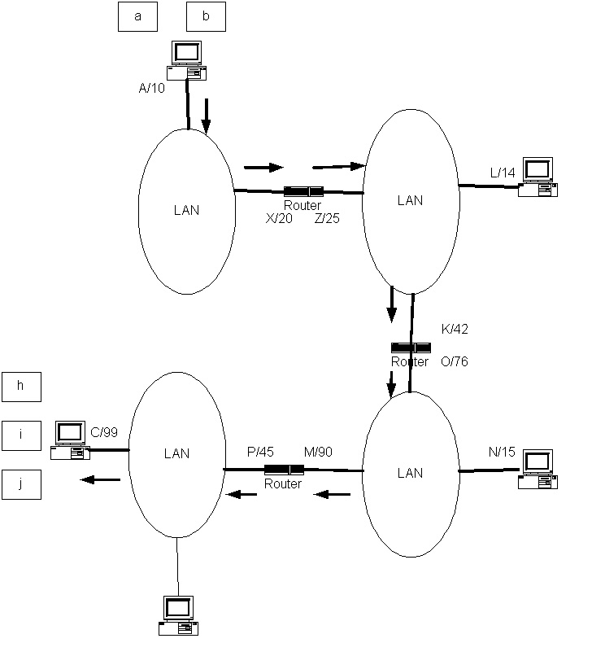
Figure 1: Exercise 8.

