CGS 3269 – Computer Systems Architecture

Memory

Overview

The term "memory" can mean a lot of things, even if you restrict your definition to that of the computer field. Strictly speaking, memory is anything that can hold data, even a single bit. Not all forms of memory work with neither equal efficiency nor speed, but the basic concept is the same with all of them - preserve bits of information in a recognizable and recoverable form. Computer memory is affected by several characteristics, each of which we will examine in some detail. First and perhaps foremost is the technology with which the memory is fabricated. The world’s first commercially available computer was the Univac whose CPU employed vacuum tube technology. The memory of the Univac consisted of 1000 words (each 60-bits wide holding 12 five-bit characters). Vacuum tubes were far too costly to employ for the memory so the designers of the Univac built 100 memory modules (each was a shift register capable of holding 10 words) consisting of mercury delay lines. Within each module, the circuitry introduced electrical pulses at one end of the delay line and detected them 404 μs later at the other end. After the circuitry detected the pulse, it amplified, cleaned, and reinserted them at the beginning of the delay line. The average access time was 202 μs or half the total time a word took to pass through the delay line. During the 1960’s the dominant main memory technology was magnetic core. The storage cells in a core memory were built of doughnut shaped ferrite cores which could be magnetized in one of two directions. Magnetized one direction the cell represented the value 1 and magnetized the other direction the cell represented the value 0. Individual cores were organized into core planes and with further circuitry organized into memory banks. Large core memories cost millions of dollars. Today’s semiconductor memories of the same size cost only a few hundred dollars. A second important characteristic of memory is its speed. The speed of a memory unit describes how quickly data in the memory unit (or module) can be passed to the microprocessor. The basic correlation between processor speed and memory speed is that the faster the processor the faster the memory requirement. The cycle time of core memory was typically in the 1000 to 2000 ns range. Today's quickest memory (commercially available) has a cycle time of 8 nanoseconds (8 × 10⁻⁹ sec) with standard rates in the 40 to 150 ns range. The capacity of a memory module refers to the number of bytes (typically measured in terms of megabytes these days) the module is capable of storing (remembering).

The Memory Hierarchy

registers

cache

main memory

secondary memory

off-line memory

Figure 1 – The Memory Hierarchy

The memory of the computer is organized into a hierarchy which is illustrated if Figure 1. At the highest level, closest to the CPU, are the processor registers. The registers are the processor’s own local memory. The registers represent the fastest memory in the system. It is quite common for the control unit portion of the CPU to also require its own internal memory, which is sometimes referred to as processor main memory. The processor level memory is typically followed by one or two levels of cache memory denoted as L1 and L2 cache. Next comes the main memory which is typically made from dynamic random access memory (DRAM). Main memory is the primary working storage of a computer and is often called the working memory. Persons who have been in the field a long time may still refer to the main memory as core memory (a hold over from the days when technology used to build memory consisted of a fabric of wires with a ferrite doughnut, called a core). Today, core technology is only a history lesson, but all modern memory technologies share one very important characteristic with core memory - that is, electricity is able to alter the "state" of the memory. Many people also commonly refer to the main memory of the PC as the RAM memory (since the CPU must be able to access this memory in a random fashion), however as we will see, this has a slightly different connotation when applied to memory technology. Typical modern PCs will contain anywhere from 64 MB to 512 MB of main memory (although some systems will support more than this).
The three levels of register memory, cache memory, and main memory together form what is commonly known as the internal memory of the computer. Storage devices that provide backup to the internal memory are collectively called the external memory. The external memory is comprised of a secondary memory and off-line memory. External memory is also called auxiliary memory or mass memory and sometimes, although incorrectly, off-line memory. External memory refers to the various tape and disk storage systems that are available (tapes, floppys, zip drives, CDs, optical drives, etc). Typically, secondary memory is anywhere from tens to thousands of times larger (in capacity) than main memory. Typical systems today may contain several hundred gigabytes of secondary memory (note: 1 GB = 1024 MB). Secondary memory is one important step away from the processor in that any information contained in the secondary memory must first be moved into the main memory in order for the processor to operate on it. Secondary memory is almost always based upon an electro-mechanical technology. This means that in addition to the moving electrical signals, it also requires the physical movement of disks, tapes, read/write heads, etc. in order to access the memory. Mechanical things move much more slowly than do electrical signals. This means that access to secondary memory is much slower than access to main memory.

The memory hierarchy has developed primarily due to the trade-off among three key characteristics of memory: cost, capacity, and access time. Memory manufacturers have developed many different forms of computer memory with widely different values for these three parameters. Given these three parameters, several relationships hold:

- The faster the access time, the higher the cost per bit.
- The higher the capacity, the lower the cost per bit.
- The higher the capacity, the slower the access time.

Thus, the computer designer is faced with a dilemma; design the system with the fastest, largest, cheapest memory available. The way to resolve this dilemma is of course to not rely on any single memory technology for the entire system. Thus the hierarchy puts the fastest, most expensive, and smallest capacity require memory where it is needed the most – closest to the processor, with slower, less expensive, and greater capacity memory further from the processor. Looking again at Figure 1, as you go down the hierarchy the following occurs:

- Cost per bit decreases.
- Capacity increases drastically.
- Access time increases.
- Frequency of access to the memory by the processor decreases.
The key to balancing the hierarchy properly, rests squarely with item four. This item is based upon the principle of the locality of reference. The principle of the locality of reference basically states that memory references by the processor for both instructions and data will tend to cluster, meaning that once a reference is made to a memory location all references made certain time period following the first reference will be to a memory location which is very “close” to the first occurrence. Over time the many different clusters may be accessed but within a certain time frame the references will tend to be within the same cluster (group of addresses).

Between the two forms of memory there is always a balance which must be achieved - for main memory the most important aspect is for it to be as fast as possible but, you would like to have as much as possible. For secondary memory the most important aspect is its capacity (you want it to be as big as possible) but, you would like it to be as fast as possible. The following example illustrates how and why the memory hierarchy has developed as it has.

Example:
Suppose that the processor has access to two levels of memory. Level 1 contains 1000 words with an access time of 0.1 μs. Level 2 contains 100,000 words with an access time of 1 μs. Assume that if a word is to be accessed in Level 1, then the processor accesses it directly. If it is in Level 2, then the word is first transferred to Level 1 and then accessed by the processor. For simplicity, we’ll ignore the time required for the processor to determine if the word is in Level 1 or Level 2. The hit ratio H, is defined as the fraction of all memory accesses that are found in the faster Level 1 memory. Let T1 be the access time for Level 1 and T2 the access time.

If a high percentage of the words required by the processor are in the Level 1 memory, then the average access time will be closer to that of the Level 1 memory than the Level 2 memory. On the other hand if a high percentage of the words required by the processor are located in the Level 2 memory, then the average access time will exceed that of the Level 2 memory. For example, if 95% of all the accesses are found in Level 1 the average access time for all accesses will be: (0.95)(0.1μs) + (0.05)(0.1μs + 1μs) = 0.095 + 0.055 = 0.15μs. If the reverse is true and 95% of all accesses are found in Level 2 then the average access time for all accesses will be: (0.05)(0.1μs) + (0.95)(0.1μs + 1μs) = 0.005 + 1.045 = 1.05μs.

The overall memory hierarchy makes use of the fact that as you go down the hierarchy less frequent access to that memory portion of the memory will occur.

Characteristics of Memory

The memory systems of modern computers are complex subjects, which can be more manageable if we classify certain characteristics of the memory. While many different characteristics could be considered, the most important seem to be:
- Location of the memory (see the memory hierarchy above).
- Capacity of the memory.
- Unit of transfer into and out of the memory unit.
- Access method.
- Performance parameters such as access time and cycle time.
- Physical type (semiconductor, magnetic, optical, etc.).
- Physical characteristics such as volatile and non-volatile.
- Organization.
- Packaging the memory.

We’ll examine each of these characteristics briefly and then examine some of them in greater detail in subsequent sections.

Location

See the above section on the memory hierarchy.

Capacity

For internal memory the capacity is typically specified in terms of bytes or words. Typical word lengths are 8, 16, 32, and 64 bits. External memory capacity is almost always referred to in terms of bytes. Typical modern systems will have anywhere from 16K to 512K (or more) internal memory and anywhere from a few GB (gigabytes) to many TB (terabytes, 1 TB = 2⁴⁰ bytes) or even PB (petabytes, 1 PB = 2⁵⁰ bytes) of external memory not counting off-line memory which is virtually unlimited. To put these numbers into perspective, there are on the order of 2⁴⁰ characters in all of the books in the Library of Congress, one day’s worth of HDTV or a feature length movie would display roughly 2⁴⁰ pixels. A 1990’s supercomputer could reference its own memory at the rate of about 1 PB/day or generate output at the rate of about 1PB/year. Rapidly decreasing unit costs for memory implies that main memory sizes will continue to grow for the foreseeable future. Indications are that eventually all memory used for nonarchival purposes will become part of the main memory.

Unit of Transfer

This memory characteristic is somewhat related to capacity. For internal memory, the unit of transfer is typically equal to the number of data lines into and out of the memory module (this is not true for some of the newer technologies like Rambus memory). This is often equal to the word length (but it may not be either!). Several issues affect the unit of transfer for internal memory:

- Word: The “natural” unit of memory organization. The size of the word is typically equal to the number of bits used to represent a number and to the instruction length. There are however, many exceptions. For example, the CRAY-1 has a 64-bit word length but uses 24-bit integer representation. The VAX has a very large number of instruction lengths which are all various multiples of bytes, yet has a word size of 32 bits.

- Addressable units: In many systems the addressable unit is the word. However, some systems allow addressing at the byte level. Regardless of which type of addressing is used, the relationship between the length in bits A of an address and the number N of addressable units is 2^{A} = N.

- Unit of transfer: For the main memory, this is the number of bits read out of or written into the memory at a time. The unit of transfer does not need to equal a word or an addressable unit. For external memory, data is often transferred in much larger units than words, typically referred to as blocks.

Access methods

- Sequential access: Memory is organized into units of data, called records. Access must be made in a specific linear sequence. Stored addressing information is used to separate records and assist in the retrieval process. A shared read/write mechanism is used, and this must be moved from its current location to the desired location, passing and rejecting each intermediate record. Thus, the time to access an arbitrary record is highly variable. Tape units are sequential access devices.

- Direct access: As with sequential access, direct access involves a shared read/write mechanism. However, individual blocks or records have a unique address based upon their physical location. Access is accomplished by direct access to reach a general vicinity plus sequential searching, counting, or waiting to reach the final location. Again, access time is highly variable. Disk units are direct access.

- Random access: Each addressable location in the memory has a unique, physically wired-in addressing mechanism. The time to access a given location is independent of the sequence of prior accesses and is constant. Thus, any location can be selected at random and directly addressed and accessed. Main memory and some cache systems are random access.

- Associative: This is a random access type of memory that enables one to make a comparison of desired bit locations within a word for a specified match, and to do this for all words simultaneously. Thus, a word is retrieved based on a portion of its contents rather than on its address. As with ordinary random access memory, each location has its own addressing mechanism, and retrieval time is constant and thus independent of location or prior access patterns. Cache memories will typically be the only place where associative memory will be employed.

Performance

This characteristic is perhaps one of the more important as far as the user is concerned. Typically three performance parameters are most important:

- Access time: For random access memory, this is the time required to perform a read or write operation. It is the total time from the instant that an address is presented to the memory to the instant that the data has either been stored (write) or made available for use (read). For non-random access memory, this parameter represents the total time taken to position the read-write mechanism at the desired location.

- Memory cycle time: This parameter only applies to random access memory. It is the access time plus any additional time that is required before a second access to the memory can begin. This additional time might be required to allow transients on the signal lines to die out or to regenerate data if the read is a destructive one.

- Transfer rate: This is the rate at which data can be transferred into or out of a memory unit. For random access memory it is equal to the reciprocal of the memory cycle time, i.e., 1/(cycle-time). For non-random access memory, the following relationship will hold:

$T_{N}=T_{A}+ \frac{N}{R}$ where: T_{N} = average time to read or write N bits
T_{A} = average access time
N = number of bits transferred
R = transfer rate in bits/second (bps)

Physical Types

Throughout the history of the computer, many different physical types of memory have been employed. Today for internal memory, the most common type by far is semiconductor memory. For external memory, the most common type is magnetic surface memory, used for disks and tapes. Optical and magneto-optical are also currently employed but to lesser degrees.

Physical Characteristics

Volatility: As with human beings, computers have both short-term (main memory) and long-term (secondary memory) memories. The former are fleeting, the latter are lasting. As far as computer memory is concerned, the reaction it has to an interruption of power defines the difference between long-term and short-term memory. The technical name for this phenomenon is volatility. Computer memory is classified into two distinct categories: volatile and non-volatile. Volatile memory is fast. Non-volatile memory is slow, often much, much slower. PCs built with non-volatile memory while immune to the loss of power would be prohibitively expensive and excruciatingly slow.

Volatile memory: The information in the memory cell last only as long as the source of power remains constant. Disconnect the power from the memory cell and the contents will disappear in a few microseconds. The main memory in nearly every PC is volatile.

Non-volatile memory: Information in the memory cell remains there until it is overwritten. Interruption from the power supply does not affect the contents of the memory cell. Read-only-memory (ROM) and flash memory are two common types of non-volatile memory found in modern PCs. Non-volatile memory can be simulated by providing back-up power (usually in the form of a battery). This is commonly done in the CMOS memory configuration memory systems used in most PCs. However, this type of memory will remain vulnerable to the loss of power from the back-up source - if the battery dies - so too does the contents of the memory.

- Erasability: Non-erasable memory cannot be altered, except by destroying the memory unit. Semiconductor memory of this type is known as ROM (Read Only Memory). Practical nonerasable memory must also be non-volatile.

Organization

For random access memory, the organization of the memory is a key issue which affects the overall performance of the computer. The organization of the memory refers to the physical arrangement of the bits into the formation of words and the various techniques employed to this end. Many times, the obvious arrangement is not the one which is chosen. The reasons for this are many, some of which we discussed in the earlier section on the memory hierarchy, some of which we will discuss in the remainder of this set of notes. Historically, different reasons may have affected the organization of the memory; we will restrict ourselves to dealing only with semiconductor memory.

The basic element of semiconductor memory is the memory cell. Although a wide variety of electronic technologies are used, all semiconductor memory cells share certain properties:

- They have two stable (or semi stable) states, representing binary 0 or 1.
- They are capable of being written into (at least once), to set the state.
- They are capable of being read to sense the state.

Figure 2 below illustrates a basic memory cell and the operations of (a) writing to the cell and (b) reading (sensing) the cell’s state. Most commonly, the cell has three functional terminals capable of carrying an electrical signal. The select terminal selects a particular memory cell for a read or write operation. The control terminal indicates the operation (a read or write). For writing, the remaining terminal is used to carry an electrical signal that sets the state of the cell to 0 or 1. For reading, the remaining terminal is used to carry an electrical signal that outputs the cell’s state. The details of the internal organization, functioning and timing of the memory cell depend upon the specific integrated circuit technology that is used. Some of these details we will see later for specific types of memories, but for the most part go way beyond the level with which we are concerned.

Figure 2 – Basic memory cell operations
For semiconductor memory, one of the key design issues is the number of bits of data that can be read/written at one time. At one extreme is an organization in which the physical arrangement of cells in the memory array is the same as the logical arrangement (as perceived by the processor) of the words in the memory. The array is organized into W words each B bits wide. For example, a 16 Mbit chip could be organized as 1M 16-bit words. At the other extreme is the so-called one-bit-per-chip organization, in which data is read/written one bit at a time. For the time being we’ll focus on DRAM (Dynamic Random Access Memory), ROM (Read Only Memory) is similar, although somewhat simpler.

Figure 2 illustrates a typical organization of a 16 Mbit DRAM chip. In this particular example, 4 bits are read/written at a time. Logically, the memory array is organized as four square arrays of 2048 x 2048 cells (elements). Many different physical arrangements are possible, but in all cases the array elements are connected by both horizontal (row) and vertical (column) lines. Each horizontal line connects to the select terminal of each cell in its row; each vertical line connects to the data-in/sense terminal of each cell in its column.

Address lines supply the address of the word to be selected. A total of (log₂ W) lines are needed. In the example of Figure 3, 11 address lines are needed to select one of the 2048 rows (since 2¹¹ = 2048, log₂(2048) = 11). These 11 lines are fed to a row decoder which has 11 input lines and 2048 output lines. The logic of the decoder activates a single line from the 2048 outputs depending upon the bit pattern on the 11 input lines (2¹¹ = 2048 possible combinations of bits in 11 positions). An additional 11 address lines select one of the 2048 columns of 4 bits per column. Four data lines are needed for the input and output of 4 bits to and from a data buffer. On input (write), the bit driver of each bit line is activated for a 1 or 0 according to the value of the corresponding data line. On output (read), the value of each bit line is passed through a sense amplifier and presented to the data lines. The row line selects which row of cells is used for reading/writing.

Because only four bits are read/written to this DRAM chip, there must be multiple DRAMs connected to the memory controller to read/write a word of data to the bus. The number of address lines shown is only 11, when in actuality 22 are required (11 for the row address and 11 for the column address in a 2048 x 2048 array). The reason for this is simply to save space in terms of the number of pins required for the chip. The 22 required address lines are passed through select logic which is external to the DRAM chip and then multiplexed onto the 11 address lines. The first 11 address signals are passed to the DRAM chip to define the row addresses of the array, followed by the 11 address signals which represent the column addresses. These signals are accompanied by row address select (RAS) and column address select (CAS) signals which provide timing to the DRAM chip.

Figure 3 – Typical 16 Mbit DRAM (4M x 4)

Figure 3 also illustrates the refresh circuitry which is part of any DRAM chip. A simple technique for refreshing the memory is, in effect, to disable the chip while the memory cells are refreshed. The refresh counter steps through all of the row values. For each row, the output lines from the refresh counter are supplied to the row decoder and the RAS line is activated. This causes each cell in the row to be refreshed. There are many other techniques that can be used to refresh dynamic memory and we will look at them in more detail later.

The use of multiplexed addressing combined with square arrays has resulted in a quadrupling of memory size with each new generation of memory chips. One more pin devoted to addressing doubles the number of rows and columns, and so the size of the chip memory grows by a factor of four (2¹¹ = 2048, 2¹² = 4096, a 4096 x 4096 array contains 4x the number of cells that a 2048 x 2048 array contains).

Chip Packaging

Like microprocessor chips, memory chips are mounted on a package that contains pins for connections to the outside world. There are many different standards as well as proprietary configurations for packaging the chips. Figure 4 illustrates two different memory package configurations with the pin/signal configurations. Figure 4a illustrates an EPROM while Figure 4b illustrates the 16 M-bit DRAM from the earlier example.

Figure 4 – (a) EPROM packaging, (b) DRAM packaging

The EPROM package of Figure 4a, illustrates the arrangement for an 8 Mbit chip organized as 1M x 8. In this case, the organization is treated as a one-word-per-chip package. The package has 32 pins, which is one of the standard chip package sizes. The pins support the following signal lines:

- The address lines of the word being accessed. For 1M words, a total of 20 (2²⁰ = 1,048,576 = 1M) pins are needed. These are labeled A0-A19.
- The data to be read out (remember it’s a ROM) consists of 8 lines (1 word = 8 bits). These are labeled D0-D7.
- The power supply to the chip, labeled V_{CC}.
- A ground pin, labeled V_{SS}.
- A chip enable pin, labeled CE. Since there may be more than one memory chip connected to the same address bus, the CE pin indicates whether or not the address is valid for this particular chip. The CE pin is activated by logic connected to the higher order bits of the address bus (i.e., address bits above A19).
- A program voltage pin, labeled V_{pp}, that is supplied with the proper voltage during programming (a write operation to a ROM chip).

The DRAM chip of Figure 4b illustrates the pin configuration for a 16 Mbit chip organized as a 4M x 4 chip (see the earlier example). This package illustrates several differences from the ROM chip. Since a RAM chip can be updated, the data pins are input/output pins. The write enable pin, labeled WE, and the output enable, labeled OE, indicate if the current operation is a write or read operation. Because the DRAM is accessed by row and column, and the address is multiplexed, only 11 address pins are required to specify the 4M row/column combinations (2¹¹ x 2¹¹ = 2²² = 4M). The only other pins required are the RAS and CAS lines mentioned earlier and the power and ground pins.

Module Organization

If a RAM chip contains only 1 bit per word, then obviously the minimum number of chips required will be equal to the number of bits in a word. Thus a machine with a 32-bit word would require 32 RAM chips. As an example of this, Figure 5 illustrates how a memory module consisting of 256K 8-bit words could be organized. For 256K words, an 18-bit address is required and would be supplied to the memory module from some external source (like the address lines of the bus to which the memory module is attached). The address would be presented to 8 different 256K x 1-bit chips, each of which provides an input/output of 1 bit.

Figure 5 – 256K 8-bit word DRAM module organization

The organization of Figure 5 works as long as the size of the memory equals the number of bits per chip. In the case where a larger memory is needed, an array of chips is required. This case is illustrated in Figure 6. Figure 6 represents a 2MB DRAM memory module that built from sixteen 256K x 4-bit RAM chips. Each pair of chips in the figure represents 256KB. The line labeled Sel is the chip select line mentioned earlier. Each word is 1 byte wide (8 bit word) so two 4-bit chips are needed to contain a single word. Since each RAM chip can store 256 K 4-bit words, a total of eight pairs of chips are needed to store 2MB. Each chip has 18 address lines (2¹⁸ = 256K), while the entire memory system requires 21 address lines (2²⁰ = 1M so 2²¹ = 1Mx2¹ = 2M). The three remaining address lines are used to select which set of pairs of RAM chips are enabled. In Figure 6, the high-order three bits of the 21-bit address are used as chip select with the low-order 18 bits of the address are used to select the same word in every pair of chips. This memory module organization is referred to as high-order interleaved memory. In this configuration, consecutive words lie on the same set of chip pairs. For example, when the address changes from 256K-1 to 256K, or 512K-1 to 512K, and so on, the next word is on the next chip-pair.

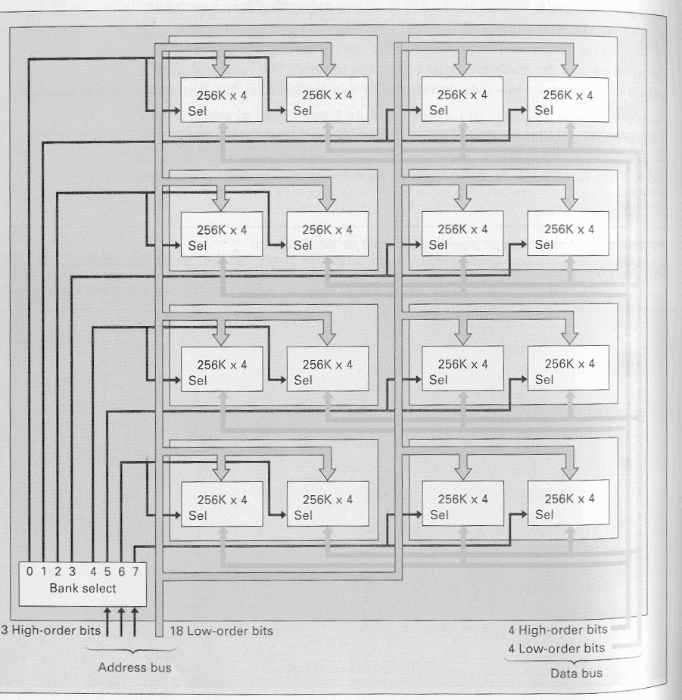Figure 6 – 2MB DRAM module of 16 - 256K x 4bit RAM chips

