CAP 5937 – HW
Dr. Lobo / Adam Schwarz
Assigned: June 22, 2004

Dressed Human Model Detection

HW Assignment

Purpose:
This Assignment will demonstrate an understanding of the Short-Cut Rule as described in Liang Zhao’s thesis paper and how it is applied to de-composing contours into recognizable body parts.

Assignment:
You will need to implement the Short-Cut Rule and algorithm for decomposing the contour of a person or other object. Your program should first decide where the NCM’s (Negative Curvature Minima) are located and then determine the best cut for each NCM. Then as a final step merge the regions to create only the significant body parts.

Algorithm:
- Load Contour Data (image pixels) into data structure
- Determine Location of significant NCM (tweak the threshold value to match the test run data depending how you implement the NCM finding)
- Use the equations described in the paper to determine the locations of the best cuts for EACH NCM
- (Optional ~ Bonus Points) Group the over-segmented parts leaving only the significant parts and the parts that can’t be decomposed any further
- Display on screen the cuts along with the original contour silhoutte
- Save this image file as output#.ext as it corresponds to the input file: test#.raw

Test Data:
All test files and the example file are 128x128 b&w image files saved in the .raw file format. They are included on the class website in the testData.zip file, which contains the 4 test images and the example image (example.raw) that will be used to match the example run (see below).

Example Run:

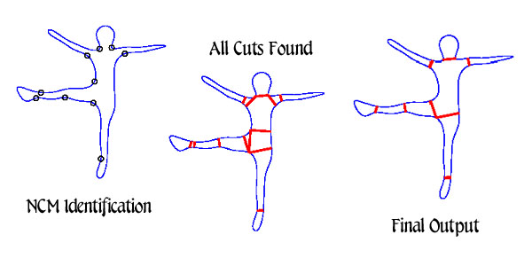

NCM Identification:
First thing to check is to make sure that your NCM points are matching up closely with the above picture, it doesn’t have to be exact, but you should have the same number of points and in approximately the same locations.

All Cuts Found:
Use the two equations presented in the paper for finding the optimal cuts (see Short-Cut Rule, section 2.3 of the paper and slides 9-15). These results should look something like the middle picture above. Note: If you choose to not do the bonus implementation, then save this image as your output image.

Final Output:
Group the over-segmented parts using the method described in section 2.3.2 of the paper and slide 13 or another method of your choice.* This output should be saved out as an image to be submitted with your report/summary.
*Note: If you choose to use a different method for merging the over-segmented parts, describe this method in detail and add it on as an extra page to your summary report.

To Turn in:
You should submit your program written in the language of your choice along with your 4 output image files. There should also be a brief written summary talking about your experience with this project, implementation of the algorithm(s), and your results including how they matched or didn’t match what you expected.

- Program (programming language of your choice)
- 4 output image files (format of your choice)
- Brief summary (1-2 pages, see description above for more details)

Test Files:

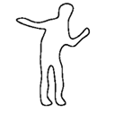  test1.raw | 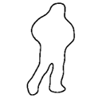  test2.raw
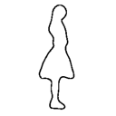  test3.raw | 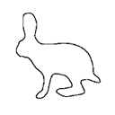  test4.raw

