FriendFinder
- This is the screen you first see as soon as you turn ON the app :
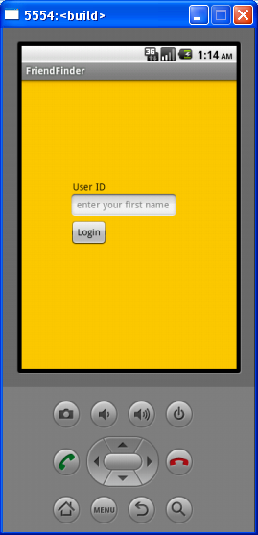

- Enter your user id and click on “login” :
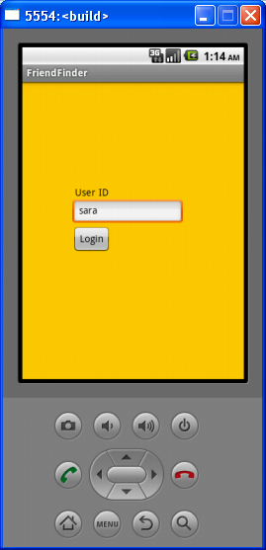

- This is the next screen you see after you have clicked on “Login”. Here you enter the name of your friend whose address you want to find and get directions to.
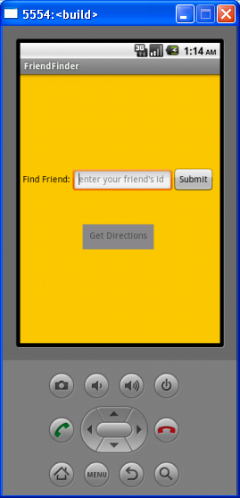

- I entered my friend’s name as “maryam”.
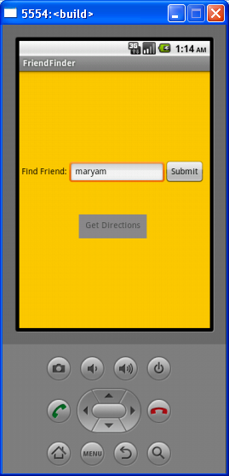

- After that click on “Submit”. As soon as you click on it, your friend’s current location coordinates get loaded onto the app and the “Get Directions” button is enabled for you to click on it. (You will notice that after you click on “Submit”, the “Get Directions” button gets highlighted) Click on it :
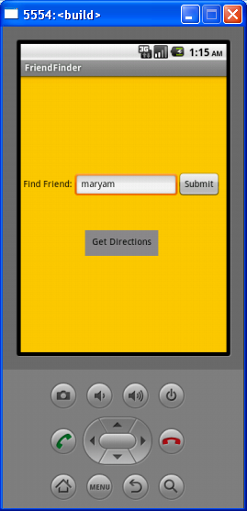

- When you click on “Get Directions”, FriendFinder builds the url for Google Maps. The Activity to load the url is now called and the Google Maps Application begins :
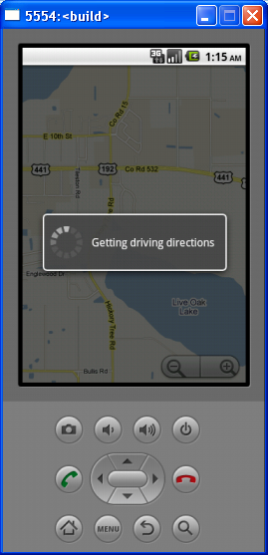

- This is what you get next. A list of options to choose from. (This is till where I showed you in the presentation demo in class today). What I forgot to show you was what happens when you click on any of these options. For example, I will show you what happens when you click on “Show on map” :
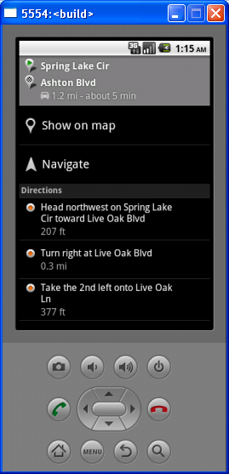

- So you click on “Show on map” to view the directions on Google Map :
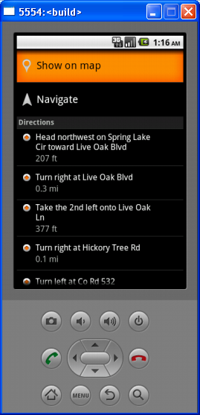

- This is where you are. You can keep clicking on the → button to see where to go next (or on ← to see the reverse directions) :
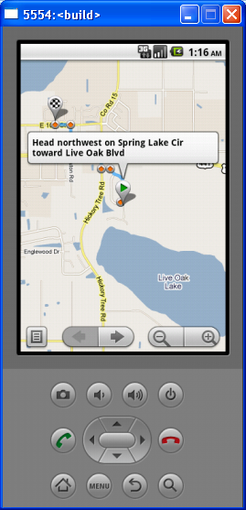

- (next) :
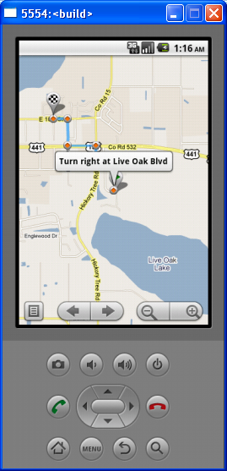

- (next) :
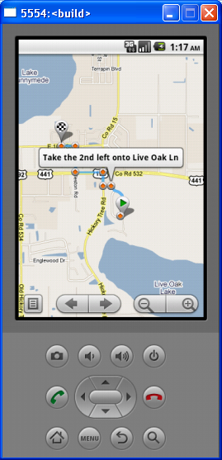

- (next) :
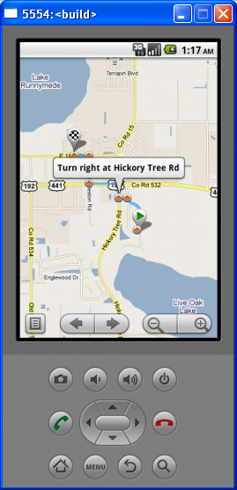

- (next):
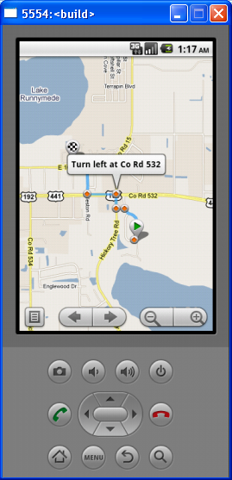

- (next):
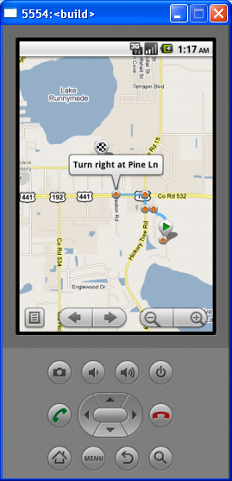

- (next):
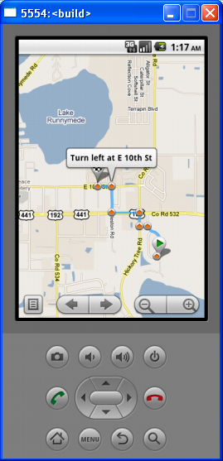

- (next):
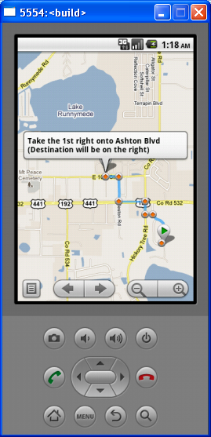

- You have reached the destination. This is where your friend is :
