EEL 5881- Spring 2006
UML Homework
Due: March, 8, 2006

- Hard copy of the homework must be submitted at the class on the above due day.
- E-mail the soft copy of your model and executable source code to the TA (shiyuan_jin@yahoo.com) on the due date, preferably in a compressed file.
- No late submission will be accepted

Suppose you are asked to design a restaurant billing software system. The following is the use case diagram of the system:
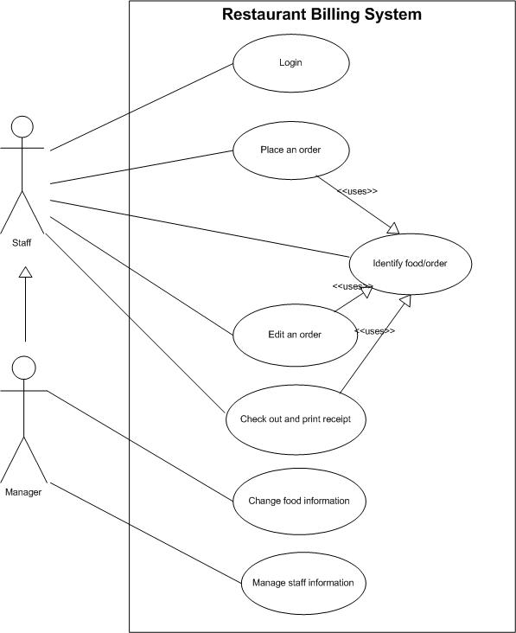

There are two actors in this system: Staff and Manager. A manager is actually a special staff who can manage food and staff information, which are prohibited for a regular staff. Each staff has his/her user name, password, name, role (a regular staff or a manager), etc. Use cases like “place an order”, “Edit an order”, and “Check out and print receipt”, need to include “identify food/order” use case to identify the desired food or order.

All use cases are described below:
Login use case:
- To use the system, each staff should enter correct user name and password to login.

Place an order use case:
- When placing an order for a customer, the staff should input food ID number, quantity, etc. Each order also includes an order ID number, food item names and unit prices. The order ID is a unique number automatically generated by the system. Item names and unit prices are automatically acquired through calling the “search food/order” use case. Of course, an order can have multiple food items.

Search food/ order use case:
- The staff can either search any food or order by typing corresponding food ID or order ID number, respectively.

Edit an order use case:
- The staff can change food items, quantity in an order. But before editing, he/she needs to use “identify food/order” use case to identify that order.

Check out and print receipt use case:
- The “identify food/order” use case needs to be included to identify an order to check out.
- The receipt information includes date, item list, payment type (cash or credit), unit price, quantity, and total price, etc.

Change food information use case:
- Only the manger has the right to change food information, such as, food item ID, food name, unit price, etc.

Manage staff information use case:
- Only the manager has the right to manage staff information. This information can be the name of a staff, role (regular staff or manager), user name and password.

Based on the above information, you need to do the following problems:

Problem 1: Identify all the classes from these use cases (hint: look for nouns) and develop a class diagram for these classes and show:
  - class attributes, private/public methods
  - inter class relationship (e.g. show appropriate generalization, associations; label associations with appropriate multiplicities; name associations if it helps understanding; show navigability if any; show aggregation if any)

Please follow the UML notations precisely: do not invent your own symbols. Assignment can be done using ArgoUML (available at http://argouml.tigris.org/) or Microsoft Visio, or other UML tools.

Problem 2: Use any object oriented programming language like Java, C++, to implement the following scenario. In your main method, create instances of all relevant classes to the scenario, and print out the contents of each instance (or object), e.g., ID, name, price, and so on.

Scenario:
A staff places an order for a customer. The order includes two kinds of items (e.g. one sandwich, two chicken wings). After the customer finishes dinner, the staff identifies the customer’s order and print out a receipt for the customer.

You may not need to implement all classes in your class diagram in problem 1, but any class implemented here should conform to what it is defined in your class diagram. Some methods in a class may not necessarily need to be implemented; however, all methods have to be defined. A database system is not considered here, so system login verification can be ignored in the implementation. Basically, all the relevant classes in the scenario above must be implemented.

