EEL 5881- Fall 2007
Homework #2
Due: November 15, 2007

- Hard copy of the homework must be submitted to the instructor in class.
- Send the soft code of your model to the email address of the TA (samprasluo@hotmail.com)
- No late submission will be accepted

Implement the classes as shown in the following diagram. You can use any programming language which supports object oriented programming such as Java/C++ for implemtation.

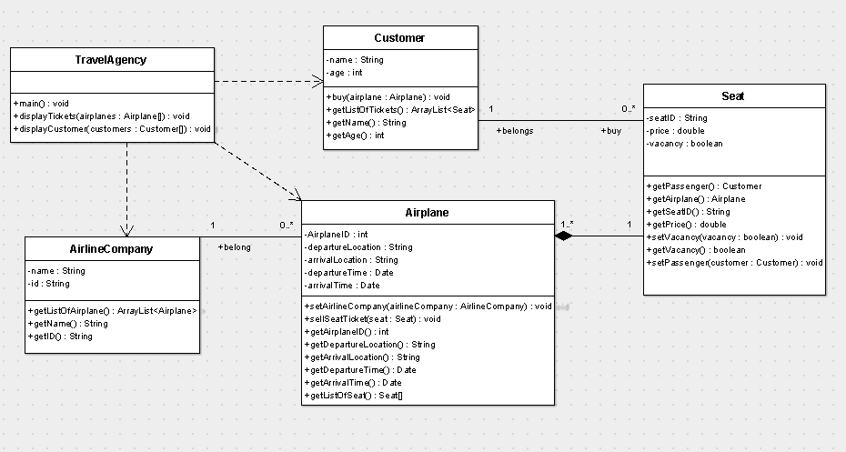
You need to:

- Provide an implementation of all the classes.

- In the main method of TravelAgency class:
  - create four instances of Airplane (such as A380)
  - create certain number of Seat for each airplane (such as F4)
  - create two instances of AirlineCompany (such as American Airline)
  - assign airplanes to airline companies
  - create instances of five customers
  - alloe every customer buy two tickets
- In the displayTickets() method, for each airplane:
  - display the airline company name of the ticket
  - display the airplane information of the ticket
  - display the seats information in the airplane
  - display the name of passenger if the seat is not vacancy

The full name in ticket is airlineCompany.getID()+airplane.getID()+seat.getID().
For instance, UA888 F4 means airline company id “UA”, airplane id “888” and seat id “F4”.

- In the displayCustomer () method, for each customer display:
    - The customer name and age
    - The tickets that the customer bought

Hint:
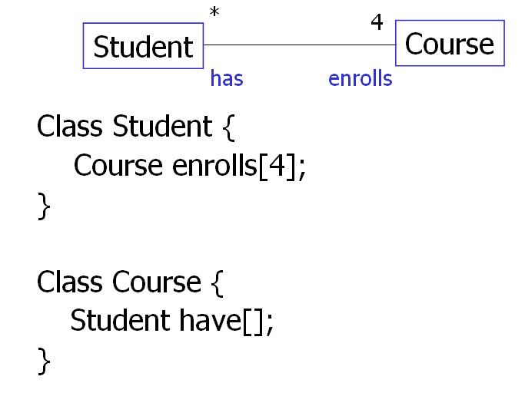

But when we do not want to display students’ information for a given course

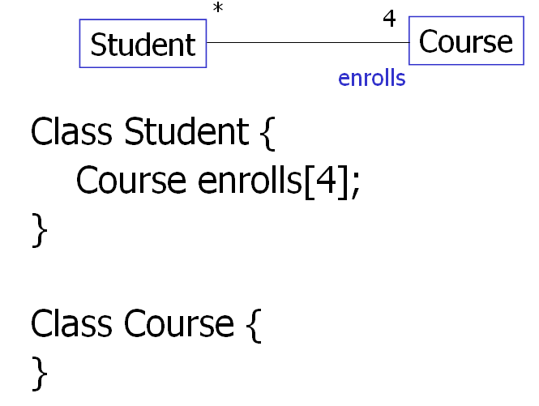

The difference is when a student wants to register a course, he/she has to put the course object in enrolls[] array and put “student.this” to have[] array for the first figure. We just need to put course object in enrolls[] array for the second figure.

