EEL 4884 – Spring 2005

Homework #3

Note:
- Home work is due on April 4th, 2005
- No late submission will be accepted
- Please send a soft copy of your homework at khan@bond.cs.ucf.edu
- In case of mailing problems, you can also provide a soft copy on floppy disk or CD-ROM to the instructor in the class

Implement the classes as shown in the following diagram. You can use any language (that support object oriented programming, like Java/C++) to implement them.

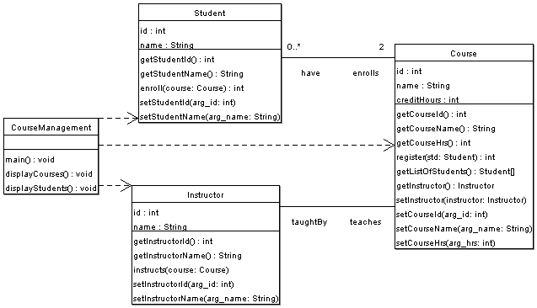

You need to:

- Provide implementation of all the classes

- In Course Management class’ “main” method:
  - Create instances of three (3) courses (e.g. EEL 4884, EEL 3801 and EEL 3420)
  - Create instances of three (3) instructors
  - Assign instructors to each course
  - Create instances of five (5) students
  - Register every student for any two courses

- In Course Management class’ “displayCourses” method:
  - For each course, display on screen:
    - Course id, course name and credit hrs
    - Display the name of course instructor
    - Display the list of students (student id and names) registered in that course

- In Course Management class’ “displayStudents” method:
  - For each student, display on screen:
    - Student id and name
    - List of courses (course id and names) that the student is enrolled in

