EEL 4884 – Spring 2005

Homework #1

Note:
- Home work is due on Februaury 7, 2005
- Homework should be submitted to the instructor in the class
- No late submission will be accepted
- Provide a hard copy of your report.
- Please send a soft copy of your model at khan@bond.cs.ucf.edu

Suppose that you are working as a system analyst for a company that develops software for academic campuses. It provides support for both the students and instructors.
Based on the currently available set of requirements, following use cases are determined:

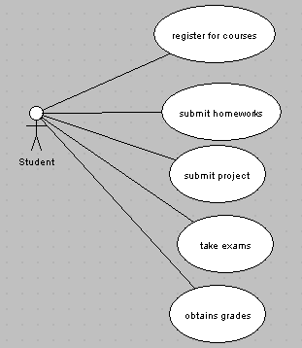

Note that every student has a unique id, email address and a name. You do not need to maintain other information like mailing address, age etc.

Now, each of this use case needs to be elaborated. In the following, these use cases are elaborated.

Register for courses use case:
- The student should be able to register for courses
- Every course has a course id (e.g. EEL 4884) and course name
- Every sudent has to register for exactly four (4) courses
- Every course has 3 credit hours
- Every course is taught by an instructor assigned by the university
- Every course has a class room and time assigned to it
- Every course has 20% for homework, 40% for project and 40% for final exam
- Every course has uniform grading policy: >80% (A), 70%-80% (B), 60%-70% (C), <60% (D)

Submit homework use case:
- Students get four (4) homeworks assigned during the classes
- The homework should be submitted on due date
- Students should get a grade for each homework

Submit project use case:
- Students will get a project assigned during the classes
- Every poject has a uniquie id and name
- The project should be submitted on due date
- The porject will have some team members
- Students should get a grade for the project

Take exam use case:
- Students should take a final exam on a given date
- The exam will have a location, time and duration
- Students should get a grade for the exam

Obtain grades use case:
- Students should be able to obtain grades for each registered homework
- The grades distribution should also be available (e.g. 15% homework, 25% project, 32% exam and grade is ‘B’)

Alongwith these requirements, the system should be able to answer following questions:
- Given a student id, what courses has the student registered for?
- Given a student id, what is the weekly schedule of the student?
- Given a student id, what is the grade distribution of the student?
- Given a course id, which students are registered in that course?
- Given a course id, what is the exam date for that course?
- Given a project id, who are the team members?
Etc.

In your assignment you need to perform following tasks:

- Identify all the classes from these use cases (hint: look for nouns)
- Develop a class diagram for these classes that shows:
  - Class attributes, private/public methods
  - Inter class relationship (e.g. Show appropriate generalization, associations; label associations with appropriate multiplicities; name associations if it helps understanding; show navigability if any; show aggregation if any)

Important

- You should obviously follow the UML notations precisely: do not invent your own symbols. Assignment can be done using ArgoUML, which is a free modeling tool. ArgoUML is available at http://argouml.tigris.org/ and is quite easy to install and use.
- If you need any assistance for the tool or homework, place contact your Lab Teaching Assistant during lab session.
- There will be a UML presentation in the class on Jan 31, 2005. You can ask about any questions regarding this homework during/after that presentation.

