EEL 4884- Fall 2005
Homework #2
Due: November 30, 2005

- Hard copy of the homework must be submitted to the instructor in class.
- Send the soft copy of your model to the email address of the TA (samprasluo@hotmail.com)
- In case of mailing problems, you can also provide a soft copy on floppy disk or CD-ROM to the instructor in the class
- No late submission will be accepted

Implement the classes as shown in the following diagram. You can use any language (that support object oriented programming, like Java/C++) to implement them.

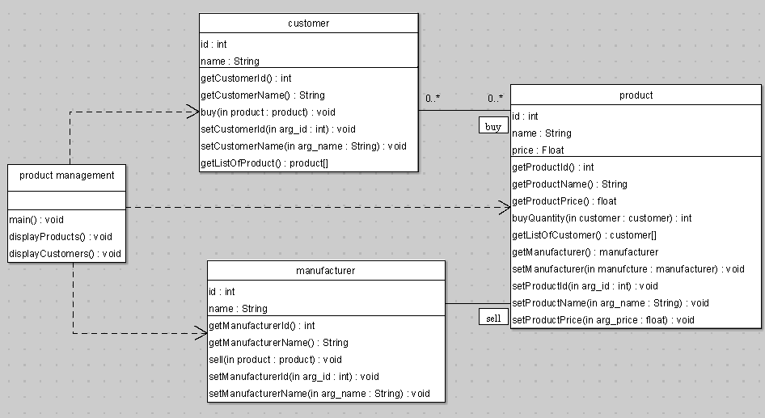

You need to:

- Provide implementation of all the classes

- In Product Management class “main” method:
  - Create instances of three (3) products (e.g. Dell inspire700m, Sony T7 DC and SanDisk 1G MP3)
  - Create instances of three (3) manufacturers
  - Assign manufacturers to each product (suppose that each product is provided by the different manufacturer).
  - Create instances of five (5) customer
  - Let every customer buy 2 products (suppose that each customer must buy 2 products).

- In Product Management class “displayProducts” method:
  - For each product, display on screen:
    - product id, product name and price
    - Display the name of product manufacturer
    - Display the list of customer (customer id and names) buy that product

- In Product Management class “displayCustomers” method:
  - For each customer, display on screen:
    - customer id and name
    - List of product (product id and names) that the customer buy

