COP 4331C- Spring 2013
Homework 3
Due: April 11, 2013

- Please submit the homework through webcourses2 (please don’t send files via email!)
- Homework is individual assignment, not to be worked on as a group!
  - Format: COP4331C_Spr13_HW3_LastName_FirstName.pdf
- NO late submissions will be accepted

Assignment statement:

Each student is required to choose a research paper from the list of recommended conferences or journals provided below by using UCF library resources and prepare a written report.

Recommended conferences and journals:
The papers should be chosen from the following conferences and journals within the last couple of years [publication date 2010 or later]:
- ACM Transactions on Software Engineering and Methodology (TOSEM)
- IEEE Transactions on Software Engineering
- SIGSOFT: Foundations of Software Engineering
- ICSE: International Conference on Software Engineering

- You can search and find papers by accessing the UCF library. Please see the instructions at the end of the homework.
- You can access the UCF Library from any of the labs on campus or you can access off campus by using your library ID number.

- You can determine whether a paper falls within your topic area by using the keywords given in the papers or title of the paper or simply reading and looking through the paper content. If you still cannot determine, please see the TAs for assistance.

- The report should have the following sections:
  - summary of the author’s contributions
  - strengths and weaknesses of the approach
  - suggested improvements

- Please note that the report should be written on your own words, copying sections directly from the research paper is strictly forbidden. The report should be as lengthy as it requires you to present your findings and opinions, longer report does not necessarily mean better!

- The deliverables include
  - The soft copy of the report
  - The web link to the soft copy of the chosen research paper such that TAs can review the paper– please note that the full citation of the paper is must be included in the cover page of the report
    - Full citation includes the following: author names, title of the paper, conference/journal name, page numbers, (volume, no for journals), month, year

Research topics:
The following software engineering areas will be researched by the students:
- Requirements and Specifications
- Design
- Implementation and Integration
- Maintenance
- Testing
- Software Metrics and Configuration Management
Research topic assignments:
The following presents the assignments of research paper areas to each student:

Students | Topic
 | Requirements and Specifications
  Last Name | Middle Name | First Name
  Adams | Amanda | Robin
  Alcantara |  | Joshua
  Amoros | Alexis | Alwin
  Amrani |  | David
  Arribas |  | Marcos
  Aument | Douglas | Stephen
  Baker | Galen | Padraic
  Balogh | Q. | Alexander
  Barnes | Douglas | Justin
  Bassiouni | M | Hosam
  Batten | Michael | Steven
  Bird | Lloyd | Michael
  Bolton | Robert | Anthony
  Brown | William | Andrew
  Burkhart | William | Christopher
  Burrows | Scott | Jared
  Cabrera | Daniel | Anthony
  Cardenas | William | Michael
  Carlson | Dale | Michael
  Carpenter | James | Daniel
 | Design
  Cary | Tarleton | James
  Dale | S. | Amanda
  Daniel | Edward | Robert
  Davila |  | Jay
  Delgado | A | Jefferson
  Diaz-Rivera | M. | Alexander
  Diehl | Woodrow | Jason
  Donley | Michael | Eric
  Douberley |  | David
  Drausal |  | Alejandro
  Eckstein | Aaron | James
  Enriquez |  | Rafael
  Farneski | Victor | Ryan
  Farney |  | Kira
  Fields | Michael | Aaron
  Gabriele |  | Daniel
  Garcia | N. | Steven
  Gati | Alexander | Christian
  Gilmore | Franklin | John
  Guarino | Andrew | John
 | Implementation and Integration
  Guerra Marin | J. | Jorge
  Guzman |  | Esteban
  Haines | Dudley | Stockwell
  Harn |  | Andrew
  Harrigan | Patrick | Ryan
  Helffrich |  | Nicolas
  Hellinger | Adriaan | Thomas
  Higgins | Stephen | Joshua
  Hocalar |  | Yuksel
  Holmes | Stephen | Kyle
  Howard | Bradley | Steven
  Jezisek | E. | Edward
  Johnson | Aubrey | Tyler
  Kadlec | Leigh | Marshall
  Khan | Nafeez | Justin
  Kinberger | Webster | Cory
  Leber | Anthony | Michael
  Lee |  | Daniel
  Leite | Paulo | Joao
  Leonhardt | James | Tyler
 | Maintenance
  Li |  | Meng-Tse
  Lillo | Gabriel | Charles
  Linton | Anthony | Christopher
  Lombardi | Rae | Jessica
  Louden | Roy V | Robert
  Lunceford | Michael | Sean
  Manning | Matthew | Thomas
  Mayben | Mel | Daniel
  McGrath | Patrick | Adrian
  McKean | H. | Jason
  Miner |  | Elizabeth
  Moyerman | Ryan | Joshua
  Nagy-Kato | Alexander | Drew
  Nguyen | Huy | David
  Nicholson | Elliot | Graham
  Olszewski | Mark | Christopher
  Orem | Christopher | William
  Orooji | Naseam | Beckylin
  Osterhout | Ross | Jacob
  Padilla |  | Christofer
 | Testing
  Pearce | William | Ryan
  Peou | Mony | Mercy
  Peters | Andrew | Kurt
  Pitman | James | Alexander
  Poplavski |  | Michael
  Prohaska | Glenn | Jason
  Pytel | Adam | Tomasz
  Quintero | Leonel | Alexander
  Ramsey | Dominique | Brandon
  Rivas | Daniel | Stefan
  Roberts | Alexander | Nicholas
  Rodenburg |  | Wayne
  Rodriguez | Alicia | Katherine
  Romero | Andres | Julio
  Rorer | James | Andrew
  Royal | Paul | Stephen
  Rubio-Perez |  | Laura
  Samms | Oneil | Kevin
  Santos | Rosa | Vivian
  Savela | Michael | Christopher
 | Software Metrics and Configuration Management
  Schwyzer | James | Robert
  Sinha |  | Saumya
  Sirabella | T | Matthew
  St Louis | Frantz | Lomar
  Thomas | Roberto | Krysten
  Thornton | D. | Caleb
  Torroella |  | Alejandro
  Ulrich | Gregory | Jonathan
  Valera | Eduardo | Carlos
  Vitale | Michael | Paul
  Walker | Jenea | Jasmine
  Walls | Eugene | Kyle
  Warburton | John | Philip
  Watson | Thomas | Andrew
  Whitehead |  | Antonio
  Wilhite | Bruce | William
  Zuber | Lee | Danny

Instructions on how to access UCF Library Resources:

Please use the UCF Library to search for articles; there should be no need to pay for any of the articles.

Step by step Instructions to search on the UCF Library:

1) Log into http://library.ucf.edu

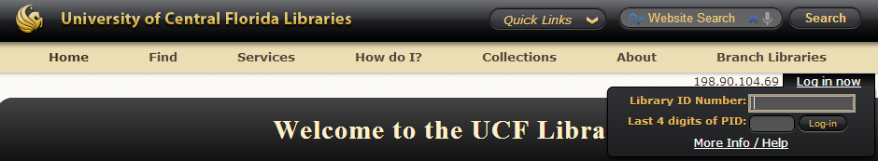
Figure 1
2) Enter your login information in the boxes provided (see Figure 1). Sometimes a login link may appear on the upper right corner. Your login info should be your Library Number (the number identified as Lib in your UCF card) and password of the last 4 digits in your PID (unless you have changed this before).

Note: Your browser most likely will want to add a proxy server to connect to the UCF campus. If it does allow this to occur, otherwise you won’t be able to access the library.
3) As can be seen in Figure 3, here you need to select on the find box the option that says Articles & Databases
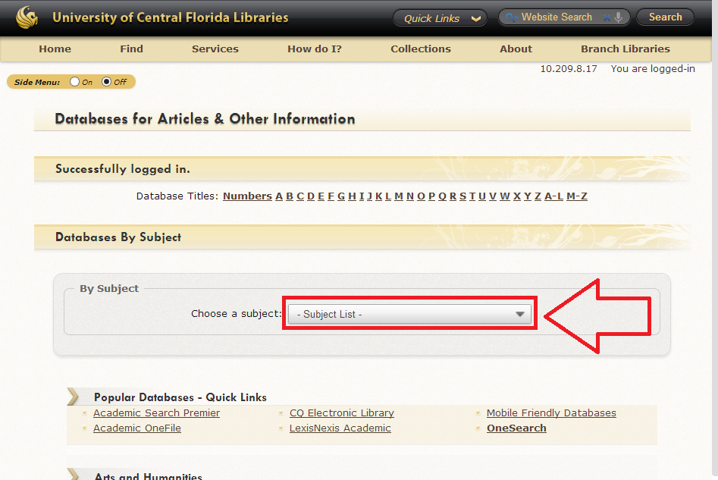
Figure 3

4) Now you can select a subject from the list box in Figure 4.

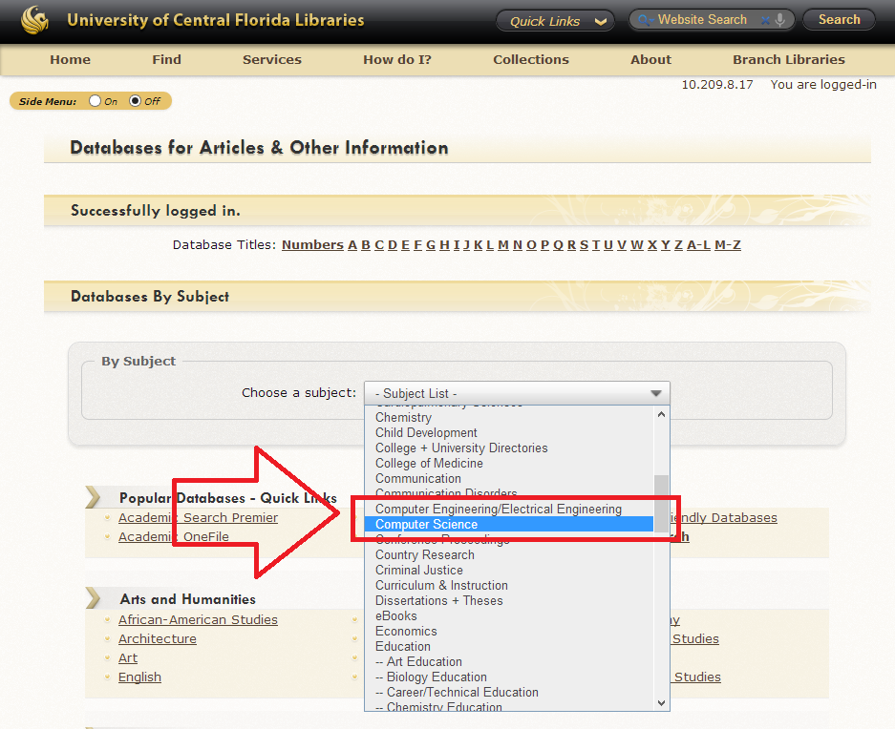

Figure 4

5) The recommendation would be to use either Computer Engineering/Electrical Engineering or Computer Science options (see Figure 4).

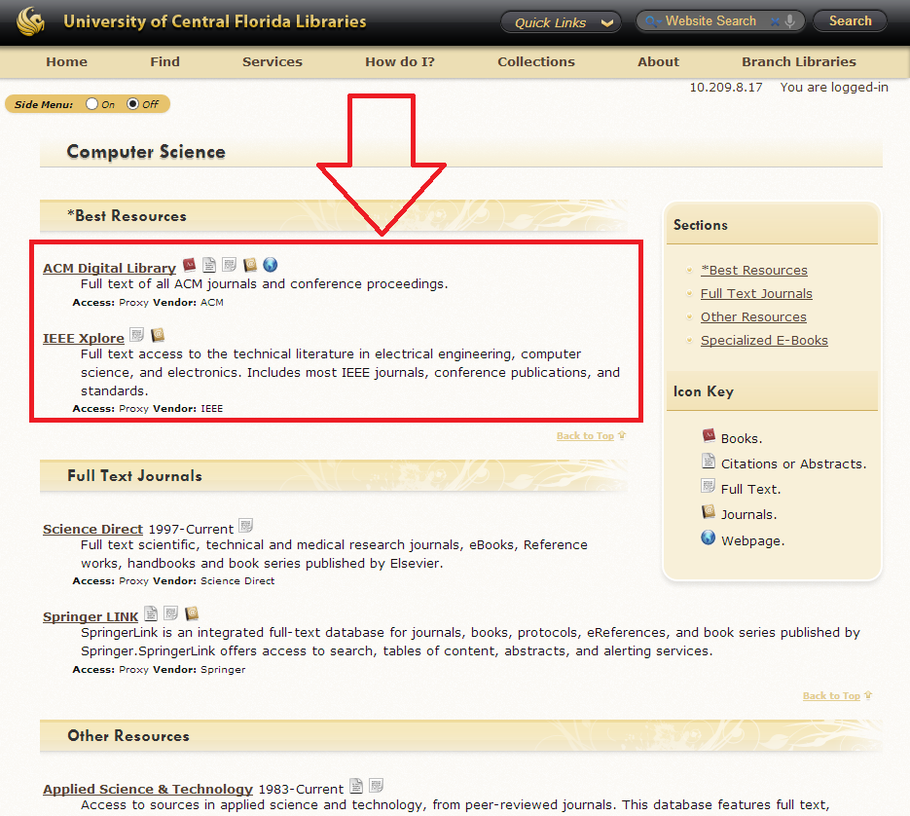

Figure 5

6) Now select your source of preference. Figure 5 shows where the IEEE Xplore and ACM Digital Library are located. Once you click on either link you will be transported to the IEEE/ACM website and from there on you will need to use their search bar (see Figure 6).

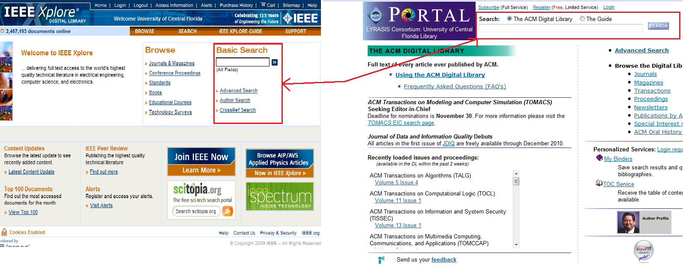

Figure 6

