COP 4331 - Fall 2014
Homework 3
Due: November 13, 2014

- No late submissions will be accepted
- Please submit the homework through Webcourses using the following format: COP4331_Fall14_HW#_LastName_FirstName.pdf, where # will be 1, 2, or 3.
- This homework assignment is an INDIVIDUAL assignment, not a team effort!!!

Problem statement:

Each student is required to choose a research paper from the list of recommended conferences or journals provided below by using UCF library resources and prepare a written report.

Recommended conferences and journals:
The papers should be chosen from the following conferences and journals:
- ACM Transactions on Software Engineering and Methodology (TOSEM)
- IEEE Transactions on Software Engineering
- SIGSOFT: Foundations of Software Engineering
- ICSE: International Conference on Software Engineering

- You can search and find papers by accessing the UCF library. Please see the instructions at the end of the homework.
- You can access the UCF Library from any of the labs on campus or you can access off campus by using your NID.

- You can determine whether a paper falls within your topic area by using the keywords given in the papers or title of the paper or simply reading and looking through the paper content. If you still cannot determine, please see the TAs for assistance.

- The report should have the following sections:
  - summary of the author’s contributions
  - strengths and weaknesses of the approach
  - suggested improvements

- Please note that the report should be written on your own words, copying sections directly from the research paper is strictly forbidden. The report should be as lengthy as it requires you to present your findings and opinions, longer report does not necessarily mean better!

- The deliverables include
  - The soft copy of the report
  - The web link to the soft copy of the chosen research paper such that TAs can review the paper– please note that the full citation of the paper is must be included in the cover page of the report
    - Full citation includes the following: author names, title of the paper, conference/journal name, page numbers, (volume, no for journals), month, year

Research topics:
The following software engineering areas will be researched by the students:
- Requirements and Specifications
- Design
- Implementation and Integration
- Maintenance
- Testing
- Software Metrics and Configuration Management
Research topic assignments:
The following presents the assignments of research paper areas to each student:

Students | Topic
 | Requirements and Specifications
  Name
  William Adkins
  Austin Alig
  Elizabeth Anderson
  Salim Andraos
  Kaan Arikan
  Parbattie Balkaran
  Christopher Beier
  Jonathan Bennett
  Thomas Bergens
  Alex Berliner
  Alan Birmaher
  Connor Boyle
  Jason Braswell
  Joseph Burfield
  Brianne Canonico
  Jonathan Carelli
  Nigel Carter
 | Design
  Christopher Chaffin
  Lakshmidhar Chigurupati
  Michael Chisolm
  James Choi
  Mathew Church
  Nicholas Cinti
  Raymond Cload
  Brian Cook
  Jonathan Coole
  Miguel Corona
  Mathew Cross
  Charles Dorer
  Darin Doria
  Evan Dorundo
  Jacob Duckett
  Zachary Duckett
  Luis Duque
 | Implementation and Integration
  Michelle Edwards
  Matthew Faller
  Charles Fannin
  Krystal Folkes
  Alex Gordon
  David Gundler
  Remo Gutierrez
  Tyler Harbin-Giuntoli
  Cindy Harn
  Oscar Hedblad
  Melissa Holguin
  Adam Hollifield
  Horia Ionescu
  Katie Jurek
  Benjamin Kirksey
  Michael Kirsche
  Christopher Kovaleski
 | Maintenance
  Roman Larionov
  Lance Lebanoff
  Logan Lebanoff
  Tyler Logsdon
  Megan Loyd
  Ivan Lugo
  James Luke
  Han Ly
  Mario Massad
  Montrel McCall
  Christopher Mccue
  Ramses Mederos
  Alexander Mena
  Andrew Mendoza
  Kyle Mera
  Julien Missial
  Robert Montalbano
 | Testing
  David Moore
  Shawn Morrison
  Sachin Nayee
  Ross Pape
  Michael Paulsen
  William Pearigen
  Paul Perdue
  Carlos Pereda
  Michael Pittman
  Ethan Pitts
  Megan Postava
  Jimmie Potts
  Pedro Poveda Quevedo
  Valerie Rabon
  Clifford Rice
  Jose Rivera
  Cody Showers
 | Software Metrics and Configuration Management
  David Sierra
  Sevena Skeels
  Matthew Smith
  Adam Stack
  Mitchell Taitano
  Charles Taylor
  Jason Tiller
  Tulio Troncoso
  Seiji Uchiyama
  Kyle Urquhart
  Brian Vermillion
  Ryan Villaflores
  Michael Wahlberg
  Brandon Workman
  Franklin Yi
  Ryan Zimmerman

Instructions on how to access UCF Library Resources:

Please use the UCF Library to search for articles; there should be no need to pay for any of the articles.

Step by step Instructions to search on the UCF Library:

1) Log into http://library.ucf.edu

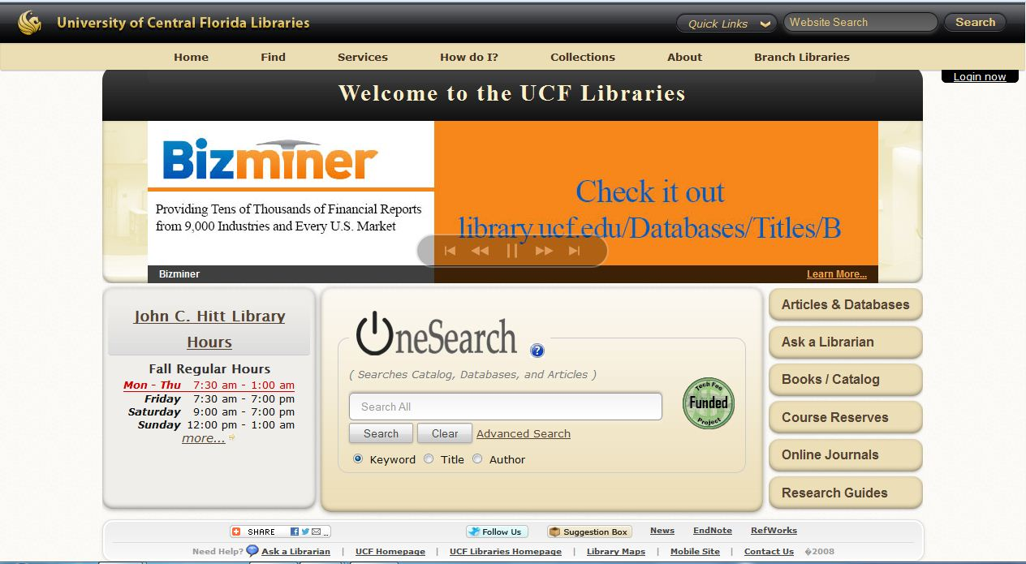
Figure 1

2) Enter your login information by clicking the log in button appear on the upper right corner. Your login info should be your NID and NID password. Once you click log-in the below page will be displayed. Enter your information.

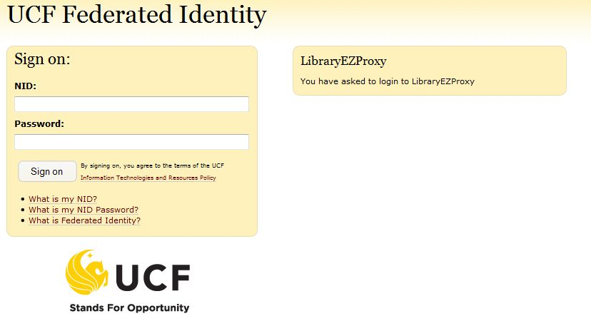
Figure 2
3) After successfull log in. We can see the below page. Where you can click the Engineering & Computer Science. Or you can scroll down to see Fig 4 and then click Computer Science. The recommendation would be to use either Computer Engineering/Electrical Engineering or Computer Science options.

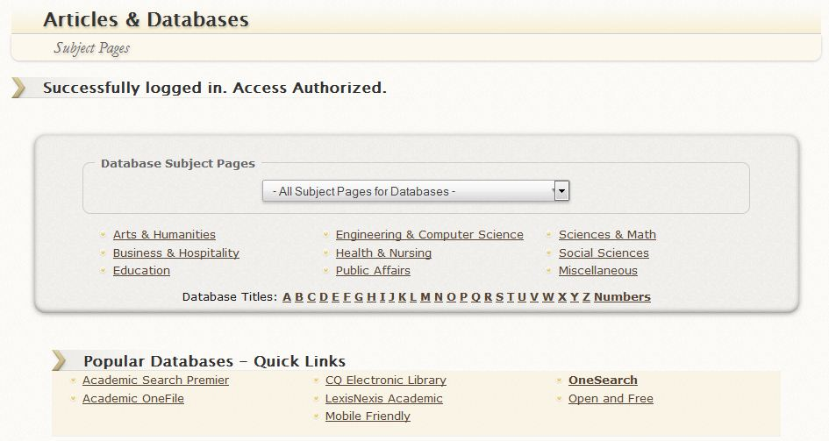

Figure 3
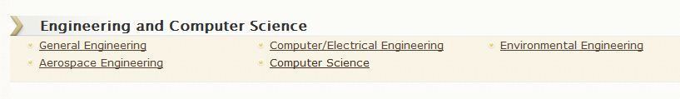

Figure 4

4. Now you can see the below page. Select any resource.

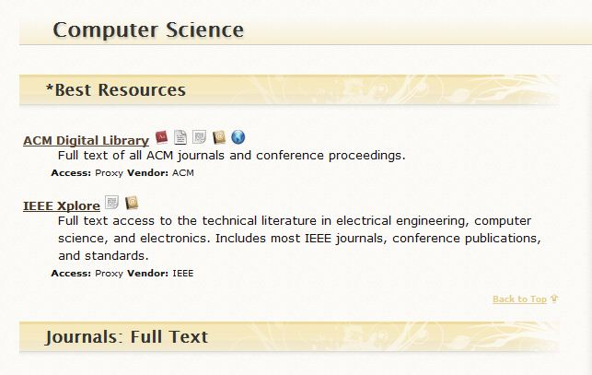
Figure 5

6) Now select your source of preference. Figure 5 shows where the IEEE Xplore and ACM Digital Library are located. Once you click on either link you will be transported to the IEEE/ACM website and from there on you will need to use their search bar (see Figure 6).

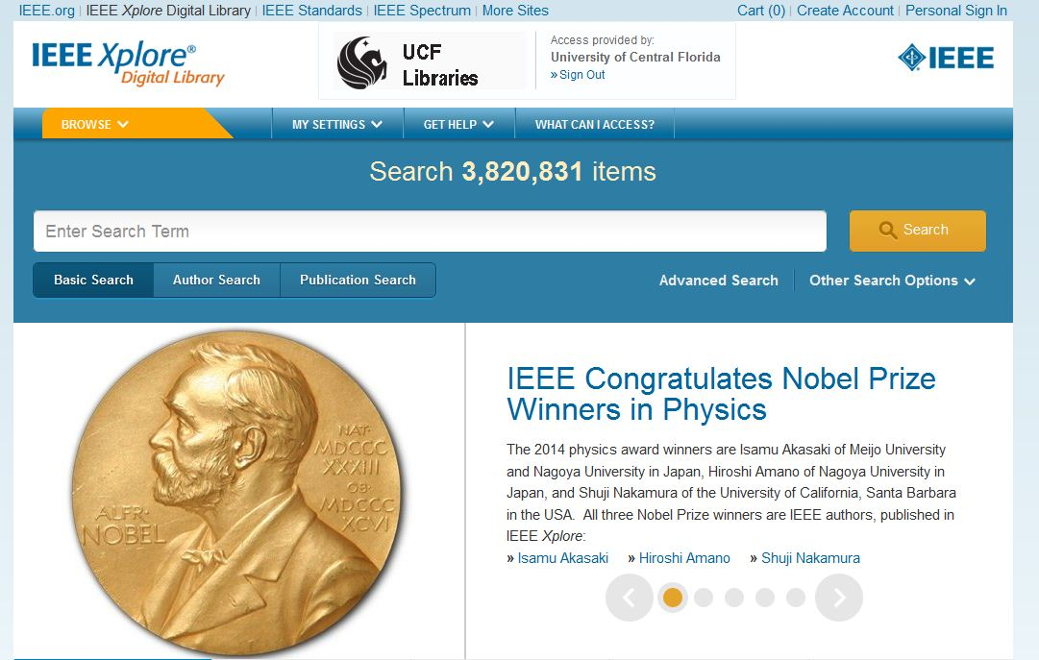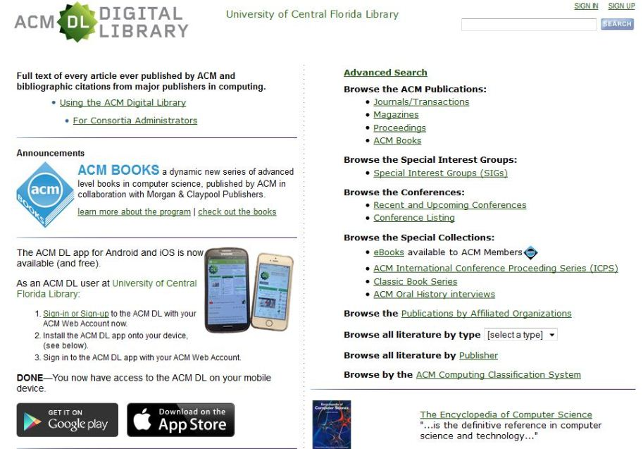

Figure 6

