COP 4331C- Fall 2010
Homework 3
Due: November 18th, 2010 (extended till November 23rd)

- Send the soft copy of your model to the TAs (hpagey@cs.ucf.edu or slmnkhokhar@gmail.com)
- The subject line should read COP 4331 Section (1 or 2) Homework 3 (note the spaces).
- All submissions must be a single file with .pdf extension
- No late submission will be accepted

Assignment statement:

Each student is required to choose a research paper from the list of recommended conferences or journals provided below by using UCF library resources and prepare a written report.

Recommended conferences and journals:
The papers should be chosen from the following conferences and journals:
- ACM Transactions on Software Engineering and Methodology (TOSEM)
- IEEE Transactions on Software Engineering
- SIGSOFT: Foundations of Software Engineering
- ICSE: International Conference on Software Engineering

- You can search and find papers by accessing the UCF library. Please see the instructions at the end of the homework.
- You can access the UCF Library from any of the labs on campus or you can access off campus by using your library ID number.

- You can determine whether a paper falls within your topic area by using the keywords given in the papers or title of the paper or simply reading and looking through the paper content. If you still cannot determine, please see the TAs for assistance.

- The report should have the following sections:
  - summary of the author’s contributions
  - strengths and weaknesses of the approach
  - suggested improvements

- Please note that the report should be written on your own words, copying sections directly from the research paper is strictly forbidden. The report should be as lengthy as it requires you to present your findings and opinions, longer report does not necessarily mean better!

- The deliverables include
  - The soft copy of the report
  - The web link to the soft copy of the chosen research paper such that TAs can review the paper– please note that the full citation of the paper is must be included in the cover page of the report
    - Full citation includes the following: author names, title of the paper, conference/journal name, page numbers, (volume, no for journals), month, year

Research topics:
The following software engineering areas will be researched by the students:
- Requirements and Specifications
- Design
- Implementation and Integration
- Maintenance
- Testing
- Software Metrics and Configuration Management
Research topic assignments:
The following presents the assignments of research paper areas to each student:

Section 001 Students | Section 002 Students | Topic
 |  | Requirements and Specifications
  Abassian,John T
  Allen,Charles Toshiro
  Angelidis,Niki
  Ashcroft-Thew,Jerome Lyon
  Banks,Karl Adam
  Barton,Laura Anne
  Behrenberg,Philip James
  Bhuiyan,Md Motiur
  Bieber,Robert David
  Birencwaig,Aaron M
  Boscacci,Justin Lee
  Acedera,Jordan K.
  Ali,Imran
  Amori,Mohammad Sami
  Arribas Jr,Isidro
  Augspurger,Justin A.
  Baldeck,Graham Joseph
  Bender,Jason
  Bertrand,Brent A
  Blythe,Christian A
  Brown,Kylie Rachelle
  Brunson,Christopher Gerard
  Calvo,Michael Faze
 |  | Design
  Bugallo,Bryan
  Caraballo,Arian
  Carroll,Thomas Alan
  Clark,Brian P.
  Colon,Hector Ricardo
  Conner,Thomas Paul
  Eberhardt,Joshua Uriah
  Estes,Joshua Batteh
  Forward,Colin Archer Martin
  Gamble,Benjamin Joseph
  Grisetti,James
  Cheban,Sergey Y.
  Cook,Joshua Tyler
  Crane,Clifton James
  Crane,Derek Scott
  Darios,Drem Silva
  Doherty,Daniel Michael
  Dugan,Andrew Richard
  Edison,John David
  Edwards,Jordan Elizabeth
  Esclamado,Flor Leonard E.
  Foreste,Hawk
  Fraser II,Stephen Colby
 |  | Implementation and Integration
  Harmic,Andrew Vincent
  Harrison,Steven Robert
  Heintz,Jason Peter
  Higginbotham,Robert Stephen
  Hochreiter,Jason Eric
  Huereca,Matthew Cory
  Kittelson,Amos Benjamin
  Kuo,Tzu-Wei
  Laborde,Pierre
  Lora,Anthony
  Manis,Charles Richard
  Funchess,Michael Aubrey
  Gilbert Jr,Donald Victor
  Goldberg,Steven Carl
  Golden,Zachary Ross
  Gomez,Nicholas
  Hernandez,Brian
  Judd,Danielle
  Kafalas,Thomas David
  Kilgore,Dennis Blake
  Klein,Aaron Robert
  Lopez,Michael B
  Luaders,Anthony Benjamin
 |  | Maintenance
  Masson,Jeffrey Raymond
  McCall,Angela N
  McCall,Corey Scott
  Mendez,Britney Marie
  Mosley,Shaun Willie
  Munoz,Sandra Patricia
  Muzac,Mickenson
  Nichols,Steven Andrew
  Olsen,Eric Daniel
  Oppold,Peter J.
  Orchard,Christopher Marshall
  Lubonty,Joseph John
  Lunder,Joseph E
  Luu,Amber Nicole
  Mancini,Alejandro Alberto
  McConnell,Ryan
  McKeown,Christopher Darren
  McVey,Travis Scott
  Miller,Brent Michael
  Moran Jr,John J
  Mota,Daniel
  Myron,Jeffrey S
  Newton II,Charles Lewis
 |  | Testing
  Orlando,Dana Marie
  Peery,Jacob Miles
  Phillips,Britt Daniel
  Porter,Kevin Eugene
  Rivas,Jorge Alejandro
  Rodriguez,Hector Enrique
  Rodriguez,Stephen Kurt
  Romano,Claudio Anibal
  Thornton,Sean Kevin
  Scheuringer,Kurt
  Starnes,Elizabeth Kelly
  Pagliari,Andrew James
  Pereira,Renan C
  Plyler,Daniel Malone
  Quicker,Michael
  Rees,Christopher Robert
  Sands,Ryan J
  Santiago,Kenneth
  Schwyzer,Robert James
  Semeniuk,Michael C
  Shah,Chintan Gautam
  Sisco,William John
  Tonner,Peter David
 |  | Software Metrics and Configuration Management
  Stewart,Robert William
  Sullivan Jr,John McGraw
  Taylor,Patrick W
  Thornton,Sean Kevin
  Umran,Firoz
  Weaver,Brandon Sean
  Yeung,David P.
  Zainal,Zeyad Abdulmunem
  Zaino,Tyler Leonard
  Zawadski,Richard Aaron
  Torres,John Anthony
  Tran,Tri Phuoc
  Uphoff,Matthew M
  Van,Moi
  Velasquez Avila,Diego
  Velazquez-Rodriguez,Wilfredo
  Williams,Samuel Paul
  Wiseman,Justin Alexander
  Wolas,Christopher A.
  Wronski,Nicholas David

Instructions on how to access UCF Library Resources:

Please use the UCF Library to search for articles; there should be no need to pay for any of the articles.

Step by step Instructions to search on the UCF Library:

1) Log into http://library.ucf.edu

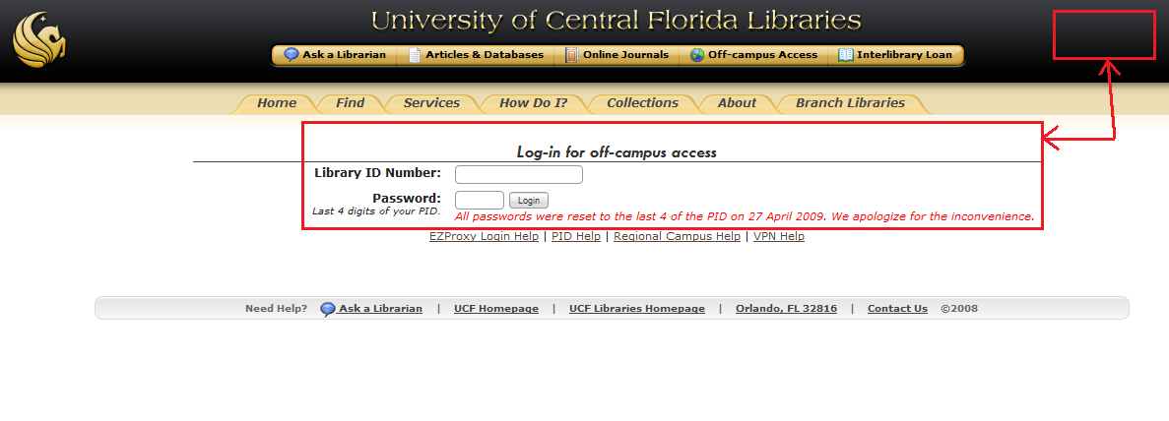
Figure 1
2) Enter your login information in the boxes provided (see Figure 1). Sometimes a login link may appear on the upper right corner. Your login info should be your Library Number (the number identified as Lib in your UCF card) and password of the last 4 digits in your PID (unless you have changed this before).

Note: Your browser most likely will want to add a proxy server to connect to the UCF campus. If it does allow this to occur, otherwise you won’t be able to access the library.

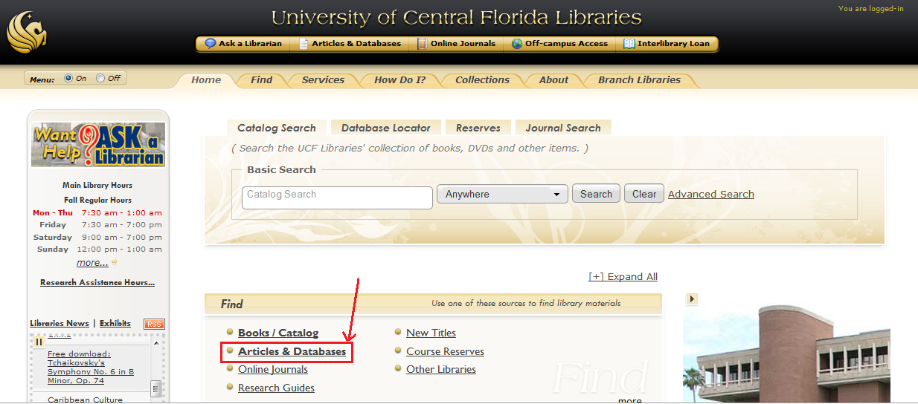
Figure 2

3) As can be seen in Figure 3, here you need to select on the find box the option that says Articles & Databases

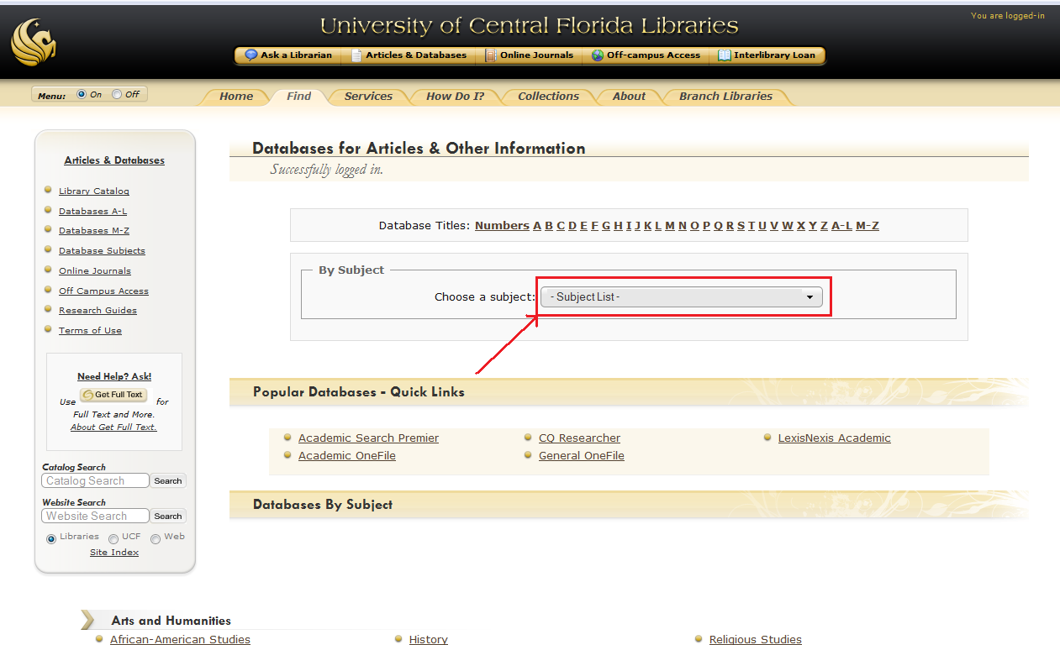

Figure 3

4) Now you can select a subject from the list box in Figure 4.

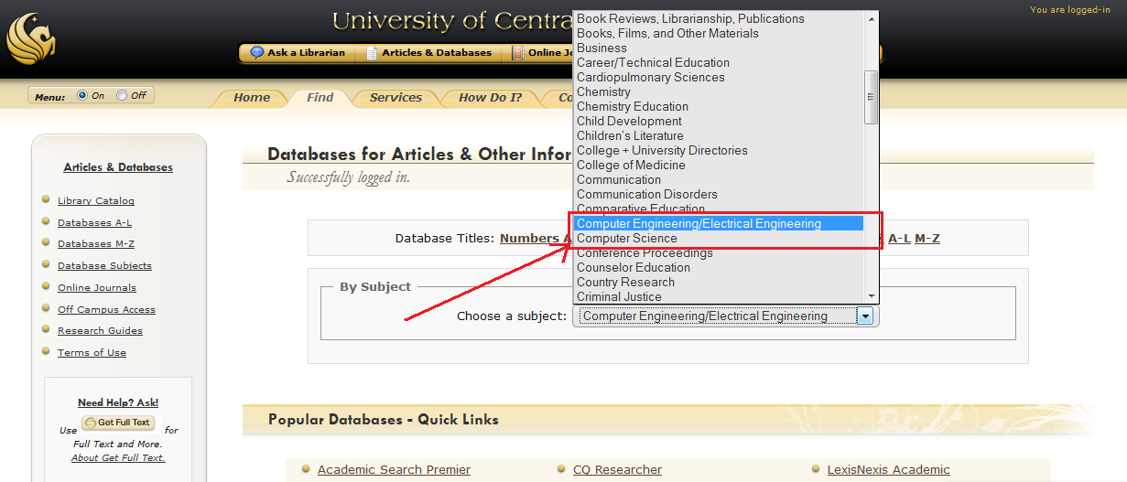

Figure 4

5) The recommendation would be to use either Computer Engineering/Electrical Engineering or Computer Science options (see Figure 4).

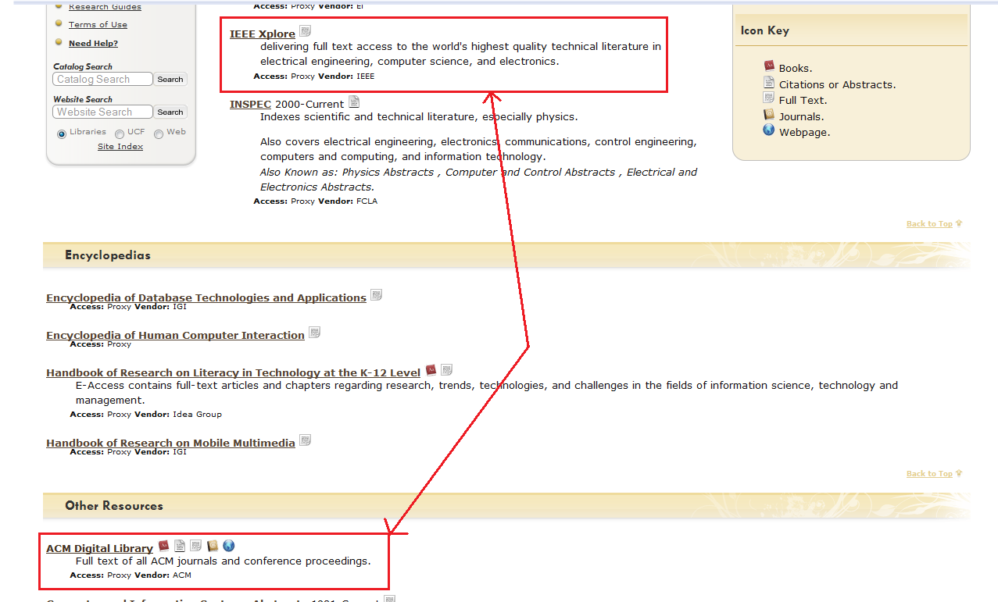

Figure 5

6) Now select your source of preference. Figure 5 shows where the IEEE Xplore and ACM Digital Library are located. Once you click on either link you will be transported to the IEEE/ACM website and from there on you will need to use their search bar (see Figure 6).

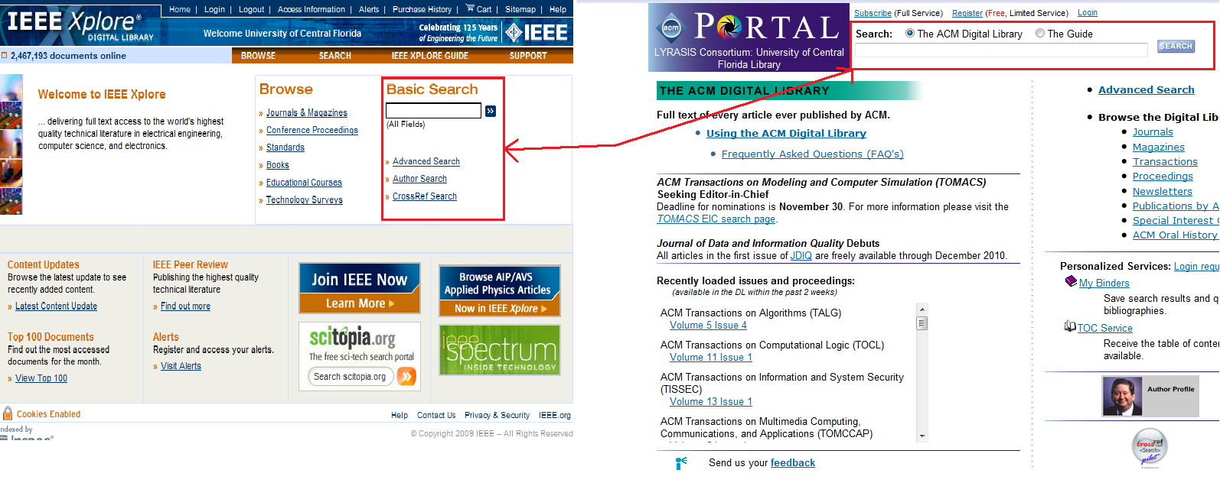

Figure 6

