COP 4331C- Fall 2009
Homework 3
Due: December 3, 2009

- A hard copy has to be handed in to the instructor at the beginning of the class period.
- Send the soft copy of your model to the email address of the TA (hlugo@eecs.ucf.edu, apetkova@cs.ucf.edu)
- No late submission will be accepted

Assignment statement:

Each student is required to choose a research paper from the list of recommended conferences or journals provided below by using UCF library resources and prepare a written report. The hard copy of the written report and the hard copy of the research paper must be turned in to the instructor.

Recommended conferences and journals:

The papers should be chosen from the following conferences and journals:
- ACM Transactions on Software Engineering and Methodology (TOSEM)
- IEEE Transactions on Software Engineering
- SIGSOFT: Foundations of Software Engineering
- ICSE: International Conference on Software Engineering

- You can search and find papers by accessing the UCF library. Please see the instructions at the end of the homework.
- You can access the UCF Library from any of the labs on campus or you can access off campus by using your library ID number.

- You can determine whether a paper falls within your topic area by using the keywords given in the papers or title of the paper or simply reading and looking through the paper content. If you still cannot determine, please see the TAs for assistance.

- The report should have the following sections:
  - summary of the author’s contributions
  - strengths and weaknesses of the approach
  - suggested improvements

- Please note that the report should be written on your own words, copying sections directly from the research paper is strictly forbidden. The report should be as lengthy as it requires you to present your findings and opinions, longer report does not necessarily mean better!

- The deliverables include
  - The hard copy of the report
  - The hard copy of the chosen research paper – please note that the full citation of the paper is must be included in the cover page of the report
    - Full citation includes the following: author names, title of the paper, conference/journal name, page numbers, (volume, no for journals), month, year

Research topics:
The following software engineering areas will be researched by the students:
- Requirements and Specifications
- Design
- Implementation and Integration
- Maintenance
- Testing
- Software Metrics and Configuration Management
Research topic assignments:
The following presents the assignments of research paper areas to each student:

Students | Topic
Adam Holbrook  Afsaan Kermani  Alan Beauchamp  Alex Bermudez  Amy Meckes  Andrew Lichenstein  Angela Johnson  Austin Montoya  Bobby Millward  Brian McAuliffe | Requirements and Specifications
Chris Campbell  Chris Heyman  Curtis J. Laketek  David Calllies  David Weston  Diana E. Escobar-Pazo  Diego Nunez  Elroy Ashtian  Eric Tryon  Francis Luna  Frank Bruno | Design
Garrett Lund  Geoff Huston  Hazel P. Madolid  James Sexton  Jason Blackford  Jason Miller  Jason Morse  Johanna Vasquez  Jose Suarez  Joshua West  Justin Doll | Implementation and Integration
Kevin Tiller  Lisa B. Soros  Logan Skiles  Marc Camilien  Mark Hull  Mark Taylor  Matt Fontaine  Matthew Campbell  Matthew Znoj  Michael J Bernard | Maintenance
Michael Schutz  Michelle Renert  Nathaniel Boucher  Nick Rimer  Paul Setlak  Raeginald Timones  Ryan Hall  Ryan Senesac  Stephanie M. Day  Stephen Smith | Testing
Steven Bularca  Steven Robertson  Temesgen Tewolde  Tim Cronin  Timothy Holley  Todd Denton  Travis Blanchette  Willie J. Stephens  Yazen Ghannam  Zhen Cai | Software Metrics and Configuration Management

Instructions on how to access UCF Library Resources:

Please use the UCF Library to search for articles; there should be no need to pay for any of the articles.

Step by step Instructions to search on the UCF Library:

1) Log into http://library.ucf.edu

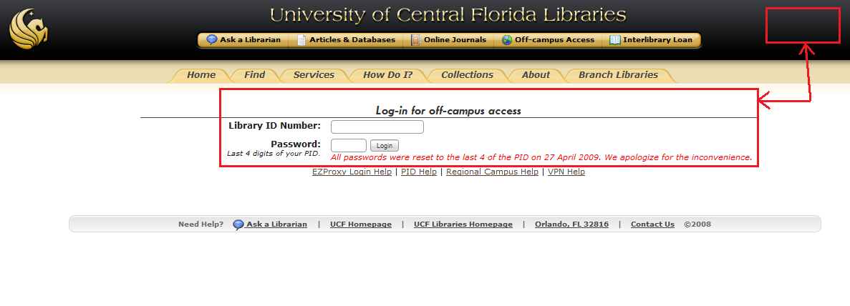
Figure 1
2) Enter your login information in the boxes provided (see Figure 1). Sometimes a login link may appear on the upper right corner. Your login info should be your Library Number (the number identified as Lib in your UCF card) and password of the last 4 digits in your PID (unless you have changed this before).

Note: Your browser most likely will want to add a proxy server to connect to the UCF campus. If it does allow this to occur, otherwise you won’t be able to access the library.

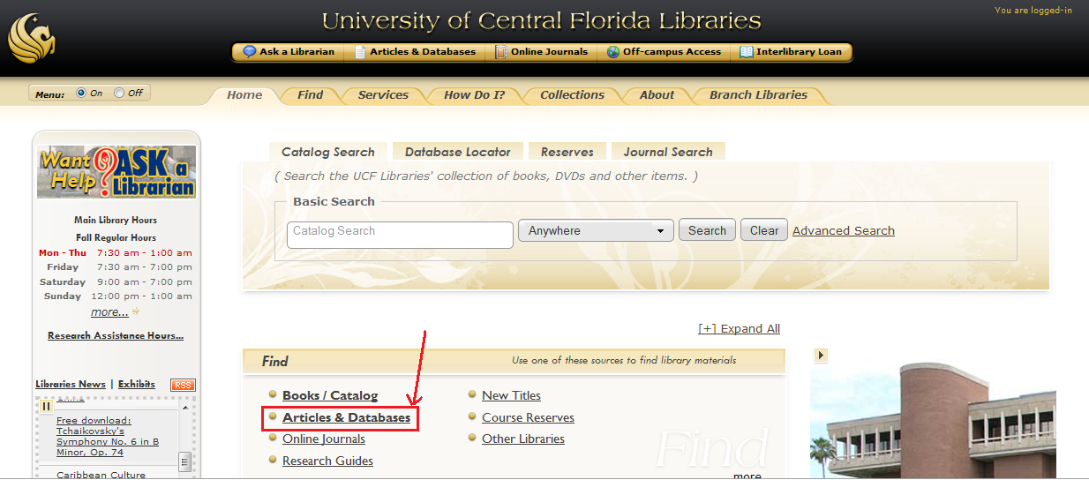
Figure 2

3) As can be seen in Figure 3, here you need to select on the find box the option that says Articles & Databases

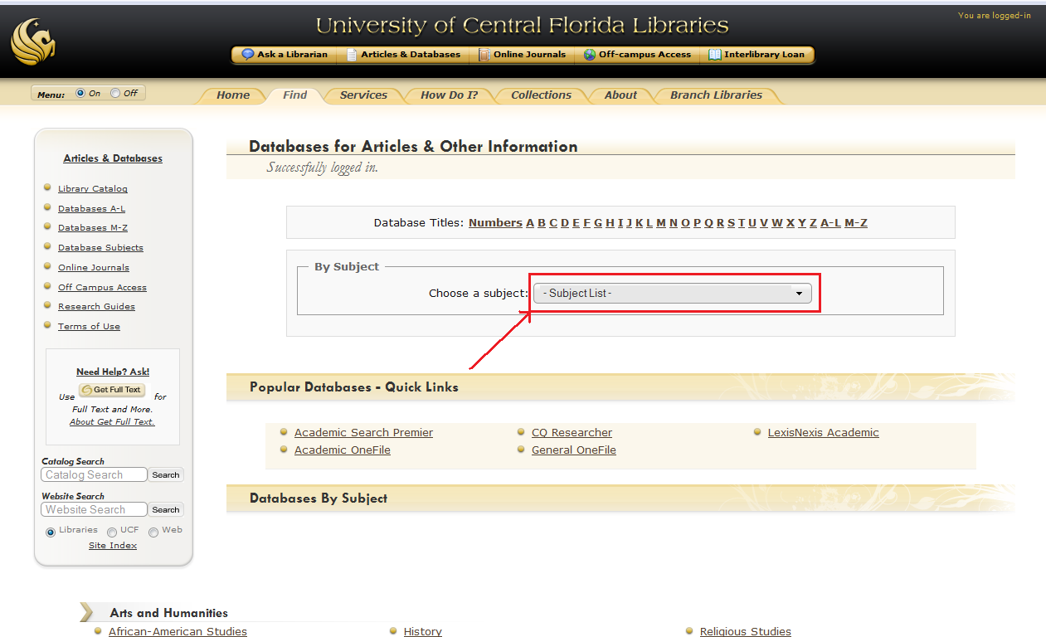

Figure 3

4) Now you can select a subject from the list box in Figure 4.

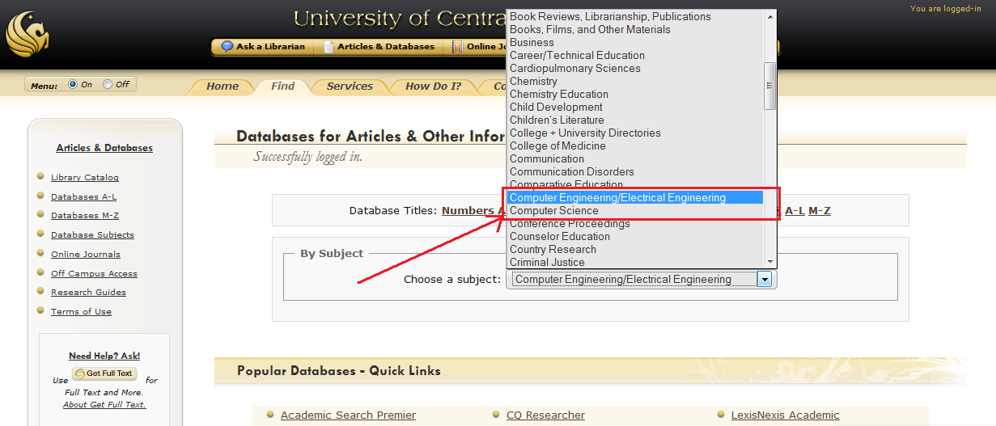

Figure 4

5) The recommendation would be to use either Computer Engineering/Electrical Engineering or Computer Science options (see Figure 4).

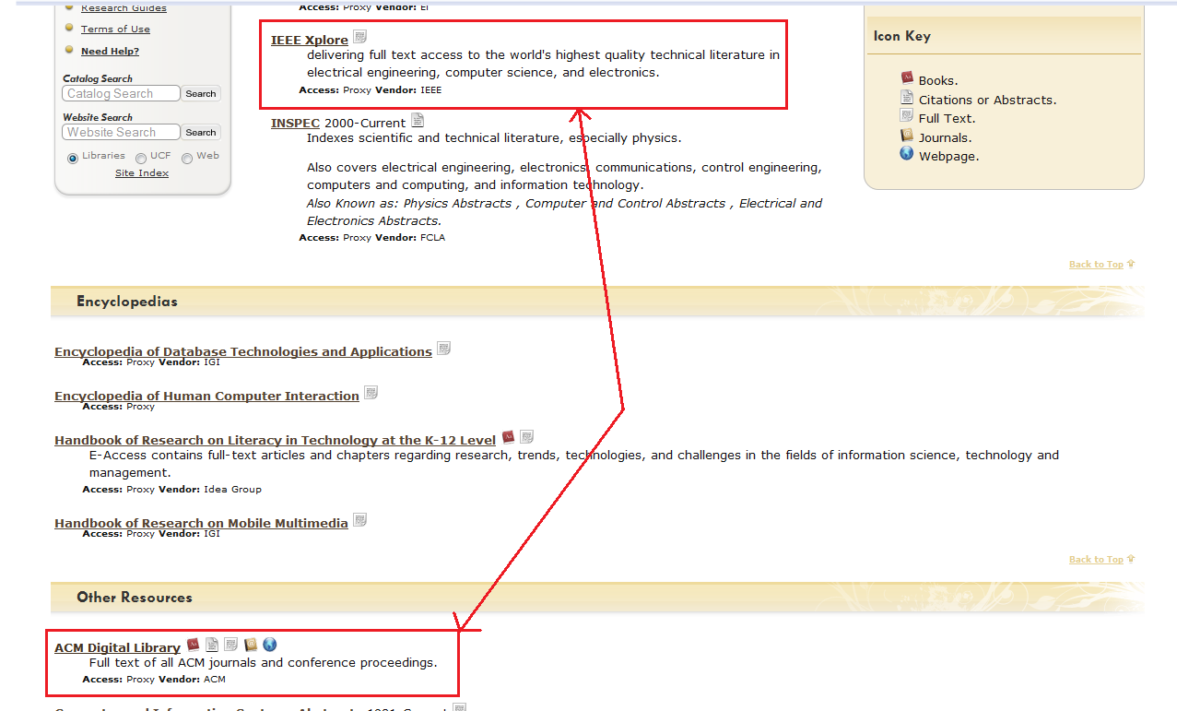

Figure 5

6) Now select your source of preference. Figure 5 shows where the IEEE Xplore and ACM Digital Library are located. Once you click on either link you will be transported to the IEEE/ACM website and from there on you will need to use their search bar (see Figure 6).

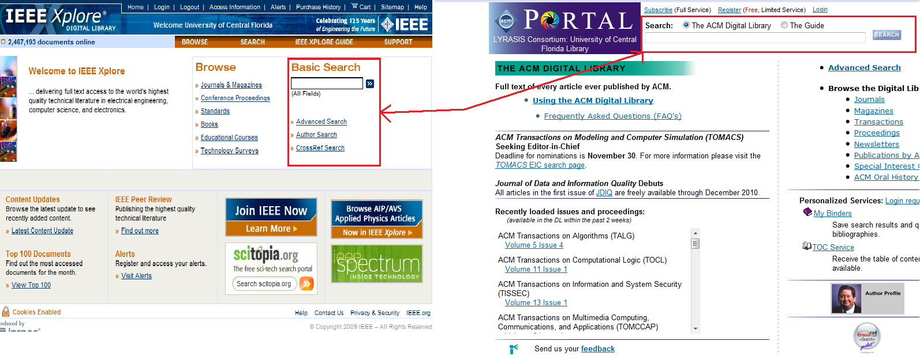

Figure 6

