COP 4331- Fall 2009
Homework 2
Due: October 29, 2009

- A hard copy has to be handed in to the instructor at the beginning of the class period.
- Send the soft copy of your model to the email address of the TA (hlugo@eecs.ucf.edu, apetkova@cs.ucf.edu)
- No late submission will be accepted

Problem statement:

You are asked to enhance the registration system designed in previously on Homework 1. The administration wants you to make a waiting list system for cases when high demanding courses are full and more students want to take them. The following sequence diagram shows what the adding course process will look like:

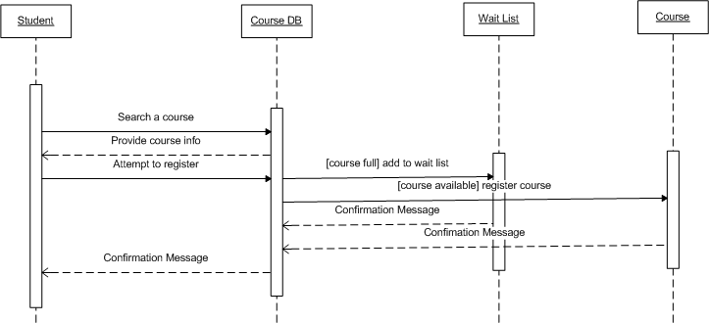

After the preliminary registration process is finished (i.e. registration deadline passes prior to start of classes) the system will pass by the waiting lists and add the first N students that are on the list where N is the number of available spaces, whether a new section is opened or some spaces are freed. The problem is that this waiting list does not follow a first come first serve policy. In fact it the turns will be based on priorities. Students that will graduate on the same academic year will have the highest priority, followed by students that have taken the course the least times (0, 1, 2, 3, …, etc.). Of course the system can always be administratively overridden in case something goes wrong.

Question:

You are required to provide an implementation for this system and simulate its behavior. You will need to hand in:

- Correct class diagram of the waiting list system (be sure that everything that appears in the description can be seen at the diagram)
- Implementation of all the classes in the class diagram (using an Object Oriented language)
- Documentation following a coding standard (e.g. Java Coding Standard)
- Implementation of an example scenario
    - Course has 5 available spaces
    - 10 students are entered (5 of them should enter the waiting list), info of these 5 is provided bellow, note that the first 5 doesn’t matter their info because they will find the space to register:
      - Sophomore taking the course for the 3rd time
      - Senior taking the course for the 2nd time
      - Freshman taking the course for the 1st time
      - Junior taking the course for the 1st time
      - Senior taking the course for the 1st time
    - 3 of the registered students will drop out of the course (doesn’t matter which)
    - Waiting list system will fill any available spaces with the students at the list according to their order
    - Administrator ends up adding manually one student, follow the priority convention for this one (there should be one out, which one?)
    - Print the left out student and the list of registered students

Hints:

- The java coding standard can be found at: http://java.sun.com/docs/codeconv/.

