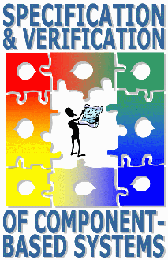 | Call for Papers
 | SAVCBS'05
Workshop at
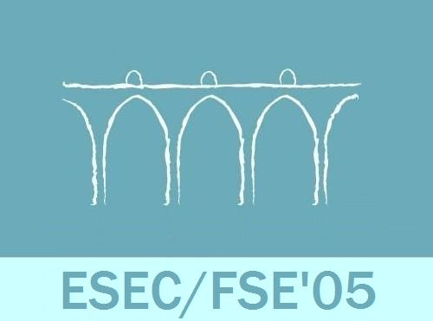
September 5-6, 2005
The fourth workshop on specification and verification of component-based systems is affiliated with ESEC/FSE'05 and will be held at the Campolide campus of the New University of Lisbon, Portugal, September 5-6, 2005. Seven page papers are due on June 20, 2005.

Theme and Topics of Interest
SAVCBS is focused on using formal (i.e., mathematical) techniques to establish a foundation for the specification and verification of component-based systems. Suggested research topics of interest include (but are not limited to):
- Techniques for component-based verification or reasoning
- Component-based specification languages
- Static analysis, advanced type systems, or model checking of components and component compositions
- Verification-oriented design methodologies for components
- Dynamic checking techniques, including run-time assertion or property checking
- Specification and verification of non-functional component behavior (performance, memory, concurrency, etc.)
- Unifying formal descriptions of concurrency properties with model-based behavioral descriptions of components
- Balancing tradeoffs (automatic/manual verification, soundness/completeness, static/dynamic verification, testing/formal verification, scalability/coverage, etc.)
- Theories of component composition
- Industrial experience, such as adoption issues, with formal techniques for component-based systems
- Case studies of applying formal techniques to component based systems
- Educational experience or tactics for formal approaches to component-based systems
Submissions should outline the current state of research or practice, describe the most pressing shortcomings, and formulate goals for future development.

Submissions
Submissions must not exceed 7 pages. We encourage, but do not require, use of the ACM Conference format. Please add page numbers to your submission, to make adding comments easier. Papers will be accepted in PDF or Postscript formats. Papers will be submitted on-line at http://www.paperdyne.com/savcbs05.html.

Important dates
Submission deadline: June 20, 2005
Early registration (with hotel) deadline: July 1, 2005
Notification date: July 18, 2005
Final versions: August 1, 2005

Workshop Paper Selection Committee:
- Gary T. Leavens, chair (Iowa State)
- Jonathan Aldrich (Carnegie Mellon)
- Mike Barnett (Microsoft Research)
- Betty H. C. Cheng
- Steve Edwards (Virginia Tech)
- Cormac Flanagan (Univ. Calif. Santa Cruz)
- Dimitra Giannakopoulou (NASA Ames/RIACS)
- Gerard J. Holzmann (NASA/JPL)
- Joe Kiniry (University College Dublin)
- K. Rustan M. Leino (Microsoft Research)
- Jeff Magee (Imperial College, London)
- Peter Müller (ETH Zürich)
- Corina Pasareanu (NASA Ames Research Center)
- Erik Poll (Raboud University Nijmegen)
- Andreas Rausch (University of Kaiserslautern)
- Robby (Kansas State)
- Wolfram Schulte (Microsoft Research)
- Natasha Sharygina (Carnegie Mellon)
- Murali Sitaraman (Clemson)

Web Page:
See http://www.cs.iastate.edu/SAVCBS/ for more details.

