REU Summer 2013

Assignments. Session 1-2

1) Using the Matlab rgb2hsv function, write a program to display the individual hue, saturation and value channels of a given RGB colour image

Help:



2) Considering the Roberts and Sobel edge detectors (see slides), apply them to three-channel RGB images and display the results. Display the results as a three-channel colour image and as individual colour channels (one per figure).

Note how some of the edge responses relate to distinct colour channels or colours within the image. When an edge is visible in white in the edge-detected three-channel image, what does this mean? Repeat this task for the HSV colour space. How do the results differ in this case?

3) In the code that calculate the Smoothing Gaussian, the filtering (convolution) is performed in 2 steps: temp=conv2(double(image),double(gaussiano),'same');  
smooth=conv2(double(temp),double(gaussiano),'same');

instead of a single convolution of a rectangular Kernel. Why do you think it was done in this way? How could you build the Sobel Kernel in the same way?.

4) Create a function to perform Laplacian of Gaussian using separability.

5) Implement your own canny edge detector using the steps described in class.

a) Smooth image with a Gaussian filter

b) Compute derivative of filtered image

c) Find magnitude and orientation of gradient

d) Implement a non-maximal suppression.

6) Implement the filter or combinations of filters, thresholding, equalization, resizing, griding or any in your mind to produce a text as readable as possible of the following images (See files)

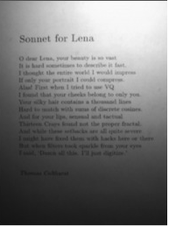

C:\Users\gonzalo\Documents\REU2013\Session2\text2.jpg