COT 4210 Final Exam 8/1/2012

Name: ______________________________________

1) (15 pts) Using the algorithm in the textbook, convert the following NFA into a DFA that accepts the exact same language. No need to draw any unreachable states in the resulting DFA.

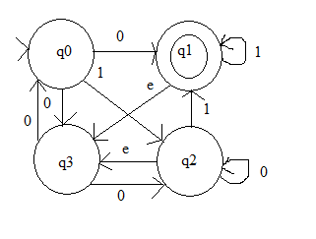

2) (10 pts) Using the algorithm in the textbook, convert the regular expression below into an NFA that describes the same language. Make sure to put in the epsilon transitions as dictated by the algorithm, even if they don't seem necessary.

$\left(a∪b\right){\left(a∪ab\right)}^{*}\left(b∪ε\right)aa$

3) (10 pts) Create an PDA that accepts the same language as described by the grammar below, using the algorithm covered in the textbook.

S → AB | 0
A → AAB | 11 | ε
B → ABS | 10 | 01

4) (15 pts) Let L = { a^{i}b^{j}c^{k} | j > i and j > k }. Is L a Context Free Language? Prove your answer.

5) (15 pts) Let L = { <D, M> | D is a DFA and M is a Turing Machine such that L(M) = L(D) } Is L decidable? Prove your answer.

6) (15 pts) Using the 3-SAT ≤_{P} SUBSET-SUM reduction shown in the textbook, transform the following Boolean formula in 3-CNF into a set of integers and a target value.

$$(a∨\overline{b}∨c)∧(\overline{a}∨b∨c)∧(a∨\overline{b}∨\overline{c})∧(\overline{a}∨\overline{b}∨c)∧(a∨b∨\overline{c})$$

7) (15 pts) Let PARTITION-DIFF = { <S, t> | S is a set of positive integers that can be partitioned into two sets U and V such that the sum of the elements in U minus the sum of the elements in V equals t.} Prove that PARTITION-DIFF is NP-COMPLETE. (Note: A partition of a set is when each element in the original set is placed into exactly one of two sets. The two resulting sets are the partition of the first. For example, a possible partition of the set {2, 9, 6, 5, 12} is {2, 6, 5} and {2, 12}. The difference for this particular partition is 1.

8) (5 pts) Michael Phelps won his 19th Olympic medal recently in the 4 x 200 freestyle relay. Of those 19 medals, 2 are silver and 2 are bronze. How many of them are gold?

____________
Scratch Page - Please clearly label any work on this page you would like graded.

