Spring 2015 COT 4210 Exam #1
February 19, 2015

Name: __________________________________

1) (10 pts) Design a DFA that accepts the following language over the alphabet {a, b}: L = { w | w has exactly one occurrence of the substring "aa".} Express your DFA as a state diagram drawing. Make sure to label the start state, all accept states and all transitions clearly. Note: the number of substrings of length 2 in a string of length n is n-1. Thus, two different substrings in a string may overlap and share characters in common.

2) (15 pts) Using the algorithm shown in the text to convert the NFA below to an equivalent DFA that accepts the same language. Remember to only create the "reachable" states in the DFA to save time.
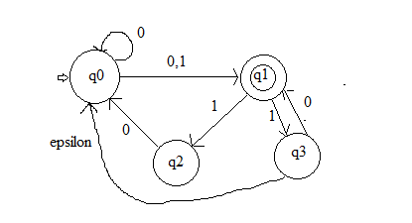

3) (15 pts) Consider the process of converting a DFA to a regular expression that expresses the same language. The initial DFA has states q0, q1 and q2. In the beginning of the process states S and F are added, with an epsilon transition from S to the start state of the DFA, q0, and epsilon transitions from the accept states q1 and q2 to F. Finally, F is denoted as the only accept state. After ripping out q1, the 4 state GNFA looks like this:

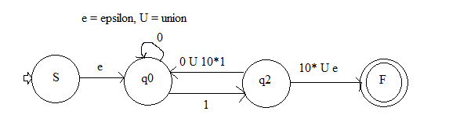
Complete the process of determining the equivalent regular expression by first ripping out q0, followed by ripping out q2. (Note: credit will be taken off for ripping the states in the opposite order, so please follow these directions.)

4) (10 pts) In class we proved that the language $L_{1}=\{0^{n}|n∈Primes\}$ over the alphabet {0} was not regular. Utilizing this result, show that the language $L_{2}=\{0^{n}|n∈Composite\}$ is not regular. (Note: for the purposes of this question, composite numbers are positive integers greater than 1 that can be expressed as a product of two non-necessarily distinct integers, neither of which is the number itself.) Do not use the pumping lemma in your proof. Try to use an indirect method that is easier. For a bit of extra credit, explain why using the pumping lemma to show this language isn't regular directly is problematic.

5) (15 pts) The context free grammar below is in the process of being converted to Chomsky Normal Form. In the form below, a separate start state has been added, but epsilon rules haven't been removed. Show the result of removing these epsilon rules.

S₀ → S
S → ABC | a | BB | C
A → ab | cC | ε
B → BC | BCB | ACA | ε
C → c | CA | CB

6) (15 pts) Consider the language of valid matching parentheses taken from the alphabet { '(', ')', '[', ']' }. An example of a string in the language is ([()()[()]]). Design a PDA to accept this language. Note: your PDA should accept the empty string. Show the state diagram of your PDA clearly illustrating all six parts in the formal definition of all PDAs. Note: The only character that can close an ‘(‘ is ‘)’ and the only character that can close an ‘{‘ is ‘}’. Thus, (} is NOT a valid string in this language.

7) (15 pts) Let $L=\left\{a^{i}b^{j}c^{k}\right|i ≥j≥k\}$ over the alphabet {a, b, c}. Using the Pumping Lemma for Context Free Languages, prove that L is not context-free.

8) (5 pts) What is the first ingredient listed on the list of ingredients for a granola bar?

_________________
Scratch Page - Please clearly mark any work on this page you would like graded.

