COT 4210 (Discrete Structures II) Exam #1
February 9, 2012

Name: ___________________________________________

Note: Please justify your answer to each question. No answer, even if it is correct, will be given full credit without the proper justification.

1) (15 pts) Let L, over the alphabet {a,b,c}, be described by the regular expression

$\left(ε∪a∪aa\right)\left(ε∪b∪bb\right)\left(ε∪c∪cc\right)$.

Create a DFA that accepts the exact same set of strings described by this regular expression. (Note: Do NOT use the R.E to DFA algorithm. Rather, just determine what the language is and try to create DFA for it.) Clearly label the start state, all accept states and all transitions. Briefly justify why the DFA you have created accepts this language, exactly.

2) (10 pts) Construct an NFA over the alphabet {a,b,c} that recognizes the language described by the regular expression a*b*c*. Clearly label the start state, all accept states and all transitions. Briefly justify why the NFA you have created accepts this language, exactly.

3) (15 pts) Consider converting a DFA to a regular expression. In the process, a GNFA is created and the states of the GNFA are ripped out one by one. The picture below represents a GNFA with four states: s, 1, 2, and f, where s is the designated start state and f is the designated accept state. Using the algorithm shown in class for ripping out a state from a GNFA, show the result of ripping out state 1.
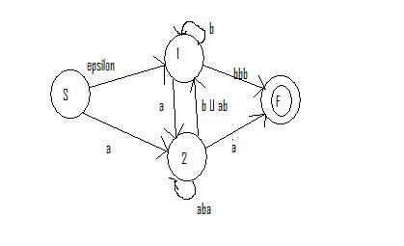

4) (10 pts) Prove that the following language over the alphabet {0, 1} is NOT regular via the Pumping Lemma:

L = { 0^{2n}1^{n} | n ≥ 0 }

5) (20 pts) Prove that the following language over the alphabet {0, 1} is NOT regular via the Pumping Lemma:
L = { w | w contains a different number of 0s and 1s }

Note: This question is more difficult than the previous one. The trick is that somehow, no matter what the substring y is, that there will be an integer number of times you can pump it so that the number of 0s and 1s becomes equal.

6) (15 pts) Define w^{R} to be the reverse string of w. A palindrome is any string w such that w = w^{R}. Thus, if w = 1101, then w^{R} = 1011. Create a PDA over the alphabet Σ ={0,1} that accepts the following language:

L = { w | w is a palindrome, ie w = w^{R} }

Clearly indicate the start state, accept states, extra characters in the tape alphabet, and mark the transitions as indicated in the textbook (char read, char pop → char push).

7) (14 pts) True/False: Determine if the following statements are true or false. (Each one is two points.) Circle your choice.

a) If L₁ and L₂ are regular languages TRUE FALSE
then L₁ $∪$ L₂ is a regular language.

b) If L₁ and L₂ are NOT regular languages TRUE FALSE
then L₁ $∪$ L₂ is NOT regular language.

c) If L₁ and L₁ $∪$ L₂ are regular languages, TRUE FALSE
then L₂ is a regular language.

d) If L₁ and L₂ are context free languages, TRUE FALSE
then L₁ $∪$ L₂ is a context free language.

e) If L₁ and L₂ are context free languages, TRUE FALSE
then L₁ $∩$ L₂ is a context free language.

f) L = { w | w contains the same number of TRUE FALSE
occurrences of 01 and 10}. L is regular.

g) L = { w | w contains the same number of TRUE FALSE
occurrences of 00 and 11}. L is regular.

8) (1 pt) Name one type of food served at Fuji Sushi. ______________________
Scratch Page – Please clearly mark any of the work on this page you would like graded.

