COT 4210: Discrete Structures II
Exam #1
September 23, 2010

Name: _______________
Lecturer: Arup Guha

(Directions: Please justify your answer to each question. No answer, even if it is correct, will be given full credit without the proper justification.)

1) (9 pts) Create a DFA that accepts any string without consecutive appearances of the character 1. Let the alphabet for this language be {0, 1}. Clearly label the start state, all accept states and all transitions. Briefly justify why the DFA you have created accepts this language, exactly.

2) (15 pts) Create a DFA equivalent to the NFA shown below using the algorithm shown in class and discussed in the text.
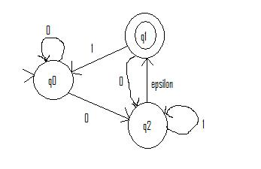

3) (15 pts) The intersection of two regular languages is regular also. Prove this statement in the following manner:
a) Assume you have a DFA D₁ which accepts the first regular language, L₁.
b) Assume you have a DFA D₂ which accepts the first regular language, L₂.
c) Describe, in detail, how to create a DFA D₃ which accepts the language L₁ $∩$ L₂.

(Note: In order to get full credit on this question, you must answer the following questions precisely: How many states will D₃ have? What is the correlation between states in D₃ and D₁ and D₂. How can each transition in D₃ be calculated? Which states in D₃ will be accept states?)

4) (15 pts) Prove that the following language is NOT regular via the Pumping Lemma:

L = { 0^{n}1^{m} | n > 2m > 0 }

5) (15 pts) Create a context free grammar that describes the following language:

L = { 0^{2n}1^{n} $∪$ 1^{p}0^{q} | n ≥ 0, p > q > 0 }

Justify that your grammar describes this language.

6) (15 pts) Draw a PDA that accepts the following language: C = {x#y | x, y $∈$ {0, 1}*, |x| = |y| but x ≠ reverse(y)}. Clearly state your stack alphabet, your set of states, the start state and all transitions.

7) (15 pts) Use the pumping lemma for context free languages to show that the following language is NOT context free:

{w#x | w is a substring of x, where x$∈$ {a, b}*}

8) (1 pt) After what very large number is the company Google named? ____________________

