One-Dimensional Arrays

How to Define an Array

Some types of tasks require many variables of the same type. For example, imagine needing to store all the test scores for students in a class. It would be tedious to create 30 (or more) variables and give each of them names. Furthermore, it would be even more tedious to refer to all the proper variables and use those variables appropriately.

An array allows the user to declare many (usually related) variables of the same type using a single variable name. Before we get to how to declare an array, let’s look at a visual depiction of an array named test_scores of size 10:
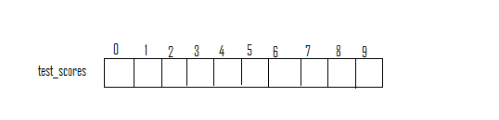

In particular, the memory locations of each of these variables is contiguous and notice that each location is given a “number”, which is known as that specific variable’s index. (These are the numbers written on the outside of the boxes.) The first valid index in an array is always 0 and the last is the length of the array minus one.

In order to create an array, you must specify three pieces of information:

- The type of information each variable will store.
- The name of the array
- The number of elements the array will store.

The generic syntax of an array declaration is as follows:

<type> <var name>[size];

In the original version of C, the expression for the size was required to be a constant. In C99, this expression can be any integer variable. However, it must be noted that under some compilers, variable-length arrays, don’t always work in a consistent manner. It’s best to either make the size of an array constant, or use dynamic memory allocation, which has not yet been taught. (This topic is not within the scope of this class, and therefore is not contained in this textbook. For further information, look up the use of the functions malloc, calloc, realloc and free elsewhere.)

Imagine that you wanted to store ten test scores. Since each score is guaranteed to be an integer, it’s safe to store the scores in an integer array. Since we need to store ten scores, ten will be our size. A reasonable name for the variable is test_scores. Here is the corresponding variable declaration:

int test_scores[10];

How to Access a Variable within an Array

Once a variable is declared, then all of the variables within the array are ready to be used. Note that none of these variables is initialized at this point in time. Namely, any values could potentially be stored in these 10 integer variables. To access an individual one, brackets must be used and the index for that variable must be placed in the brackets. The following expression refers to the first variable in the array:

test_scores[0]

This expression can be used in any context that a typical int variable can be used. In fact, the rules that govern this type of expression are identical to the rules that govern any int variable. It can be on the left-hand side of an assignment statement or part of any arithmetic expression. For example, if we wanted to set this variable to zero, we would execute the following line of code:

test_scores[0] = 0;

The corresponding picture is as follows:
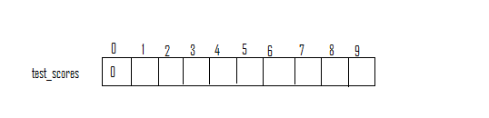

Similarly, if we wanted to take the average of the first three test scores, assuming that they were already initialized, we could do something like the following:

double avg = (test_scores[0]+test_scores[1]+test_scores[2])/3.0;

Using Loops to Operate on Arrays

Of course, it would be tedious to set each variable in the array to 0 individually:

test_scores[0] = 0;
test_scores[1] = 0;
test_scores[2] = 0;
etc.

So, typically, most programmers use loops when operating on arrays. The following loop would set each variable in the array above to zero:

int i;
for (i=0; i<10; i++)
test_scores[i] = 0;

After the loop has run five times (out of ten), the array would look as follows:
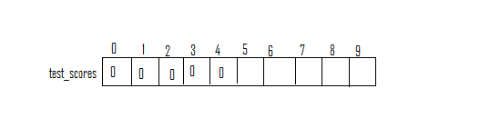
At the end of the loop, the array would be fully initialized:
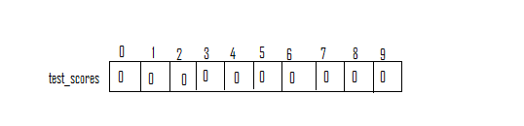

Three very common tasks with arrays are the following:

- Setting each item in the array to some initial value.
- Reading in values from the user or file directly into an array.
- Adding up the contents of each variable in an array.
- Print out each value in an array.

All four can be handled with for loops. We’ve already shown how to do the first.
Assuming the variable i is already declared, here is how to do the last three tasks:

for (i=0; i<10; i++)
scanf(“%d”, &test_scores[i]);

int sum = 0;
for (i=0; i<10; i++)
sum += test_scores[i];

for (i=0; i<10; i++)
printf(“%d “, test_scores[i]);

Notice the commonality of structure between all four tasks. In each situation we use a for loop. The looping index starts at 0 and ends at the length of the array minus one. Notice how the looping index naturally acts as an index into the array, going through each item in the array exactly once, in order. For so many tasks involving arrays, we want to process each value in the array once, and doing this processing in order works. Inside the body of each of these loops, we simply process the current element. You can think of it as an assembly line. The for loop automates going from item 0 to item 1 to item 2, etc. Inside the loop we simply specify what must be done to each item, whether it should be set to some value, initialized from user input, accumulated, or printed it out.

Let’s take a closer look at the second segment of code above that sums up all 10 values in the array test_scores. Let’s assume that we’ve already initialized the array with the following values (by reading them in from the user): 89, 47, 75, 94, 97, 100, 82, 85, 79, and 61. Also, let’s introduce the variable sum and set it to zero. Also, let’s begin the initialization statement in the for loop. At this point in time our picture is as follows:
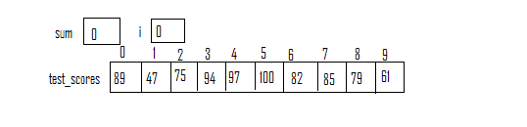
We check to see if i is less than 10 and it is. Then we execute the statement:

sum += test_scores[i];

where i is equal to 0. We access test_scores[0], which stores 89. This value is then added into sum. Then we increment i to 1:
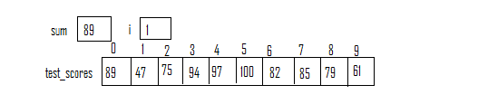
Since i is still less than 10, we execute the same statement. This time though, test_scores[i] evaluates to 47, since i is 1, this time around the loop. Thus, we will add the value 47 into sum (which is currently 89). After we increment i again, we have:
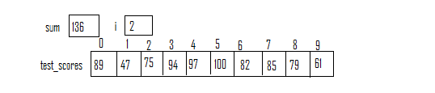
After one more iteration, we will add test_scores[2], which is 75, into sum, since i is equal to two. After incrementing i for a third time, our picture is as follows:
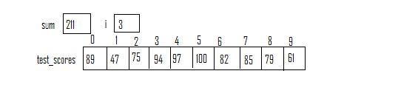
From this point, hopefully it’s clear how the loop accesses each test score as needed to accumulate the sum. This is very similar to examples from the loop chapter, except that the values being added are stored in the array. We must simply specify which values, one-by-one, that we want added into our sum. Using a looping variable allows us to easily access each element in the array, as needed.
A Simple Sample Program

Consider the task of reading in five test scores from the user and printing those scores back out in reverse order. We have already outlined how we will read the scores in. Now, we must consider how to print those out in reverse order. The idea above prints the scores out in the same order they were entered. A little bit of thinking will reveal that if we simply change the order in which we go through the indexes, we should be able to print the scores out in reverse order. Namely, we can start our loop at the highest possible index and count backwards, subtracting one each time through the loop.

Here’s the program:

int main() {

int i, test_scores[5];

printf("Please enter 5 test scores.\n");
for (i=0; i < 5; i++)
scanf("%d", &test_scores[i]);

printf("Here are the scores in reverse order: ");
for (i=4; i >= 0; i--)
printf("%d ", test_scores[i]);

return 0;
}

Array Initialization Short-Cut

Sometimes, if a easy pattern can’t be exploited with a loop to initialize an array, the values can be explicitly initialized as follows:

int vals[10] = {4, 3, 3, 5, 4, 4, 3, 5, 5, 4};

The left-hand side remains the same, but on the right-hand side we have an expression that starts with an open brace, followed by each initial value, in the corresponding order, separated by commas, followed by the closing brace and semicolon. Here is a picture of the corresponding array:


Incidentally, can you determine the meaning of the values stored in the array above? Can you guess what the following value will be? (The answer will be at the end of the chapter!)

Array Example: Searching for a value in an array

One of the most common tasks performed on an array is a search for a particular value. Let’s look at a straightforward way to do this in a segment of code. Assume the array numbers is already filled with values, has the length SIZE, and that all of the variables used have already been defined appropriately.

int index, val;

printf("What is the number to search for?\n");
scanf("%d", &val);

int found = 0;

// Assume the length of numbers is SIZE.
for (index=0; index < SIZE; index++) {
if (numbers[index] == val)
found = 1;
}

if (found == 1) {
printf("%d was in the array.\n", val);
}
else {
printf("%d was NOT in the array.\n", val);
}

It is typical to use a variable as a “flag” to keep track of whether or not some event has occurred. In this case, the variable found keeps track of whether or not the integer val has been located in the array numbers. Initially, we set this flag to 0. If we ever see val in the array, we can change found to 1, or true.

Array Example: Counting How Many Times a Value Appears in an Array

Searching for a particular value is quite similar to the task of counting how many times that value appears. In fact, the only change we have to make to the previous example is change the variable found to be an accumulator variable that adds up how many times the chosen value was seen. Thus, inside the if statement, instead of just setting found to 1, we would want to add one to it, to indicate that we’ve seen one more copy of the value for which we are searching. We’ll also change the name of the variable so that it is meaningful. Here are the relevant changes:

int numTimesSeen = 0;

// Assume the length of numbers is SIZE.
for (index=0; index < SIZE; index++) {
if (numbers[index] == val)
numTimesSeen++;
}

printf(“%d was in the array %d times\n”, val, numTimesSeen);

Basically, all we are doing is going through each value in the array as before. Now, whenever we find the value in question, we simply add one (just like adding a tally mark), indicating that we’ve seen that value one more time. When we are done, this accumulator variable, numTimesSeen, will store the number of times val appears in the array numbers. We will use this idea in future examples.
Array Example: Finding the Maximum Value in an Array

This works nearly identically to finding the maximum value in a list of numbers entered from the user. In this example, we’ll simply read these values into the array first from a file and then go through this array, looking for the maximum value. Assume that the file numbers.txt has exactly 100 integers in it, separated by white space.

#include <stdio.h>

#define SIZE 10

int main() {

// Will store the raw data (numbers) here.
int numbers[SIZE];

printf(“Please enter the %d test scores.\n”, SIZE);

// Read in all of the data into the array.
int i;
for (i=0; i<SIZE; i++)
scanf("%d", &numbers[i]);

// Currently, our largest value is numbers[0].
int max = numbers[0];

// If we find a larger value, update.
for (i=1; i<SIZE; i++)
if (numbers[i] > max)
max = numbers[i];

printf("The largest value was %d.”, max);

return 0;
}

Once we read in the values, the key is to simply keep track of the largest number we’ve seen so far, going through the array from the smallest index (0) to the largest (9). Basically, we set our max initially to numbers[0], since we haven’t seen any other numbers yet. Then, we go through the rest, and update max whenever we find a bigger number.
Array Example: Pizza Orders

Consider the following problem:

A pizza place has 5 different types of pizza, each with its own price. Write a program that reads in how many of each pizza in an order and prints out the total price of the order. First, the user will be prompted to enter all the pizza prices, and then they will be prompted to enter the number of each type of pizza ordered.

We can solve this problem with one array, but will use two arrays to keep our solution more straightforward.

Both arrays will be of size 5. The first one will store the price of each pizza:

Index | 0 | 1 | 2 | 3 | 4
Array Value | 9.99 | 12.99 | 7.00 | 14.99 | 11.99

The other array will store the number of each type of pizza the user is getting:

Index | 0 | 1 | 2 | 3 | 4
Array Value | 2 | 1 | 4 | 0 | 1

In the specific example above, the user is getting two of pizza #0, one of pizza #1, four of pizza #2, none of pizza #3, and 1 of pizza #4, for a total of

2 x $9.99 + 1 x $12.99 + 4 x $7.00 + 1 x $11.99 = $72.96

Thus, in our program, we’ll prompt the user to enter all the pizza price data first, and read it all into one array that stores the prices, followed by prompting the user to enter the quantity data for the order which will be stored in a second array.

Then we can loop through both arrays, multiplying the number of pizzas of one type by the price of that pizza, and then we can add each of these terms.

The solution to the problem is on the following page.
// Arup Guha
// 12/9/2011
// Pizza Array example for Junior Knights

#include <stdio.h>

#define SIZE 5

int main() {

double prices[SIZE];
int quantity[SIZE];
int i;

// Read in all of their prices into the array.
printf("Enter the prices of the 5 types of pizza, in order.\n");
for (i=0; i<SIZE; i++) {
scanf("%lf", &prices[i]);
}

// Read in the number of each pizza ordered.
printf("Enter the number of each pizza you are ordering, in order.\n");
for (i=0; i<SIZE; i++) {
scanf("%d", &quantity[i]);
}

double cost = 0;
for (i=0; i<SIZE; i++) {
cost = cost + quantity[i]*prices[i];
}

// Print out the answer for this case.
printf("On day %d, you will spend $%.2lf at Lazy Moon.\n", i, cost);

return 0;
}

