Skippy and His New Jetski
Filename: jetski

After a somewhat lengthy disappearance, Springfield Skippy has made his presence known on the beach with his new jetski. The problem is that Skippy is quite reckless on his jetski, so no one else in the water is safe when he's in the area. To deal with this problem, the beach patrol would like to put up warning signs in the areas where Skippy could potentially be riding his jetski.

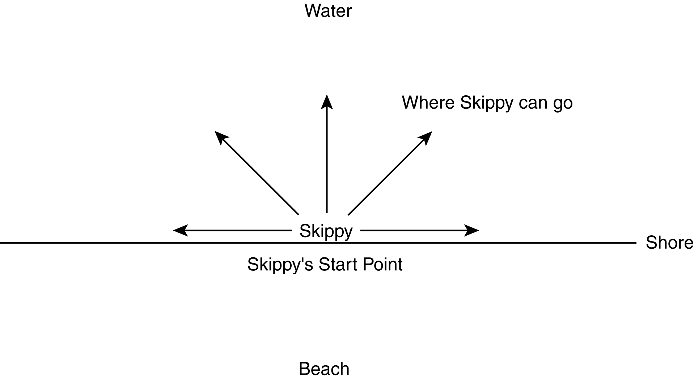

The Problem:

Your goal will be to help the beach patrol with their task by figuring out the total area where Skippy could be after a given time period given information about the speed of his jetski and the amount of time he will be on his jetski.

Assume that coastline at the beach is perfectly straight and can be modeled by the x-axis in the coordinate plane. Thus, all the points with a negative y-value are part of the beach, and all the points with a positive y-value are in the water. Skippy always starts at the point (0, 0) and is liable to go in any direction in the water from that point. Assume that Skippy's speed on the jetski is constant. So his jetski travels exactly the same speed regardless of whether he's headed up shore, down shore, or anywhere in between. Let S be the semi-circular zone where Skippy could possibly reach in the time he jetskis. Your goal is to determine the area of S. For your calculation, assume π is equal to 3.1415926535898.

The Input:

Since Skippy likes his jetski, he will spend several days at the beach. The first line will contain a single positive integer, n (n < 100), describing the number of days Skippy ventures into the ocean. The next n lines will contain two positive integers each. The first positive integer, s, on each of these lines, represents the speed of Skippy's jetski in miles per hour. The second positive integer, m, on each of these lines, represents the number of minutes Skippy will ride his jetski.

The Output:

For each day at the beach, you will output a single line header of the following format:

Day k:

where k is an integer in between 1 and n, inclusive.

Follow this with a space, and then the area in square miles rounded to the nearest hundredth (.005 rounds up), where Skippy could potentially be for that day at the beach.

Sample Input:

2
30 60
5 120

Sample Output:

Day 1: 1413.72
Day 2: 157.08

