CDA6530 (Fall 2015)
Homework 1: Probability and Random Variables
(assigned 09/02; due: 09/13 midnight, submitted via Webcourse)
1 (15 points). Bill and George go target shooting together. Both shoot at a target at the same time. Suppose Bill hits the target with prob. 0.3, George, independently, hits the target with prob. 0.6.
a). Now both of them shoot once and exactly one shot hits the target. What is the prob. that it was George's shot?
b). Now both of them shoot twice and the target is hit exactly twice. What is the prob. that George hits it at least once?

2 (20 points). A gambler has in his pocket a fair coin and a cheating coin (which will show up head with 80% of the chance). He selects one of the coins at a random, and when he flips it, it shows tail.
a). What is the probability that it is a fair coin?
b). Suppose that he flips the same coin a second time and again it shows tail. Now what is the probability that it is a fair coin?

3 (15 points). A university department knows that 50% of those graduate applicants who are given offers by the department will not accept the offer. Consequently, it makes up a policy to send out 8 offers for the 5 available positions. What is the probability that the department cannot fill up the existing 5 positions?

4 (25 points). Suppose each of three persons tosses a coin. If the outcome of one of the tosses differs from the other outcomes, then the game ends. If not, then the three persons start over and re-toss their coins.
a). Assuming fair coins, what is the probability that the game will end with the first round of tosses?
b). If all three coins are biased and have probability of 0.25 of landing heads, what is the probability that the game will end at the first round?
5 (25 points). The advantage of packet switching vs. circuit switching. The following figure shows that many users are sharing an 4Mbps access link to the Internet. Suppose each user is either in active status that required data access rate of 100k Bytes/second, or in silence status that the user requires no data. Each user is active 5% of the time, and users are independent with each other in their activities.
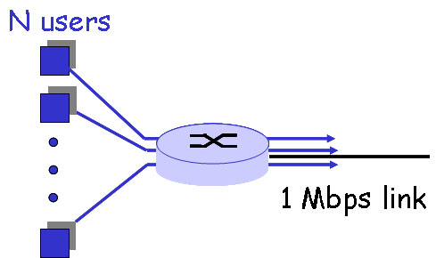
a). If circuit switching is used, how many user can this access link support?
b). If packet switching is used and there are 8 users. How often is this access link completely idle? How often does this link serve exactly two users? You must provide the final numerical solution.
4Mbps access link
c). If packet switching is used and there are 30 users, how often does the access link be congested? You must provide the final numerical solution.

