Sp 98
EGN 3420 Exam 1 Name__________________

DO ANY 3 PROBLEMS

Check the 3 problems you want graded:

1. 2. 3. 4.

Problem 1 (45 pts)

The function f(x) = cos(x) is expanded in a 1st order truncated series about the pt x=a.

f₁(x) = f(a) +f’(a)(x-a)

The point “a” is chosen so that f₁(π) = 0. (see graph)

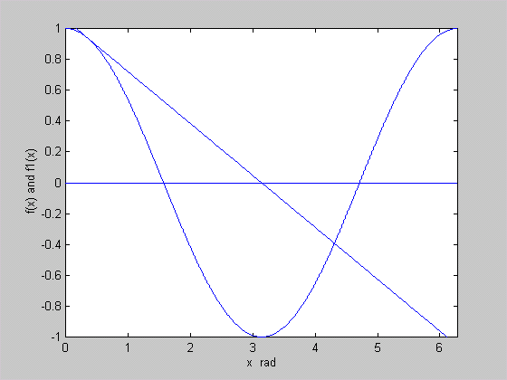
a
π
f(x)=cos(x) and f₁(x) expanded about x=a
f₁(x)
f(x) = cos(x)
a) Show that “a” is a root of f(a) = (π-a) tan(a) - 1 = 0. Hint: $\text{tan}(a)=\frac{\text{sin}(a)}{\text{cos}(a)}$

- Try to find the root by doing 5 iterations of the Simple One Point Iteration Method starting with an initial guess of a₀ = 1. Use the table below to enter your results (4 places after the decimal point). Be sure to show how you found g(a) and comment on whether the method appears to be converging.

i | a_{i} | a_{i+1}=g(a_{i})
0 | 1
1
2
3
4
5

c) Try to find the root by doing 3 iterations of the Newton-Raphson Method starting with an initial guess of a₀ = 1. Use the table below to enter your results (4 places after the decimal point). Is the method converging?
Hint:$\frac{d}{\text{da}}\text{tan}(a)={\text{sec}}^{2}(a)=1+{\text{tan}}^{2}(a)$

i | a_{i} | f(a_{i}) | f’(a_{i}) | a_{i+1}
0 | 1
1
2
3

Sp 98
EGN 3420
Exam 1 Name__________________
Problem 2 (30 pts)

The function f(x) = x³ - 6.75x² + 13.25x - 7.5 has a root located between 3 and 5. Fill in the tables below for the first three iterations of the Bisection Method and the False Position method. Express all answers to four digits after the decimal point.

Iteration | x_{l} | x_{u} | x_{r} | f(x_{l}) | f(x_{r}) | |e_{A}|, %
1 | 3 | 5
2
3

Bisection Method

Iteration | x_{l} | x_{u} | x_{r} | f(x_{l}) | f(x_{u}) | f(x_{r}) | |e_{A}|, %
1 | 3 | 5
2
3

False Position Method

Sp 98
EGN 3420
Exam 1 Name__________________
Problem 3 (25 pts)

Solve the system of equations below by finding the inverse of the coefficient matrix. You must show sufficient work in the process of finding the inverse to receive full credit, i.e. the complete cofactor matrix must be shown or the entire set or row equivalent matrices if the Gauss-Jordan Method is used.

x + 2y + 3z = 6
2x - 3y - z = -2
5x + 4y - 6z = 3
Sp 98
EGN 3420
Exam 1 Name__________________
Problem 4 (40 pts)

Given the following system of equations

- Convert the augmented matrix into its echelon form and find the value of K which results in an infinite number of solutions.
- For the case when infinite solutions exist, determine whether x₂ can be arbitrary without finding the solution.
Note: You may come and check with me to see if you obtained the correct answer to Part 1. If your answer is incorrect, I will give you the correct answer and there will be a penalty of 10 pts.
- Show that x₄ is arbitrary and find the solution with x₄ as the arbitrary unknown.

