**COT 4210 Fall 2018 Sample Midterm 2 Key Name: KEY**

**1.** Write a **Context Free Grammar** for the language

**L = { ak bm cn | k = n + m, or m = k + n, or n = k + m, k>0, m>0, n>0 }.**

***S → aAc | aA’bbC’c***

***A → aAc | aA’b | bC’c***

***A’ → aA’b | ***

***C’ → bC’c | ***

**2.** Consider the language **L = { an bn! | n>0 }**.

Use the Pumping Lemma for Context-Free Languages to show that **L** is not context-free.

***PL: Provides N>0***

***We: Choose aNbN! ∈ L***

***PL: Splits aNbN! into uvwxy, |vwx| ≤ N, |vx| > 0, such that ∀i≥0 uviwxiy ∈ L***

***We: Choose i=2***

***Case 1: vwx contains only b’s, then we are increasing the number of b’s while leaving the number of a’s unchanged. In this case uv2wx2y is of form aNbN!+c, c>0 and this is not in L.***

***Case 2: vwx contains some a’s and maybe some b’s. Under this circumstances uv2wx2y has at least N+1 a’s and at most N!+N-1 b’s. But (N+1)! = N!(N+1) = N!*N+N ≥ N! + N > N!+N-1 and so is not in L.***

***Cases 1 and 2 cover all possible situations, so L is not a CFL.***

**3.** Present the **CKY** recognition matrix for the string **bbabb** assuming the Chomsky Normal Form grammar, **G = ({S,A,B,C,D }, {a,b}, R, S)**, specified by the rules **R**:

**S → AB | BA | BD**

**A → CS | CD | a**

**B → DS | b**

**C → a**

**D → b**

|  |  |  |  |  |  |
| --- | --- | --- | --- | --- | --- |
|  | **b** | **b** | **a** | **b** | **b** |
| **1** | **BD** | **BD** | **AC** | **BD** | **BD** |  |
| **2** | **S** | **S** | **SA** | **S** |  |
| **3** | **B** | **SB** | **SA** |  |
| **4** | **SB** | **SB** |  |
| **5** | **SB** |  |

**4**. Choosing from among **(Y)** **yes**, **(N)** **No**, categorize each of the following closure properties. No proofs are required.

|  |  |  |
| --- | --- | --- |
| **Problem / Language Class (C)** | **Regular** | **Context Free** |
| Closed under union with Context Free languages? | N | Y |
| **Closed under quotient with languages of its own class (C), i.e., L1/L2** | Y | N |
| **Closed under difference with languages of its own class (C), i.e., (difference (L1, L2) = L1 – L2 )?** | Y | N |
| **Closed under intersection with languages of its own class?** | Y | N |

**5**. Prove that any class of languages, ***C***, closed under union, concatenation, intersection with regular languages, homomorphism and substitution (e.g., the Context-Free Languages) is closed under **Erase Middle with Regular Sets (em)**, where **L ∈ *C***, **R** is Regular, **L** and **R** are over the alphabet **Σ**, and **L em R = { xz | x,z ∈ Σ+** and **∃y ∈ R,** such that **xyz ∈ L }.** You may assume substitution **f(a) = {a, a’},**  and homomorphisms **g(a) = a’** and **h(a) = a, h(a’) = λ**. Here **a∈Σ** and **a’** is a distinct new character associated with each **a∈Σ**.You must be very explicit, describing what is produced by each transformation you apply.

***L em R = h( f(L) ∩ Σ + g(R) Σ + )***

***f(L) = { w | w ∈ L } where w has some (or none) of its letters primed. f(L) is a CFL since CFLs are closed under substitution.***

***g(R) = { y’ | y ∈ R } where y’ has all of its letter primed. g(R) is Regular since Regular languages are closed under homomorphism.***

***Σ + g(R) Σ + = { xy’z | x,z ∈Σ + and y ∈ R, This is a Regular language since Regular languages are closed under concatenation.***

***f(L) ∩ Σ + g(R) Σ + = { xy’z | xyz ∈ L, x,z ∈Σ + and y ∈ R} . This is a CFL since CFLs are closed under intersection with Regular.***

***L em R = h( f(L) ∩ Σ + g(R) Σ + = { xz | x,z ∈Σ + and ∃y ∈ R where xyz ∈ L } is a CFL since CFLs are closed under homomorphism.***

**6.** Consider the CFG **G = ( { S, T }, { a, b }, R, S )** where **R** is:

**S → a T T | T S | a**

**T → b S T | b**

**a.)** Present a pushdown automaton that accepts the language generated by this grammar. You may (and are encouraged) to use a transition diagram where transitions have arcs with labels of form **a, α → β** where **a** ∈ **Σ∪{λ}**, **α, β ∈ Γ\***. Note: I am encouraging you to use extended stack operations.  
  
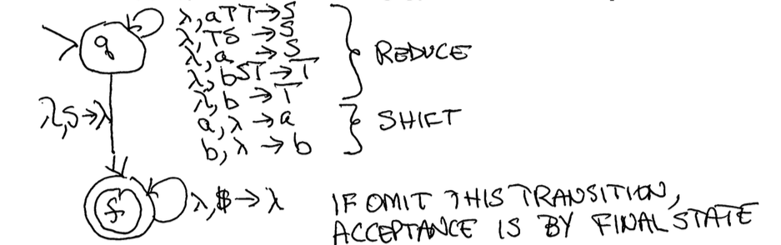

Above treats stack contents as being read backwards (deep to shallow).

What parsing technique are you using? (Circle one) **top-down** or **bottom-up**   
How does your PDA accept? (Circle one) **final state** or **empty stack** or **final state and empty stack**  
What is the **initial state**? q   
What is the **initial stack content**? $   
What are your **final states** (if any)? f   
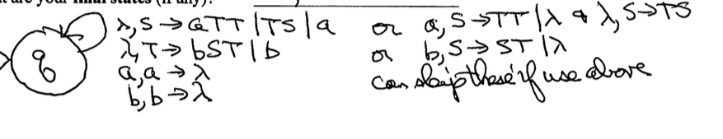

Or can have **a,S → TT | λ; λ,S → TS**

**b,T → ST | λ**

What parsing technique are you using? (Circle one) **top-down** or **bottom-up**   
How does your PDA accept? (Circle one) **final state** or **empty stack** or **final state and empty stack**  
What is the **initial state**? ***q***   
What is the **initial stack content**? ***S***   
What are your **final states** (if any)? ***None***   
**b.)** Now,using the notation of **ID**s (Instantaneous Descriptions, **[q, x, z]**), describe how your PDA accepts strings generated by **G**.

***[q, w, $] ⇒* [f, λ, λ] if by final state and empty stack (my solution on (a) Bottom-Up)***

***[q, w, S] ⇒* [q, λ, λ] if by empty stack (my solution on (a) Top-Down)***

**7.** Consider the context-free grammar **G = ( { S, A, B }, { a,b }, R, S )**, where **R** is:

**S → SAB | BA**

**A → AB | a**

**B → bS | b |** **λ**

**a.)** Remove all **λ**-rules from **G**, creating an equivalent grammar **G**’. Show all rules.

***Nullable = {B}***

***G’:***

***S → SAB | SA | BA | A***

***A → AB | a Note: There is a rule A → A but it was removed***

***B → bS | b***

**b.)** Remove all **unit** rules from **G’**, creating an equivalent grammar **G**’’. Show all rules.

***Unit(S)=Chain(S)={S,A}; Unit(A)={A}; Unit(B)={B}***

***G’’:***

***S → SAB | SA | BA | AB | a***

***A → AB | a***

***B → bS | b***

**c.)** Convert grammar **G’’** to its **Chomsky Normal Form** equivalent, **G’’’**. Show all rules.

***G’’’:***

***S → S<AB> | SA | BA | AB | a***

***A → AB | a***

***B → <b>S | b***

***<AB> → AB***

***<b> → b***

***In exam I may have some Unproductive non-terminals and some Unreachable ones.***