**COT 4210 Fall 2014 Sample Midterm#2 Name:**

**1.** Present a Mealy Model finite state machine that reads an input **x ∈ {0, 1}\*** and produces the binary number that represents the result of adding the twos complement representation of decimal **-6**, that is adding binary **1…1010** to **x** (this assumes all numbers are in two’s complement notation, including results). Assume that **x** is read starting with its least significant digit.  
Examples: **00010 → 11100; 11001 → 10011; 01011 → 00101**

**2.**

**a.)**Let **L** be defined as the language accepted by the finite state automaton **A=({A,B,C},{0,1},δ,A,{C})**:

0

**A**

**B**

**C**

**A**

1

1

0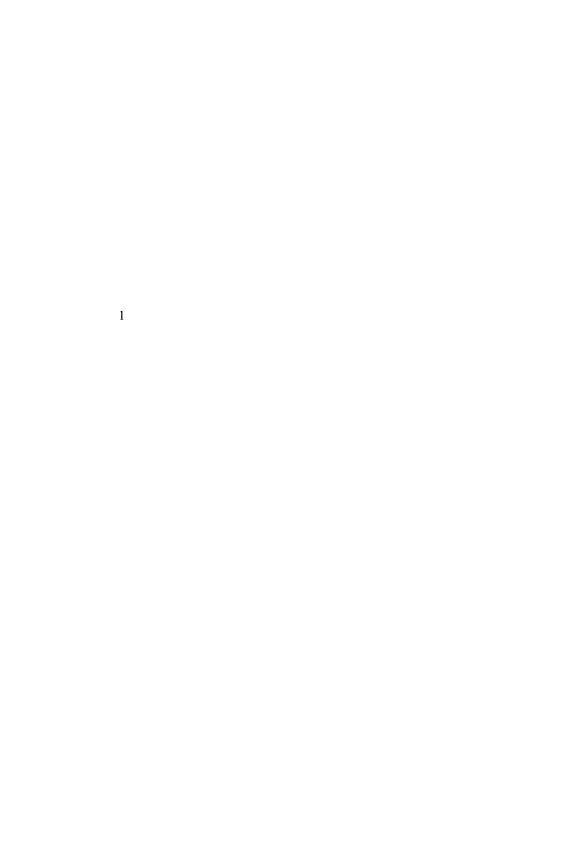

0

Present a right linear grammar that generates the language **L**.

**b.)** Consider the regular grammar **G = ({S, A, B}, {0, 1}, R, S)**, where **R** is:

**S → 0 S | 1 A | 0**

**A → 1 B | λ**

**B → 0 S**

Present an automaton **A** that accepts the language generated by the **G**:

**3.** Assuming you have computed the sets, **Rki,j**, for each pair of states, **(qi,qj)**, in some DFA. How is **Rk+1i,j** calculated, where **k+1** is no greater than the number of states in the associated DFA?

**4.** Analyze the following language, **L**, proving it is **non**-regular by showing that there are an **infinite** number of equivalence classes formed by the relation **RL** defined by:   
 **x RL y**  if and only if [ **∀z** ∈ **{a,b,c}\***, **xz** ∈ **L** exactly when **yz** ∈ **L ]**.   
where **L = { ck an bm | n** < **m, k > 0 }**.   
You don’t have to present all equivalence classes, but you must demonstrate a pattern that gives rise to an infinite number of classes, along with evidence that these classes are distinct from one another.

**5.** Write a context-free grammar for the language **L = { ck an bm | n** < **m, k>0 }**. Yes, this is the one you just showed is not Regular.

**6.** Which of the following are correct definitions of an ambiguous grammar? Write **T**(true) or **F**(false).

There are two distinct derivations of some string **w** derived by the grammar

There are two distinct parse trees for some string **w** derived by the grammar

**7.** Use the Pumping Lemma for context-free languages to show **L = { an bn2 | n > 0 }** is **not** a CFL. *Be complete and remember to differentiate what you get to do and what the PL gets to do.*

**8.** Consider the CFG **G = ( { S, T }, { a, b }, R, S )** where **R** is:

**S → a T T | T S | a**

**T → b S T | b**

**a.)** Present a pushdown automaton that accepts the language generated by this grammar. You may (and are encouraged) to use a transition diagram where transitions have arcs with labels of form **a, α → β** where **a** ∈ **Σ∪{λ}**, **α, β ∈ Γ\***. Note: I am encouraging you to use extended stack operations.

What parsing technique are you using? (Circle one) **top-down** or **bottom-up**   
How does your PDA accept? (Circle one) **final state** or **empty stack** or **final state and empty stack**  
What is the **initial state**?   
What is the **initial stack content**?   
What are your **final states** (if any)?

**b.)** Now,using the notation of **ID**s (Instantaneous Descriptions, **[q, x, z]**), describe how your PDA accepts strings generated by **G**.

**9.** Consider the context-free grammar **G = ( { S, B, E }, { 0, 1, i, e, s }, R, S )**, where **R** is:

**S → i B S E | s**

**B → 0 | 1**

**E → λ | e S**

**a.)** Remove all **λ**-rules from **G**, creating an equivalent grammar **G**’. Show all rules, including copied ones.

**b.)** Convert grammar **G’** to its Chomsky Normal Form equivalent, **G’’**. Show all rules, including copied ones from part (a).

**10.** Let **C** be some class of formal languages that is closed under substitution of members of its own class and under intersection with Regular Languages. Prove that **C** is also closed under **RealWrappers**, where **RealWrappers(L) = { xz | x, z ∈Σ+, ∃y∈Σ+, w=xyz ∈ L }**. You may assume substitution **f(a) = {a, a’},**  and homomorphisms **g(a) = a’** and **h(a) = a, h(a’) = λ**. Here **a∈Σ** and **a’** is a new character associated with each **a∈Σ**.

**11.** Fill in the following table with **Y** (yes) or **N** (no) in each cell, depending upon whether or not the class of languages is closed under the stated operation.

|  |  |  |
| --- | --- | --- |
|  | **Regular Languages** | **Context Free Languages** |
| Concatenation with Regular |  |  |
| Quotient with Regular |  |  |
| Complementation |  |  |
| Superset |  |  |

**12.** Present the **CKY** recognition matrix for the string **v + ( v – v)** assuming the Chomsky Normal Form grammar specified by the grammar   
**G = ( { E, A, B, T, U, L, R, P, M }, { v, +, –, (, ) }, Rules, E )**, where the **Rules** set is:

**E → E A | E B | L U | v**

**A → P T**

**B → M T**

**T → L U | v**

**U → E R**

**L → (**

**R → )**

**P → +**

**M → –**

|  |  |  |  |  |  |  |  |  |  |  |  |  |
| --- | --- | --- | --- | --- | --- | --- | --- | --- | --- | --- | --- | --- |
|  | **v** | **+** | **(** | | **v** | | **–** | | **v** | | **)** | |
| **1** |  |  |  | |  | |  | |  | |  | |
| **2** |  |  |  | |  | |  | |  | |  | |
| **3** |  |  |  | |  | |  | |  | |  | |
| **4** |  |  |  | |  | |  | |  | |  | |
| **5** |  |  |  | |  | |  | |  | |  | |
| **6** |  |  |  | |  | |  | |  | |  | |
| **7** |  |  | |  | |  | |  | |  | |

***Note: Do not be surprised if the above table is sparsely populated.***

***Hint: Be concerned if it’s densely populated.***